Simulate ASCII Data Transmission using Vector Source

Objective Simulate transmission of ASCII data using a vector source.

Background

The ASCII is a 7 bit code for standard English text, punctuation, and symbols. Digital computers typically use word lengths in multiples of 8 bits. ASCII encoded text uses 8 bits per character with the most significant bit (MSB) set to 0.

To transmit ASCII codes, they have to be broken up into binary symbols, that are sent serially to the receiver. The simplest method is to transmit the 0’s and 1’s individually for the 8 bits.

Bytes may be broken into M-ary symbols with M=1 for individual bits, M = 2 for pairs of bits, and M = 3 for triplets of bits. The conversion process is called parallel-to-serial conversion. The rate at which the symbols are transmitted is called the symbol rate (aka baud rate).

Flowgraph: test_ascii_list.grc

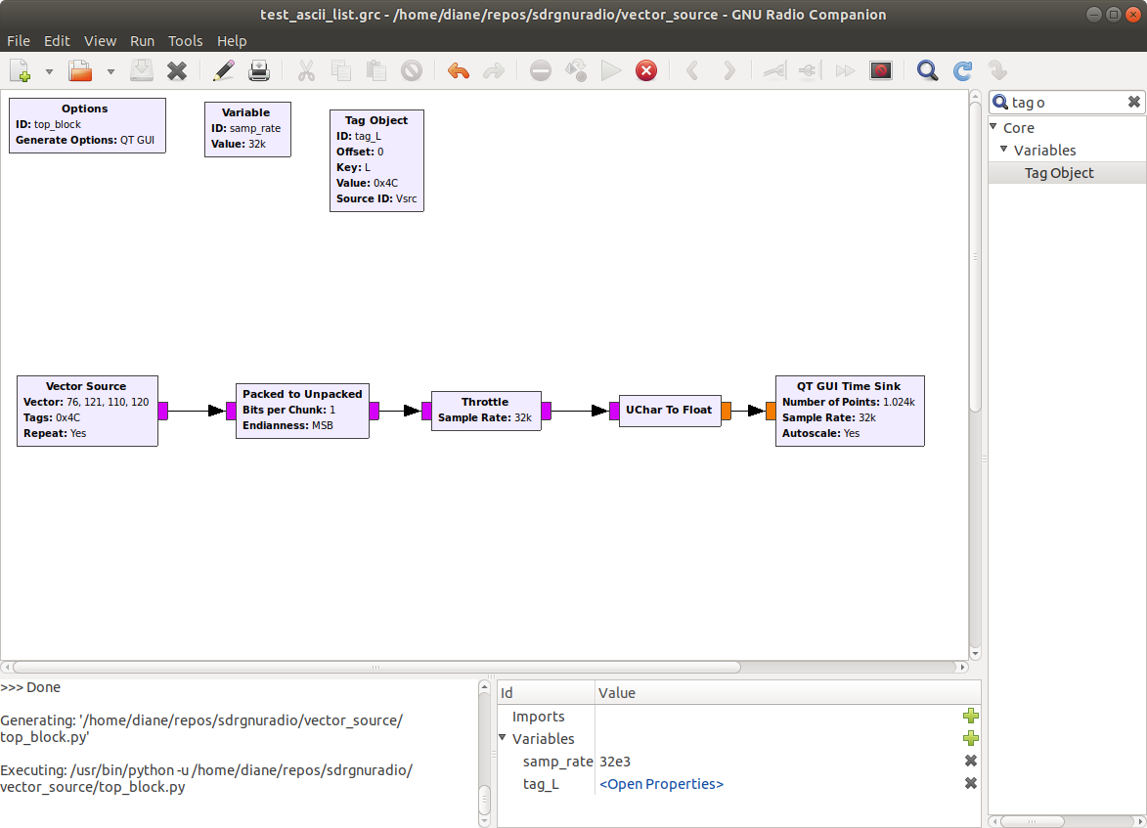

Variables

samp_rate 32e3

Tag Object

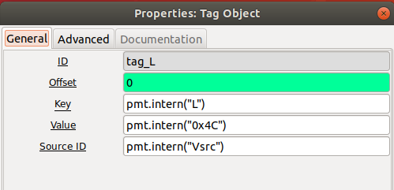

Vector Source Block

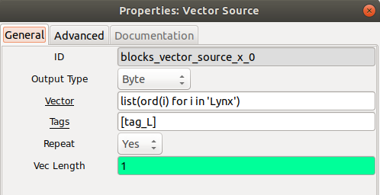

The input vector is interpreted as a list of integers and truncated to bytes when output. Note the output type is Byte.

Note: The ASCII integer values for Lynx are 90,121,110,120. The hex values are 4C, 79, 6E, 78

Packed to Unpacked Block

Bits per chunk: 1
Endianness: MSB

This block is required

A packed byte, consisting of 8 bits is the input. The output for an 8 bit byte will be 8 bytes.

The bits in the bytes input stream are grouped into chunks of bits_per_chunk bits and each resulting chunk is written right- justified to the output stream of bytes.

Example: input byte is 0xF2, which is binary 11110010

If MSB is chosen, then the output is

00000001 00000001 00000001 00000001 000000000 00000000 00000001 00000000

If LSB is chosen, then the output is

000000000 000000001 000000000 000000000 00000001 00000001 00000001 00000001

Throttle Block

Sample rate: samp_rate

Throttle block is used in the simulation only, recommended to avoid over-taxing CPU resources.

UChar to Float – converts the unsigned char to a floating point data type. Needed to display values on the Scope Sink. Scope Sink cannot handle the byte data type.

QT GUI Time Sink Output – Vector Source Input ‘Lynx’, Symbol Rate 32k samples per second
‘
Figure 1 below shows the binary pattern for the ASCII string Lynx. The start of the letter L is tagged with the value 0x4C.

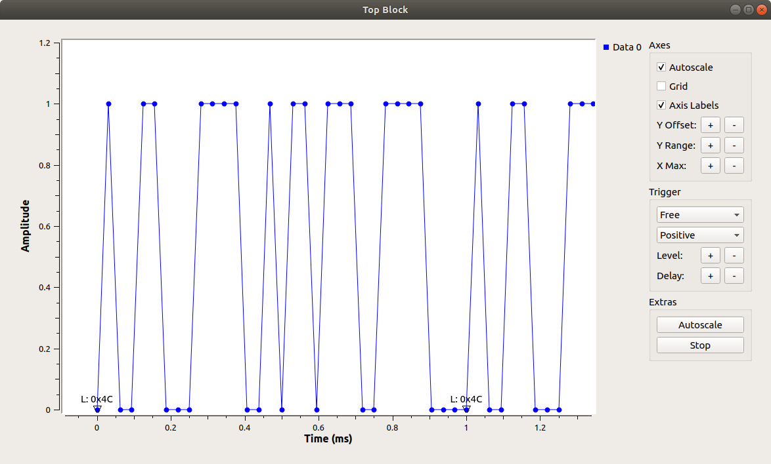

Figure 1: Time Sink Output for Vector Source Input ‘Lynx’

Starting at time 0, we see the binary pattern 0100 1100, for the 0x4C representing the character ‘L’. The ‘L’ was unpacked into 8 bits, and takes approximately 0.25 ms for transmission.

The sample rate is set to 32k samples per second, which has a period of 1/32000 = 0.03125 ms/sample.

There are 8 samples per symbol. 8 samples/symbol x 0.03125 ms/sample = 0.00025 seconds/symbol.

The symbol rate is the reciprocal value: 4000 symbols/second.

Figure 2 below shows the last bit of symbol ‘L’ at time t = 0.2194 ms, which is 0.306 ms less than the expected 0.25 ms. With this being a simulation run locally on my computer, I don’t know the reason for the time difference. This will have to be further analyzed at a future time.

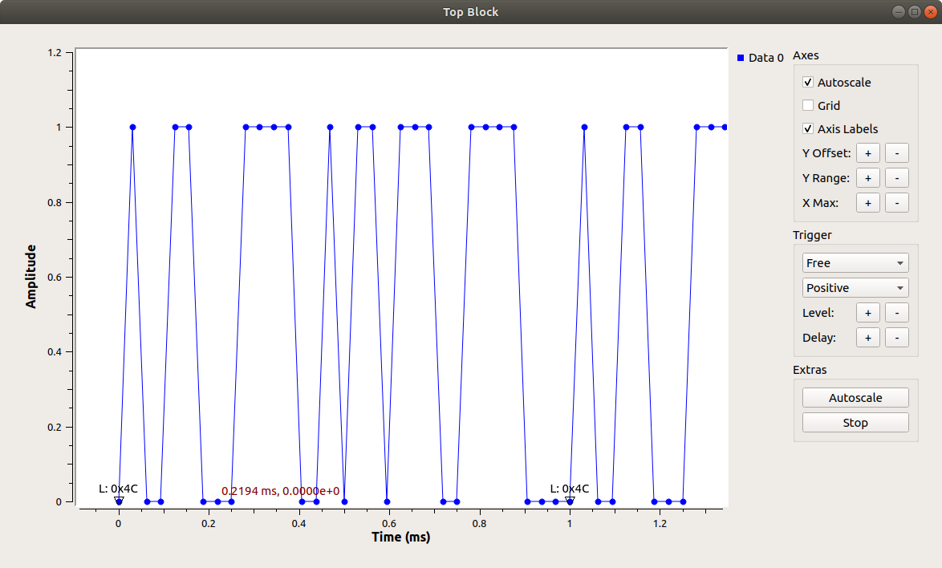
Figure 2, End of symbol ‘L’ at 0.2194 ms

Continuing forward in time, the next binary pattern is 0111 1001, 0x79 for the ‘y’. This is followed by 0110 1110, 0x 6E for the ‘n’, and then by 0111 1000, 0x78 for the x. The pattern then repeats as long as the simulation runs.

Conclusion:

The objective of simulating ASCII data transmission, with a Vector Source, was achieved. Each bit of the ASCII data was transmitted one symbol at at time.

It was illustrated that the symbol rate is a function of the sample rate and the bits per chunk settings. The symbol rate shown on the time sink output did not exactly match the calculated symbol rate. This may be a cause for concern and should be further investigated if this method is used for actual data transmission.

