Terrorism Encounter by the Department Of Homeland Security in America

Student’s Name

Institution Affiliation

Course

Date

**Abstract**

Since 2003 when the Department of Homeland Security was formed, there has been a change in how the government of United States encounters terrorism. Despite the rise of terrorism in America, the Department of Homeland has made efforts to prevent terrorist attacks from happening on American soil. The primary role of the department was to protect the citizens of the United States and bring safety in the country. The department has set goals and objectives that will help encounter these terrorist activities and prevent threats from terrorists. This paper is going to introduce to homeland security and take through the efforts made by the department to reduce such attacks and show how effective the efforts are towards achieving the goal of keeping America safe.

**Introduction**

Homeland security being a department set aside to improve safety in the United States of America, its primary role is to prevent terrorist attacks in American soil. It deals with various sectors including the prevention of terrorist attacks, emergency responses to human-made and natural disasters, border and immigration crisis and cybercrimes. The department ensures the safety of all Americans, and it is given the authority to apprehend all terrorist activities posed on the American soil. This paper will be tackling one of the roles of the department, which is preventing terrorism.

**Terrorism**

The United States of America has experienced the rise of terrorist attacks. There has been an increase in terrorist threats of using weapons of mass destruction in America. Weapons of mass destruction including nuclear, biological and chemical weapons are meant to wipe a large number of people, and it is upon the department of homeland security to ensure that these kinds of guns do not fall into the wrong hands of terrorists. The mass killing of innocent people and destruction of property should remain the first emergency in a nation and that it should be of great concern to the government. This explains why the American government has made efforts to implement an act that led to the formation of the department of homeland security to attend to these kinds of emergencies (Howard et al., 2006).

The graph below shows the number of deaths in America caused by attacks from radical Islamic violent extremists and violent far-right extremists against the year from 2001 and 2016. The bar graph clearly shows that there is an increase in deaths from terror attack, and most of them are caused by far-right extremists. The terrorism is mostly domestic, and statics have shown that there are few foreign attacks faced by the government of the United States.

**Since September 12, 2001, to December 31, 2016, USA Reported 85 Attacks Resulting in 225 Deaths**

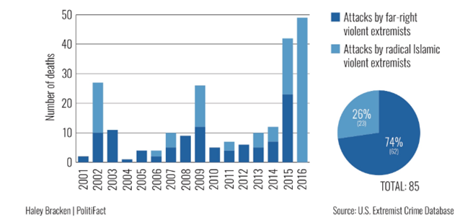

*The above data was obtained from the Government Accountability Office (GAO)*

The department of homeland security has identified primary threat attacks which we are going to talk about. Domestic terrorism is one of the major threat attacks that the department has identified. It includes terrorist from within the country, which consists mostly of hate crimes. These domestic terrorists have made their attacks based on religion, sex, races, ethnicity and national origin. There has also been an increase in racist attacks that have caused the attention of national security in the country. Targeted violence is another threat attacks that the department has identified. Targeted violence may be as a result of grievance from within or outside and that they lack a clear motive as to why they happen. Then we have The Radical Islamist Terrorist Threat which is mainly caused by some radical Islamist movements (Purpura, 2007). Al-Qa’ida remains to be one of the most pressing fundamental Islamic terrorist threats to the homeland department. Below is a presentation of the overview of the objectives that the department of homeland security has laid to encounter terrorism.

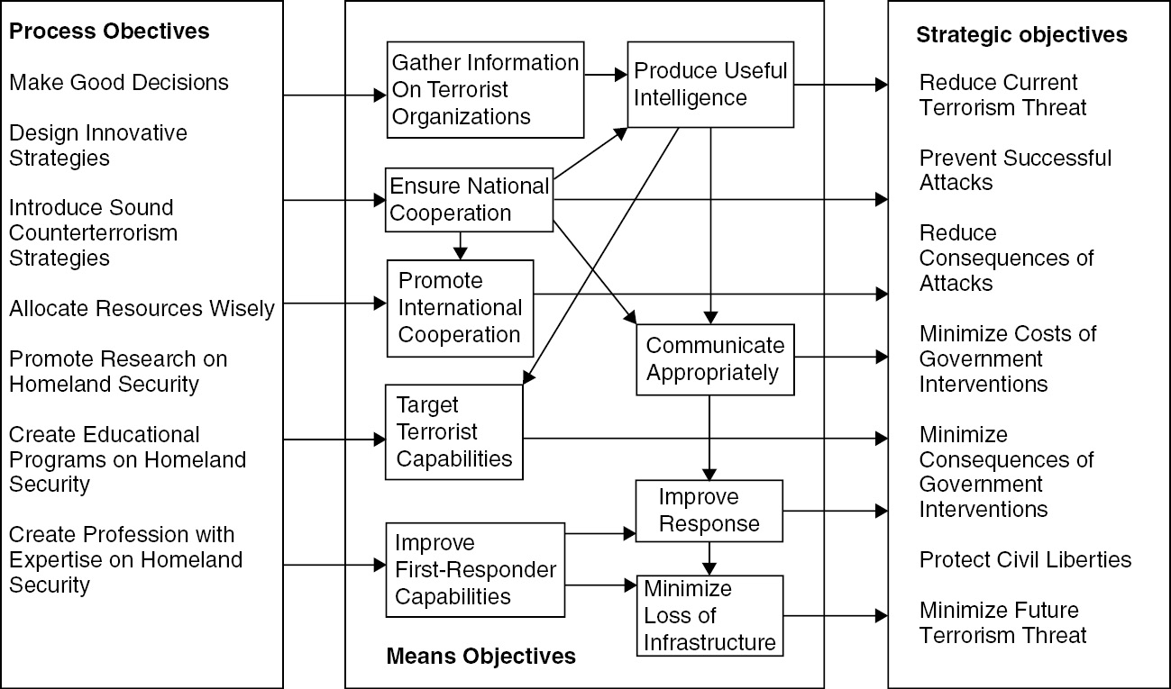

The department has developed plans that will enable them to achieve their primary goal of reducing these attacks. Various principles are meant to ensure that the country builds on its previous successes as well as identifying and foreseeing on future threats towards protecting the people of America. The first principle is to understand the positive uses of technology. Technology can provide meaningful, innovative solutions to problems associated with terrorism and targeted violence of mass killing of people. The government allocated resources to the department for the betterment of technology and weapons. Secondly, the department must adapt and understand the threat environment. As these terrorist activities increase, the department of homeland security needs to change to its capabilities to the new security landscapes and develop quick and innovative response towards terrorism.

Collaborating with domestic and international partners is another principle meant to ensure safety in America. The department has the task to address terrorist threats with international collaboration and interagency. These include the sharing of information about terrorism and the use of sufficient intelligence to reduce the cases. Emphasizing on the locally-based solution is another principle that Homeland has outlined. This is an important principle as the department needs to ensure that the communities are well aware of these criminal activities and that they should report these crime suspects in case of terror attack suspicion (Purpura, 2017). Finally, among the principles, the department should uphold individual rights. That entails defending of individual rights including privacy but ensuring maximum cooperation from individuals against countering terrorism. The department of Homeland has come up with the following goals to encounter threats from terrorist.

**Understand The Targeted Violence Threat Environment And Supporting Partners In The Homeland Security Enterprises**.

The capability of the department to respond to targeted violence and terrorism quickly dramatically depends on the ability to understand how these attacks happen and adopt on how they develop. There are various ways in which Homeland can achieve this goal. One is deploying the most effective technology to solve criminal activities and addressing present and emerging threats. The department is meant to invest testing, researching and ensuring the deployment of useful technological solutions towards terror. The department is required to partner with the technology sector to achieve this goal. It has also identified key technologies to develop the homeland security posture. Establishment of a flexible development, contracts and adoption of technology is also an effort made by the department. The department should be able to expand the existing partnership and form new friendships that will enable achievement.

To achieve the goal of understanding these threats, the other objective is to conduct an in-depth analysis of the present and emerging threats and sharing the information with homeland security. Apart from understanding the dangers of targeted violence and terrorism, the department needs also to study how these threats develop. The department deals with analyzing intelligence on these particular threats and informs on the actions to be taken on these threats. It also facilitates a national competence in identifying, preventing terrorism and stopping the mass attacks. Through the analysis and approach of this intelligence and information, the department of homeland security is meant to achieve the understanding of these threats and how they are approached by the government (Caudle, 2003). Sharing of information builds a good connection between the department and other private sector partners which in turn improves security.

Another objective is to encourage the department’s knowledge to leverage investigations that require law enforcement. One advantage of understanding the threat environment is to support the department’s learning to run active missions and achieve them, thus protect Homeland. The priority action for the department is that it will work to encourage information sharing between Homeland and other sectors. The different priority is to give resources to the department and ensure - highly trained personnel. These priority efforts will increase the strength of the department of homeland security, thus reduce terrorism activities.

**Prevent terrorist from entering America**

This entails denying terrorist opportunity to study the country’s immigration, international and domestic travel coordination. Terrorists regularly tend to explore migration, travel and trade systems. To prevent this, the department has formed strategies like screening, detection and vetting in our transport systems. There have been various objectives set by the department to achieve this goal. One of the purposes is detecting terrorist that make attempts to travel to America. It includes stopping the terrorist from exploiting and exploring trade and transport systems of the country. The Homeland department is expanding cooperation with other foreign states to improve an individual’s identity and identify possible threats before they can occur on American soil (Purpura, 2007. Some of the priority actions the department is developing are to expand the borders of America and improve the abilities of vetting. The following pie circle presents the percentage movement of extremist into America.

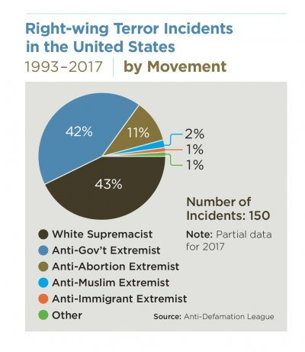

*The image above was obtained from the Anti-defamation League.*

Another objective is to improve counterterrorism abilities of the foreign partners. Many countries now encounter a rise in terrorist attacks that originate from within their borders. It is therefore essential for the international partners to improve their ability to detect terrorism and fraud among the partnered nations. The priority actions are to enhance this goal is to develop the security sector and strengthen international cooperation in efforts to encounter terrorism. To stop these threats facing the country, the department of homeland security will keep on collaborating with international partners to support the American government to achieve its goal of encountering terrorists. The following pie circle presents a percentage overview of tactics used by a terrorist in 2017. The analysis shows that terrorists used bombs more to do their terrorist activities. The tactic of Assassination was used less compared to other tactics.

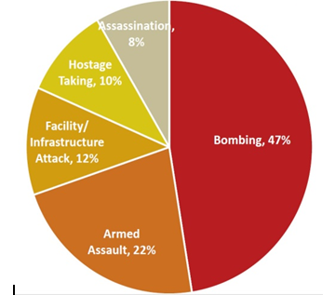

*The data above was obtained from the Annex of Statistical Information.*

Another objective that will help achieve the goal is that there should be the improvement of the homeland department’s security that governs surface, aviation and marine transportation. Terrorist and other criminals have vowed to exploit aviation, surface and maritime transportation for a range of terrorist activities such as transporting of nuclear weapons. Government agencies in the transport sector are at significant risk as terrorist try to exploit their knowledge to attend to their criminal activities. Homeland is working to improve security in the transport sector globally by introducing enhanced security measures (White, 2016). For instance, Homeland has developed CCTV and increased screening and vetting systems at major international airports. These efforts are meant to prevent a foreign terrorist from entering the country or even prevent weapons from being shipped into the country.

**Prevent targeted violence and terrorism**.

The national strategy for the department is to involve the United States government in implementing a global prevention architect with the help of other partners to prevent the terrorist threat. In 2018, a US secret service assessment centre reviewed mass attack and found out that most of the terrorist used firearms and half of them had committed suicide after the attack. They also found out that two-thirds of the terrorist had mental problems, including depressions. Over the last five years, the department has worked closely with mental health professionals on making sure the nation knows these kinds of threats. However, the proper way the homeland security can help reduce these attacks is by working closely with the federal government and educating the public on reporting any suspicious terror attacks.

There are various objectives that the homeland department has to achieve the goal of preventing terrorism. One is to strengthen the society in resisting any form of terrorism and ensuring awareness of the terrorist threat (Purpura, 2017). An organisation that is aware of the terrorist lays the best foundation towards stopping targeted violence and terrorism. The department of Homeland has worked closely with the science and technology sector by ensuring sponsorship of scientific data collection and analyzing such threats. The priority action for the objective is to form partnerships that support the prevention of terrorism locally. Another priority is to raise social awareness and mobilization to violence. The department will need to increase awareness among the citizens on possible threats and encourage the public to report suspicious terror cases.

Another objective is online influence on counter-terrorism. Communication across the world has been influenced by online platforms. Online space offers essential growth to the terrorism of various terrorist movements. The department of Homeland, therefore, monitors such online activities and partners with the society in apprehending these terrorist activities. The priority action for this objective is to cooperate with partners in the private sector in campaigning and educating individuals on how to handle violence. The department of Homeland will use technology to monitor online platforms for terrorism activities.

**Improving infrastructure protections and creating public readiness**

The country’s infrastructure and public areas are the primary targeted areas for mass attacks from these terrorists (White, 2016). The department of Homeland will cooperate with the federal agents to protect the infrastructure and increase security in the targeted areas. Ensuring that the nation is ready to tackle such terrorist attacks is also a role of the department. One of the objectives of this goal is to provide the preparedness towards potential terrorist attacks. The department has dedicated resources to strengthen the society in readiness towards these attacks. As terrorism and targeted violence is hard to predict, the department has to ensure that the public is prepared for those attacks. The department has a role in educating individuals to take preparedness as a shared responsibility to improve security. This also helps the public in recovering from these attacks. Some priority actions are to enhance preparedness and ensuring the allocation of resources in readiness to these attacks.

The department has to ensure protection against crime actors by using new technologies. It also needs to develop public awareness on misuse of the latest technology on terrorist activities. The other priority action to be taken is to support and offer sponsorship research on upcoming technologies. The department should be in a position to defend the public against threats arising from new technologies and form partnership to tackle misuse of technology. It should be able to partner with foreign and federal agencies in encountering terrorism using new technologies. The department should be in a position to give quick responses in case of attacks and work towards securing the citizens of America.

**Recommendation**

The goal and objectives set by the homeland security are practical and by far a success as there has been a significant change, and the people of America feel safe. Since the department of homeland security was formed in 2003, it has dramatically helped America in handling terrorism and preventing significant attacks. The department has blocked terrorist activities on American soil and has helped in bringing dangerous criminals to justice. The department has also come up with new technology and weapons to fight and prevent terrorism. By the help of foreign and federal agencies, the department has achieved their goals, and they are ready to encounter emergency attacks from terrorist by the support of the American government.

**Conclusion**

As the department develops, it has come up with abilities that have seen successful encounter of terrorism. Encountering multiple terrorist attacks from within and foreign has shown the responsibility of a modern security department on handling such attacks. As a country, we need to resist calls to terrorism and report suspicious criminal activities that may put the lives of American citizens in danger. We must cooperate with local authorities in attending security matters because it enhances our safety. The department of homeland security, continue to be vigilant, and they look forward to encountering various crises and threats and protecting the life of the citizens of the United States.

**References**

Caudle, S. (2003). Homeland Security: A Challenging Environment; the Meaning of Homeland Security, Its Intent, and the Key Issues Officials Will Encounter in Addressing Its Policy and Management Challenges. *The public manager*, *32*(1), 19. Retrieved from: <https://www.questia.com/library/journal/1G1-102947802/homeland-security-a-challenging-environment-the>

Erbschloe, M. (2004). *Implementing homeland security for enterprise IT*. Burlington, MA: Digital Press. Retrieved from: <https://books.google.co.ke/books?id=xgLGHwZZZ0wC&printsec=frontcover&dq=department+of+homeland+security+counter+terrorism&hl=en&sa=X&ved=0ahUKEwjq2q781YrqAhUK2KQKHcZfCQwQ6AEILjAB#v=onepage&q=department%20of%20homeland%20security%20counter%20terrorism&f=false>

Howard, R. D., Forest, J. J. F., & Moore, J. C. (2006). *Homeland security and terrorism: Readings and interpretations*. New York: McGraw-Hill. Retrieved from: <https://books.google.co.ke/books?id=ViC49z8oQL0C&q=department+of+homeland+security+counter+terrorism&dq=department+of+homeland+security+counter+terrorism&hl=en&sa=X&ved=0ahUKEwjq2q781YrqAhUK2KQKHcZfCQwQ6AEITDAE>

Mueller, J., & Stewart, M. G. (2011). *Terror, security, and money: Balancing the risks, benefits, and costs of homeland security*. Oxford University Press. Retrieved from: <https://books.google.co.ke/books?hl=en&lr=&id=YkPRCwAAQBAJ&oi=fnd&pg=PP1&dq=preventing+terrorism+by+homeland+security&ots=_3e5Ah544y&sig=n4uKXBs6h-otrAsR23JmOkvBaqo&redir_esc=y#v=onepage&q=preventing%20terrorism%20by%20homeland%20security&f=false>

Paul, V., ‎Michae,l O., ‎& Nicholas, B. (2008). Terrorism and Homeland Security: Thinking Strategically About Policy. Retrieved from: <https://books.google.co.ke/books?id=oBOghw40bUEC&printsec=frontcover&dq=department+of+homeland+security+counter+terrorism&hl=en&sa=X&ved=0ahUKEwjq2q781YrqAhUK2KQKHcZfCQwQ6AEIJjAA#v=onepage&q=department%20of%20homeland%20security%20counter%20terrorism&f=false>

Purpura, P. P. (2007). *Terrorism and homeland security: An introduction with applications*. Amsterdam: Butterworth-Heinemann. Retrieved from: <https://books.google.co.ke/books?id=3ItzwLVo8DwC&printsec=frontcover&dq=department+of+homeland+security+counter+terrorism&hl=en&sa=X&ved=0ahUKEwjq2q781YrqAhUK2KQKHcZfCQwQ6AEIZTAH#v=onepage&q=department%20of%20homeland%20security%20counter%20terrorism&f=false>

United States. Office of Homeland Security. (2002). *National strategy for homeland security* (No. 87). Office of Homeland Security. Retrieved from: <https://books.google.co.ke/books?hl=en&lr=&id=ktNDIOgqEa4C&oi=fnd&pg=PR7&dq=preventing+terrorism+by+homeland+security&ots=zpjwu4Oa7i&sig=tVkMQFOCGq5nTYqF9ikelycaAzg&redir_esc=y#v=onepage&q=preventing%20terrorism%20by%20homeland%20security&f=false>

White, J. (2016). *Terrorism and homeland security*. Retrieved from: <https://books.google.co.ke/books?id=XINTCwAAQBAJ&printsec=frontcover&dq=department+of+homeland+security+counter+terrorism&hl=en&sa=X&ved=0ahUKEwjRzdGr4YrqAhUO26QKHS3uCdw4ChDoAQhwMAg#v=onepage&q=department%20of%20homeland%20security%20counter%20terrorism&f=false>

Country Reports on Terrorism 2017 - United States Department of State. (2019, August 6). Retrieved from: <https://www.state.gov/reports/country-reports-on-terrorism-2017/>