**Analytical Framework of TESLA**

Innovation diffusion theory explains what, why, and how technology and new ideas spread within an organization or a company. In 1962, Everett Rogers came up with the theory to focus mainly on the business organization, environment, and technology. In this case, the framework is used in the analysis of the processes and practices of Tesla Inc. The main innovation technique used by Tesla is the reduction of the price of products to increase the accessibility of electric vehicles (EV) by a wider customer crowd. In adopting the different innovations, there have to be different stages including the innovation itself, communication of the innovation in the different organizational channels, continued practice of innovation, and inclusion of the social system (Rogers, 2010). The customer groups of the Tesla Company differ in desires and needs. These differences are noticeable in the different stages of innovation cycles of Tesla’s products. The diffusion of innovations in tesla has taken several turns including the reduction of technological problems. The third model of tesla as shown below includes some of the promising concepts to electric mobility.

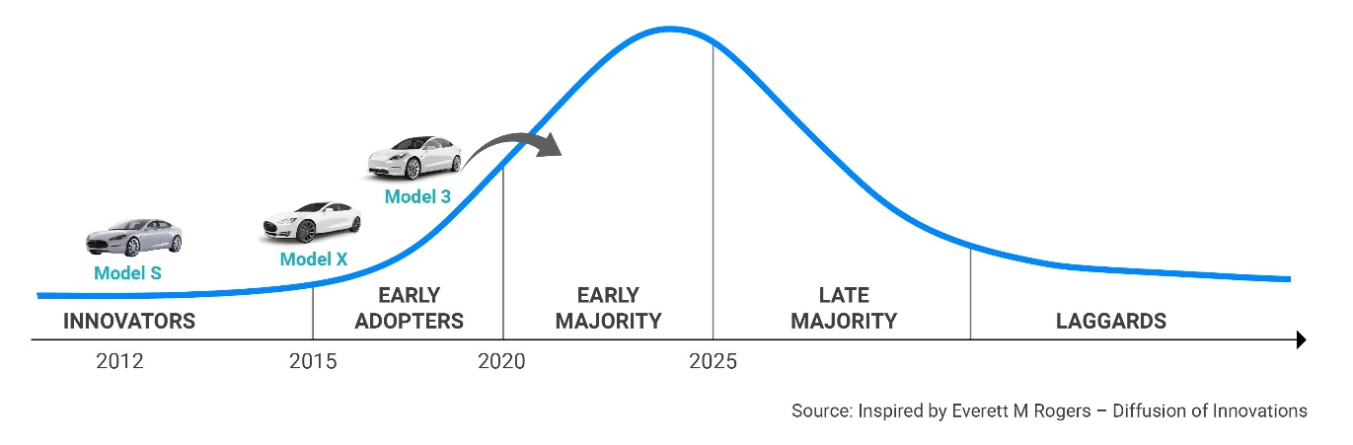

Tesla’s electric mobility that ranges up to approximately 600KM outdoes other entrants. Low MSRP in the latest models is efficient as compared to the old models with plans of achieving 99% coverage in Europe. Likewise, diffusion innovation is focused on different Tesla’s EV pain points such as charging time, charging network, purchasing costs, and driving range. Tesla focuses on the minimalistic interior characterized by the innovative-looking and sleek designs of touchscreens and surfaces. Majorly, artificial intelligence (AI) is deployed in enhancing in-car software and hardware integration. These are some of the examples of the diffusion of innovation within Tesla that seeks to address owners of EVs.

Technology lifecycle theory is another theory that can be used to explain the development and research, rise, maturity, and failure of a company or organization. Nikolai Kondratiev in 1925, first observed this theory where different chronological demographics such as laggards, late majority, early majority, early adopters, and innovators are involved (Yegorov, 2011). In this case, the technology lifecycle theory in Tesla is depicted by the introduction of new car models with cosmetic and minor functional changes. Tesla embraces the culture of smartphone companies by releasing repeated software updates that change and improve car functionality. The updating of the best-selling Model S by Tesla is a milestone consideration in the technology lifecycle theory. Tesla products have proven to pass the introductory stages with a notable production of eco-friendly EVs.

The company mainly targets a wide scope of consumers from the range of Early Adopters to Early Mortality. The market share of Tesla Company continues to grow with the increased sensitization over the matters of global warming. The imposed regulations over emissions challenges the company to keep up with technological changes. Tesla focuses on tuning the designs while the main focus of the business is awareness among the customer scope. Despite the low scales, the competition is low since the company uses eco-friendly material in its products, the materials include boron steel that is used to safeguard the light aluminum used. The electrolytes and the lithium batteries support the consumer needs efficiency. This prevents the company from getting into the decline and failure stages.

**References**

Rogers, E. M. (2010). *Diffusion of innovations*. Simon and Schuster.

Yegorov, Y. (2011, May). Long economic waves as innovation cycles. In *Proceedings of Simon Kuznets International Symposium. SKISD, Kyiv, Ukraine*.