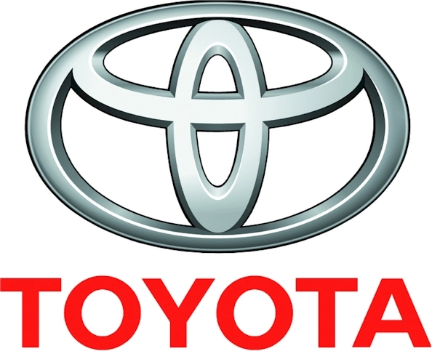

**Abdul Lateef Jameel Company**

**To:** Ibrahim Al-Badawi,

Fleet Maintenance Supervisor,

Prince Mohammed Bin Fahad University

Al-khobar

**From:** Salman Z Al Harthi,

Sales and Marketing Department

Abdul Lateef Jameel Company 21/09/2020

Dear Sir,

With regards to your letter of 26th of June, and your follow-up telephone conversation, here are the cost of the parts (wholesale) as requested.

**2019 Coaster Bus**

|  |  |  |  |  |  |
| --- | --- | --- | --- | --- | --- |
| **Model / Item** |  | **Code** | **Unit** |  | **Price** |
| Brake Cylinder(L/R) |  | 12345A | 10 paris |  | 3567 Each SAR |
| Brake Paid |  | 2436Y | 20 pais |  | 2265 Each SAR |
| Brake Cylinder |  | 2345Z | 10 pairs |  | 2167 Each SAR |
| Retaining Springs |  | 2356X | 10 pairs |  | 58 Each SAR |

We look forward to doing business with you in the near future.

Thank you for your consideration.

Yours Sincerely

***Salman Z Al Harthi,***

Manager Sales & Marketing

|  |
| --- |
|  |