# Assignment 2: Leveraged Investing

Instructions:

1. Read the scenario.
2. Assess and analyze Taylor’s investment idea. Justify your answer with both qualitative and quantitative reasoning.
   * Should Taylor make this investment?
   * Should he include leverage in his investment mix?
3. Assignment should be completed in **Excel**.
4. Note: You must show ALL your calculations to receive marks

**Scenario:**

Taylor Lautner, a client of yours with a net worth in excess of $3.5 Million, is considering making a “small” investment and is seeking your advice. In all his free time, he has been following the ABC Income fund and likes the annual interest income of $0.300/ unit that the fund pays, but is concerned about how that would be taxed with his marginal rate of 40%. He is considering purchasing $75,000 worth of the fund and wants your advice on whether or not he should borrow an additional $52,500 from his Home Equity Line of Credit and service the 3.0% simple interest only while he owns the investment – allowing him to buy $127,500 worth of the fund. His neighbor, Billie Satzky, is telling him it’s a bad idea – but he wants your professional opinion.

The annual interest income distribution off the fund is not set-up as a DRIP, but rather pays directly out to an account in Taylor’s name. The fund is currently trading at $15.00.

**REQUIRED:**

With calculations, demonstrate to Taylor how his return would be impacted under both the “best” and “worst” 12 month returns highlighted in the chart below (expressed as 12 month percentage gains and/or losses). Include: a baseline scenario (i.e. no leverage), as well as, both a best case and worst case. Make sure to include any relevant taxation implications in your illustration of the after-tax returns in each scenario. Lastly, make a reasoned and supported recommendation to Taylor – as to whether or not you believe that this is something that he should consider.

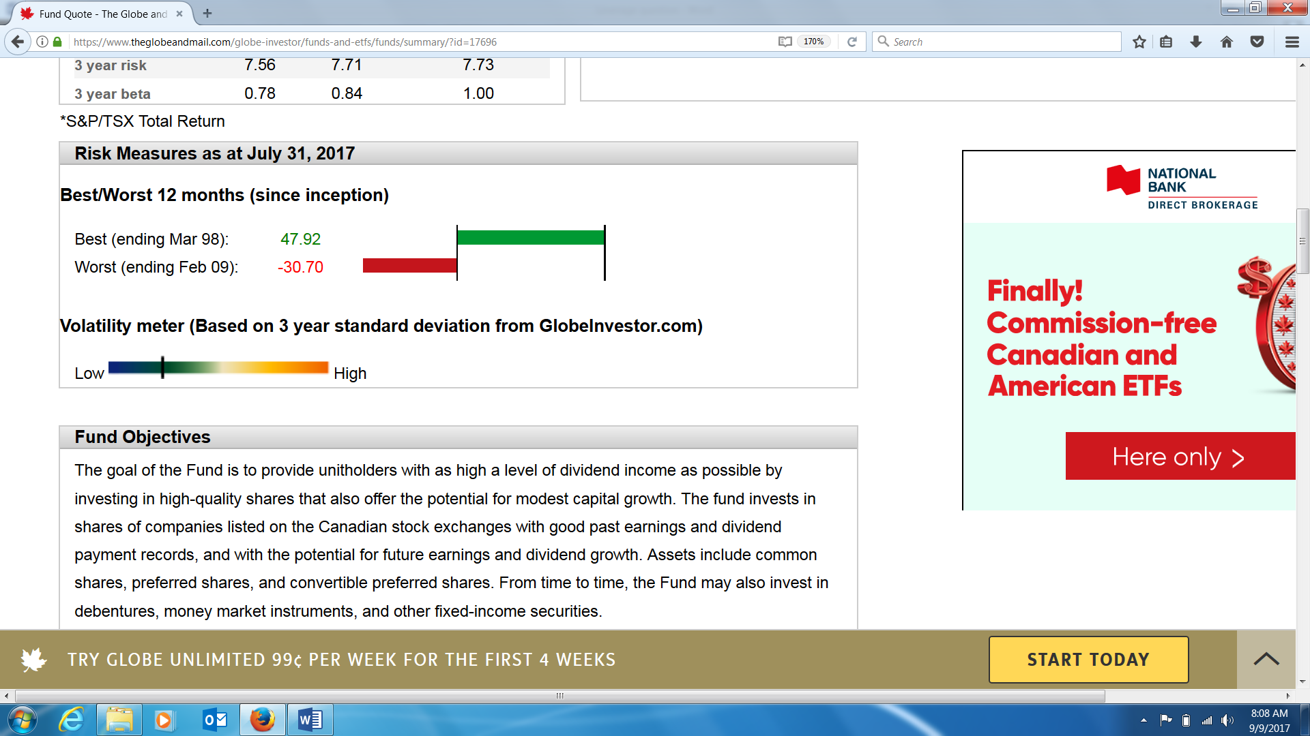

## Marking Guide

|  |  |  |
| --- | --- | --- |
| **Criteria** | **For full marks** | **Marks** |
| Quantitative analysis | Proper baseline is established and illustrated (no leverage), then both the best case and worst case are fully examined – including a clear illustration of the taxation impact through all outcomes using correct formulas and calculations. | 22 |
| Qualitative analysis | Detailed and clearly stated analysis of the situation including an assessment of the appropriateness of the strategy as it relates to the specific circumstances of the client and the data provided. | 6 |
| Format | Clear and logically organized structure with section and sub-section headings, use of consistent font, with few to no grammatical or punctuation errors. | 2 |
| Total |  | 30 |