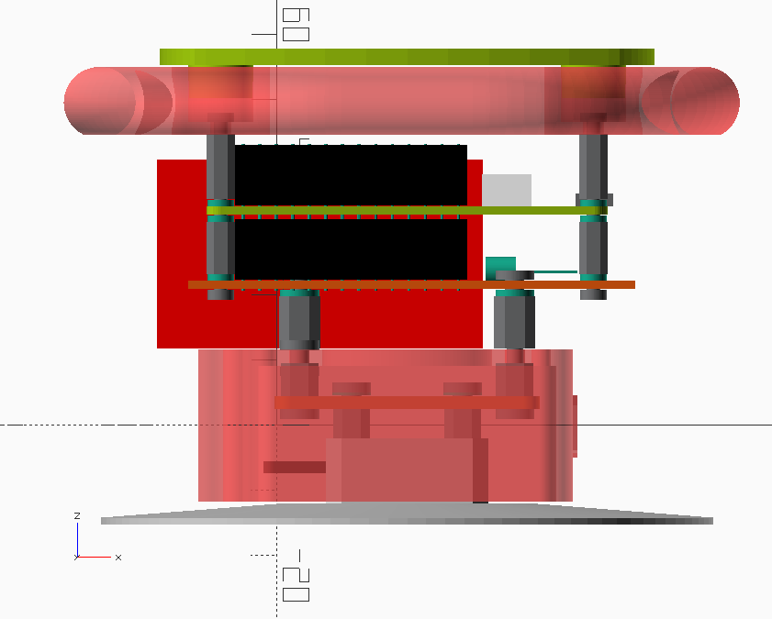
21
17+19
12
13
16
15
11+14
9
8
5
4
3
2
11+14
22
23
6
10
7
18+20

