https://www.hackerrank.com/challenges/climbing-the-leaderboard/problem?fbclid=IwAR2_PUT6ZpGQenj0AG-BiAAGfc9kLAoVrQNQvtbzI0O2S812DITFA-m2O8E
Alice is playing an arcade game and wants to climb to the top of the leaderboard and wants to track her ranking. The game uses Dense Ranking, so its leaderboard works like this:
- The player with the highest score is ranked number
- on the leaderboard.
- Players who have equal scores receive the same ranking number, and the next player(s) receive the immediately following ranking number.
For example, the four players on the leaderboard have high scores of
, , , and . Those players will have ranks , , , and , respectively. If Alice's scores are , and , her rankings after each game are , and .
Function Description
Complete the climbingLeaderboard function in the editor below. It should return an integer array where each element
represents Alice's rank after the
game.
climbingLeaderboard has the following parameter(s):
- scores: an array of integers that represent leaderboard scores
- alice: an array of integers that represent Alice's scores
Input Format
The first line contains an integer
, the number of players on the leaderboard.
The next line contains space-separated integers , the leaderboard scores in decreasing order.
The next line contains an integer, , denoting the number games Alice plays.
The last line contains space-separated integers
, the game scores.
Constraints

for for The existing leaderboard,
• , is in descending order.
• Alice's scores,
- , are in ascending order.
Sample Input 1

Array: scores

100

100

50

40

40

20

10

Array: alice

5

25

50

120

7
100 100 50 40 40 20 10
4
5 25 50 120
Sample Output 1
6
4
2
1
Explanation 1
Alice starts playing with
players already on the leaderboard, which looks like this:
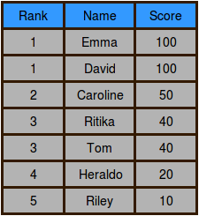
After Alice finishes game
, her score is and her ranking is
:
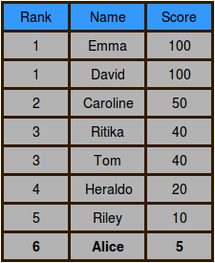
After Alice finishes game
, her score is and her ranking is
:
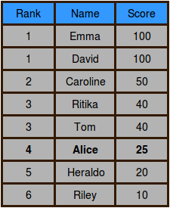
After Alice finishes game
, her score is and her ranking is tied with Caroline at
:
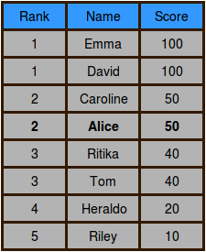
After Alice finishes game
, her score is and her ranking is
: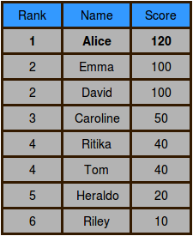
Sample Input 2
CopyDownload

Array: scores

100

90

90

80

75

60

Array: alice

50

65

77

90

102

6
100 90 90 80 75 60
5
50 65 77 90 102
Sample Output 2
6
5
4
2
1

