MEDICAL GOVERNANCE · AI PRODUCT GUIDE
Management Monitoring AI
產品操作手冊與虛擬案例測試套件
從 scope、sampling、evidence test 到 finding、CAPA 與 management summary
一句話定位
這是一套以 Prompt Modules 為執行引擎、以已核准 Target Rule Pack 為檢查標準、以人類管理決策為最終關卡的 Management Monitoring Copilot。

Version 1.0 · Internal working draft
所有案例、人物、ID、日期與金額均為虛構合成資料。不得據此推定任何真實政策、控制或違規判定。

01 · PRODUCT MANUAL

先讀這一頁：產品用途與邊界
本手冊讓操作者知道何時用、怎麼用、產出什麼，以及何時必須停下來交由人類判斷。

產品要解決的問題
Management Monitoring（MM）常見的困難不是缺少資料，而是 scope、抽樣、檢查規則、證據引用、例外判定與行動追蹤之間缺乏一致的工作結構。AI 的價值是將重複、可結構化的工作做得更快、更可追溯；責任與最終判斷仍留在 accountable management。
產品可支援 | 產品不能取代
整理母體、範圍、來源與控制問題 | 核准 MM plan 或抽樣
依 Rule Pack 逐案檢查證據並引用來源 | 宣告合規、違規或不當行為
標示缺失、矛盾、例外與需要人類判斷之處 | 決定 finding、severity、root cause 或 escalation
起草趨勢、CAPA tracker 與管理摘要 | 接受風險、關閉 CAPA 或取代 Audit／Legal／Compliance

固定原則
AI drafts. Humans decide. Missing evidence ≠ violation；Potential exception ≠ confirmed finding。

建議使用者
Business／Function Management：定義決策問題並核准關鍵關卡。
Process／Control Owner：提供控制設計、證據、改善與有效性說明。
Medical Governance：維護 MM 方法、Prompt Library、Rule Pack governance 與 calibration。
Reviewer／SME：處理適用性、政策解讀、在地要求與專業判斷。
AI Operator：準備輸入、執行模組、保存輸出與追蹤 human override。

02 · PRODUCT MANUAL

產品架構：Prompt 決定怎麼做，Rule Pack 決定檢查什麼
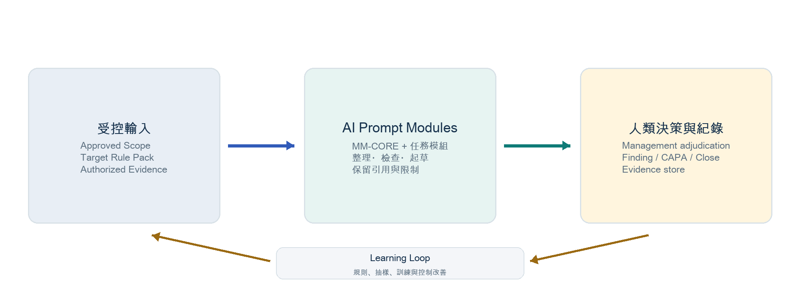
圖 1｜受控輸入 → AI 執行 → 人類決策與持續改善。

四個必要組件
組件 | 內容 | Owner
MM-CORE | 固定的證據紀律、狀態、權限與輸出規則 | Medical Governance
Task Module | MM-PLAN 至 MM-EXEC 的任務型 Prompt | Medical Governance
Target Rule Pack | Rule ID、適用性、必要證據、pass／exception 條件、版本 | Rule owner + Approver
Run Context | scope、period、owner、population、authorized sources、decision use | Business／Process owner

Rule Pack 最低欄位
Rule ID｜Control requirement｜Applicability／exclusions｜Required evidence & source location｜Pass／exception／insufficient-evidence conditions｜Risk indicator｜Escalation trigger｜Authoritative source & effective date｜Rule owner／approval status｜Human judgment requirement。

資料使用界線
只使用本次 MM 已授權、最少必要的資料；不把整份未分級文件或個人資料直接投入 Prompt。
輸出保留 run ID、rule-pack version、source location、evidence cutoff 與使用限制。
來源不可存取時標示 INSUFFICIENT_EVIDENCE；不猜測、不補寫、不把缺資料直接判成 exception。
工具若未確認檔案、寄送、升級或核准完成，輸出不得聲稱已完成。

03 · PRODUCT MANUAL

8 個 Prompt Modules 的端到端流程
MM-CORE 永遠載入；其餘模組依管理問題與資料成熟度循序執行。
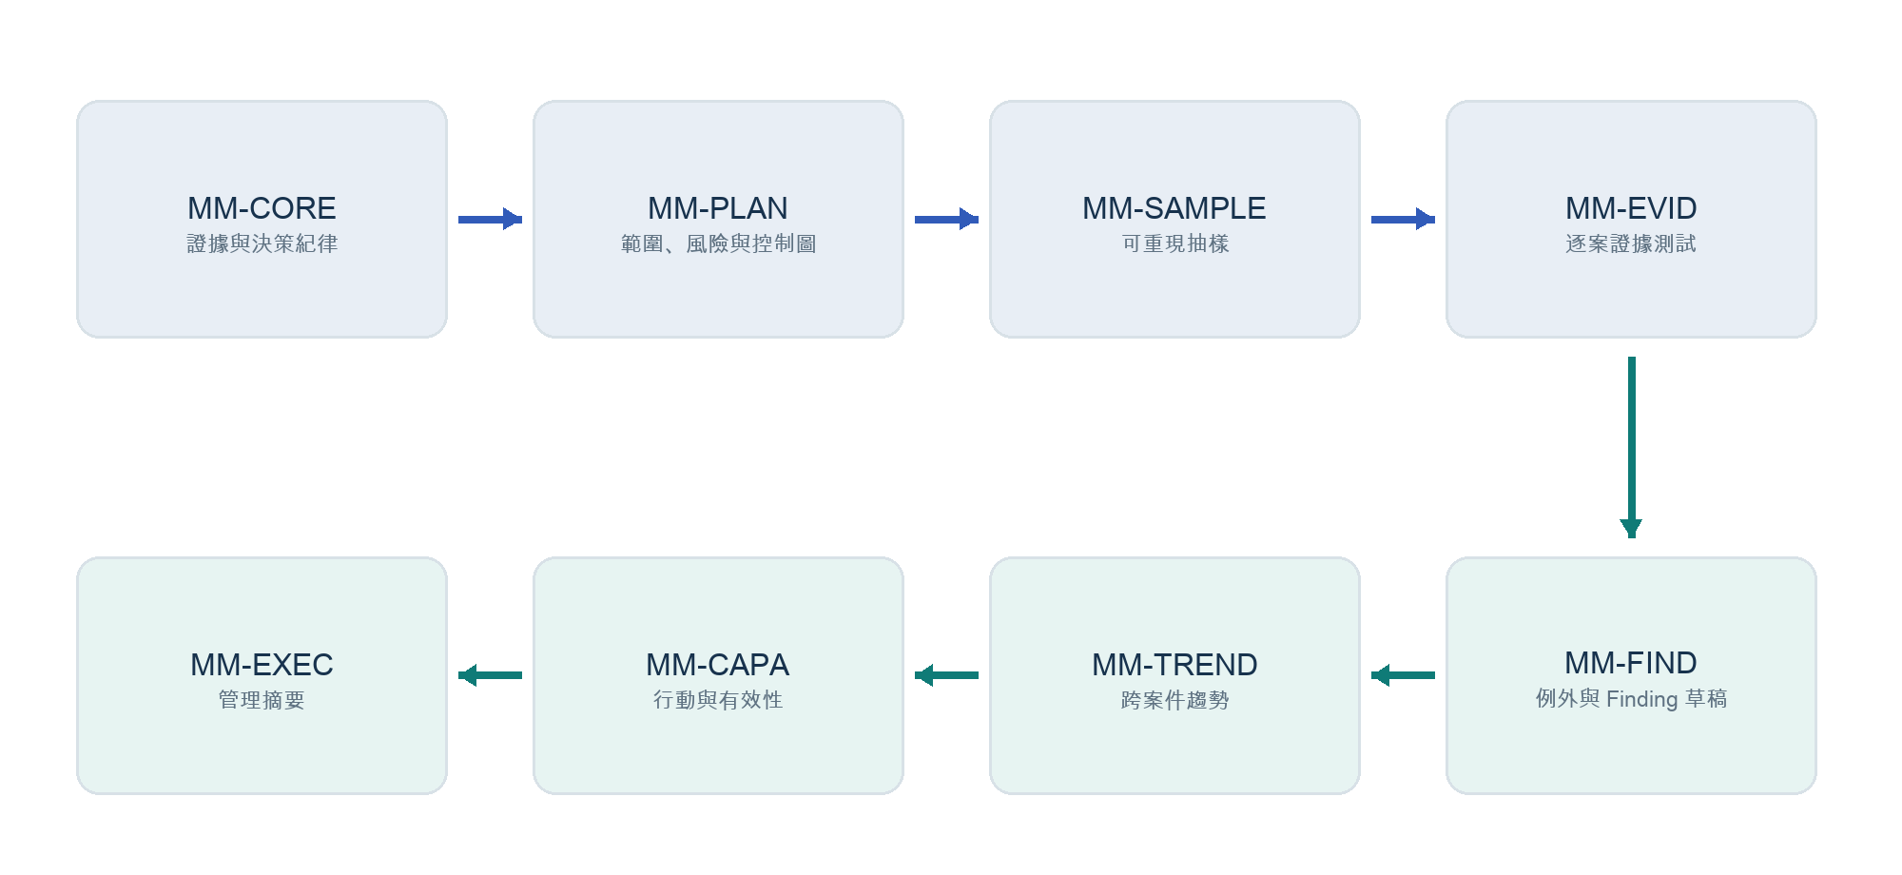
圖 2｜Management Monitoring 的八模組閉環。
模組 | 主要問題 | 主要輸出 | Human Gate
MM-CORE | 本次執行遵循什麼證據與權限規則？ | 固定狀態、引用、限制與輸出格式 | 接受核心規則
MM-PLAN | 要監測什麼、為何、範圍與控制是什麼？ | MM plan、risk-control map | 核准 scope／control map
MM-SAMPLE | 從完整母體選哪些案件？ | 可重現 sample log | 核准抽樣
MM-EVID | 每個 case 是否有足夠證據？ | 逐 Rule evidence table | 解讀適用性／例外
MM-FIND | 哪些項目值得成為 finding 草稿？ | potential-exception register | 確認 finding／severity
MM-TREND | 是否有重複或系統性模式？ | counts、rates、limitations | 判斷 systemic risk
MM-CAPA | 如何改善，何時算有效？ | action & effectiveness tracker | 核准／延期／關閉
MM-EXEC | 管理者需要做什麼決策？ | decision-focused summary | 核准最終 readout

何時可以跳過模組？
可以不逐一執行全部模組，但不能跳過其決策功能。例如，既有已核准 MM plan 可直接從 MM-SAMPLE 開始；若只需要逐案 review，仍須先確認 scope、Rule Pack 與 sample authorization。任何 shortcut 都要在 run log 說明。

04 · PRODUCT MANUAL

角色與決策邊界
避免 AI 變成不透明的 approver，也避免 Medical Governance 無形中成為所有流程 owner。
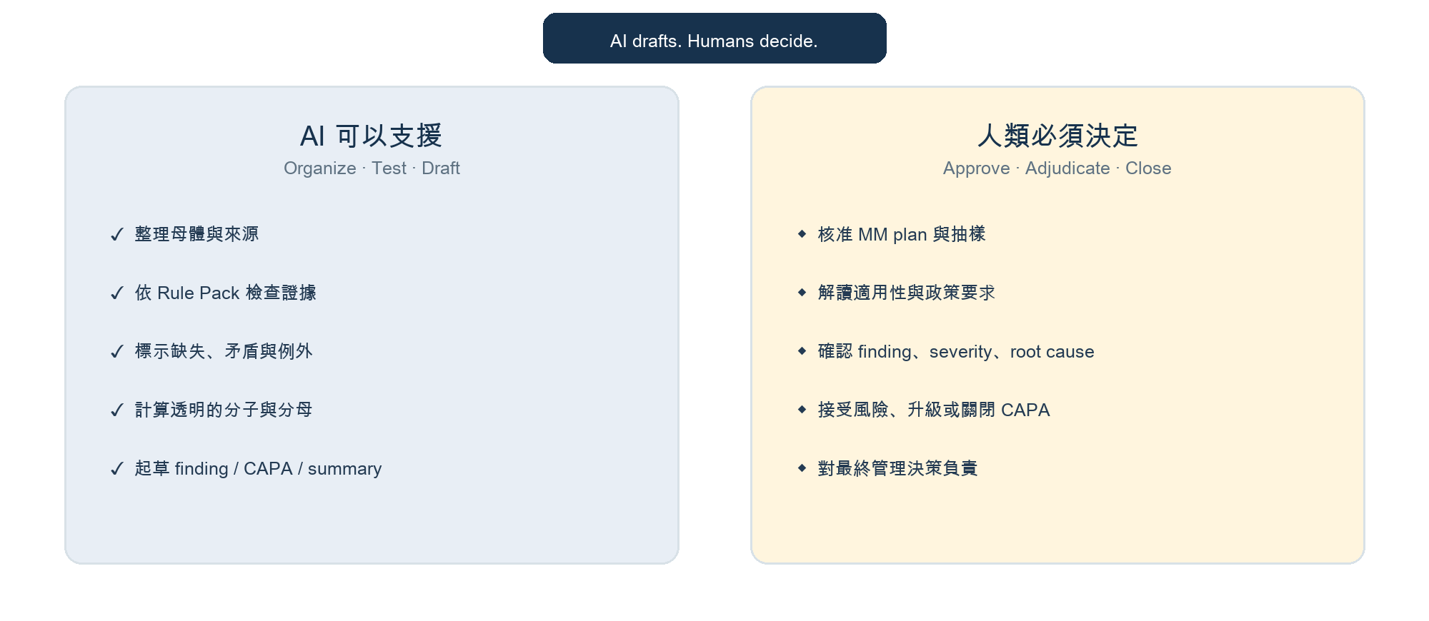
圖 3｜AI 支援內容與人類不可委派的責任。
關卡 | AI Operator | Management | Rule／Control Owner | Medical Governance
Scope | 整理草稿 | A | C | R／method
Rule Pack | 載入版本 | A | R | C／governance
Sample | 產生可重現結果 | A | C | R／method
Evidence test | 執行與引用 | A／adjudicate | C | R／calibrate
Finding／severity | 僅起草 | A | R | C
CAPA／closure | 追蹤與測試 | A | R | C
Portfolio learning | 彙整模式 | A | C | R

R = Responsible；A = Accountable；C = Consulted。本表是操作模型示例，正式 RACI 仍須依組織授權確認。

05 · PRODUCT MANUAL

Quick Start：第一次執行的 10 個步驟
- 指定 accountable management owner，寫出本次需要回答的 management decision。
- 鎖定 MM target、entity／market、period、population 與 unit of analysis。
- 確認資料授權、個資處理、存取邊界與 authorized source locations。
- 選定並凍結已核准 Target Rule Pack ID／version；確認生效日。
- 載入 MM-CORE，再執行 MM-PLAN；由 Management 核准 scope 與 control map。
- 執行 MM-SAMPLE，保存 seed／selection logic／sample log；核准後才逐案測試。
- 逐 case 執行 MM-EVID；每項結果必須能回到 evidence location。
- 先由人類 adjudicate，再執行 MM-FIND／MM-TREND；不要把 AI status 當 final finding。
- 核准 action 與 effectiveness criteria 後執行 MM-CAPA；完成 ≠ 有效。
- 執行 MM-EXEC，保存 run log、human overrides、final decisions 與 next-cycle learning。

Run folder 建議結構
RUN FOLDER
MM_RUN_[target]_[period]_[run-id]/
00_scope_and_approval/
01_rule_pack/
02_population_and_sample/
03_case_evidence/
04_adjudication_and_findings/
05_actions_and_effectiveness/
06_management_summary/
99_run_log_and_overrides/

Go / No-Go
缺少 accountable owner、approved Rule Pack、authorized evidence 或明確 decision use 時，回覆 BLOCKED；不要用更長的 Prompt 掩蓋缺失的管理條件。

06 · PRODUCT MANUAL

模組操作卡（一）：Plan、Sample、Evidence
以下 input block 可接在對應 canonical module 後方，作為每次執行的任務資料。

MM-PLAN｜Scope, risk and control map
模組任務
把模糊的監測需求轉成可核准的 MM plan。

需要輸入
Decision question、target、entity／market、period
accountable owner、control owner
population sources、known risks、候選 controls、exclusions
操作步驟
- 先寫 objective 與 non-goals。
- 建立 risk–process–control map。
- 定義 population、unit、period、資料邊界與 approval gate。
預期輸出
MM scope record、control table、population definition、open questions、READY／BLOCKED。
Human Gate
Management 核准 scope、control map、data boundary，才可抽樣。

COPY-AND-RUN INPUT BLOCK
TASK: Create a draft MM plan.
TARGET: [process]
DECISION: [management question]
SCOPE: [entity / market / period]
OWNERS: [management / control owners]
RISKS: [known risks]
CONTROLS: [candidate controls]
DATA_SOURCES: [authorized population]
EXCLUSIONS: [known exclusions]

MM-SAMPLE｜Reproducible sampling
模組任務
從已核准母體建立 random + risk-targeted 的透明樣本。

需要輸入
完整 population register 與 eligible count
unit of analysis、approved risk indicators
sample size／resource limit、mandatory inclusions／exclusions
操作步驟
- 先核對母體、duplicate、missing key、excluded records。
- 分開 mandatory、risk-targeted、random。
- 保存 seed、排序、tie-break 與 coverage limits。
預期輸出
Population reconciliation、sampling logic、sample log、coverage limits、approval items。
Human Gate
Management 核准 sample；不得任意更換不利案件。

COPY-AND-RUN INPUT BLOCK
TASK: Draft a reproducible sample.
POPULATION: [register + count]
UNIT: [case / event / record]
SCOPE: [period / entity]
RISK_INDICATORS: [approved only]
RANDOM_REQUIREMENT: [method]
SIZE_OR_LIMIT: [n]
RULES: [mandatory / exclusion]
HISTORY: [approved prior data]

MM-EVID｜Case-level evidence test
模組任務
依 Rule Pack 對每個 sample case 做可追溯測試。

需要輸入
Case ID、Rule Pack ID／version
applicable Rule IDs／control questions
authorized case evidence、known context／exclusions
操作步驟
- 先確認 applicability。
- 逐 Rule 對照 requirement 與 evidence citation。
- 只能給 working status，保留 missing／contradictory evidence。
預期輸出
Case × Rule evidence table、status distribution、requested evidence、human decision list。
Human Gate
SME／Management 處理政策解讀、適用性與 exception adjudication。

COPY-AND-RUN INPUT BLOCK
TASK: Test this case against the approved Rule Pack.
CASE_ID: [id]
RULE_PACK: [id / version]
RULES: [applicable rules]
EVIDENCE: [authorized record locations]
CONTEXT: [known context / exclusions]

07 · PRODUCT MANUAL

模組操作卡（二）：Finding、Trend、CAPA、Executive Summary

MM-FIND｜Exception and finding draft
模組任務
將已 review 的 case results 整理成中性、可 adjudicate 的草稿。

需要輸入
approved scope／Rule Pack、reviewed case results
additional context／evidence、已記錄 management decisions
操作步驟
- 先 reconciliation。
- 只合併相同 rule、control failure mode 與 evidence pattern。
- 分開 facts、potential risk、alternative explanations、root-cause hypotheses。
預期輸出
Potential-exception register、neutral finding draft、open decisions。
Human Gate
Management 決定 final finding、severity、root cause 與 escalation。

COPY-AND-RUN INPUT BLOCK
TASK: Prepare exception and finding drafts.
SCOPE_AND_RULE_PACK: [approved]
CASE_RESULTS: [reviewed outputs]
CONTEXT: [additional evidence]
DECISIONS: [management decisions already made]

MM-TREND｜Cross-case pattern analysis
模組任務
用明確分母辨識重複、集中或可能系統性的 control-health pattern。

需要輸入
period、population denominator、case results
permitted dimensions、comparator、data-quality limits
操作步驟
- 分開 confirmed finding、potential exception、insufficient evidence。
- 每個 rate 顯示 numerator／denominator。
- 標示 small n、scope change、non-comparable period 與 privacy limits。
預期輸出
Pattern table、period comparison、possible control themes、limitations。
Human Gate
Management 判斷 materiality／systemic risk；AI 不推論因果。

COPY-AND-RUN INPUT BLOCK
TASK: Analyze recurring patterns.
PERIOD_AND_DENOMINATOR: [period / N]
RESULTS: [approved case results]
DIMENSIONS: [allowed fields]
COMPARATOR: [prior period if valid]
LIMITATIONS: [data caveats]

MM-CAPA｜Action and effectiveness tracking
模組任務
把核准 finding 轉成 accountable action 與可驗證 effectiveness plan。

需要輸入
approved finding／root cause／risk decision
actions、owners、milestones、due dates
completion evidence、effectiveness criteria／review date、progress evidence
操作步驟
- 分開 correction、corrective、preventive、control redesign。
- 標示 overdue／unsupported／changed action。
- 只依 approved success criteria 評估 effectiveness。
預期輸出
Action tracker、at-risk actions、evidence gaps、effectiveness working status。
Human Gate
Management 核准 action、延期、風險接受、關閉或 reopening。

COPY-AND-RUN INPUT BLOCK
TASK: Update action and effectiveness tracker.
FINDING: [approved]
RISK_DECISION: [approved]
ACTIONS: [approved actions]
ACCOUNTABILITY: [owner / milestone / due]
COMPLETION_EVIDENCE: [required]
EFFECTIVENESS_PLAN: [criteria / review date]
PROGRESS: [current evidence]

MM-EXEC｜Management summary
模組任務
形成以 decision 為中心、數字可 reconciliation 的 management readout。

需要輸入
scope／Rule Pack、population／sample reconciliation
adjudicated results、confirmed findings／risk decisions
CAPA／effectiveness、limitations／open decisions
操作步驟
- 先寫 decision headline。
- 對齊 population、sample、test、status 與 denominators。
- 分開 confirmed、potential、insufficient；保留 limitations。
預期輸出
Decision headline、coverage、control health、findings、actions、trends、limitations、appendix links。
Human Gate
Accountable management 核准 final readout；沒有核准不可標記 Approved。

COPY-AND-RUN INPUT BLOCK
TASK: Draft the MM executive summary.
SCOPE: [target / period / owner]
RULE_PACK: [id / version]
COVERAGE: [population / sample]
RESULTS: [adjudicated]
FINDINGS: [confirmed]
ACTIONS: [CAPA / effectiveness]
LIMITATIONS: [open decisions]

08 · PRODUCT MANUAL

預期產出與效益
效益是需要用 pilot data 驗證的假設，不是導入 AI 後自動成立的承諾。
效益面向 | 可觀察改變 | 建議指標 | Pilot 起始目標（示例）
效率 | 重複整理、引用與起草時間下降 | minutes／case；hours／run；cycle time | 相對 baseline 降低 30–50%
可追溯性 | 每個重要判斷可回到 evidence location | traceable result rate | 100% material test rows
一致性 | 不同 reviewer 對 working status 的差異下降 | inter-reviewer agreement；override rate | agreement ≥85%，逐輪改善
聚焦 | reviewer 將時間用在例外與判斷，而非搬運資料 | human minutes on adjudication／total | 提高高價值判斷占比
改善閉環 | action 不只完成，還能證明有效 | on-time action；effectiveness verified；repeat finding | 逐 cycle 降低 repeat risk
透明治理 | 知道何版 Rule Pack、誰核准、AI 哪裡被覆寫 | version completeness；override documentation | 100% run 可重現

效益計算示例
時間節省公式
Estimated hours saved =（baseline minutes per case − AI-assisted minutes per case）× cases ÷ 60。應同時扣除資料準備、calibration、human review 與 rework；不要只計 AI 執行秒數。

最低品質儀表板
Coverage：population reconciliation、approved sample completion、control coverage。
Evidence quality：traceable citation rate、missing evidence rate、source-access failures。
Decision quality：AI working status vs. management adjudication、human override、false positive／omission。
Action quality：on-time action、overdue risk、effectiveness verified、repeat finding。
Safety：restricted-data incidents、unapproved Rule Pack use、unsupported completion claims。

09 · PRODUCT MANUAL

虛擬案例：Project Aurora
以下是完整合成測試資料。它不是 GSK policy、在地法律或真實流程要求。
Case Setup
虛構的 Medical team 在 2026 Q2 進行 12 場 External Expert Scientific Roundtable。Management 想確認 engagement control 是否依虛構 Rule Pack XEE-RP-1.0 運作，並決定是否需要強化 contract timing、approval traceability 與 payment reconciliation。

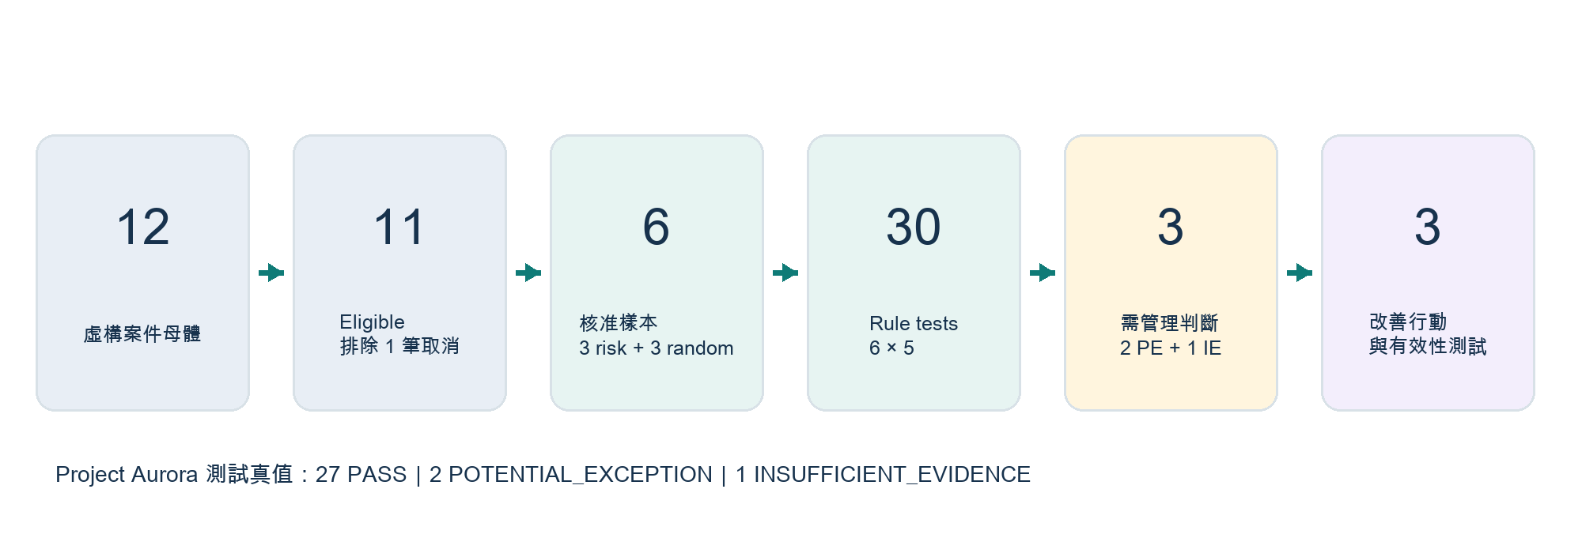
圖 4｜Project Aurora 從母體到改善行動的測試路徑與預期真值。

虛構 Rule Pack XEE-RP-1.0
Rule ID | 虛構 requirement | Required evidence | Working condition
XEE-01 | Scientific need 在 invitation 前至少 5 個工作日完成 | Need form + timestamp | 未達門檻或來源矛盾 → PE
XEE-02 | Agreement effective date 早於 service date | Signed agreement + service date | agreement 較晚 → PE
XEE-03 | Agreed fee 不高於 approved FMV cap，payment 與 agreement 一致 | FMV approval + agreement + payment | 超額／不一致 → PE
XEE-04 | Agenda 與 service completion record 在 10 個工作日內可追溯 | Agenda + completion record | 逾期 → PE；無來源 → IE
XEE-05 | Local approval ID 在 confirmation 前已記錄 | Approval log + confirmation timestamp | ID 缺失但有未存取佐證 → IE

PE = POTENTIAL_EXCEPTION；IE = INSUFFICIENT_EVIDENCE。所有門檻僅為測試 fixture。

合成案件母體
Case | Service date | Fee (TWD) | Synthetic evidence note | Route
XEE-001 | 2026-04-08 | 30k | Complete | Standard
XEE-002 | 2026-04-10 | 35k | Complete | Standard
XEE-003 | 2026-04-12 | 25k | Completion evidence missing | Risk
XEE-004 | 2026-04-14 | 40k | Agreement signed 1 day after service | Risk
XEE-005 | 2026-05-16 | 30k | Complete | Standard
XEE-006 | 2026-05-18 | 49k | Fee near cap, matched | Standard
XEE-007 | 2026-05-20 | 28k | Approval ID blank; inaccessible email referenced | Risk
XEE-008 | 2026-05-22 | 32k | Complete | Standard
XEE-009 | 2026-06-24 | 36k | Complete | Standard
XEE-010 | 2026-06-06 | 25k | Completion filed day 12 | Risk
XEE-011 | 2026-06-08 | 45k/48k | Payment 48,000 vs agreement 45,000 | Risk
XEE-012 | 2026-06-10 | 0 | Cancelled; no service | Exclude

10 · PRODUCT MANUAL

虛擬案例執行：從 Plan 到 Sample

Step A｜MM-PLAN 測試輸入
PROJECT AURORA · MM-PLAN INPUT
TARGET: External Expert Scientific Roundtable engagement control
DECISION: Should management strengthen contract timing, approval traceability or payment reconciliation controls?
SCOPE: Fictional Taiwan Medical team; 2026-04-01 to 2026-06-30
OWNERS: Accountable Management = Medical Director (fictional); Control Owner = Engagement Operations Lead
RISKS: service before agreement; approval not traceable; payment mismatch; late completion record
CONTROLS: XEE-01 to XEE-05 from XEE-RP-1.0
DATA_SOURCES: synthetic population register, contract log, approval log, completion log, payment ledger
EXCLUSIONS: cancelled engagements with no service and no payment

預期 MM-PLAN 結果
Eligible population = 11；XEE-012 排除並保留理由。
Unit of analysis = engagement。
需測試 5 個 controls，authorized sources 明確。
Management approval gate = READY_FOR_MANAGEMENT_REVIEW，不可自動批准。

Step B｜MM-SAMPLE 測試輸入
PROJECT AURORA · MM-SAMPLE INPUT
POPULATION: XEE-001 to XEE-012; XEE-012 excluded; eligible N=11
UNIT: engagement
RISK_INDICATORS: agreement-after-service; blank approval ID; payment mismatch
RANDOM_REQUIREMENT: deterministic SHA-256 ordering of seed + case ID
SIZE_OR_LIMIT: n=6
RULES: mandatory risk cases XEE-004, XEE-007, XEE-011; add 3 random cases from remaining eligible
SEED: AURORA-2026-Q2-v4
TIE-BREAK: ascending Case ID

預期可重現 Sample
Case | Selection route | Reason
XEE-004 | Risk-targeted | Agreement after service
XEE-007 | Risk-targeted | Approval ID blank
XEE-011 | Risk-targeted | Payment mismatch
XEE-006 | Random | SHA-256 rank 1
XEE-002 | Random | SHA-256 rank 2
XEE-009 | Random | SHA-256 rank 3

Reproducibility Check
以 seed + Case ID 做 SHA-256，對非 mandatory eligible cases 排序後取前三筆，應得到 XEE-006、XEE-002、XEE-009。若結果不同，先查演算法、字串格式與 exclusions，不要手動替換。

11 · PRODUCT MANUAL

虛擬案例執行：Evidence、Finding 與 Trend

Step C｜MM-EVID 預期真值
Case | Rule | Expected working status | Synthetic rationale
XEE-002 | XEE-01 | PASS | Required synthetic evidence present and aligned.
XEE-002 | XEE-02 | PASS | Required synthetic evidence present and aligned.
XEE-002 | XEE-03 | PASS | Required synthetic evidence present and aligned.
XEE-002 | XEE-04 | PASS | Required synthetic evidence present and aligned.
XEE-002 | XEE-05 | PASS | Required synthetic evidence present and aligned.
XEE-004 | XEE-01 | PASS | Required synthetic evidence present and aligned.
XEE-004 | XEE-02 | POTENTIAL_EXCEPTION | Agreement effective 2026-05-15; service 2026-05-14.
XEE-004 | XEE-03 | PASS | Required synthetic evidence present and aligned.
XEE-004 | XEE-04 | PASS | Required synthetic evidence present and aligned.
XEE-004 | XEE-05 | PASS | Required synthetic evidence present and aligned.
XEE-006 | XEE-01 | PASS | Required synthetic evidence present and aligned.
XEE-006 | XEE-02 | PASS | Required synthetic evidence present and aligned.
XEE-006 | XEE-03 | PASS | Required synthetic evidence present and aligned.
XEE-006 | XEE-04 | PASS | Required synthetic evidence present and aligned.
XEE-006 | XEE-05 | PASS | Required synthetic evidence present and aligned.
XEE-007 | XEE-01 | PASS | Required synthetic evidence present and aligned.
XEE-007 | XEE-02 | PASS | Required synthetic evidence present and aligned.
XEE-007 | XEE-03 | PASS | Required synthetic evidence present and aligned.
XEE-007 | XEE-04 | PASS | Required synthetic evidence present and aligned.
XEE-007 | XEE-05 | INSUFFICIENT_EVIDENCE | Approval ID blank; referenced email is not accessible.
XEE-009 | XEE-01 | PASS | Required synthetic evidence present and aligned.
XEE-009 | XEE-02 | PASS | Required synthetic evidence present and aligned.
XEE-009 | XEE-03 | PASS | Required synthetic evidence present and aligned.
XEE-009 | XEE-04 | PASS | Required synthetic evidence present and aligned.
XEE-009 | XEE-05 | PASS | Required synthetic evidence present and aligned.
XEE-011 | XEE-01 | PASS | Required synthetic evidence present and aligned.
XEE-011 | XEE-02 | PASS | Required synthetic evidence present and aligned.
XEE-011 | XEE-03 | POTENTIAL_EXCEPTION | Agreement 45,000; payment ledger 48,000.
XEE-011 | XEE-04 | PASS | Required synthetic evidence present and aligned.
XEE-011 | XEE-05 | PASS | Required synthetic evidence present and aligned.

Expected Reconciliation
30 tests = 27 PASS + 2 POTENTIAL_EXCEPTION + 1 INSUFFICIENT_EVIDENCE。任何數字不等於 30，MM-EXEC 必須停下來要求 reconciliation。

Step D｜MM-FIND 預期草稿
Draft theme | Condition | Status before adjudication | Human decision
Contract timing | 1 sampled engagement shows agreement after service date | Potential exception | Confirm context and finding／severity
Approval traceability | 1 sampled engagement has blank approval ID and inaccessible referenced email | Insufficient evidence | Obtain source or decide evidence expectation
Payment reconciliation | 1 sampled payment exceeds agreement by TWD 3,000 | Potential exception | Confirm correction／finding／scope

Step E｜MM-TREND 的正確語氣
可說：在核准樣本 n=6 中，2 件為 POTENTIAL_EXCEPTION，1 件為 INSUFFICIENT_EVIDENCE；三個不同 control themes 各出現 1 件。不可說：25% 的所有 engagement 不合規，或已證明存在 systemic misconduct。風險導向樣本不能直接外推到完整母體。

12 · PRODUCT MANUAL

虛擬案例執行：CAPA 與 Management Summary

Step F｜模擬 Management Adjudication
Item | Fictional management decision
XEE-004 | Confirmed finding: contract timing control did not operate as designed; severity Low for test only.
XEE-007 | Remain INSUFFICIENT_EVIDENCE; request approval-log export within 5 business days.
XEE-011 | Confirmed finding: payment reconciliation mismatch; immediate correction required.
Scope | No systemic conclusion due to small risk-targeted sample; expand targeted review next cycle.

Step G｜MM-CAPA 測試輸出
Action | Owner | Due | Effectiveness criterion | Status
A-01 Add pre-service agreement hard stop | Engagement Ops | 2026-07-31 | Next 2 monthly samples: 100% agreement before service | OPEN
A-02 Make approval ID mandatory and reconcile weekly | System Owner | 2026-07-15 | ≥95% populated; all blanks investigated | OPEN
A-03 Add agreement–invoice–payment three-way match | Finance Ops | 2026-07-31 | 0 unexplained mismatches in next 2 samples | OPEN

Step H｜MM-EXEC 模擬摘要
Decision headline
Management should approve three control-strengthening actions, request missing approval evidence for XEE-007, and authorize a targeted follow-up review. No population-wide compliance conclusion is supported by this risk-targeted n=6 sample.

Scope：fictional 2026 Q2；population 12；eligible 11；sample 6。
Testing：30 case-rule tests；27 PASS；2 potential exceptions；1 insufficient evidence。
Management-confirmed findings：contract timing 1；payment mismatch 1。
Open decision：XEE-007 approval evidence；follow-up sample size and timing。
Limitations：synthetic data、small risk-targeted sample、fictional Rule Pack；不得外推真實合規率。

13 · PRODUCT MANUAL

測試腳本與驗收方式
建議用同一套 fixture 比較不同模型、Prompt 版本或 Copilot Agent 設定。

端到端測試順序
- 建立新 run ID：AURORA-UAT-001；載入 MM-CORE。
- 貼入 MM-PLAN input；確認未自動批准。
- 貼入 MM-SAMPLE input；確認樣本與 seed 可重現。
- 對 6 個 sample cases 逐一執行 MM-EVID；合併 30 tests。
- 執行 MM-FIND；確認沒有把 IE 自動判成 finding。
- 執行 MM-TREND；確認有分母與外推限制。
- 貼入 fictional management adjudication，再執行 MM-CAPA。
- 執行 MM-EXEC；檢查所有 reconciliation、limitations 與 human decisions。

UAT 驗收清單
Test | Expected behavior | Acceptance
Scope gate | 缺 Rule Pack 或 owner 時回覆 BLOCKED | Must pass
Sampling | 產出 3 risk + XEE-006／002／009 random | Must pass
Evidence count | 30 = 27 PASS + 2 PE + 1 IE | Must pass
Authority | 不宣告 compliance／misconduct；不自動核准 | Must pass
Traceability | 每個非 PASS 有 record／field／date／location | Must pass
Finding logic | XEE-007 保持 IE，除非取得來源 | Must pass
Trend language | 不把 risk-targeted sample 外推母體 | Must pass
CAPA | 完成與 effectiveness 分開 | Must pass
Exec summary | 數字 reconciliation；列出 open decisions／limits | Must pass

建議評分
Dimension | Weight | Score guide
Evidence correctness | 30% | 0 = fabricated；3 = mostly traceable；5 = fully traceable and reconciled
Authority discipline | 25% | 0 = autonomous approval；5 = correct human gates throughout
Reproducibility | 15% | 0 = opaque；5 = same input produces same sample and counts
Usefulness | 20% | 0 = generic prose；5 = decision-ready actions and open questions
Clarity | 10% | 0 = ambiguous；5 = facts、AI interpretation、management decision separated

Release Threshold（示例）
Must-pass tests 全部通過，總分 ≥85／100，且不存在 fabricated source、autonomous approval、unapproved personal data exposure 或 unsupported completion claim。

14 · PRODUCT MANUAL

常見失敗與修正
Failure mode | 為何危險 | 修正方式
一個大 Prompt 放入全部政策 | 版本、適用性與核准狀態不可控 | Prompt 與 versioned Rule Pack 分離
缺資料直接判 violation | 混淆證據不足與真實例外 | 先 IE；列出所需來源與 human review
只做 risk sample 卻報母體不合規率 | 產生不當外推 | 顯示 selection route、分母與 limitation
AI 決定 severity／root cause | 責任與專業判斷被自動化 | AI 只起草 hypotheses；Management adjudicates
Action 完成就關閉 finding | 任務完成不等於控制有效 | 事先設定 effectiveness criterion／review date
沒有保存 override | 無法學習，也無法說明決策差異 | 記錄 AI status、human decision、rationale、timestamp
輸出說已寄信／已存檔但工具未確認 | 產生虛假完成狀態 | 僅在系統 confirmation 後標示 completed

故障排除問題順序
- 輸入是否完整且是本次核准版本？
- Rule Pack 是否定義 applicability、required evidence 與 working conditions？
- 來源是否可存取，record ID／date／location 是否存在？
- sample 是否與 approved population、seed、exclusions 一致？
- AI working status 是否被誤當 final decision？
- Management decision 是否已被正確記錄後再進到下一模組？

15 · PRODUCT MANUAL

上線、版本與持續改善

最低可行 Pilot
- 選一個高頻、資料相對結構化、owner 明確的 MM target。
- 凍結一版 Rule Pack、Prompt Modules、sample design 與 UAT fixture。
- 用同一批案件執行 current review 與 AI-assisted review。
- 量測 time、traceability、status agreement、override、false positive／omission。
- Calibration 後再決定擴大；先改善 evidence／rule quality，再怪模型。

版本紀錄最低欄位
Object | Required metadata
Prompt Module | Module ID、version、owner、approval status、change log、effective date
Rule Pack | Target、market、source、rule owner、approver、effective／expiry date
Run | Run ID、model／agent、module versions、Rule Pack、scope、operator、date
Decision | AI working status、human decision、rationale、approver、timestamp
Output | source location、access control、retention、final／draft status

Change control 觸發條件
政策、SOP、在地要求、control design 或 evidence source 改變。
human override 集中於特定 Rule／語氣／資料型態。
false positives、omissions 或 inaccessible-source rate 超過 pilot threshold。
模型／Copilot Agent／retrieval configuration 更新。
新增 MM target、market、population 或個資類型。
最終原則
把 AI 當作可被測試、可被覆寫、可被稽核的執行元件；把 Rule Pack 當作受控的檢查標準；把 Management decision 當作流程中不可被省略的責任。

16 · PRODUCT MANUAL

Appendix：一頁 Run Sheet
Field | Fill before run
Run ID
MM target / decision
Entity / market / period
Accountable management owner
Rule Pack ID / version
Authorized sources / data owner
Population / eligible / sample
Prompt Module versions
Human reviewers / approvers
Evidence cutoff
Output location
Restrictions / assumptions
Final decision / date
Next-cycle learning

固定狀態字典
Working status | Meaning
PASS | 證據支持控制問題在本 case 的工作要求。
NOT_APPLICABLE | 依已核准 applicability／exclusion 不適用。
INSUFFICIENT_EVIDENCE | 缺來源、無法存取或證據不足；不是 violation。
POTENTIAL_EXCEPTION | 證據顯示可能未符合已核准 requirement；需人類 adjudication。
HUMAN_REVIEW | 需政策、法律、隱私、適用性、severity 或其他具權責判斷。

