Statistics 139 Final Project

St. Valentine’s Front-Office - An Analysis of HCS Datamatch 2015

*Frederick Widjaja, Kevin Eskici, Willy Xiao*

To view this file and any code, visit: <http://github.com/willyxiao/stat139-datamatch>

1. **A Memo from the Front-Office Staff**

As members of HCS board past and present, we reserve a special place in our heart-of-hearts for HCS’s biggest event of the year: Datamatch. Exactly one week before Valentine’s Day we release a 30-question survey ranging from sex to favorite classes at Harvard to more sex in an attempt to pair 3,000 Harvard undergraduates in a flurry of last-minute Valentine’s day love-finding, the kind of deep romantic-type love you only see in Disney animations. While we may love our matching-algorithm like any mother loves an ugly child, we understand that using the results of TheAlgorithm[1] itself as some Y variable probably won’t give us any meaningful insights into this complex symphony of human emotion. Luckily, a closer predictor of love emerges a few days after St. Valentine’s has done his deed – whether or not top-paired Datamatch couples agree to go on an HCS sponsored Waffle Date at Zinneken’s.

As witnesses to the game of love, bystanders will only see the whistling passage of Cupid’s arrow and the sparks of passion that come thereafter. But long after St. Valentine’s has retired to the locker-room, we – the metaphorical front-office staff – are still working hard pouring over the data underlying every match. Our singular purpose is to maximize matching-making efficiency between Harvard undergraduates, and we’ll do it by discovering which people are most likely to go on a Waffle Date.

We are the sabermetrics of match-making. We the latent factor underlying love. We are St. Valentine’s Front-Office.

1. **Collecting Data**

Because we are also the ones who Data-Match, [collect collect collect, sql queries monkeys]

1. **Modelling the arrow’s path**

We first approached the problem by first considering model which individually could craft a narrative for the button clicks. In these steps, we did little assumption-checking or cross-validation; the only goal was to throw arrows at a target and see which couples stuck.

1. **Pair-Wise Models**

For pair-wise models, we considered whether or not a data-matchee would click a button based on their interaction with who their matched with. If two people are in the same house or the same class year, does that make a difference?

1. **Proximity** [2][Class Year, House]

Proximity is one of the best predictors of love[3]. Within the Harvard bubble, quadlings date a disproportionate number of quadlings, Kirkland is incestuous, and Mather lathers in their troves of singles.

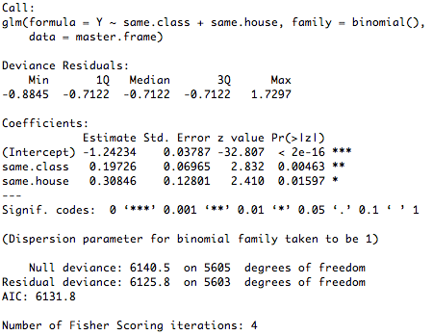

1. **The Power of Suggestion** [4][Suggested Compatibility]

If you’re told you’d be compatible with someone, does of power of suggestion compel you to try it out?

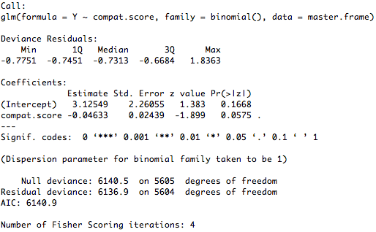

Probably not. Lol.

1. **The Underlying Truth** [5][Matching Answers]

If there exists any underlying, latent truth in the questions that HCS asks, then we ought to be able to see it here:

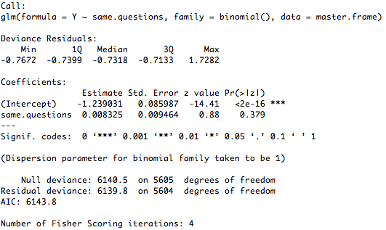

1. **Individual-Based Models**

For these set of models, we ignored the interaction between partners, but rather tried to guess whether someone would agree to a waffle date based on their own inherent traits.

1. **Personality** [6][As Determined by TheAlgorithm]

TheAlgorithm calculates 12 personality traits from the answers people give to us. Herein lies the magic of TheAlg and here, we hope to find something:

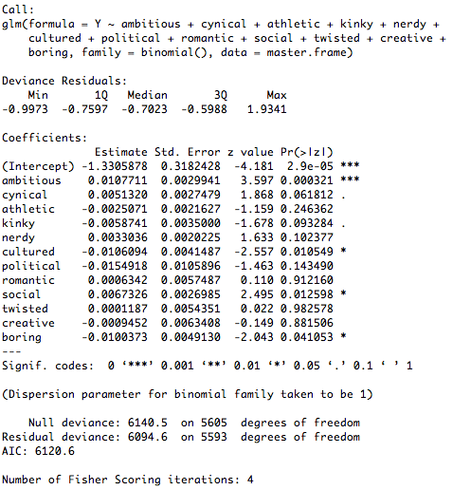

A satisfying result emerges from this model: Ambitious people are statistically significantly more likely to go on a waffle date! Wow, good for them! And…as validation to our data-match questions, good for us!

1. **Sexuality**[7][Sexuality, Gender]

Sexuality so often comes to statisticians as clear binaries and easily-discernable (read: discriminatory) categories. While we may condemn this simplistic classification in our public discourse, as statisticians, we laud it. For its simplicity and ease of implementation, we did this first.

Here is the simple output from R:

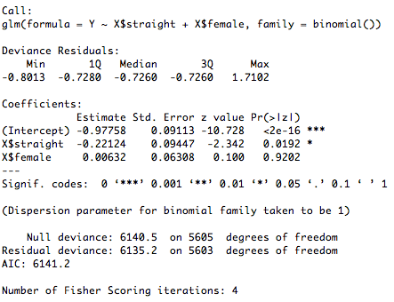

What have we found? Significance, the arbitrary p-value kind! In the variable called *straight*. Interpreting the variable gives us a conclusion that we thought might’ve been true given our daily perceptions: if you’re not straight, you’re much more likely to agree to a Waffle Date.

1. **Latent Eagerness** [8][Class Year, Time Responded to Survey]

We know everyone wants to be seen as the one who cares less,[9] but we know how much you’ve actually been waiting for Datamatch.

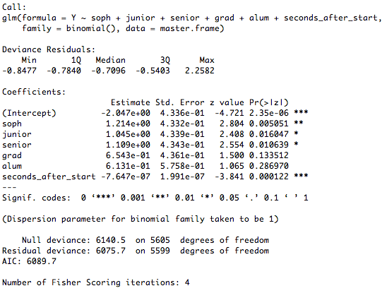

If you’re someone who filled out Datamatch early-on, then you’re quite more likely to go on a waffle date.

1. **Explicit Eagerness** [10][Prior Willingness, In a Relationship]

And finally, we can question how eager you are to go on a waffle-date given your explicit eagerness.

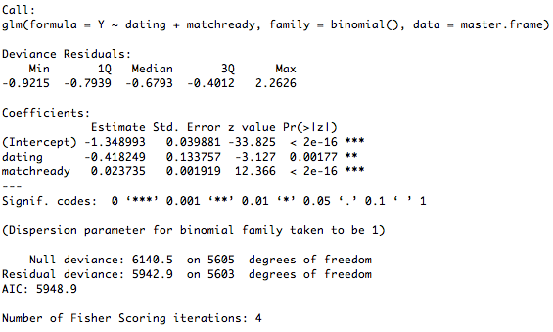

In many ways, this model by itself should give us a lot of information; we literally ask the question

1. **Love, what is the real thing?**

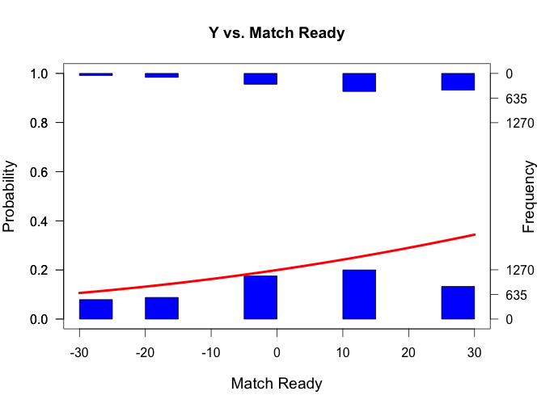

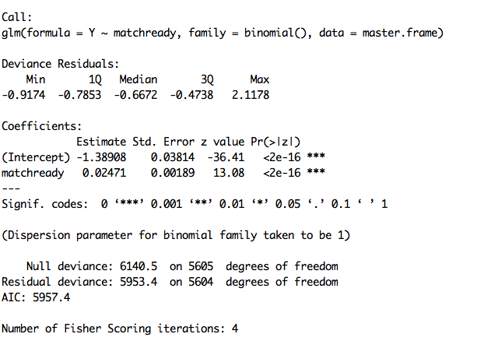

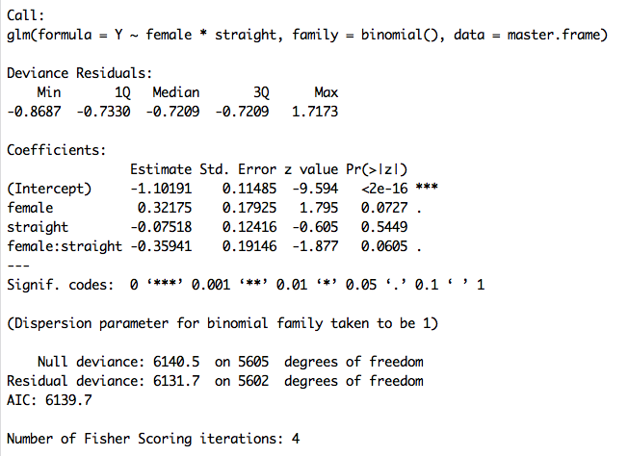

Straight-male: -1.10191 + -.07518 = -1.17709 (Prob = 0.2355758)

Non-Straight Male: -1.10191 (Prob = 0.2493822)

Straight Female: -1.21475 (Prob = 0.2288617)

Non-straight female: -0.78016 (Prob = 0.3142854)

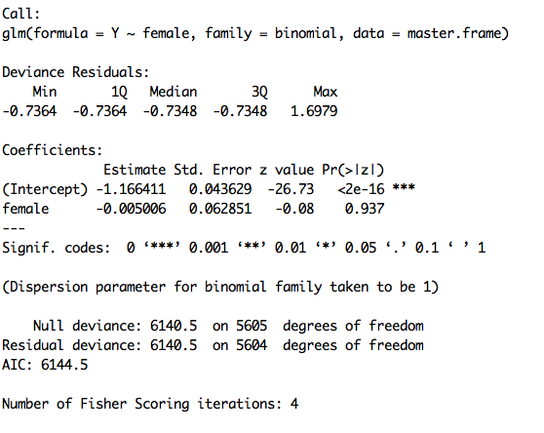

Male: Prob: 0.2375043

Female: Prob: 0.236599

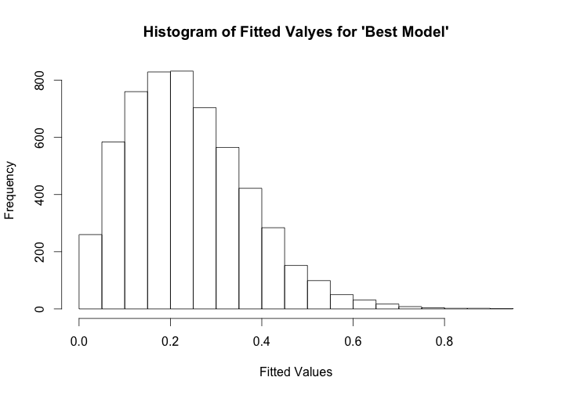

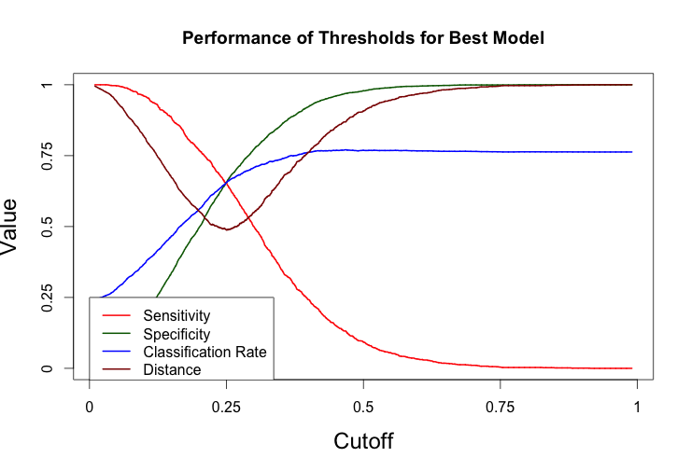

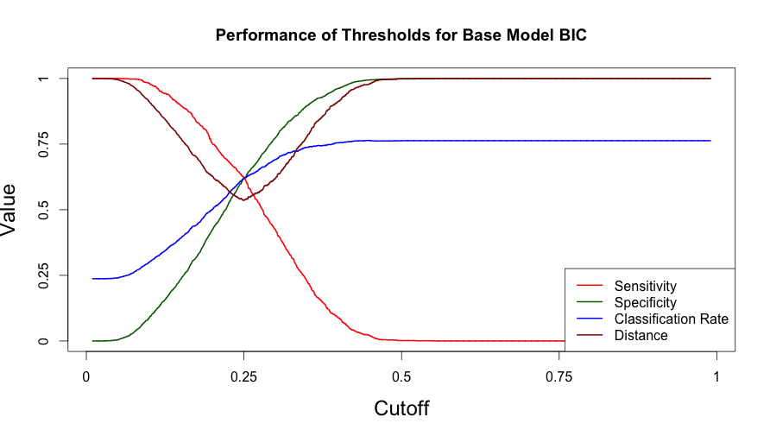­

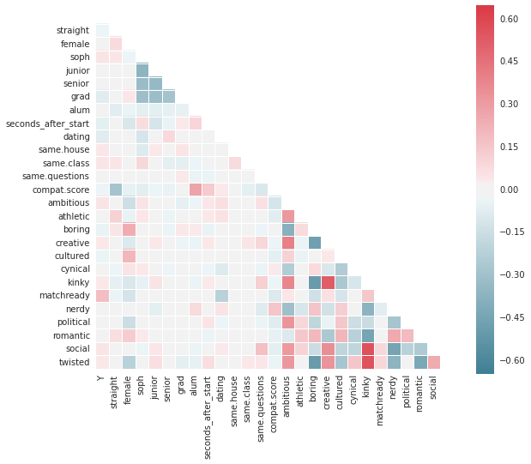

Look into?

Arm library bin plot

1. The Crimson Data on Data-Match Article
2. See model_proximity.R
3. http://www.npr.org/templates/story/story.php?storyId=112330125
4. See model_suggestion.R
5. See model_truth.R
6. See model_personality.R
7. See model_sexuality.R
8. See model_latent_eagerness.R
9. http://www.cosmopolitan.com/sex-love/advice/a5585/college-dating-screwed-up/
10. See model_explicit_eagerness.R