**Table of Contents**

1. **Introduction**
   1. Purpose………………………………………………………………………………………………………………….2
   2. Online based system………………………………………………………………………………………………2
   3. Web Based System…………………………………………………………………………………………………2
   4. User Friendly Software…………………………………………………………………………………………..2
   5. API………………………………………………………………………………………………………………………….3
   6. Performance…………………………………………………………………………………………………………..3
   7. Searching for postcodes…………………………………………………………………………………………3
   8. MYSQL database connection………………………………………………………………………………….3
   9. Who will be using the software?................................................................................3
   10. Postcode bulk search………………………………………………………………………………………..3
   11. User………………………………………………………………………………………………………………….4
2. **Overall requirements and website design:**

2.1 UI Design………………………………………………………………………………………………………………..4

2.2 HTML5……………………………………………………………………………………………………………………4

2.3 Front End (users)……………………………………………………………………………………………………4

2.4 User Help……………………………………………………………………………………………………………….4

2.5 User assumptions…………………………………………………………………………………………………..5

**3. software Requirements and constraints:**

3.1 Main Features………………………………………………………………………………………………………..5

3.2 The Database environment……………………………………………………………………………………5

3.3 Operating System environment/software constraints…………………………………………..5

3.4 API constraints………………………………………………………………………………………………………6

3.5 Internal Constraints……………………………………………………………………………………………….6

**4. Performance Requirements:**

4.1 Performance…………………………………………………………………………………………………………..6

4.2 Devices………………………………………………………………………………………………………………….6

**5. Overall Software Goals**

5.1 Main focus……………………………………………………………………………………………………………..7

**Software Requirements Specification:**

**1. Introduction**

**1.1 Purpose:**

* – The main requirements of this software are to allow for the NHS Information department to enter / input postcodes and locations to get information back from the specified input. This information being displayed will also display the travel time and distance of the specified postcode. The ability to refresh the list should also be included, as this can update and show new information relating to postcodes/locations. The software mains purpose is to display travel time and distance to the users and NHS analyst team, to provide mapping reports.

**1.2 Online Based system:**

* – As the system is online, if data is being entered, a MYSQL database connection will need to be established. This will allow for users to search for information through the online system. This information will be gathered from the MYSQL database. All this data is stored in the MYSQL database and will be updated nightly. The reason the system will be online, is because the NHS has no need for offline systems, which could prove to be more complicated as they require more technical assistance and become annoying to update with newer information. As the NHS is all online, it would make sense to have an online based system.

**1.3 Web Based system:**

* – The program will need to be based online on a web server, which will allow for staff/users to access the drive time calculator online, anywhere at any time (with internet access). The use of HTML5 will be used for the design/structure of the website. So, the MYSQL connection will be running in the HTML script. The reason for it being web based, is because almost everyone in the NHS, has access to computers, allowing for them to access a website. This way will be easier for most staff/users to use and access.

**1.4 User Friendly software:**

* User friendly:
* – As the people using the software will not know anything, or much about how the software works, it will need to be as easy to use as possible. So, making it accessible is top priority. User error needs to be considered, so error handling, so they do not break the software and get an incorrect result. It needs to be consistent as possible, basically simple to use for staff and users.

**1.5 API (Application Programming Interface):**

* – Using an API will allow for a more fluid system, as we can sue API’s to get updates on traffic and roadworks, which can provide the users with accurate drive times when they calculate their distance on the day. It will allow for the correct route to be chosen for the user, allowing them to see where they need to travel to, to get to their closest NHS service.

**1.6 Performance:**

* – in terms of performance, the system would need to be relatively fast, as the user might need to find a service quickly, so having a fast software will be helpful. As the software will be web based, it will run rather quickly, allowing for quick results, using the API.

**1.7 Searching for Postcodes:**

* – The user should be able to search for NHS services in single or bulk, so it provides them with a single distance or multiple distances? Single distance, one NHS service. Multiple/bulk shows multiple services. This includes the user being able to enter singular postcodes, as well as multiple at the same time.

**1.8 MYSQL database connection:**

* – All the data for the postcodes and user data will be stored on the database. The database will be updated along with any new information. The database will be implemented into the NHS existing database servers. The expected columns in the database would be origin, destination, travel time, travel distance, lookup date time. These columns help identify the data and help organise it.

**1.9 Who will be using the software?**

* – The way the drive time calculator will be used is that the NHS analyst team would use the data provided to create drive time mapping reports. The analyst team can use this information to see what effect it has on users if drive time is increased due to a change in services. It provides them with the ability to produce mapping reports.

**1.10 Postcode Bulk Search:**

* – In terms of bulk search, the user interface on the website (preferred way) would work so it would allow for a user/user to input a single postcode / destination or origin to search for their destination and receive information on where the NHS service is and the drive time that is required. The bulk system should also allow for users to upload an excel file which could allow them to search for many origins and destinations through this system. It essentially allows for a multiple search option, providing the users with the best ability to get the best drive time calculation.

**1.11 User:**

* – What is meant by the user? Anytime Users are mentioned in the specification, this is what is meant by the term. The users will be the users using the software to obtain an estimated drive time to the nearest NHS service or other NHS service. The other type of “user” will be the NHS staff who will also be using the system! The main staff using this software will be the NHS “Analyst” team, who will be making mapping reports through this software, which will allow them to see any changes in drive time affecting the services.

**2. Overall requirements and website design:**

**2.1 UI Design:**

* As for what the user will be seeing when they visit the website, they will be able to use the website through the design of it, by using HTML5 to achieve the overall design of the website. As the user is going to be viewing the website, we want the layout to be nice and accessible, so everything is easily located. What we want to achieve through the UI design, is the user can easily access the information through a good UI design, allowing for them to easily read this information through good design.

**2.2 HTML5:**

* HTML5 will be the selected language being used to develop the front end of the website. This is because HTML5 is one of the most used tools when it comes to developing a websites design.

**2.3 Front end (users):**

* When the user comes to view the website, the front end is what they will see, which is the design of the website. The users will use provided drive time calculator UI to calculate their drive time distance. The NHS analyst team will load this website and can instantly locate the drive time calculator connected to the API to quickly produce mapping reports.

**2.4 User Help:**

* In terms of user help, what is meant by this is that there will be little textual description on how to use the drive time calculator, as the design will allow for the practical use of the software to be very easy to understand and use. The users will have the option to put their postcodes in, to calculate their drive time distance to an NHS service closest to them. The website will be highly accessible, meaning the user can easily see what they must do to get a result from the calculator. Overall there will be some description of what to do, but the design will allow for easy use.

**2.5 User assumptions:**

* Assume:
* Assume the user has access to the internet
* Assume, the user has access to a home laptop/pc or a device of some sort
* Assume, the user using the website has access to a car or other vehicular transport

**3 Software Requirements and constraints:**

**3.1 Main Features:**

* The software must allow for a user to enter a single or multiple postcode(s)
* The UI for the website must be simple and easy to use
* The software must be easy to use by anyone of any age
* The software must work on a desktop browser
* The software must be able to provide users with quick results (performance)
* User should be able to upload an excel file with multiple postcodes to receive a bulk search in postcodes

**3.2 The database environment:**

* MYSQL will be running in the background of the software, so at any point in time, when the user requests anything, the database will be running in the background to achieve the users queries through all the stored data in the database. The API will be essentially talking to the database, so if there is any new information being displayed from the API, like traffic and other things which could cause travel problems…. This will be stored and updated in the database. The database will be an essential requirement for the software with appropriately named columns to have an organised sorting of the data.

**3.3 Operating System environment/software constraints:**

* In terms of software compatibility, the most used software in the NHS services is windows 8 or previous versions of windows, which we will need to consider when producing the software. Will it be compatible with this software? And will it run efficiently. We also need to consider the constraints of future updates? Will the software need to be updated with future versions of windows? AS the software is web based, we feel there will not be much change in terms constraints as the software will be web based. We feel the web-based system will be able to work on all operating systems such as MacOS and Windows. So, there are not really many constraints when it comes to the web-based system.
* There could be newer versions of MYSQL that release, which may change some aspects of the software, causing it to not work with the software, but it can easily be updated and changed if needed.
* In terms of other software constraints, there could be display issues, where the resolution doesn’t work with some browsers or some devices, such as iPad’s and phones when the user views it on these smaller devices. We can however tailor the needs to these specific devices, as it is not too hard to scale the software’s User Interface down to their native resolution for these devices.

**3.4 API constraints:**

* Other constraints which could affect the drive time calculator service, could be that the provider for the API can no longer provide the service, which could possible happen for bigger companies, like google. But the main concern is, if they require maintenance, the user faces a problem, where they cannot access the software for a while due to this maintenance. This should not happen too much as API’s do not often undergo major maintenance for long time periods.

**3.5 Internal Constraints:**

* In terms of internal Constraints, we mean any problems that may occur with the NHS service. As the MYSQL database will be running on an existing server in the NHS service, if any maintenance is to happen…. The database will be down, meaning information will not be saved during this time. We can implement an offline system, so if something is too have occurred like this, which is not that likely, when the system comes back online, any new data saved from the online software is updated onto the database.

**4 Performance Requirements:**

**4.1 Performance:**

* When it comes to using the online web-based system, performance is key, as the user should have their results quickly as they require to know their distance to the NHS service if they are a user. If the user is part of the NHS analyst team, they may require fast reports, so they require in optimal search time to produce their mapping reports.

**4.2 Devices:**

Any relatively new technology like a desktop, phone or laptop will be more than enough when it comes to using the software to calculate the drive time distance. Most pc’s and phones will be able to run this online software.

**5 Overall software goals**

**5.1 Main focus:**

* The focus of this drive time app is that it allows for users to quickly locate a service and receive an estimate of how long it will take to travel to their NHS service. This software should also allow for the NHS Analyst team to quickly receive reports to create mapping reports. It also our focus to ensure the web-based software is easy to use and access, and accounting for user error, so the user can still receive their data if they fail to enter a space into their postcode for example. Overall, the software being provided for this system should sufficient for the asked requirements and will execute them quickly and efficiently.

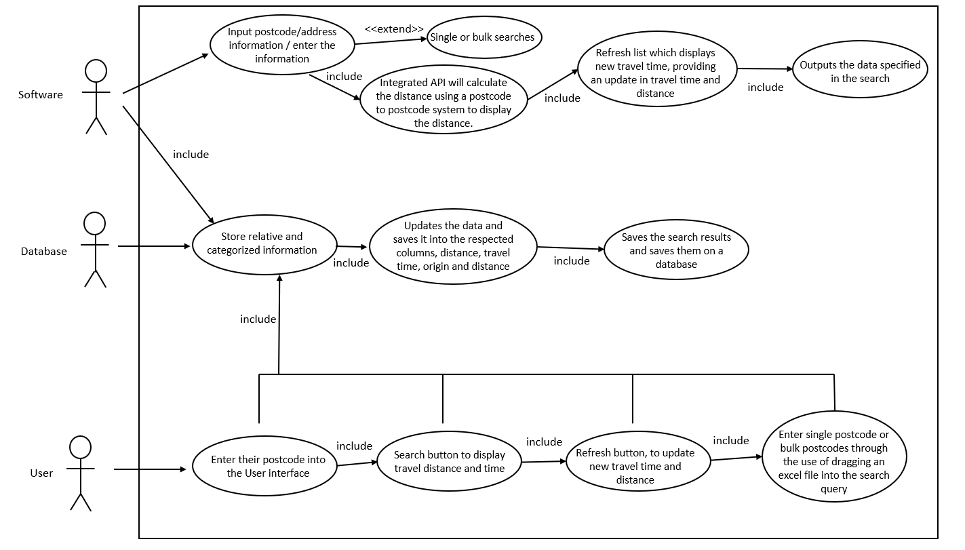

Use Case Diagram