# IHSN

1. Head over to the [IHSN Catalog](http://catalog.ihsn.org/catalog)
2. On the upper right corner Right-Click the Excel icon
   1. 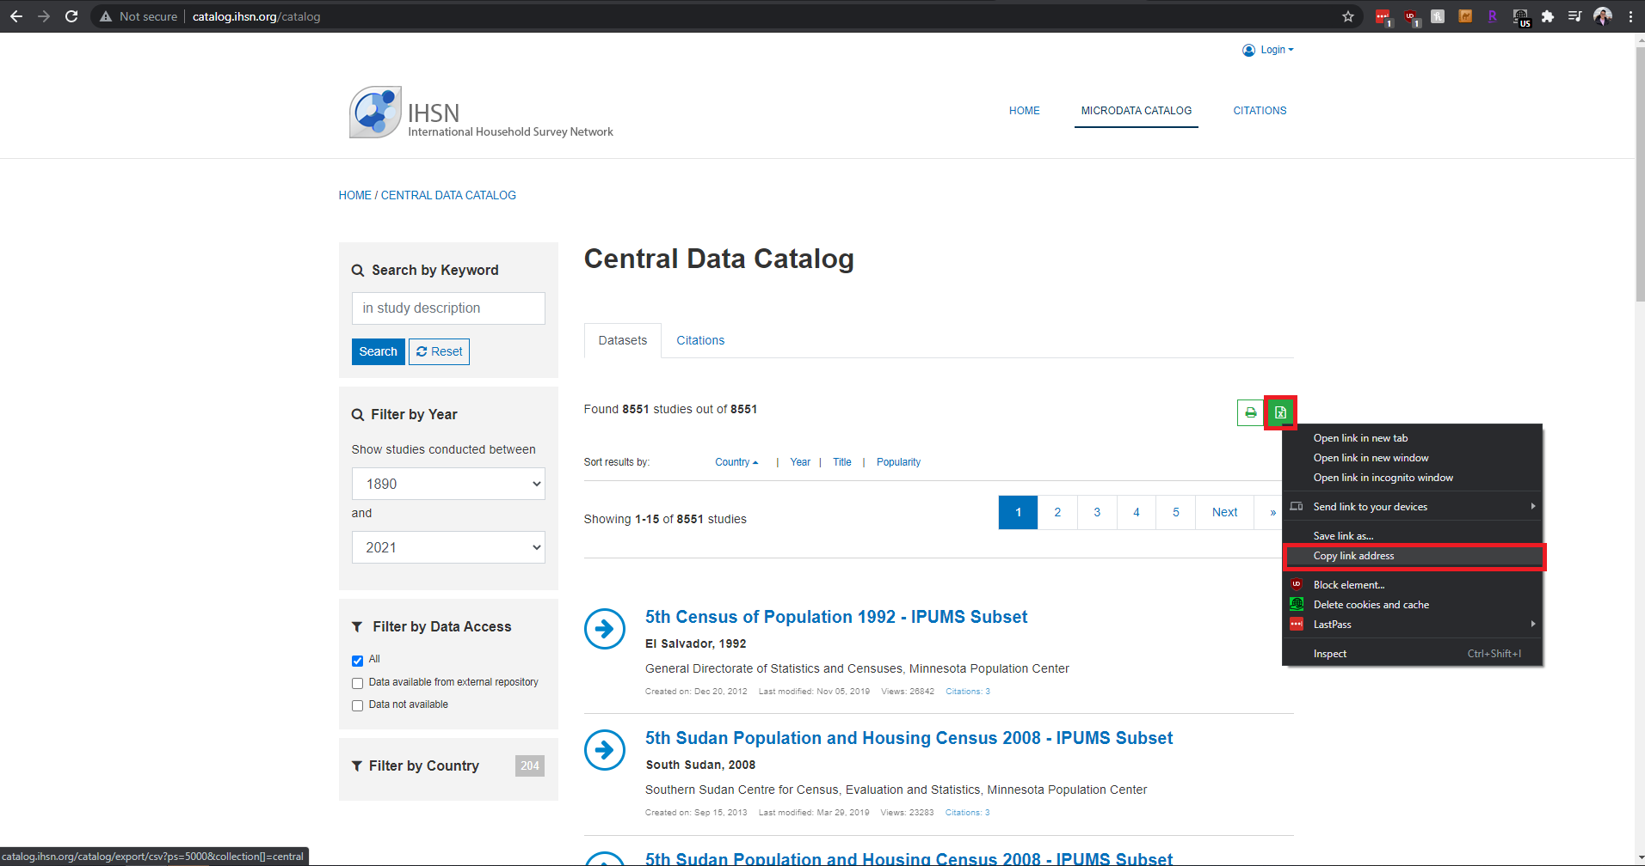
3. Click on “Copy link address”
4. On a separate tab, paste the link address
   1. 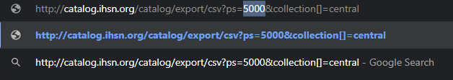
5. Change the highlighted “5000” to a number greater than the total number of entries (8551 as of 7/27). In the example below, “10,000” is used
   1. 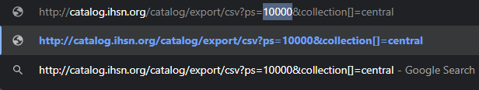
6. Hit “Enter” and save the file with an appropriate name

###### 

###### Notes

* The link will download a .csv file, which can be opened with Excel
* If step 5 isn’t properly followed, then the downloaded file will not contain all the entries (8,551 total entries as of 7/27)

# FAO

1. Head over to the [FAO catalog](https://microdata.fao.org/index.php/catalog)
2. On the upper right corner, Left-Click the Excel icon
   1. 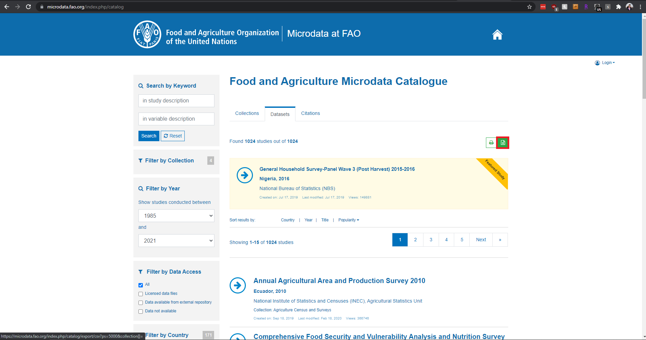
3. When the pop-up window appears, save the .csv file with an appropriate name

###### Notes

* Unlike IHSN, FAO has around 1,000 entries. FAO’s download link will support up to 5,000 entries
* For developers: you can use the [export link](https://microdata.fao.org/index.php/catalog/export/csv?ps=5000&collection%5B%5D=) within programs. For example, you can save the file using Python + the requests library and manipulate it later with another library, like pandas
* FAO downloads a .csv file

# ILO

1. Head over to the [ILO catalog](https://www.ilo.org/surveyLib/index.php/catalog/)
2. On the upper right corner Left-Click the Excel icon
   1. 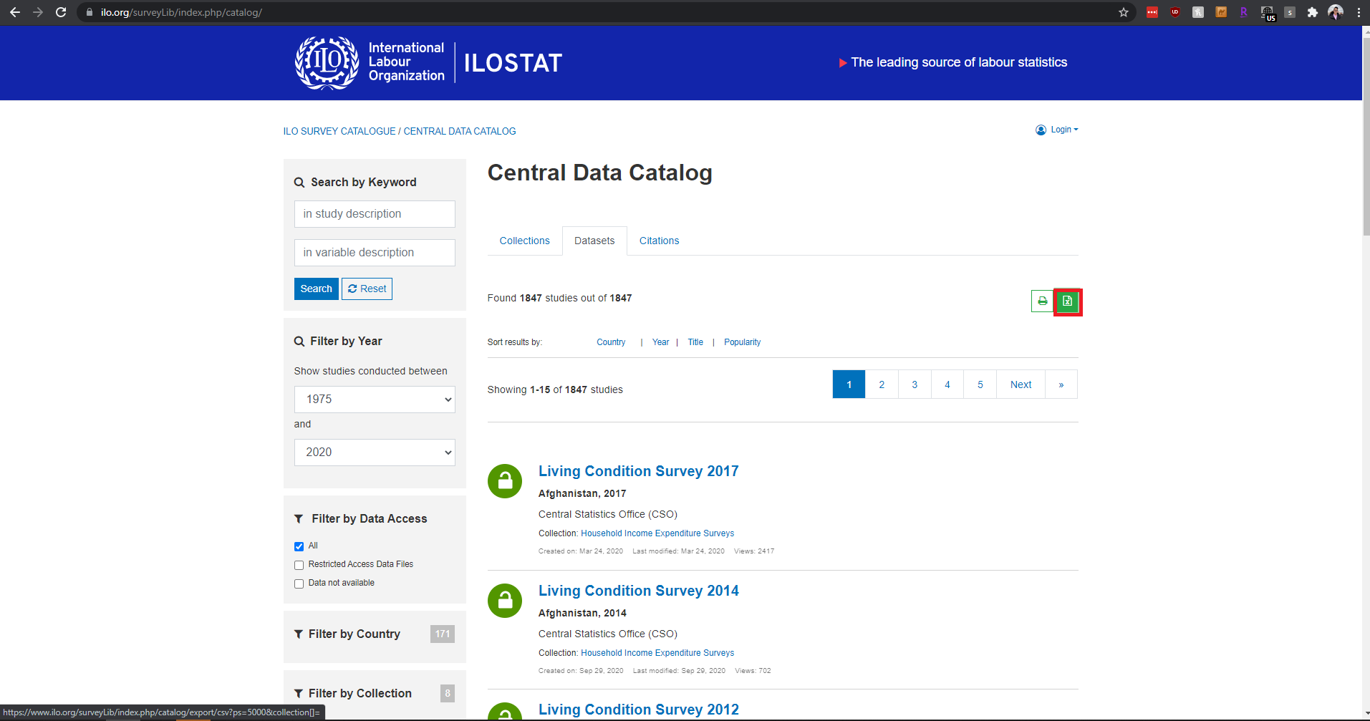
3. When the pop-up window appears, save the .csv file with an appropriate name

###### Notes

* ILO has around 1,800 entries and the download link can support up to 5,000 entries.
* Similar to FAO, you can use the [export link](https://www.ilo.org/surveyLib/index.php/catalog/export/csv?ps=5000&collection%5B%5D=) within programs
* ILO downloads a .csv file

# MICS-UNICEF

1. Head over to the [MICS-UNICEF catalog](https://mics.unicef.org/surveys)
2. On the upper right corner Left-Click the Export icon
   1. 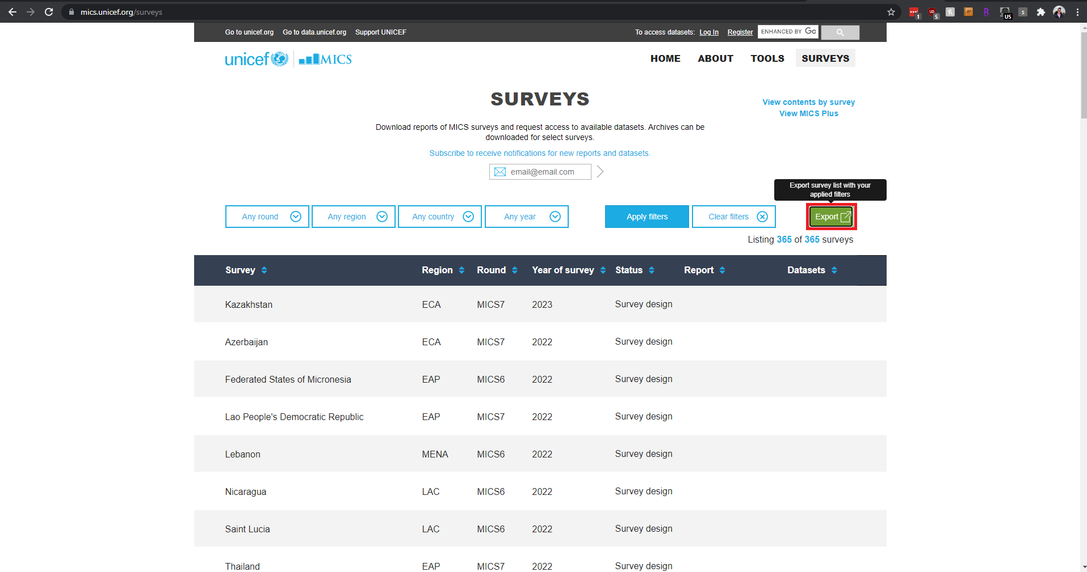
3. When the pop-up window appears, save the .csv file with an appropriate name

###### Notes

* MICS-UNICEF has around 300 entries
* MICS-UNICEF does **NOT** have an export link
* A .csv file will be downloaded

# UN Population

1. Head over to the [UN Population catalog](https://population.un.org/DataArchiveWeb/index.html#/collectedDataType)
2. On the upper right hand side of the page, Left-Click the Export icon
   1. 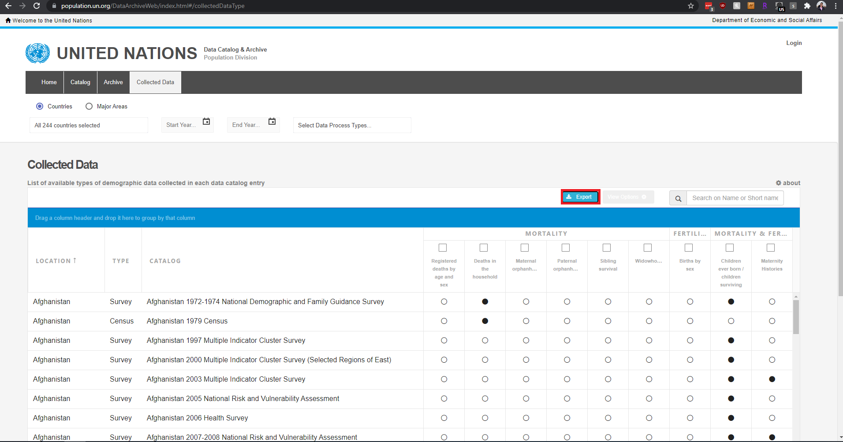
3. When the pop-up window appears, save the file with an appropriate name

###### Notes

* UN Population has around 2,300 entries in total
* UN Population downloads an **Excel** file

# UNStats

*UNStats only has ***data*** available for download. The survey themselves cannot be retrieved.

1. Head over to the [UNStats catalog](https://unstats.un.org/unsd/gender/timeuse/)
2. In the middle of the screen, you’ll find a Tableau window. Head over to the male or female section for data download
3. Click the download button on the lower right corner of the Tableau window
   1. 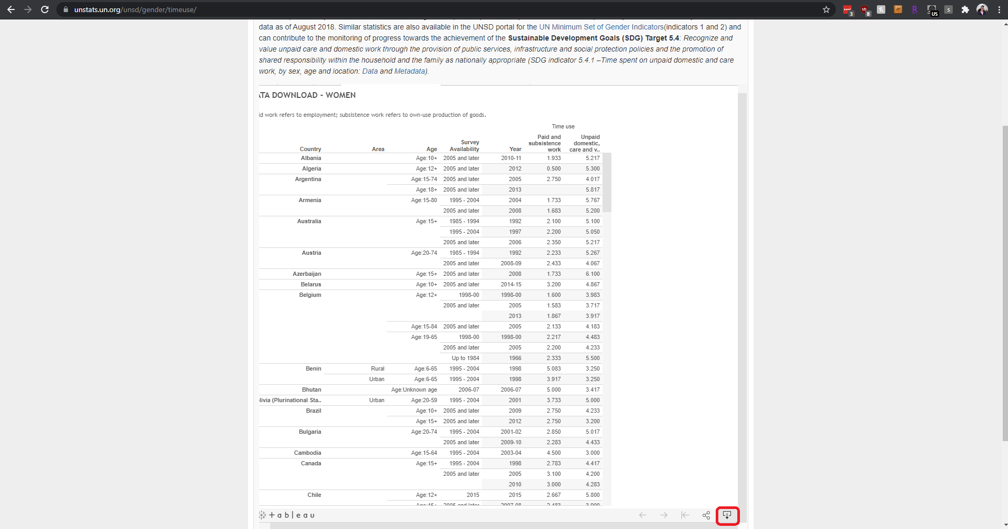
4. Click on the “Data” option
   1. 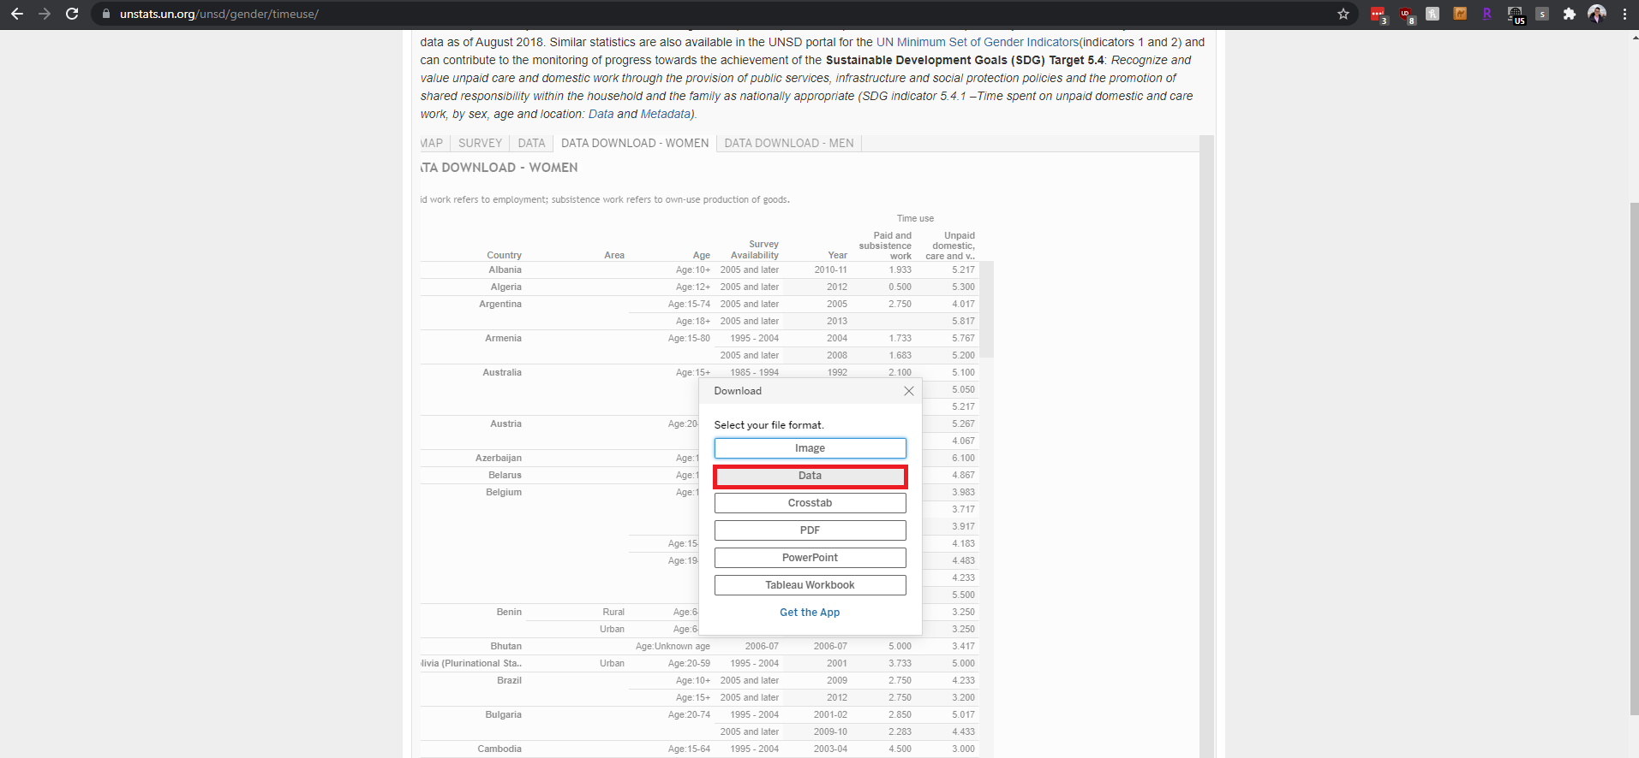
5. A new window will pop up. Head over to “Full Data” and then click on “Download all rows as a text file”. This actually downloads the data in a .csv file.
   1. 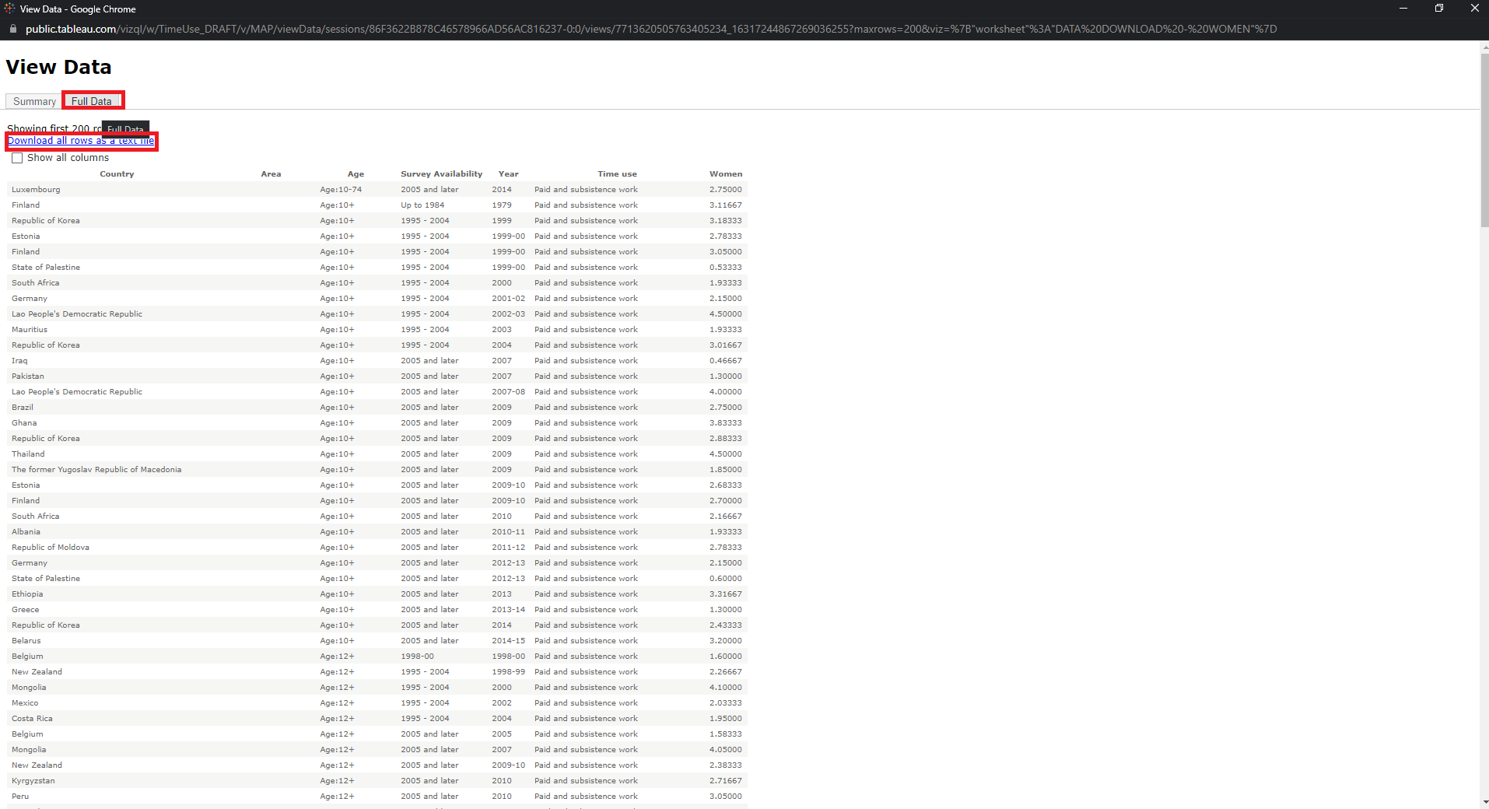
6. Make sure to give the downloaded file an appropriate name

###### Notes

* Although UNStats has a “Survey” tab in the Tableau window, there are some issues when trying to download the data from this tab. Only two entries appear in “Survey”->”Data”
* Keep in mind that the repository hasn’t been updated since August 2018
* Developers may attempt to scrape the Tableau window using [TableauScraper](https://pypi.org/project/TableauScraper/), although errors might appear as the tables/data isn’t formatted in a useful way for TableauScraper
* UNStats downloads a .csv file

# UNWomen

1. Head over to the [UNWomen catalog](https://evaw-global-database.unwomen.org/en/search)
2. On the right hand side of the page, click on the “Download All” button
   1. 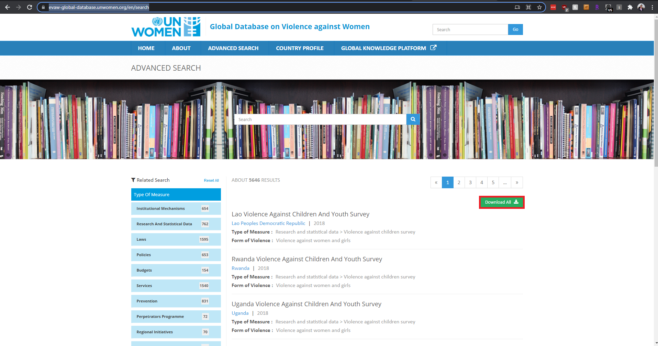
3. It takes a little while (around 30 secs) to load and a pop-up window will appear, prompting you to save the file with a name of choice

###### Notes

* Developers and users can use [this download link](https://evaw-global-database.unwomen.org/VAW/ExportToExcellDataList?countryId=&urlstring=https://evaw-global-database.unwomen.org/en/search') to download the file as well
* UNWomen downloads an **Excel** file with about 5,600 rows

# UNODC

1. Head over to the [UNODC catalog](https://www.cdeunodc.inegi.org.mx/index.php/mapa/)
2. Check the appropriate filters in the Tableau window
3. At the lower right corner of the Tableau window, click on the download icon
   1. 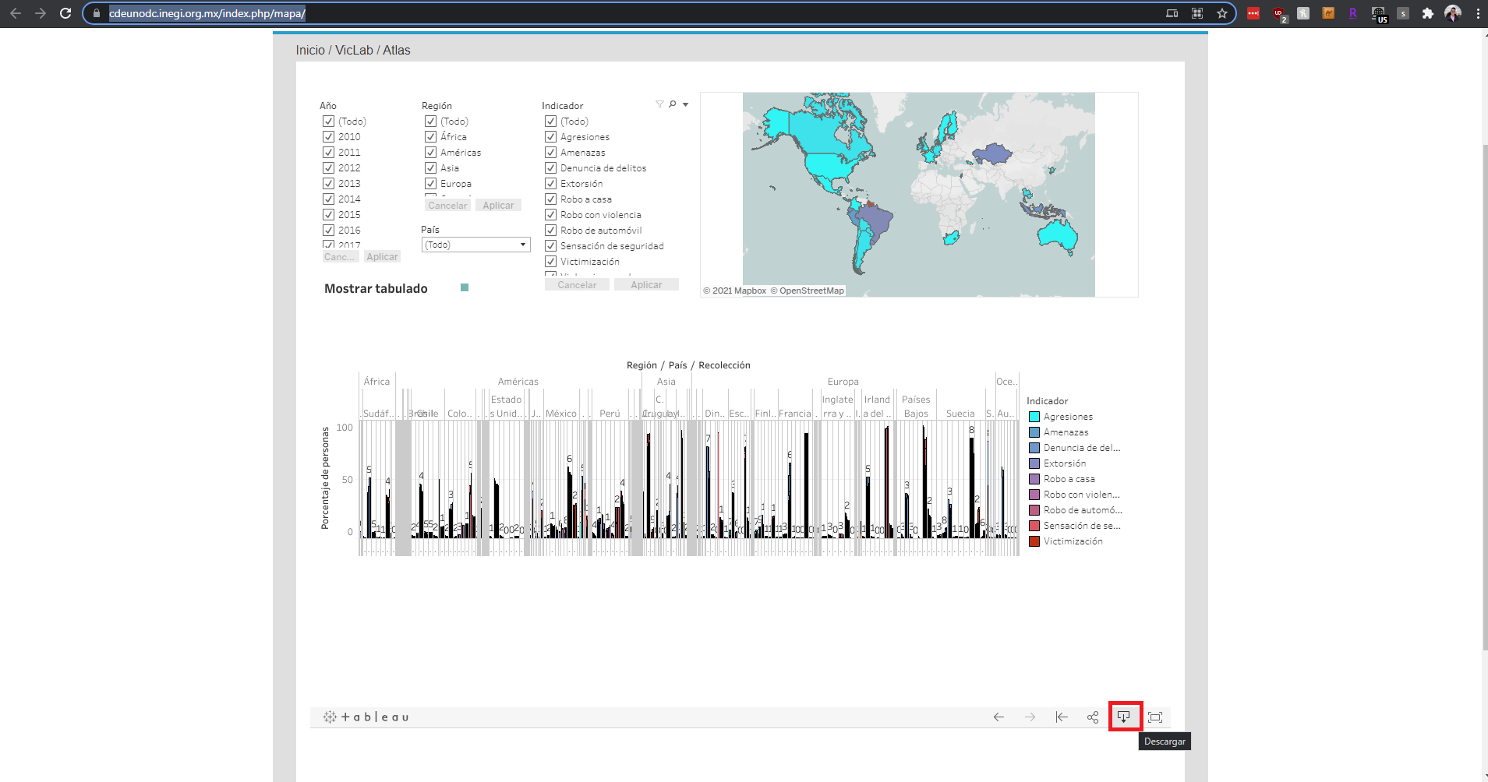
4. Click on “Datos” after the pop-up window appears
5. A new window will appear. Click on “Principal” and then “Download all rows as a text file”
   1. 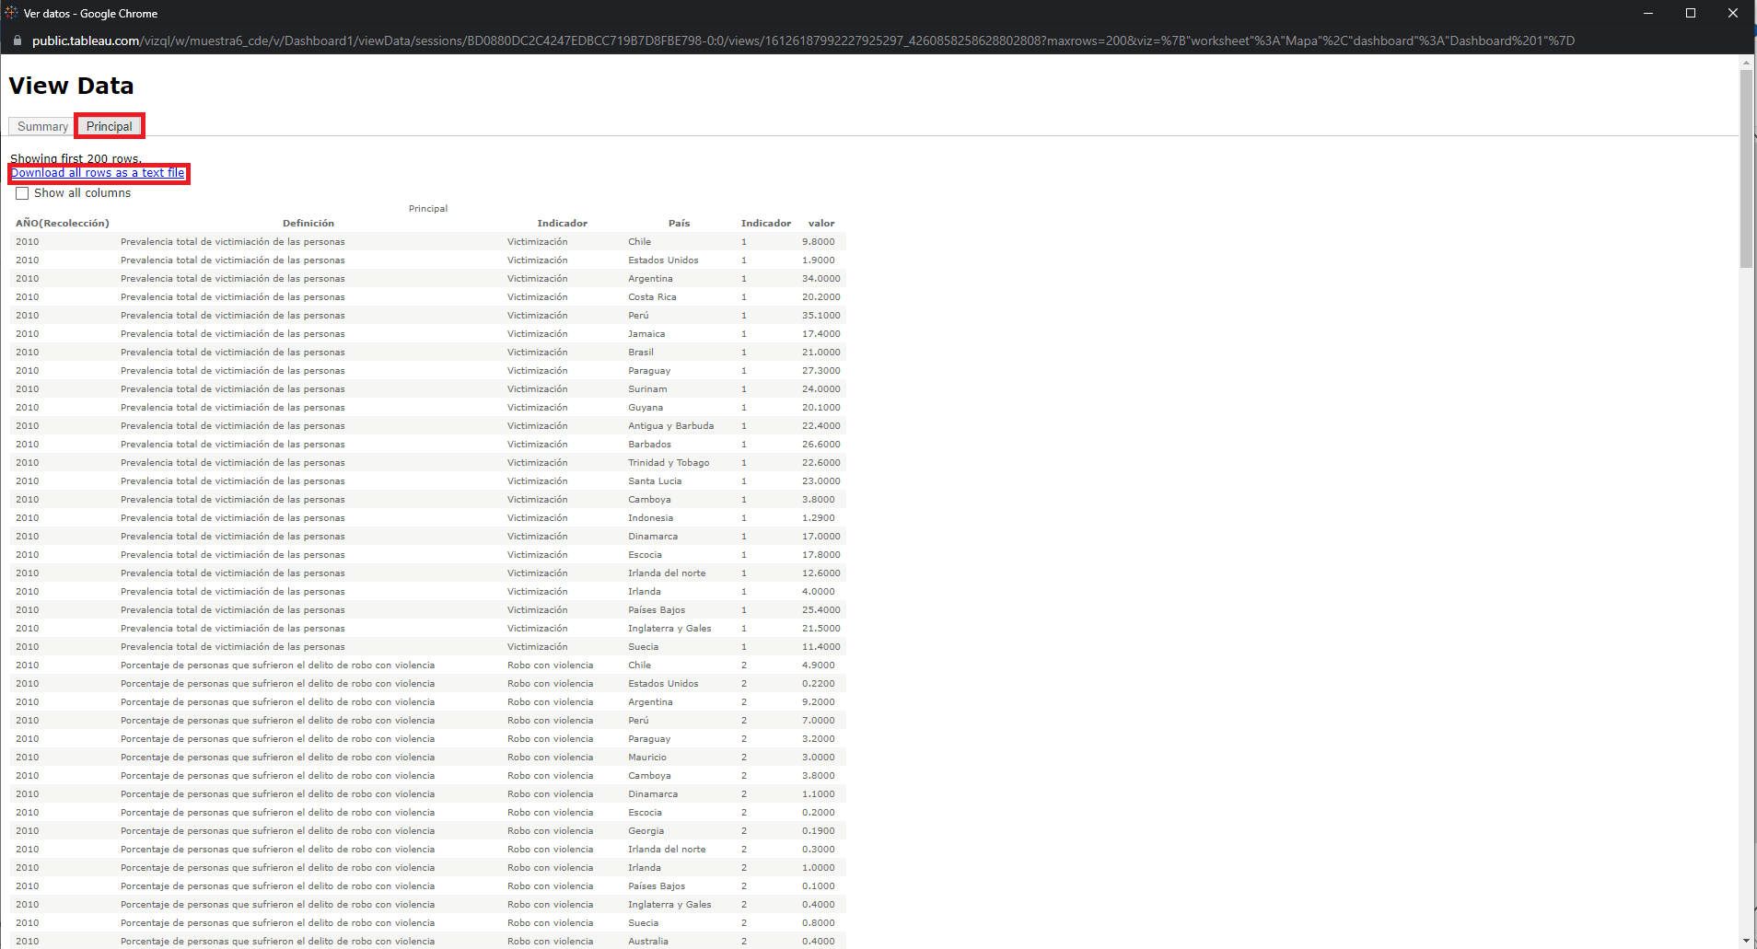
6. Save the file with an appropriate name

###### Notes

* Tableau actually downloads the data as a .csv file
* The data is in **SPANISH**
* UNODC is currently revamping their website. They will have a general source file that will be available for download when the new website deploys.
* The file has around 1,300 rows

# SDD-SPC

1. Head to the [SDD-SPC catalog](https://sdd.spc.int/census-and-survey-calendar)
2. Scroll to the bottom of the page and Left-Click Download CSV File
   1. 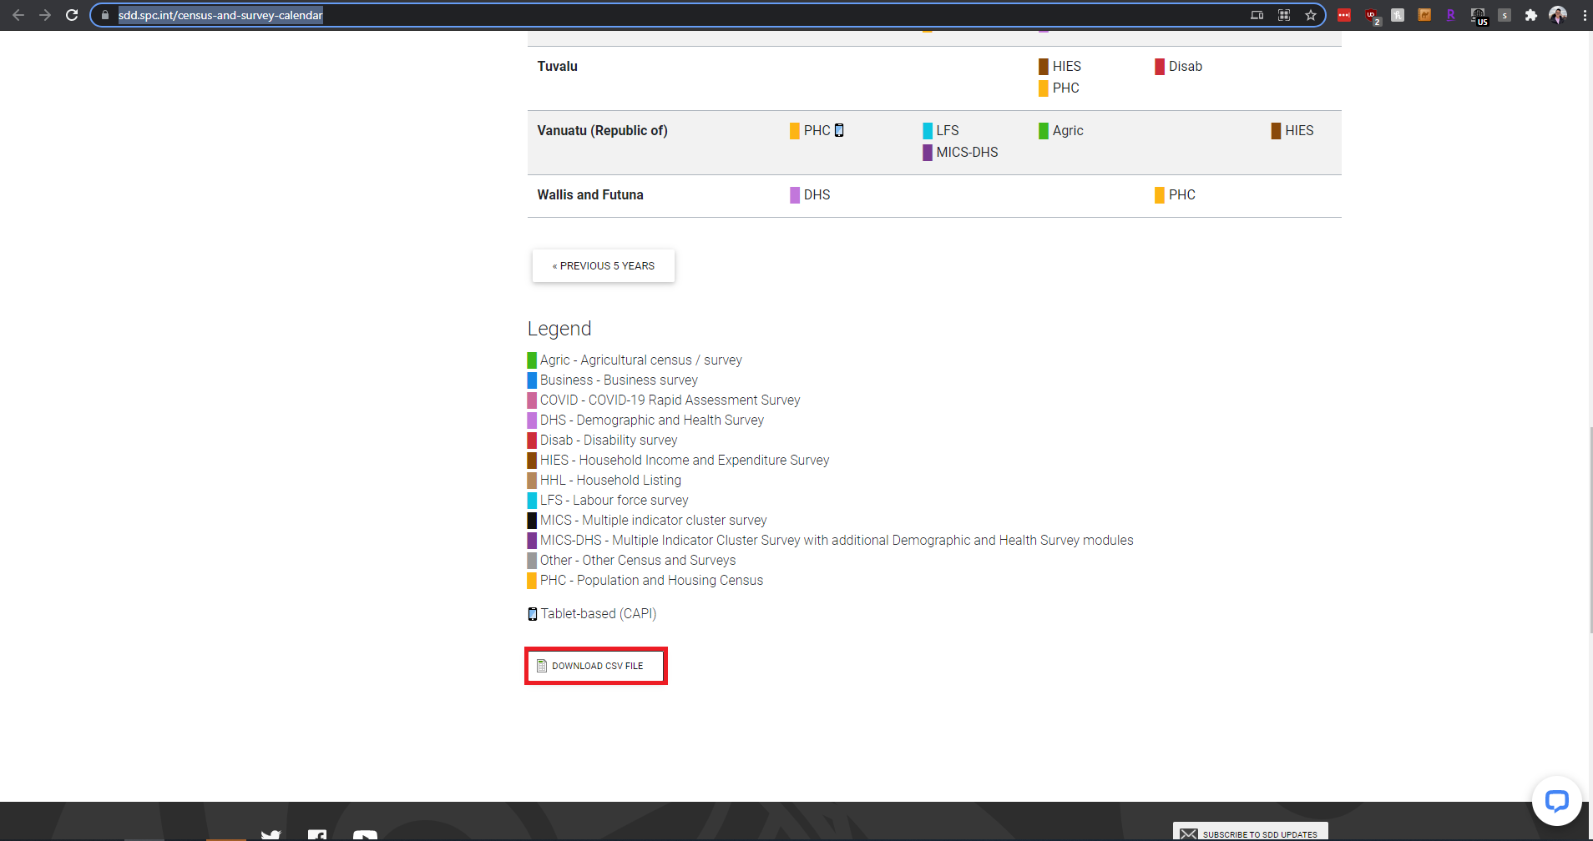
3. Save the file with a name of choice

###### Notes

* The .csv file has around 270 rows
* Developers can also opt to use the [direct download link](https://sdd.spc.int/census-and-survey-calendar/export) for their programs