TRACKING

Tracking is a module designed to monitor and manage the full lifecycle of purchase orders made by Licores Maduro — from the moment an order is placed with a supplier until it is delivered and officially received at the warehouse.

Key Purpose
The module provides end-to-end visibility of purchase orders to produce real-time tracking of Purchase orders

Core Functions
- Order Creation Tracking – Records when and by whom the purchase order was placed.
- Supplier Confirmation – Tracks acknowledgment and confirmation from suppliers.
- Shipment Monitoring – Monitors dispatch dates, shipping details, and estimated arrival times.
- Transit Status Updates – Provides real-time or periodic updates while goods are in transit.
- Delivery Confirmation – Logs arrival at the warehouse.
- Goods Receipt Validation – Confirms quantities received and flags discrepancies (damages, shortages, overages).
- Status Reporting & Alerts – Generates reports and notifications for delays or issues.
- And more.

A user interface must be created that allows the user to:
- Register / Update Purchase order Status,
- Track Status History by entering related status dates.,
- Filter Purchase orders across multiple dimensions,

Following is a structured technical outline for designing the Tracking Module.

Source Tables:
- POHDRT → Purchase order Header Table
- PODTLT → Purchase Order Detail Table

PURCHASE ORDER HEADER (POHDRT):
The Purchase Order Header Table is registered in VIP in table POHDRT.
This table contains the following relevant data:

POHDRT
PHWHSE (Warehouse)
PHPO# (Purchase Order Number
PHBORW (BEER or WINE Order)
PHBRVR (Supplier Code)
PHORDT (Order Date format YYYYMMDD)
PHSHDT (Order Ship date format (YYYYMMDD)
PHSHDT (Order Arrival Date format YYYYMMDD)
PHCON# (Container Number)
PHOQT (Total Order Quantity)
PHWEIG (Total Order Weight)
PHLTRS (Total Liters)
PHTOT$ (Total Amount)
PHOVR# (Order Vendor Number)
PHLINE (Total Order Regels)
PHSTAT (Order Status)

PURCHASE ORDER DETAIL TABLE (PODTLT):
The Purchase Order Detail Table is registered in VIP in table PODTLT
This table contains the following relevant data:

PODTLT
PDWHSE (Warehouse)
PDPO# (Purchase order Number)
PDLINE (Purchase order Line Number)
PDITEM (Item Number)
PDOQTY (Order Quantity)
PDRQTY (Received Quantity)
PDWEIG (Total Line Weight)
PDLTRS (Total Line Liters)
PDCST$ (Item Price)
PDUNIT (Units per Case)
PDSITEM (Supplier Item Code)
PDCDDT (Code Date)
PDBSW (Beer or Wine)
PDCLAS (Product Class)
PDBRVR (Supplier Code)
PDBRAN (Brand Code)
PDSUB (Sub Code)
PDRDAT (Receive Date)
PDSTAT (Order Status)

Additional fields that need to be created in the tracking Module:

Purchase Order Number | Retrieve from VIP
Status Order | Fiiled automatic/Changed automatically
Supplier | Filled automatic
Vendor/Brand | Filled automatic
Country | Filled automatic
Freight Forwarder | Filled automatic
Warehouse | Filled automatic
Total Cases Ordered | Filled automatic
Order Placed Date | Filled automatic
Comments | Input Field
Last Update Date | Input Field
Requested ETA | Input Field
Acknowlegde order 4 Days Yes/No | Input Field
Date Loading shipper | Input Field
Shipping Line | Input Field
Shipping Agent | Input Field
Vessel | Input Field
Container Number | Input Field
Consolidation Ref No. BL no. | Input Field
Container Size | Input Field
Date pro forma received | Input Field
Qty Cases Pro forma | Input Field
Factory Ready Date | Input Field
Estimated Date of Departure | Input Field
Estimated Date of Arrival | Input Field
Transit Time | Input Field
Bijlage Done? | Input Field
Date Arrival Invoice | Input Field
Invoice Number | Input Field
Date Arrival Bill of Lading | Input Field
Remarks | Input Field
Date Arrival Note Received | Input Field
Date Manifdest Received | Input Field
Date Copies to Declarant | Input Field
Date Customs Papers ready | Input Field
Date Customs Papers assesed in Asycuda | Input Field
Date Container at CPS | Input Field
Experation Date at CPS | Input Field
Date Customs Papers to CPS | Input Field
Date Container arrived at Licores | Input Field
Date container opened by Customs | Input Field
Date Container unload ready | Input Field
Return Date Container | Input Field
Days over conatiner at Licores | Calculated
Date Unload papers to Administration | Input Field
SAD Number | Input Field
B-C Number of Orders | Input Field
Exit Note Number | Input Field
Issues Comments | Input Field

Purchase Order Tracking – User Interface Specification
1. Objective
Create a user interface screen that allows users to select a purchase order from the POHDRT table and create or update a tracking record in the Tracking table within the SQL database.
The screen must allow users to:
- Search and select purchase orders.
- Automatically create a tracking record.
- Update tracking information related to the selected purchase order.

2. Data Source
Primary Table
- POHDRT – Purchase Order Header table
- PODTLT – Purchase Order Product Table
Tracking Table
- Tracking – Stores tracking and logistics information for purchase orders.

3. Purchase Order Record Selection and Tracking Creation:
When the user selects a purchase order:
- The system checks if a tracking record already exists.
- If no record exists:
  - A new record must be created in the Tracking table.
- The automatic fields must be populated automatically in the tracking table.

4. Save Functionality
When the user clicks Save:
- The system updates the Tracking table.
- Validation must be applied to required fields.
- A success message must be displayed.
Example:
Tracking information successfully updated.

5. Selection Screen (Search Criteria)
The user must be able to filter purchase orders in the Tracking Table using the following fields:
Field | Description
Order Status | Status of the purchase order
Purchase Order Number | Unique identifier of the purchase order
Supplier | Vendor supplying the goods
Freight Forwarder | Logistics company responsible for shipment
Item Number | Specific item within the purchase order
Selection Behavior
- The user enters one or more search criteria.
- The system retrieves matching purchase orders from TRACKING.
- Results are displayed in a search results grid.

6. Additional Functional Requirements
Validation
- Purchase Order Number must exist in POHDRT.
- Required tracking fields must not be empty.

Permissions
- Only authorized users may modify tracking records.

Following is an example of a user interface screen that can be amended.
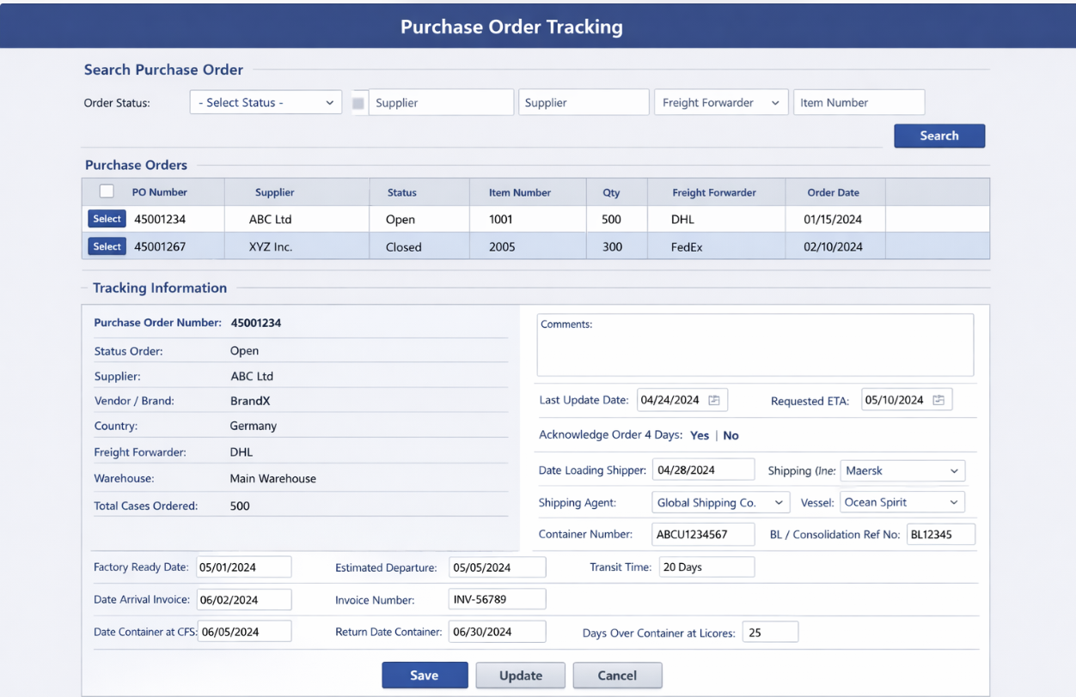

0 – 0 – 0 – 0 – 0 - 0

