From https://github.com/Wi5/odin-wi5/wiki

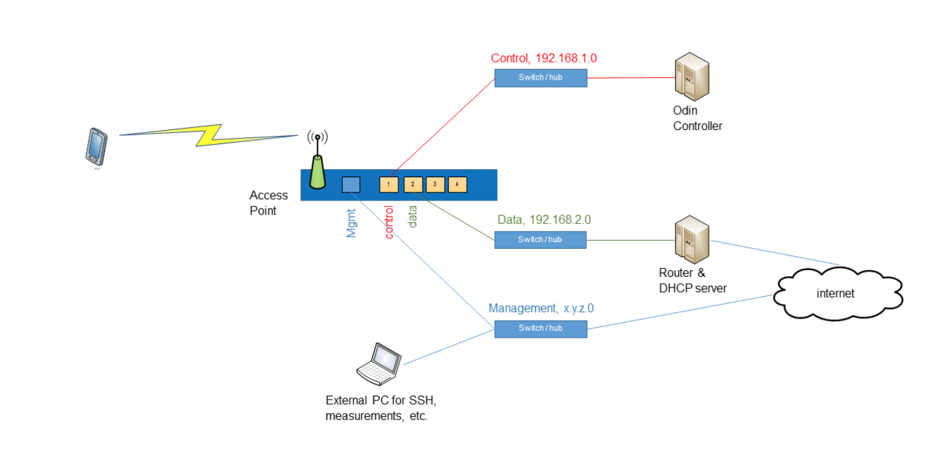

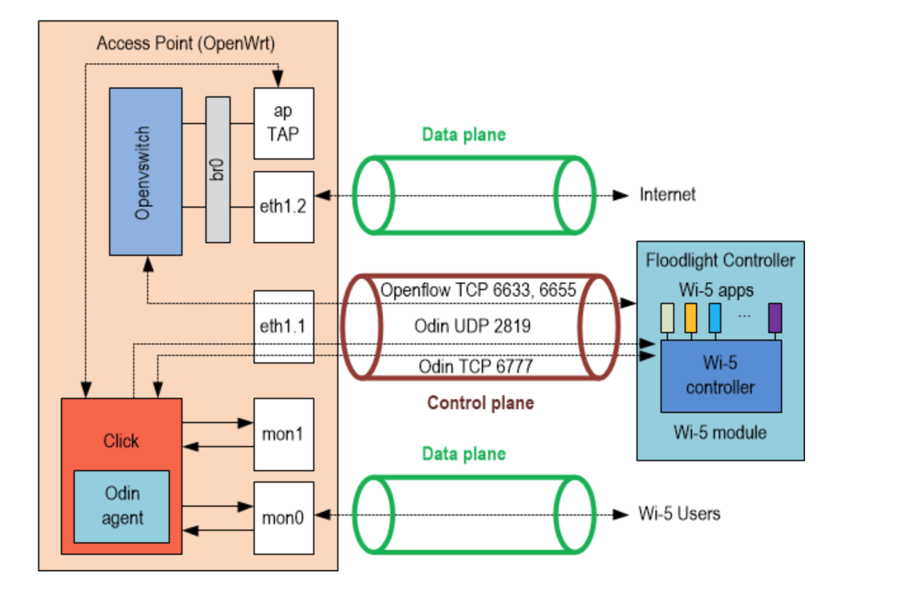

https://github.com/mininet/mininet