A young girl named Lily Wearing a colorful dress and a bow headband Smiling happily Lively and cheerful personality Punk-inspired style with

**1. 開始：莉莉的新冒險**

A young girl named Lily Wearing a colorful dress and a bow headband Smiling happily Lively and cheerful personality Punk-inspired style with Lily is playing at home when she suddenly finds a mysterious map outside her window. She decides to follow the map and explore.

一個名叫莉莉的小女孩，穿著彩色的裙子和一條蝴蝶結頭帶，開心地微笑，充滿活力和快樂的個性，帶有朋克風格。莉莉正在家裡玩耍，突然，她發現窗外有一張神秘的地圖。她決定跟著地圖去探索。

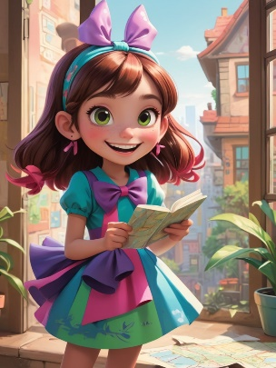 image1. **莉莉的新冒險**

**2. 準備出發：和朋友告別**

A young girl named Lily Wearing a colorful dress and a bow headband Smiling happily Lively and cheerful personality Punk-inspired style with Lily tells her little cat or dog friends that she’s going on an adventure and promises she’ll be back soon. This scene teaches children about having the courage to step out of their comfort zones and face new challenges.

一個名叫莉莉的小女孩，穿著彩色的裙子和一條蝴蝶結頭帶，開心地微笑，充滿活力和快樂的個性，帶有朋克風格。莉莉告訴她的小貓咪或小狗朋友，她將開始冒險，並承諾很快會回來。這一幕教導小朋友勇敢地走出舒適區，迎接新的挑戰。

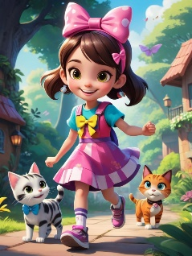 image2. **和朋友告別**

**3. 進入森林：遇到第一個挑戰**

A young girl named Lily Wearing a colorful dress and a bow headband Smiling happily Lively and cheerful personality Punk-inspired style with Lily enters a large forest and finds two different paths. She chooses the more difficult one, which teaches her to face challenges with bravery.

一個名叫莉莉的小女孩，穿著彩色的裙子和一條蝴蝶結頭帶，開心地微笑，充滿活力和快樂的個性，帶有朋克風格。莉莉走進一片大森林，發現有兩條不同的道路。她選擇了比較困難的一條，這教會了她如何勇敢面對挑戰。

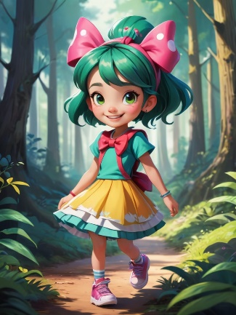 image3. **遇到第一個挑戰**

**4. 解決問題：找到關鍵的線索**

A young girl named Lily Wearing a colorful dress and a bow headband Smiling happily Lively and cheerful personality Punk-inspired style with In the forest, Lily encounters a giant maze. She bravely attempts to solve the puzzle and, in the process, learns the importance of patience and critical thinking.

一個名叫莉莉的小女孩，穿著彩色的裙子和一條蝴蝶結頭帶，開心地微笑，充滿活力和快樂的個性，帶有朋克風格。在森林中，莉莉遇到了一個巨大的迷宮。她勇敢地嘗試解開謎題，並在過程中學會了耐心和批判性思維的重要性。

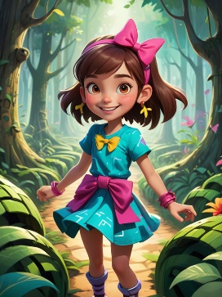 image4. **找到關鍵的線索**

**5. 遇見朋友：合作的重要性**

A young girl named Lily Wearing a colorful dress and a bow headband Smiling happily Lively and cheerful personality Punk-inspired style with Lily meets a frightened little rabbit in the maze. She comforts the rabbit and decides to work together to find the exit, teaching the value of teamwork.

一個名叫莉莉的小女孩，穿著彩色的裙子和一條蝴蝶結頭帶，開心地微笑，充滿活力和快樂的個性，帶有朋克風格。莉莉在迷宮中遇到了一隻害怕的小兔子。她安慰兔子，並決定一起合作找出出口，這一幕教導小朋友團隊合作的價值。

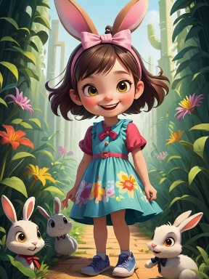 image5. **合作的重要性**

**6. 面對困難的選擇：選擇正確的道路**

A young girl named Lily Wearing a colorful dress and a bow headband Smiling happily Lively and cheerful personality Punk-inspired style with They encounter a choice: a fast but dangerous path, or a slow but safe one. After discussing it, Lily and the rabbit choose the safe route, teaching children to make thoughtful decisions.

一個名叫莉莉的小女孩，穿著彩色的裙子和一條蝴蝶結頭帶，開心地微笑，充滿活力和快樂的個性，帶有朋克風格。他們面臨一個選擇：一條快速但危險的路，或是一條緩慢但安全的路。在討論後，莉莉和兔子選擇了安全的路，這教導小朋友如何做出深思熟慮的選擇。

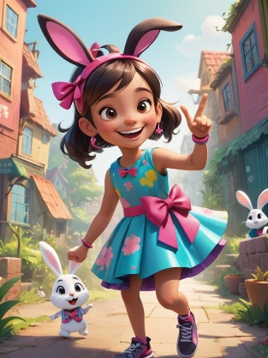 image6. **選擇正確的道路**

**7. 成長：發現自己的力量**

A young girl named Lily Wearing a colorful dress and a bow headband Smiling happily Lively and cheerful personality Punk-inspired style with After overcoming the challenge, Lily realizes she’s become stronger and smarter. This scene emphasizes the importance of self-growth.

一個名叫莉莉的小女孩，穿著彩色的裙子和一條蝴蝶結頭帶，開心地微笑，充滿活力和快樂的個性，帶有朋克風格。經過挑戰後，莉莉發現自己變得更強大、更聰明。這一幕強調了自我成長的重要性。

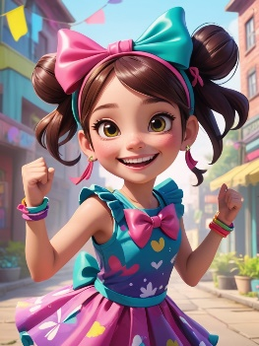 image7. **發現自己的力量**

**8. 克服挑戰：打敗大怪物**

A young girl named Lily Wearing a colorful dress and a bow headband Smiling happily Lively and cheerful personality Punk-inspired style with In the story’s climax, Lily and the rabbit face a giant monster. Using her wisdom and courage, Lily defeats the monster, showing that bravery and intelligence are keys to success.

一個名叫莉莉的小女孩，穿著彩色的裙子和一條蝴蝶結頭帶，開心地微笑，充滿活力和快樂的個性，帶有朋克風格。在故事的高潮部分，莉莉和兔子面對一隻巨大的怪物。莉莉運用她的智慧和勇氣擊敗了怪物，展示了勇氣和智慧是成功的關鍵。

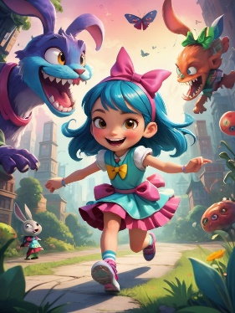 image8. **打敗大怪物**

**9. 回到家：分享冒險**

A young girl named Lily Wearing a colorful dress and a bow headband Smiling happily Lively and cheerful personality Punk-inspired style with Lily and the rabbit return home safely, and she shares her adventure with her friends. They all celebrate her success together.

一個名叫莉莉的小女孩，穿著彩色的裙子和一條蝴蝶結頭帶，開心地微笑，充滿活力和快樂的個性，帶有朋克風格。莉莉和兔子安全回到家，她與朋友們分享了她的冒險故事，大家一起慶祝她的成功。

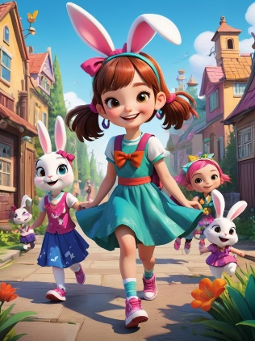 image9. **分享冒險**

**10. 結尾：莉莉的成長**

A young girl named Lily Wearing a colorful dress and a bow headband Smiling happily Lively and cheerful personality Punk-inspired style with At the end of the story, Lily smiles at her bow headband, full of confidence. She knows that no matter what challenges lie ahead, she can handle them.

一個名叫莉莉的小女孩，穿著彩色的裙子和一條蝴蝶結頭帶，開心地微笑，充滿活力和快樂的個性，帶有朋克風格。故事結尾時，莉莉微笑著看著她的蝴蝶結頭帶，心中充滿自信。她知道無論未來有多少挑戰，她都能夠應對。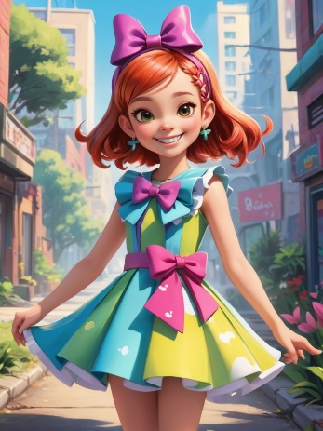 image10. **莉莉的成長**