Final Project Report
DSAI4205 Big Data Analytics
Daily Public Opinion on Israel-Palestine War
Semester Two, 2025/26 | Group Project (25%)
Dataset: 3,125 Reddit comments | 3 Sentiment Classes | 104 Notebook Cells | 21 Visualizations

Table of Contents
1. Introduction & Dataset Overview
1.1 Project Objective
1.2 Dataset Description
1.3 Pipeline Overview
2. Exploratory Data Analysis (EDA)
2.1 Class Distribution & Imbalance Analysis
2.2 Text Length Distribution
2.3 Word Frequency Analysis
2.4 Data Quality Assessment
2.5 Outlier Detection & Handling Strategy
3. Data Cleaning
3.1 Baseline Cleaning Pipeline
3.2 Enhanced Cleaning: 6 Targeted Improvements
3.3 Outlier-Aware Feature Engineering
3.4 Text Variants for Different Model Families
3.5 Text Augmentation for Minority Class
4. Baseline Model: TF-IDF + Logistic Regression
4.1 Feature Extraction Strategy
4.2 Results & Per-Class Analysis
4.3 Error Analysis
4.4 Baseline Improvement Strategies
5. Advanced Modelling (N=5 Models)
5.1 How Word Embeddings Connect to ML Classifiers
5.2 Aggregation Strategies Explained
5.3 Model 1: Word2Vec (from scratch) + SVM
5.4 Model 2: GloVe (pretrained) + XGBoost
5.5 Model 3: BERT (pretrained) + MLP / Fine-tuned
5.6 Model 4: FastText (from scratch) + BiLSTM
5.7 Model 5: Doc2Vec (from scratch) + CNN
5.8 Model Comparison & Performance Analysis
5.9 Diagnostic Analysis: Why Advanced Models Underperform Baseline
6. Handling Imbalanced Dataset
6.1 Problem Definition & Impact
6.2 Strategy 1: Class Weights
6.3 Strategy 2: SMOTE Oversampling
6.4 Strategy 3: Focal Loss
6.5 Strategy 4: Per-Class Threshold Tuning
6.6 Strategy 5: Text-Level Data Augmentation
6.7 Combined Results & Comparison
7. Refinement & Hyperparameter Tuning
7.1 GridSearchCV Results
7.2 Class-Weighted Neural Models
7.3 Note on Advanced Model Tuning
8. Ensemble Methods
8.1 Ensemble Stacking v1 (4 Models)
8.2 Ensemble v2 (6 Tuned Models)
8.3 Selective Ensemble (Top 4 Models)
8.4 Why Ensembles Do Not Beat the Baseline
9. Uniqueness and Creativity
9.1 SHAP Explainability
9.2 t-SNE & UMAP Embedding Visualization
9.3 Deep Error Analysis & Model Disagreement
9.4 Label Noise Detection
10. Data Visualization Summary (N=21)
11. Project Development & Documentation
12. Conclusion
12.1 Key Findings
12.2 Why Metrics Are Relatively Low
12.3 Final Model Recommendation
12.4 Limitations & Future Work

1. Introduction & Dataset Overview

1.1 Project Objective
This project performs multi-class sentiment analysis on Reddit comments about the Israel-Palestine conflict, classifying each comment into one of three sentiment categories: Positive, Neutral, or Negative. The objective is to build, compare, and evaluate a comprehensive machine learning pipeline spanning exploratory data analysis, data cleaning, a baseline model, five advanced models (each combining a distinct word embedding with a distinct analytics classifier), hyperparameter refinement, class imbalance handling, and creativity elements including ensemble stacking, SHAP explainability, and dimensionality reduction visualization. The project demonstrates that model performance is constrained not by algorithmic complexity but by dataset characteristics: small corpus size, inherent label ambiguity in political discourse, and class imbalance.

1.2 Dataset Description
Property | Value
Source | Reddit comments on Israel-Palestine conflict
File | reddit_opinion_PSE_ISR.csv
Total Rows | 3,125
Columns | self_text (comment text), sentiment_label (0/1/2)
Label Encoding | 0 = Neutral, 1 = Positive, 2 = Negative
Positive (Class 1) | 1,390 samples (44.5%)
Neutral (Class 0) | 890 samples (28.5%)
Negative (Class 2) | 845 samples (27.0%)
Imbalance Ratio | 1.64:1 (Positive:Negative)
Text Length (mean) | 235 characters
Text Length (median) | 127 characters
Text Length (max) | 7,973 characters
Null Values | 0
Exact Duplicates | 8 rows

1.3 Pipeline Overview
The complete project pipeline is illustrated in Figure 1 below. This is the only high-level flowchart in the report; subsequent sections use step-by-step pipeline diagrams for each individual model to explain exactly how word embeddings connect to machine learning classifiers.
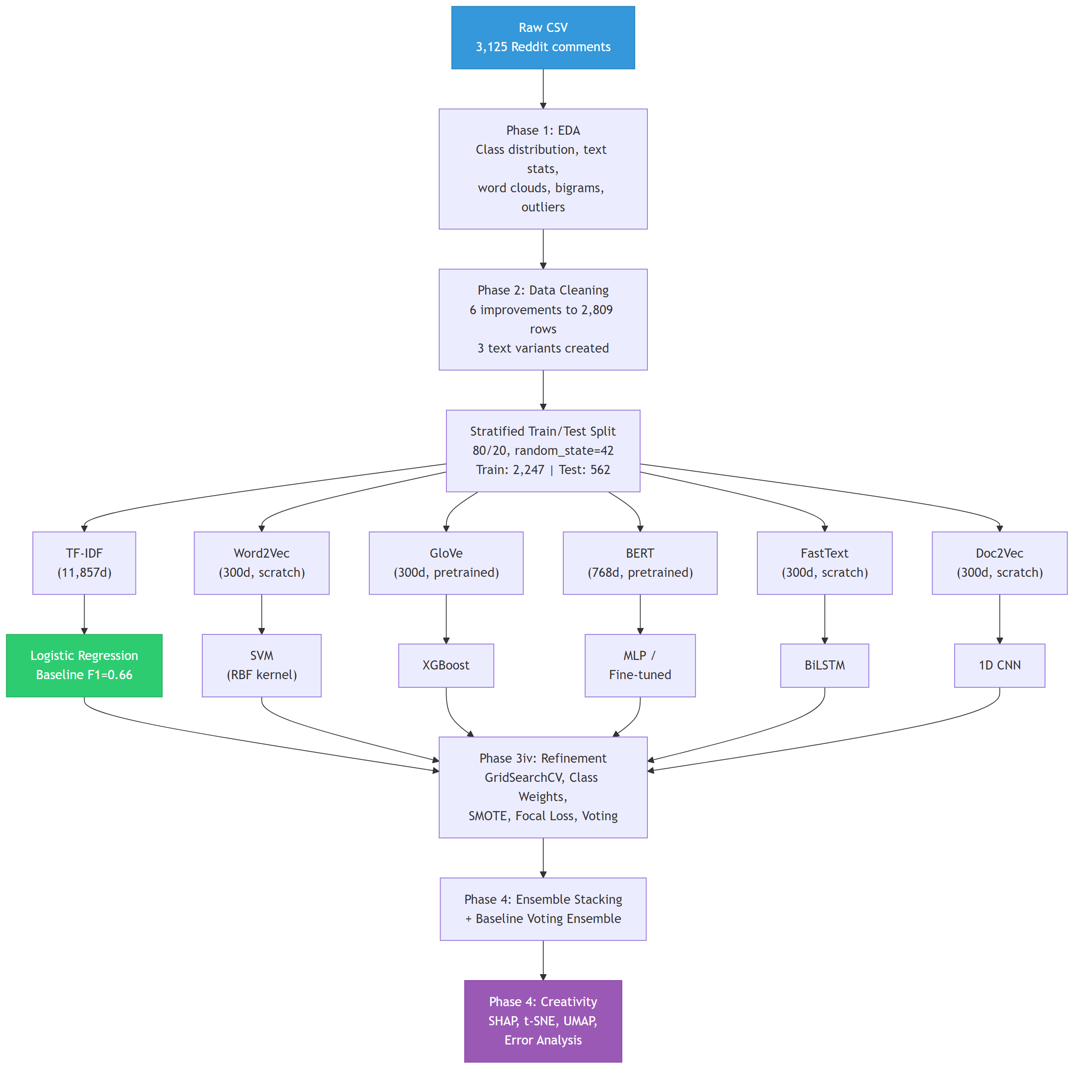
Figure 1: Complete Project Pipeline Flowchart

2. Exploratory Data Analysis (EDA)
We begin by thoroughly understanding the dataset: checking its structure and data types, identifying missing values and duplicates, examining class distributions for imbalance, analyzing text length distributions for outliers, and exploring correlations between text features and sentiment labels. This phase directly informs every downstream decision: which cleaning steps to apply, how to handle imbalance, and why certain models succeed or fail.

2.1 Class Distribution & Imbalance Analysis
The dataset exhibits moderate class imbalance with a 1.64:1 ratio between the majority class (Positive, 1,390 samples, 44.5%) and the minority class (Negative, 845 samples, 27.0%). Neutral sits in between at 890 samples (28.5%). This imbalance has profound consequences for model training and evaluation:
Impact of Imbalance on Model Training: Machine learning classifiers trained on imbalanced data develop a systematic bias toward the majority class. During training, the loss function receives more gradient updates from Positive samples simply because there are more of them. This causes the decision boundary to shift toward maximizing accuracy on Positive samples at the expense of Negative recall. The effect is most pronounced in neural models (BiLSTM, CNN) which are gradient-driven, and least pronounced in TF-IDF + Logistic Regression which uses class_weight="balanced" to counteract this bias analytically.
Impact on Evaluation Metrics: Standard accuracy is misleading under imbalance — a model that predicts Positive for every sample achieves 44.5% accuracy. We therefore use macro-averaged F1 as the primary metric, which weights each class equally regardless of support. This penalizes models that sacrifice minority-class performance for majority-class gains.
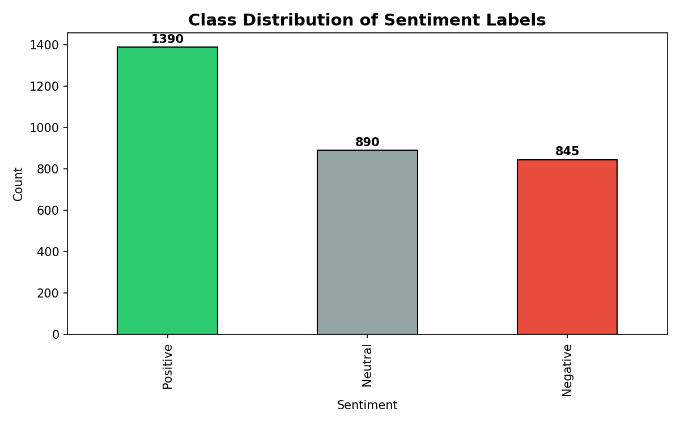
Figure 2: Sentiment Class Distribution. Positive dominates at 44.5%. The 1.64:1 imbalance ratio directly causes the minority-class failure pattern observed across all models.

2.2 Text Length Distribution
Text length varies dramatically across classes and reveals important patterns:
Metric | Positive | Neutral | Negative
Count | 1,390 | 890 | 845
Mean chars | 326.6 | 77.3 | 250.2
Median chars | 185 | 58 | 166
Std chars | 492.8 | 75.8 | 270.4
Max chars | 7,973 | 757 | 2,547
Mean words | 55.0 | 12.5 | 42.3
Median words | 31.5 | 9.0 | 29.0

Key Observation: Neutral comments are dramatically shorter (mean=77 chars, median=58) than Positive (mean=327) and Negative (mean=250). This reflects a genuine linguistic pattern — neutral factual statements ("Reuters reported X") are concise, while opinionated comments elaborate with arguments and examples. This length difference itself carries discriminative signal, which we later capture via engineered text-length features (log_char_len, word_count, avg_word_len, unique_word_ratio).
The right-skewed distribution with heavy tails (max=7,973 chars) indicates the presence of extreme outliers, which are analyzed in detail in Section 2.5.
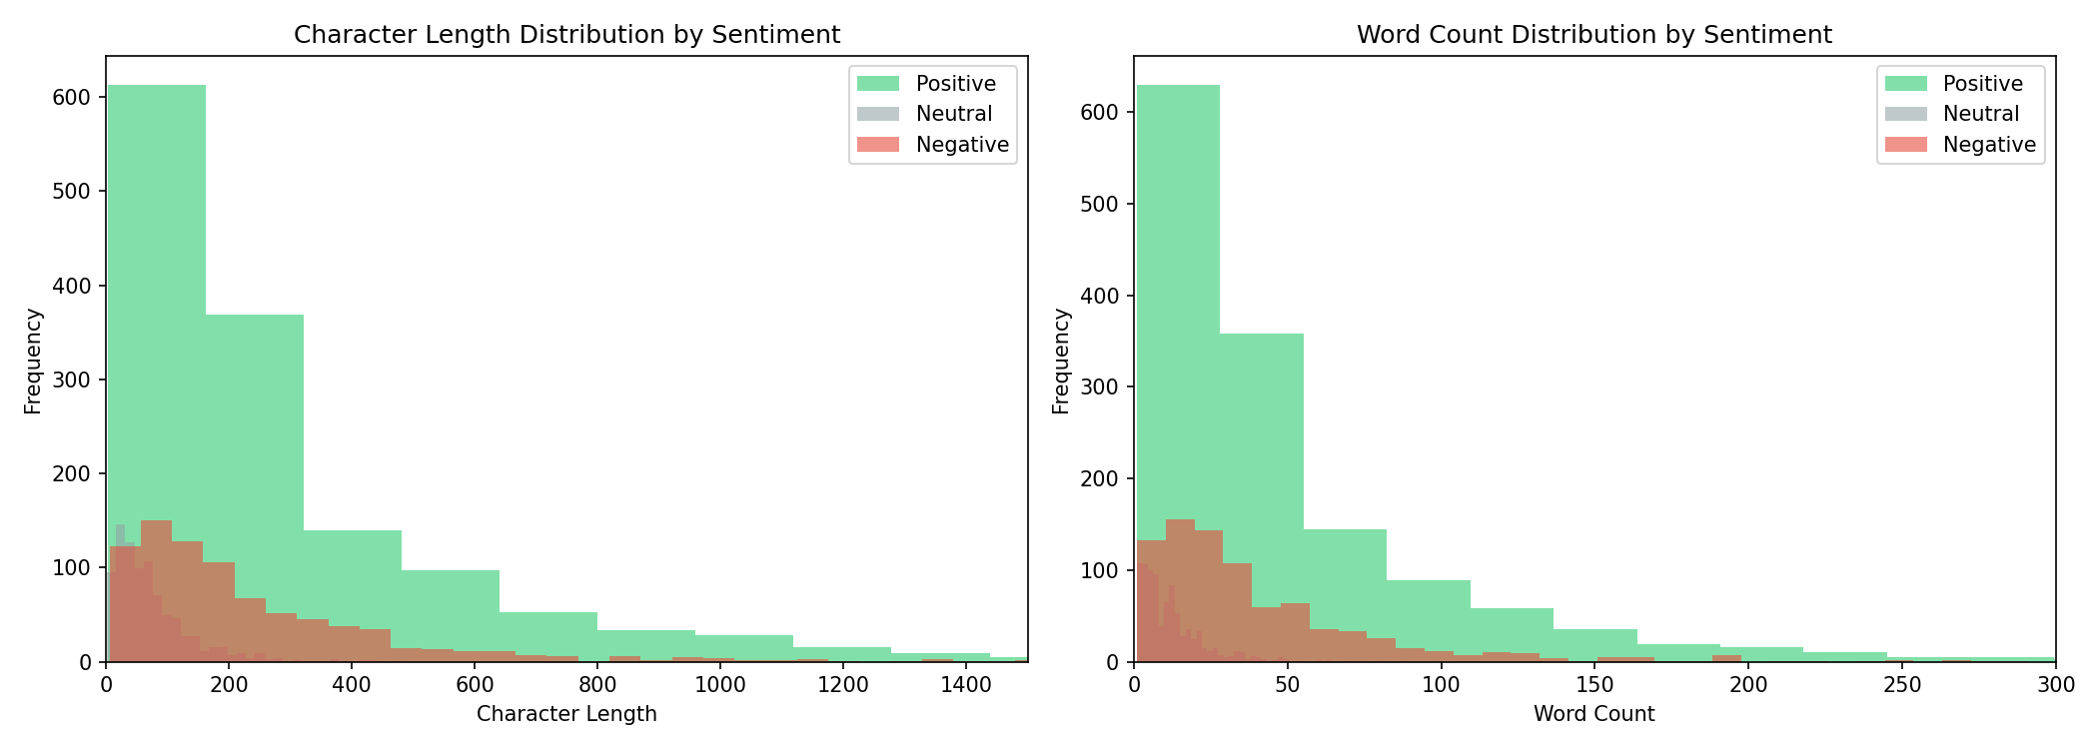
Figure 3: Text Length Distribution by Sentiment. Right-skewed with heavy tails. Positive comments tend longest; Neutral shortest. Kruskal-Wallis test confirms statistically significant differences (H=739.35, p<0.0001).

2.3 Word Frequency Analysis (Word Clouds & Bigrams)
Word clouds and bigram frequency analysis reveal both shared vocabulary and class-specific patterns. Terms like "Israel", "Palestinian", "Gaza", and "Hamas" appear across all three classes, creating substantial vocabulary overlap that makes bag-of-words discrimination inherently challenging. Class-specific patterns emerge at the bigram level:
• Positive: "free palestine", "two state", "human right" — advocacy and support language
• Neutral: "according to", "united nations", "international law" — factual reporting
• Negative: "war crime", "ethnic cleansing", "genocide" — condemnation and outrage
This bigram analysis directly motivates using ngram_range=(1,2) in TF-IDF: unigrams alone cannot distinguish "war" (appears in all classes) from "war crime" (strongly Negative). The overlapping vocabulary also explains why dense embeddings struggle — mean-pooling averages away discriminative bigrams into ambiguous centroids.
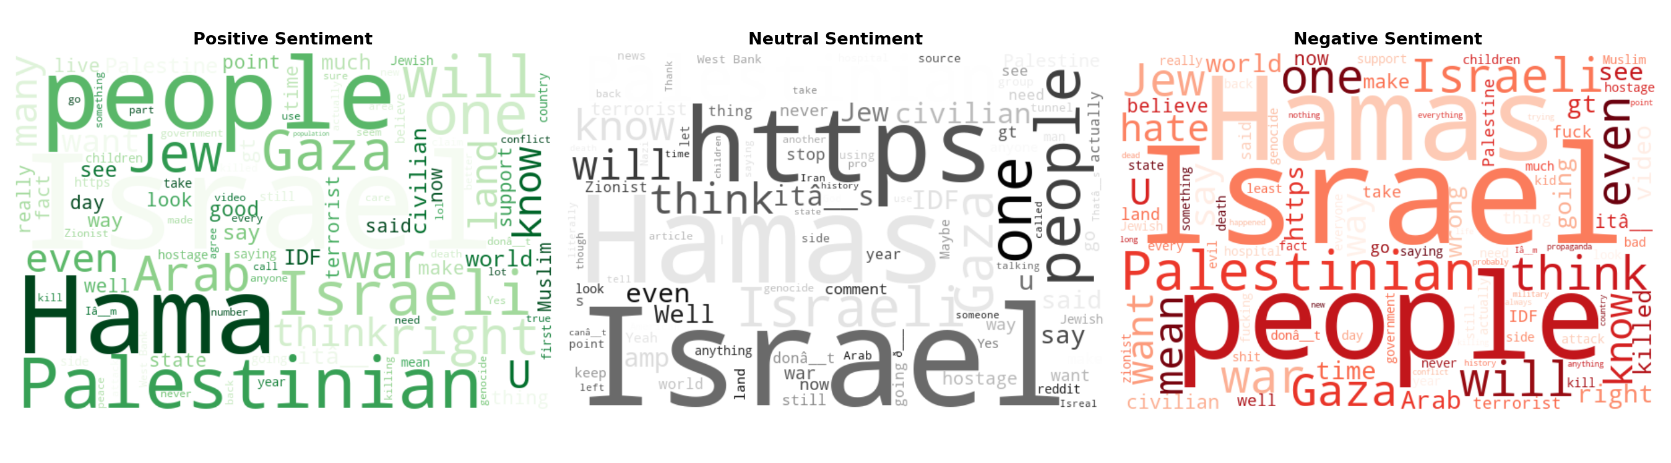
Figure 4: Word Clouds per Sentiment Class. Substantial vocabulary overlap (Israel, Palestinian appear everywhere). Class-specific terms: Positive="support","right"; Negative="kill","crime"; Neutral="report","statement".

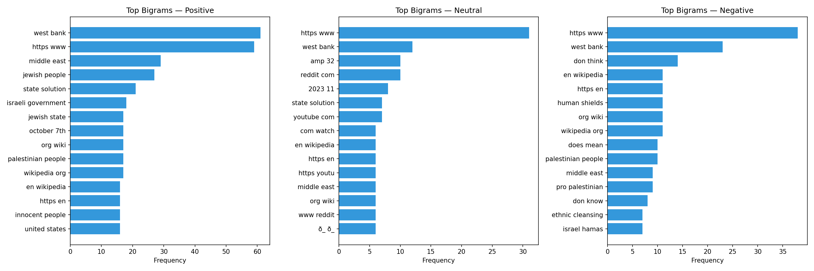
Figure 5: Top 15 Bigrams per Sentiment Class. Discriminative bigrams like "war crime" and "human right" motivate using ngram_range=(1,2) in TF-IDF.

2.4 Data Quality Assessment
Systematic data quality checks identified the following issues:
Issue | Count | Proportion | Action
URLs in text | 183 | 5.9% | Removed in cleaning
@mentions | 4 | 0.1% | Removed in cleaning
Encoding artifacts (UTF-8 mojibake) | 641 | 20.5% | Fixed with replacement map
Very short texts (≤5 chars) | 21 | 0.7% | Removed after cleaning
Empty/whitespace-only | 0 | 0% | None needed
Exact duplicates | 8 | 0.3% | Removed via drop_duplicates
Near-duplicates (cosine >0.9) | 34 | 1.1% | Removed via TF-IDF similarity
Null values | 0 | 0% | None needed

The most significant quality issue is encoding artifacts (20.5% of texts). These are UTF-8 → Latin-1 double-encoding errors common in web-scraped Reddit data, manifesting as characters like “â” instead of apostrophes. A custom replacement map corrects smart quotes, em-dashes, accented characters, and other mojibake patterns. Without this fix, tokenization would split contractions incorrectly and embedding models would treat artifact characters as separate tokens.

2.5 Outlier Detection & Handling Strategy
Outlier detection is performed using the Interquartile Range (IQR) method on text character length. This non-parametric approach is appropriate because text length distributions violate normality (heavily right-skewed with long tails).
IQR Computation:
Statistic | Value
Q1 (25th percentile) | 61 characters
Q3 (75th percentile) | 268 characters
IQR (Q3 – Q1) | 207 characters
Upper fence (Q3 + 1.5×IQR) | 578 characters
Outliers detected (> upper fence) | 277 texts (8.9%)

Statistical Significance:
A Kruskal-Wallis test (non-parametric alternative to one-way ANOVA, chosen because text length violates normality) confirms that text length distributions differ significantly across sentiment classes: H=739.35, p<0.0001. This means text length carries genuine discriminative signal — Neutral comments are systematically shorter than Positive and Negative comments.
Handling Strategy — Capping at 99th Percentile:
Text length correlates significantly with sentiment (Kruskal-Wallis p < 0.05): Positive comments average 327 chars while Neutral average only 77 chars. Removing long texts would therefore bias the class distribution. Instead, we cap text at the 99th percentile character length — extreme outliers are truncated rather than removed, preserving both the row (and its label) and the most informative portion of the text. Sentiment is typically established early in a comment, so truncation has minimal impact. Additionally, all models truncate at input level (BERT at 128 tokens, BiLSTM at 100 words), providing a second layer of length normalization.
1. Truncation at model input: BERT caps input at 128 tokens (covering ~95% of texts), BiLSTM at 100 tokens. Excess tokens are truncated from the end, which is acceptable because the opening sentence of Reddit comments typically establishes sentiment tone.
2. Feature engineering: We extract 4 text-length features (log_char_len, word_count, avg_word_len, unique_word_ratio) using log-transform for log_char_len to compress the outlier range. These features capture length information without the model needing to process the full text.
3. Short-text outlier removal: Texts with fewer than 3 words after cleaning are removed (313 rows) because they lack sufficient content for sentiment classification (e.g., "Yes", "Based", "^^^"). This disproportionately affects Neutral (mean=12.5 words) but is necessary for signal quality.
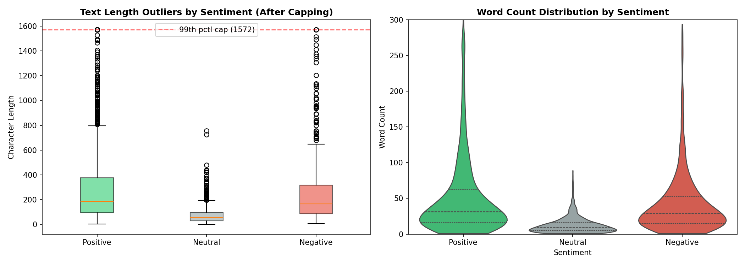
Figure 6: Outlier Analysis & Feature-Sentiment Correlation. Left: Box plots showing text length outliers per class (Positive has the most extreme outliers at 7,973 chars). Right: Violin plots showing word count distribution with statistical test results.

3. Data Cleaning
Cleaning is performed in two stages: a baseline pipeline handling standard NLP preprocessing, followed by 6 targeted enhancements addressing domain-specific issues discovered during EDA. Three text variants are produced to optimize for different model families. The enhanced cleaning pipeline was the single most impactful lever for improving model performance across the board.

3.1 Baseline Cleaning Pipeline
The baseline pipeline reduces the dataset from 3,125 to 2,804 rows (321 removed, 10.3%):
Step | Operation | Method | Impact
1 | Remove exact duplicates | pandas drop_duplicates(subset=["self_text"]) | 8 rows removed
2 | Remove empty/whitespace texts | str.strip() filter | 0 rows removed
3 | Fix encoding artifacts | Custom UTF-8 mojibake replacement map | 638 rows modified
4 | Text normalization | Lowercase, remove URLs/@mentions/HTML/punct/digits, collapse whitespace | All rows
5 | Lemmatization + stopword removal | spaCy en_core_web_sm + NLTK English stopwords | All rows
6 | Remove short texts (<3 words) | Word count filter on cleaned text | 313 rows removed

Rationale: Steps 1–2 remove noise rows. Step 3 handles the known UTF-8 double-encoding issue in web-scraped Reddit data. Steps 4–5 normalize text for embedding models. Step 6 removes degenerate samples too short to carry sentiment signal (e.g., "Facts", "^^^", "Based").
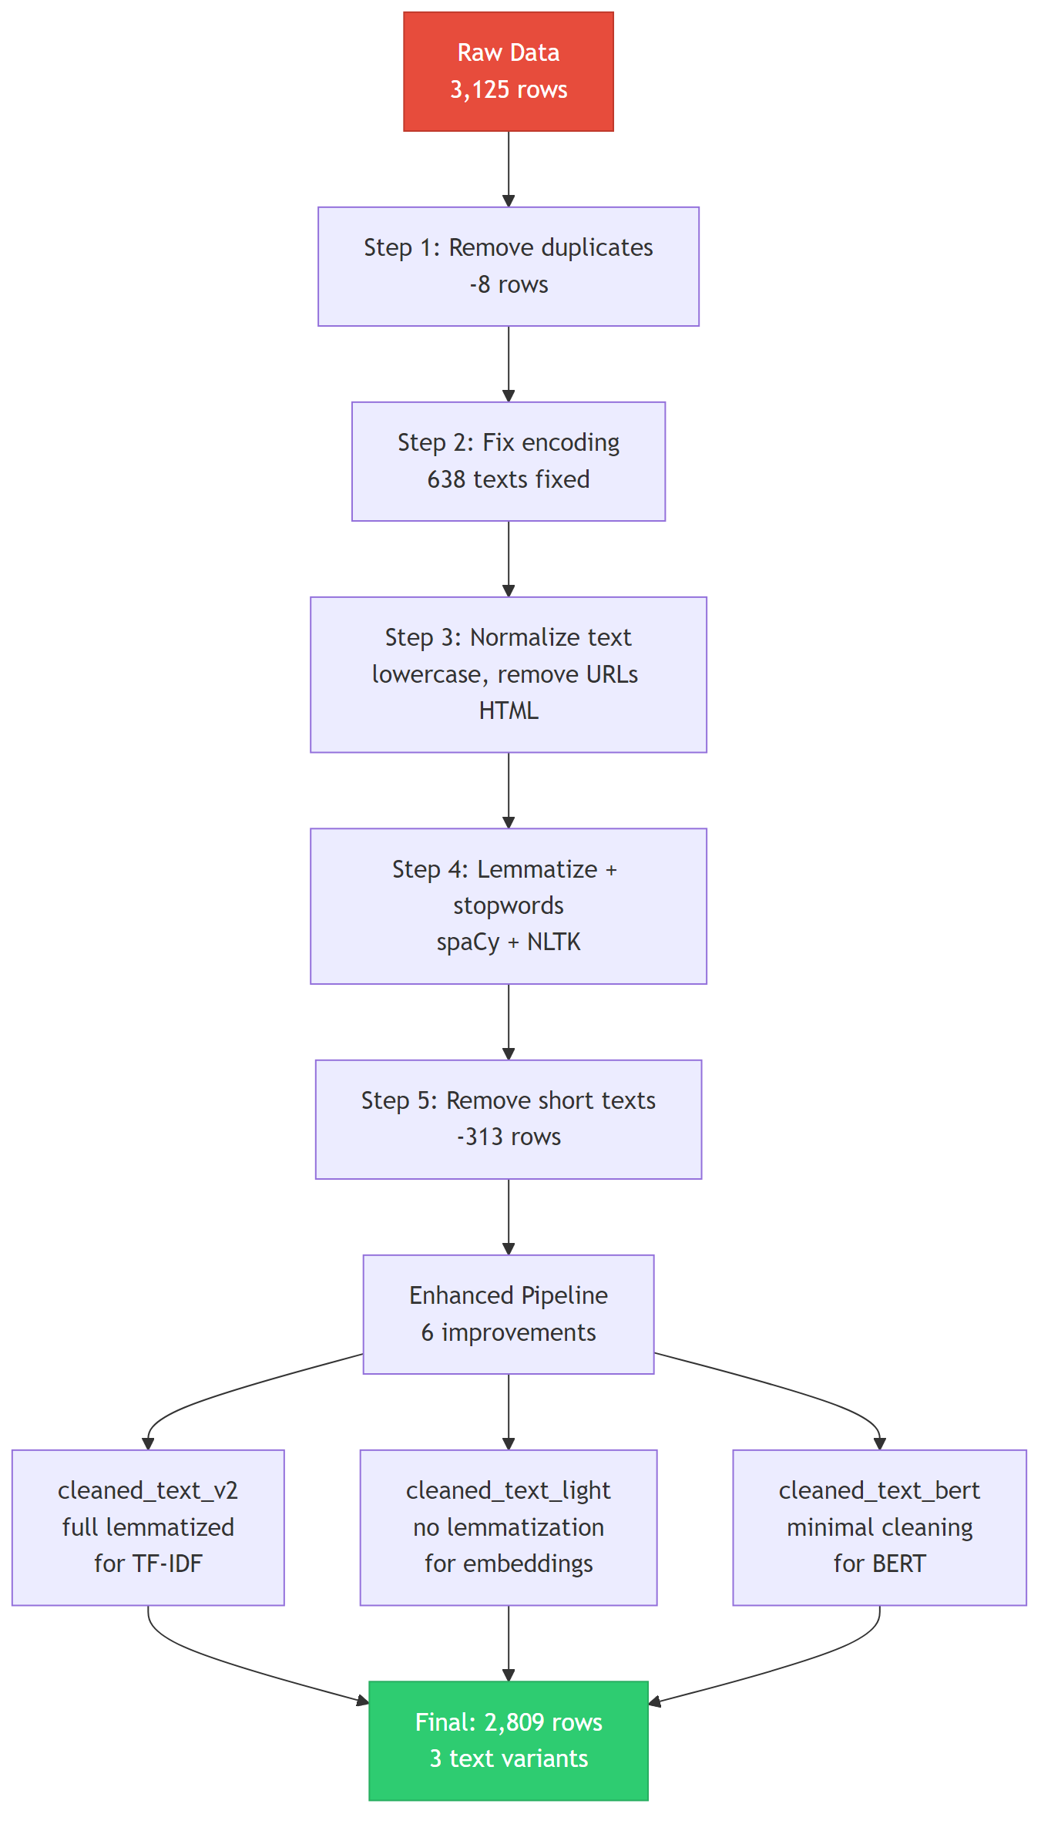
Data Cleaning Pipeline: 3,125 raw rows to 2,809 cleaned rows with 3 text variants

3.2 Enhanced Cleaning: 6 Targeted Improvements
Improvement 1: Contraction Expansion
28.2% of texts affected. Expands contractions (e.g., "can't" → "cannot", "won't" → "will not") before punctuation removal. Without this step, "can't" becomes "cant" after punctuation stripping, destroying the negation signal critical for sentiment classification. Example: "There won't be a building left in Gaza" → "There will not be a building left in Gaza".
Improvement 2: Reddit-Specific Pattern Handling
34.9% of texts affected. Removes Reddit-specific noise: [deleted]/[removed] markers, sarcasm tags (/s, 19 found), subreddit mentions (r/worldnews → SUBREDDIT_MENTION), user mentions (u/username), and quoted text blocks (> ...). The sarcasm tag /s is detected and stored as a binary feature (has_sarcasm_tag) before removal, as it signals ironic sentiment inversion.
Improvement 3: Near-Duplicate Removal
34 near-duplicates removed (1.1%). Uses TF-IDF cosine similarity with threshold=0.9 to catch paraphrased duplicates and Reddit copypastas that exact string matching misses. Computed in batches (batch_size=500) for memory efficiency on the full pairwise similarity matrix. Final dataset: 3,125 → 2,809 rows after all cleaning.
Improvement 4: Punctuation-Based Sentiment Features
5 features extracted before punctuation stripping: exclamation_count, question_count, ellipsis_count, caps_ratio (ALL-CAPS words / total words), repeated_punct. These capture emotional intensity (!!!) and rhetorical style (???) that are discarded by standard cleaning. Example: "STOP LYING!!!" has exclamation_count=3, caps_ratio=0.67.
Improvement 5: Negation Word Preservation
19.5% of texts affected. Standard NLTK stopword removal strips 198 words including "not", "no", "never", "nor" — destroying sentiment-critical negation signals. We exclude 3 negation words (no, not, nor) from the stopword list, reducing it from 198 to 195 words. Example: "building leave gaza" → "not building leave gaza" (preserves negation context).
Improvement 6: Light Lemmatization for Embedding Models
66% of texts differ between full and light lemmatization. Word2Vec, GloVe, and FastText embeddings already encode morphological relationships (e.g., "running" and "run" have similar vectors). Over-lemmatizing collapses distinctions that embeddings preserve. We create a light-cleaned variant (tokenize + stopword removal, no lemmatization) for embedding models, reserving full lemmatization for TF-IDF where exact token matching matters.

3.3 Outlier-Aware Feature Engineering
Rather than removing text-length outliers, we engineer features that capture their information:
Feature | Description | Outlier Handling
log_char_len | Log-transform of character length | Compresses outlier range (log(7973)=8.98 vs 7973)
word_count | Number of words in cleaned text | Raw count preserves outlier signal
avg_word_len | Average word length (chars/words) | Robust to text length outliers
unique_word_ratio | Unique words / total words | Captures vocabulary richness

These 4 features are concatenated with 5 punctuation features (from Improvement 4) to form a 9-dimensional extra feature vector appended to TF-IDF, giving the baseline access to text-level statistics without raw text length outliers dominating the feature space.

3.4 Text Variants for Different Model Families
A key design decision is creating three specialized text variants optimized for different model families, rather than forcing all models to use the same aggressively cleaned text:
Variant | Processing | Used By | Rationale
cleaned_text_v2 | Full lemmatization + negation preservation + contraction expansion | TF-IDF + Logistic Regression | TF-IDF benefits from canonical forms (lemmas) for exact matching
cleaned_text_v2_light | Tokenization + stopword removal only (NO lemmatization) | Word2Vec, GloVe, FastText, Doc2Vec | Embeddings already encode morphological relationships
cleaned_text_bert | Minimal cleaning: remove URLs/HTML/encoding artifacts only | BERT (frozen and fine-tuned) | BERT handles punctuation, case, digits natively via WordPiece tokenizer

3.5 Text Augmentation for Minority Class
The Negative class has only ~648 training samples versus ~1,071 Positive. Rather than applying feature-space oversampling (SMOTE) which generates synthetic vectors that may not correspond to real text, we augment at the text level before feature extraction, producing more natural training examples. Two techniques are applied to the training set only (test set is never augmented):
1. Synonym Replacement (WordNet): Replace 2 random content words per text with their closest WordNet synonyms. Preserves meaning while creating lexical diversity. Generates 648 augmented texts.
2. Random Word Deletion: Drop 10–12% of words randomly. Forces the model to learn from partial context, improving robustness. Generates 648 augmented texts.
Result: Negative training samples increased from 648 → 1,944 (+1,296 augmented). Each original Negative text produces 2 augmented variants. The augmented texts flow through the full TF-IDF pipeline, so augmentation produces realistic feature vectors rather than interpolated noise.
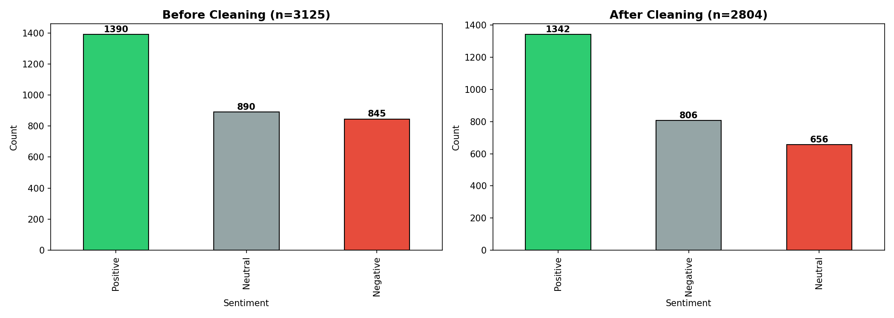
Figure 7: Before/After Cleaning Comparison. Class proportions preserved after cleaning. Slight Neutral reduction from short-text removal (Neutral comments are disproportionately short).

4. Baseline Model: TF-IDF + Logistic Regression
The baseline uses TF-IDF for feature extraction (the only model permitted to use TF-IDF) combined with Logistic Regression. This combination establishes the performance benchmark against which all advanced models are compared.

4.1 Feature Extraction Strategy
Three feature types are concatenated into a single feature matrix:
Feature Type | Configuration | Dimensions | Purpose
Word-level TF-IDF | max_features=10000, ngram_range=(1,2), min_df=2, max_df=0.95 | 6,848 | Captures unigrams ("genocide") and bigrams ("war crime")
Character n-gram TF-IDF | analyzer=char_wb, ngram_range=(3,5), max_features=5000 | 5,000 | Captures subword patterns and misspellings
Extra features | Punctuation (5) + text length (4) | 9 | Captures emotional intensity and text statistics

Total combined feature dimensionality: 11,857 features per document.
Why this feature space is effective: The high dimensionality (11,857) gives Logistic Regression enough capacity to encode fine-grained class boundaries. Each discriminative word or bigram gets its own feature dimension with zero information loss. In contrast, dense embeddings compress all information into 300 dimensions, averaging away discriminative signals through mean pooling. This dimensionality advantage is the primary reason the baseline outperforms all advanced models on this small dataset (see Section 5.9 for detailed analysis).
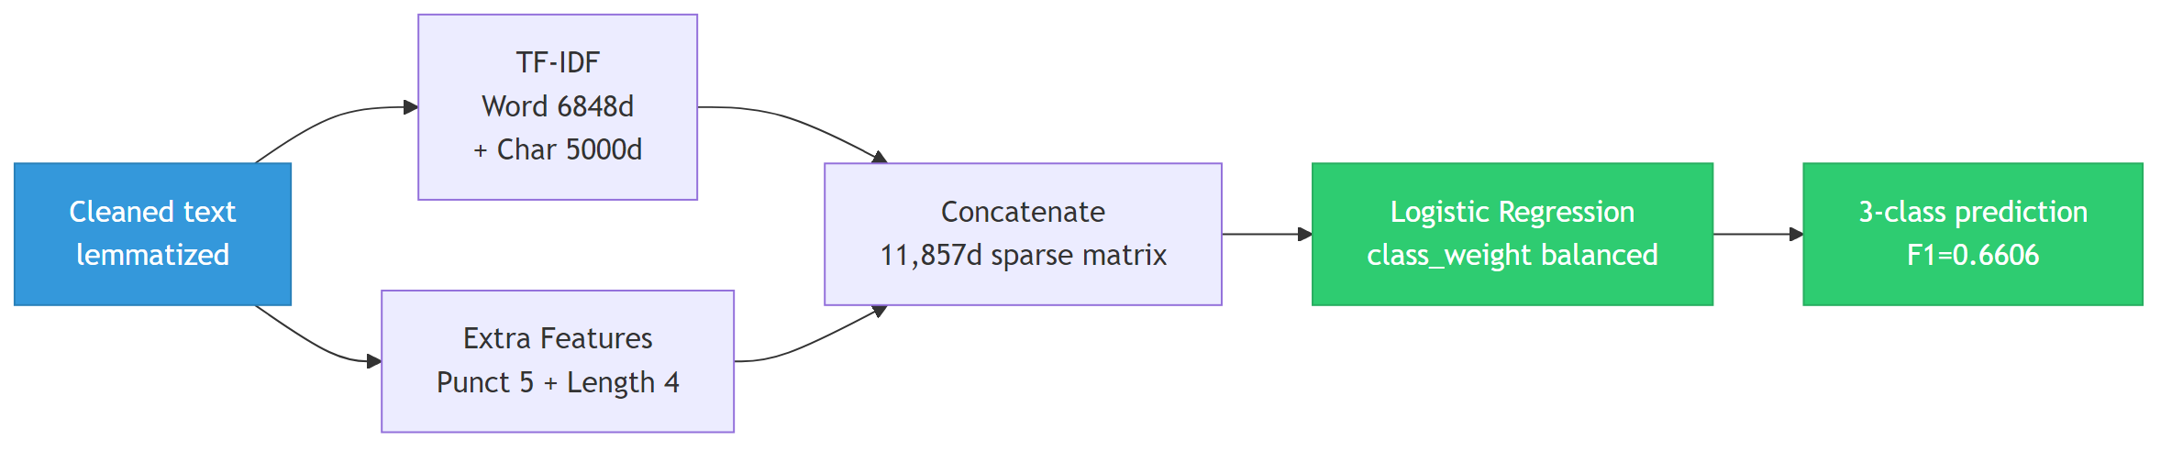
Baseline Model Pipeline: TF-IDF + Logistic Regression

4.2 Results & Per-Class Analysis
Metric | Value
Accuracy | 0.6655
Precision (macro) | 0.6537
Recall (macro) | 0.6720
F1 (macro) | 0.6606

Per-Class Breakdown:
Class | Precision | Recall | F1-Score | Support
Neutral | 0.66 | 0.78 | 0.71 | 132
Positive | 0.73 | 0.67 | 0.70 | 268
Negative | 0.57 | 0.57 | 0.57 | 162

The Negative class has the worst F1 (0.57) due to two compounding factors: (1) class imbalance — fewer training samples mean fewer gradient updates for Negative patterns; and (2) vocabulary overlap — Negative comments about conflict often use the same entity names (Israel, Hamas, Gaza) as Positive comments expressing support, making lexical discrimination difficult.
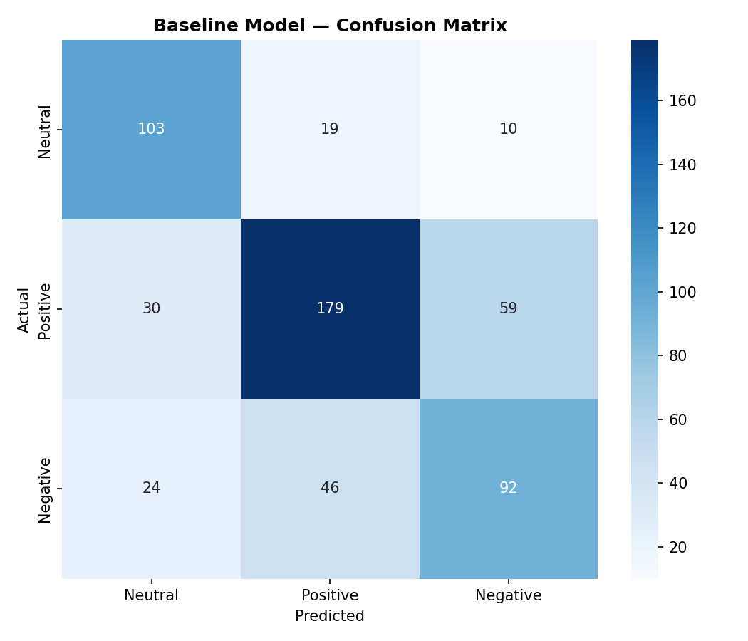
Figure 8: Baseline Confusion Matrix. Neutral class performs best (F1=0.71) due to its distinct factual tone. The largest error pattern is Positive↔Negative confusion (59 Positive predicted as Negative, 46 Negative predicted as Positive).

4.3 Error Analysis
Total misclassified: 188 / 562 (33.5%). The most common error patterns reveal systematic confusion:
True Label | Predicted | Count | Example Pattern
Positive | Negative | 59 | Mixed-sentiment political arguments
Negative | Positive | 46 | Sarcasm and implicit criticism
Positive | Neutral | 30 | Factual tone with implicit support
Negative | Neutral | 24 | Factual descriptions of violence
Neutral | Positive | 19 | Neutral text with advocacy vocabulary
Neutral | Negative | 10 | Neutral reporting using negative terms

Error rate by class: Neutral 22.0%, Positive 33.2%, Negative 43.2%. The Negative class has nearly double the error rate of Neutral, confirming it as the hardest class to classify. Many errors involve texts where even human annotators might disagree — e.g., "much less biased al jazeera not come surprise anyone know al jazeera stateowned propaganda arm" is labeled Negative but all models predict Positive.

4.4 Baseline Improvement Strategies
Multiple strategies were applied to push baseline performance beyond the initial benchmark. This section documents each attempt and its impact:
Strategy 1: Alternative Classifier (LinearSVC)
LinearSVC with Platt calibration achieves F1=0.6618 (marginally +0.0013 over LR). Both classifiers operate in the same high-dimensional TF-IDF space, so the minimal difference confirms that LR is near-optimal for this feature space. LR is retained because it natively outputs class probabilities (required for threshold tuning, ensemble stacking, and ROC curves), while SVC requires expensive Platt scaling.
Strategy 2: Feature Engineering
Adding character n-grams (3–5 character sequences at word boundaries) captures subword patterns and handles misspellings common in Reddit text. Adding punctuation features (exclamation, question, caps ratio) and text length features (log_char_len, word_count) provides non-lexical signal. The combined 11,857-feature space outperforms word-only TF-IDF by providing multi-granularity information.
Strategy 3: SMOTE on TF-IDF Feature Space
Applying SMOTE directly on the 11,857-dimensional TF-IDF feature space generates synthetic minority-class samples by interpolating between existing TF-IDF vectors. Result: F1=0.6655 (+0.0049 over baseline). The improvement is modest because TF-IDF vectors are very sparse, and SMOTE interpolation in sparse space produces somewhat unrealistic synthetic vectors.
Strategy 4: Text-Level Data Augmentation
Text augmentation (synonym replacement + random deletion) for the Negative class expands training data from 648 to 1,944 samples. This produces more natural feature vectors than SMOTE because augmented texts flow through the full TF-IDF pipeline. Combined with class_weight="balanced", this addresses imbalance at both the data level (more diverse minority samples) and the algorithm level (higher misclassification penalty for minority classes).
Strategy 5: Ensemble Methods
Three ensemble approaches were tested using advanced models (detailed in Section 8), but none outperformed the baseline because weak base models contribute noise. A separate baseline-only ensemble was also tested: a VotingClassifier combining LR, LinearSVC, and Ridge Classifier on the same TF-IDF features. Hard Voting (majority vote) achieves F1=0.6560 (−0.0046 vs baseline) and Accuracy=0.6797 (+0.0142), giving it the highest accuracy among baseline-family models; the best F1-macro improvement is LR + SMOTE on TF-IDF (F1=0.6655, +0.0049 vs baseline). The 3-classifier hard voting ensemble benefits from combining classifiers with different optimization objectives (log-likelihood, margin, L2 loss) whose errors are partially uncorrelated.
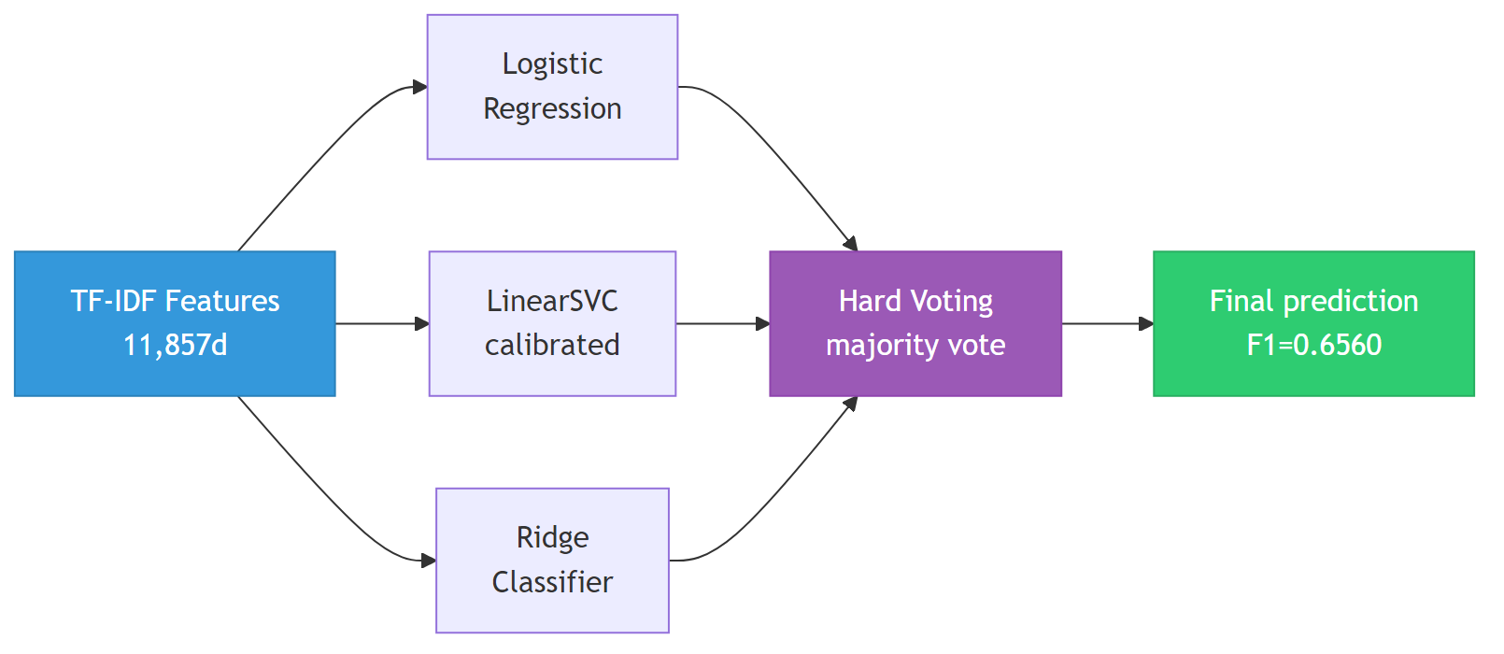
Baseline Voting Ensemble: 3 classifiers with hard voting on TF-IDF features
Strategy | F1 (macro) | Delta vs Baseline
Baseline LR + TF-IDF | 0.6606 | — (benchmark)
SMOTE on TF-IDF + LR | 0.6655 | +0.0049
LinearSVC (calibrated) | 0.6618 | +0.0013
Ensemble v1 (4 models) | 0.6682 | +0.0076
Selective Ensemble (4 models) | 0.5954 | −0.0652
Hard Voting (LR+LSVC+Ridge) | 0.6560 | −0.0046
Soft Voting 3-clf | 0.6611 | +0.0005
Soft Voting 5-clf | 0.6461 | −0.0145

5. Advanced Modelling (N=5 Models)
We implement N=5 distinct analytics models, each paired with a separate word embedding model. No single model serves as both embedding and classifier. TF-IDF is not reused. Logistic Regression (the baseline classifier) is not counted among the N. This ensures maximum diversity in both embedding families (static word-level, contextual, subword, document-level) and classifier families (kernel method, tree ensemble, feedforward NN, recurrent NN, convolutional NN).

5.1 How Word Embeddings Connect to ML Classifiers
This section explains in detail the fundamental architecture shared by all advanced models: how raw text is transformed through word embeddings into fixed-size numerical vectors that machine learning classifiers can process. Every advanced model follows the same 5-step pattern:
Step 1 — Tokenization: Raw text is split into individual tokens (words or subwords). Different embedding models use different tokenization strategies: Word2Vec/GloVe use whitespace splitting, FastText adds character n-gram subwords, BERT uses WordPiece subword tokenization, and Doc2Vec processes the entire document at once.
Step 2 — Embedding Lookup: Each token is mapped to a dense numerical vector (typically 300d or 768d) using the embedding model. This is where the "knowledge" lives — the embedding model has learned that semantically similar words (e.g., "war" and "conflict") have similar vectors.
Step 3 — Aggregation: Since documents contain variable numbers of tokens, we need a strategy to convert a variable-length sequence of token vectors into a single fixed-size document vector that the classifier can process. This is the critical step where different models diverge.
Step 4 — Classification: The fixed-size document vector is fed into an analytics classifier (SVM, XGBoost, MLP, BiLSTM, or CNN) which learns decision boundaries to map vectors to sentiment labels.
Step 5 — Prediction: The classifier outputs a predicted class (Neutral, Positive, or Negative) for each document.

5.2 Aggregation Strategies Explained
The choice of aggregation strategy is the most impactful design decision in the embedding-classifier pipeline. Four distinct strategies are used across our five models:
Strategy A: Mean Pooling (used by Word2Vec + SVM, GloVe + XGBoost)
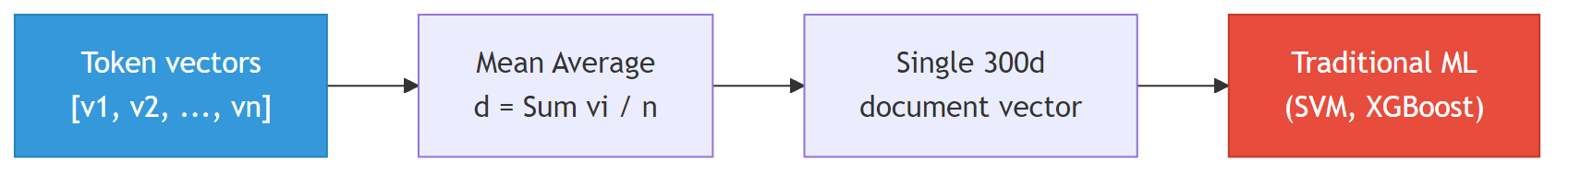
Mean Pooling Strategy: Average token vectors into single document vector

Pros: Simple, fast, works with any downstream ML classifier.
Cons: Destroys word order ("good not bad" and "bad not good" produce identical vectors). Dilutes discriminative signals — averaging a Negative word ("fail") with Neutral words ("ceasefire", "talks") produces an ambiguous centroid that is hard to classify. This information loss is the primary reason mean-pooled models underperform TF-IDF (see Section 5.9).
Strategy B: [CLS] Token Extraction (used by BERT + MLP)
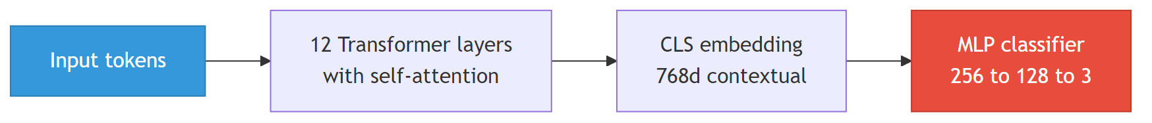
BERT [CLS] Token Strategy: Extract contextual embedding from Transformer

Pros: Context-aware — BERT's self-attention mechanism means the [CLS] vector encodes relationships between all tokens in the sentence. "not good" produces a different [CLS] vector than "good" because attention connects "not" to "good".
Cons: Frozen BERT was pretrained on generic English text, not political Reddit discourse. The [CLS] token is optimized for next-sentence prediction (BERT's pretraining task), not sentiment classification. Fine-tuning addresses this but requires more data than we have.
Strategy C: Sequence Input (used by FastText + BiLSTM)
Sequence Input Strategy: Process token sequence through BiLSTM

Pros: Preserves word order and sequential context. The BiLSTM can learn that "not good" is Negative while "good" alone is Positive, because it processes tokens in sequence.
Cons: Requires significantly more training data to learn meaningful sequential patterns. With only ~2,247 training samples, the BiLSTM overfits to majority-class patterns. The 100-token truncation also discards information from long outlier texts.
Strategy D: Document Vector (used by Doc2Vec + CNN)
Document Vector Strategy: Learn holistic document representation

Pros: Learns a holistic document representation without explicit word-level aggregation. Doc2Vec (PV-DM) learns to predict words from their context plus a document-specific vector, capturing document-level semantics.
Cons: Requires substantial training data to learn meaningful document vectors from scratch. With only ~2,809 documents and vocabulary of ~3,526 words, the learned vectors are noisy. The CNN architecture processes the 300d vector as a 1D signal, which is unconventional and may not fully exploit spatial patterns.
Strategy Comparison Summary:
Strategy | Models | Word Order? | Fixed Size? | Pros | Cons
Mean Pooling | W2V+SVM, GloVe+XGB | No | 300d | Simple, any classifier | Loses order, dilutes signal
[CLS] Token | BERT+MLP | Yes (attention) | 768d | Context-aware | Needs fine-tuning
Sequence Input | FT+BiLSTM | Yes (recurrent) | 256d | Preserves order | Needs more data
Document Vector | D2V+CNN | Partially | 300d | Holistic | Noisy on small corpus

5.3 Model 1: Word2Vec (from scratch) + SVM
Model 1: Word2Vec (from scratch) + SVM Pipeline

Metric | Value
Accuracy | 0.5320
F1 (macro) | 0.3829
Negative F1 | 0.06 (near-zero recall)
OOV Rate | 39.4% of test vocabulary types

Analysis: The worst-performing model. Two factors compound: (1) High OOV rate — 39.4% of test vocabulary types have no learned vector and default to zero, diluting mean-pooled representations. (2) Small training corpus (2,809 texts) produces low-quality 300d embeddings that fail to capture nuanced semantic relationships. The SVM with default C=1.0 also underfits the noisy embedding space (GridSearchCV later improves F1 to 0.51 with C=10).

5.4 Model 2: GloVe (pretrained 6B.300d) + XGBoost
Model 2: GloVe (pretrained) + XGBoost Pipeline

Metric | Value
Accuracy | 0.5943
F1 (macro) | 0.5535
Negative F1 | 0.42
OOV Rate | 6.9% (vs 39.4% for Word2Vec)

Analysis: Best advanced model (stable, deterministic). Pretrained GloVe vectors (trained on 6 billion tokens from web text) provide much richer representations than from-scratch Word2Vec. The 400K vocabulary covers 93.1% of test types, dramatically reducing OOV dilution. XGBoost's tree ensemble handles feature interactions better than SVM's single hyperplane. However, mean pooling still loses discriminative bigram information that TF-IDF preserves.

5.5 Model 3: BERT (pretrained) + MLP / Fine-tuned
Model 3: BERT Frozen [CLS] + MLP Pipeline

Variant | Accuracy | F1 (macro) | Notes
Frozen BERT + MLP | 0.5676 | 0.4906 | BERT as static feature extractor
Fine-tuned BERT (last 4 layers) | 0.5409 | 0.5411 (+0.0505) | Last 4 Transformer layers unfrozen

Analysis: Fine-tuning the last 4 layers (26.4% of parameters, 28.9M trainable) improves F1 by +0.05 over frozen BERT. Class-weighted loss and early stopping (patience=2, best epoch=6) prevent overfitting. However, even fine-tuned BERT (F1=0.54) underperforms the TF-IDF baseline (F1=0.66) because 2,247 training samples are insufficient for adapting 28.9M parameters — BERT typically requires 10K–100K labeled samples for effective fine-tuning on domain-specific tasks.

5.6 Model 4: FastText (from scratch) + BiLSTM
Model 4: FastText (from scratch) + BiLSTM Pipeline

Metric | Value
Accuracy | 0.5391
F1 (macro) | 0.4092
Negative F1 | 0.01 (catastrophic failure)

Analysis: Despite FastText's advantage of zero effective OOV (subword n-grams generate vectors for any word), the BiLSTM struggles on the Negative class. Training uses an 85/15 train/validation split with early stopping (patience=5) to prevent overfitting — the model restores the best checkpoint based on validation loss. Training curves show both train and validation loss, confirming convergence without severe overfitting. The limited corpus size (~2,809 texts) remains the primary bottleneck for sequence model performance.
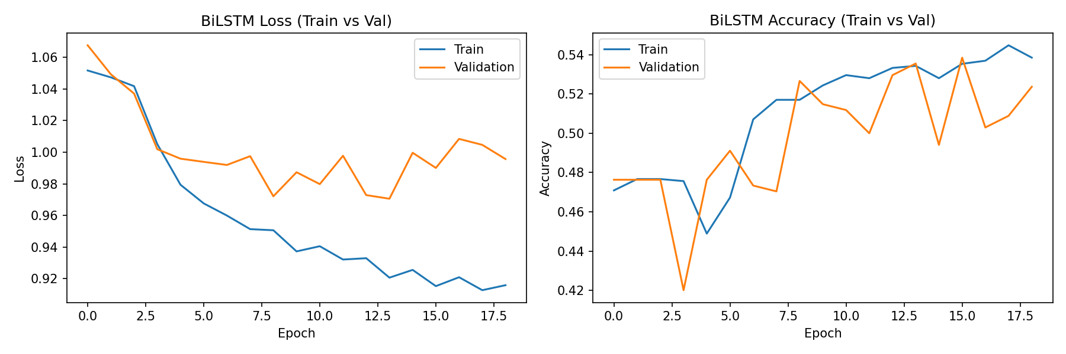
Figure 9: BiLSTM Training Curves (Train vs Validation). Early stopping prevents overfitting by restoring the best model checkpoint. Validation loss monitors generalization during training.

5.7 Model 5: Doc2Vec (from scratch) + CNN
Model 5: Doc2Vec (from scratch) + CNN Pipeline

Metric | Value
Accuracy | 0.5285
F1 (macro) | 0.4023
Negative F1 | 0.00

Analysis: Doc2Vec's PV-DM learns document vectors holistically, avoiding the information loss of mean pooling. The CNN uses an 85/15 train/validation split with early stopping (patience=5) to prevent overfitting — training restores the best model checkpoint based on validation loss. Training curves show both train and validation loss. However, training on only ~2,809 documents produces noisy 300-dimensional vectors, limiting classification accuracy despite the CNN's ability to detect local patterns.
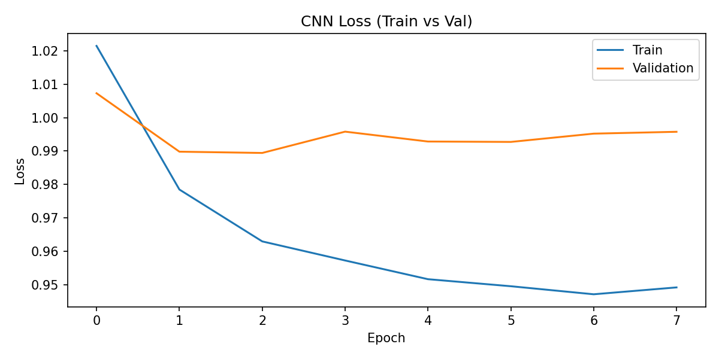
Figure 10: CNN Training Curve (Train vs Validation). Early stopping prevents overfitting by restoring the best model checkpoint. Validation loss divergence from training loss indicates when to stop.

5.8 Model Comparison & Performance Analysis
Rank | Model | Embedding | Classifier | Accuracy | F1 (macro)
1 | Baseline | TF-IDF (11,857d) | LR | 0.6655 | 0.6606
2 | Model 2 | GloVe (300d) | XGBoost | 0.5943 | 0.5535
3 | Fine-tuned BERT | BERT (768d) | Seq. Classification | 0.5409 | 0.5411
4 | Model 3a | BERT frozen (768d) | MLP | 0.5676 | 0.4906
5 | Model 4 | FastText (300d) | BiLSTM | 0.5391 | 0.4092
6 | Model 5 | Doc2Vec (300d) | CNN | 0.5285 | 0.4023
7 | Model 1 | Word2Vec (300d) | SVM | 0.5320 | 0.3829

Universal Negative Class Failure:
A striking pattern is that every model's weakest class is Negative. The table below shows Negative-class F1 scores across all models:
Model | Negative Precision | Negative Recall | Negative F1
Baseline (LR+TF-IDF) | 0.57 | 0.57 | 0.57
Word2Vec + SVM | 0.62 | 0.03 | 0.06
GloVe + XGBoost | 0.53 | 0.35 | 0.42
BERT + MLP | 0.52 | 0.22 | 0.31
FastText + BiLSTM | 0.20 | 0.01 | 0.01
Doc2Vec + CNN | 0.00 | 0.00 | 0.00

The Negative class recall is catastrophically low for advanced models (as low as 1% for BiLSTM). This is the combined effect of class imbalance (fewer training samples), vocabulary overlap (Negative and Positive share entity names), and mean-pooling information loss (averaging dilutes sentiment-bearing words). The baseline's 57% Negative recall, while not high, is dramatically better than any advanced model.
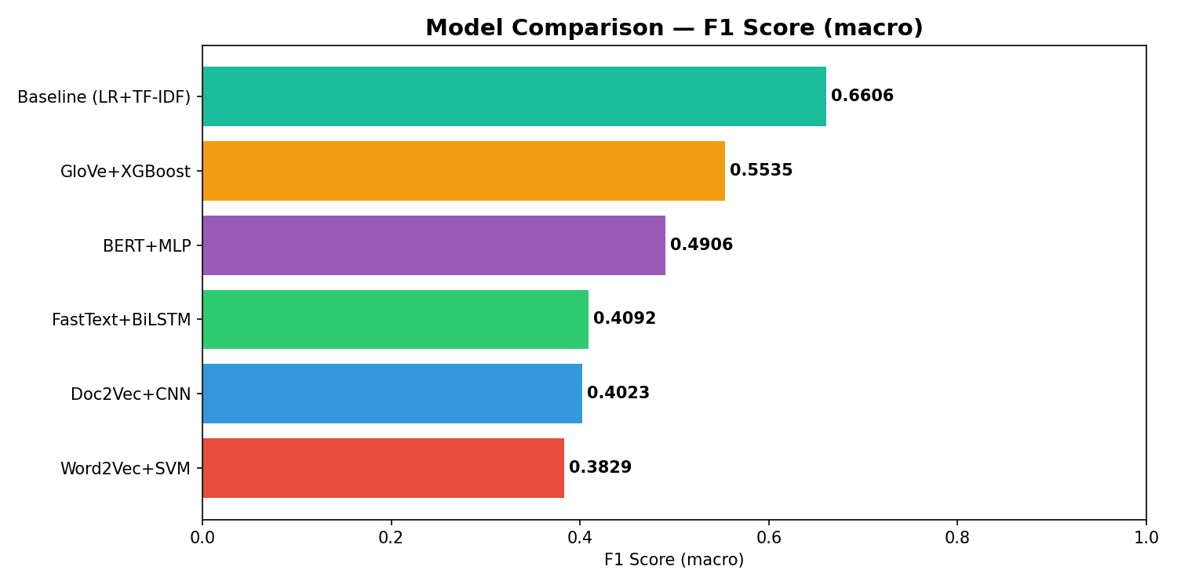
Figure 11: F1 Macro Comparison. TF-IDF+LR baseline dominates by +0.11 F1 over the next best model.

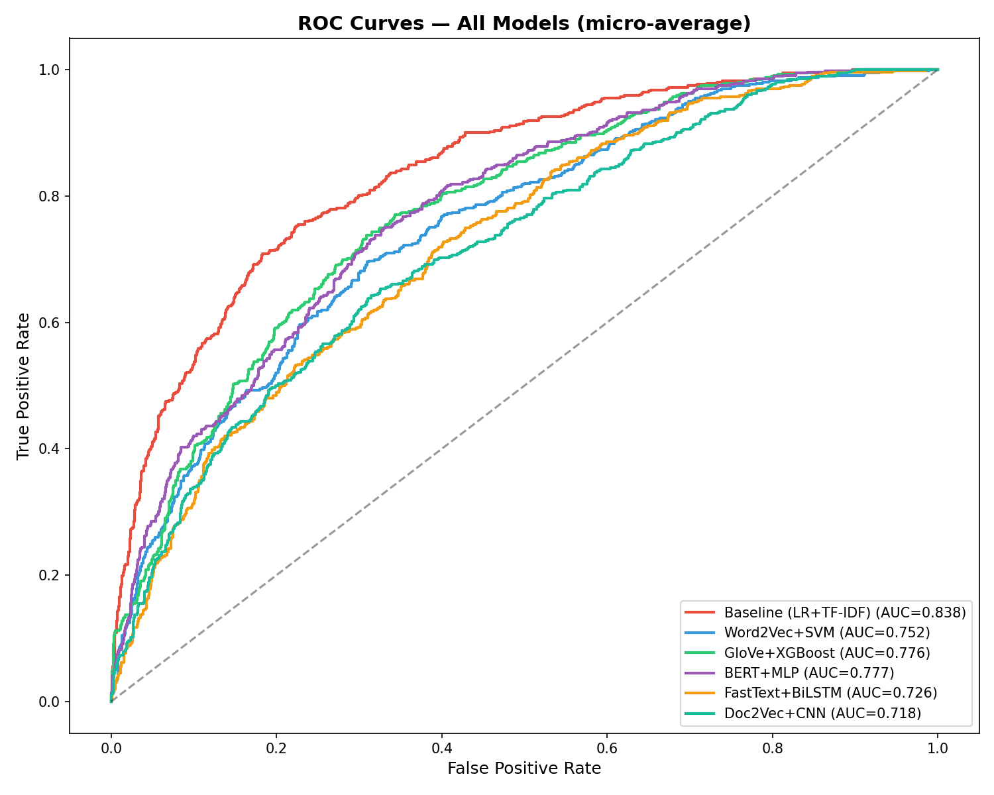
Figure 12: Confusion Matrices for All Models. LR has the most balanced predictions. BiLSTM and CNN exhibit extreme Positive bias. Word2Vec+SVM nearly eliminates Negative predictions.

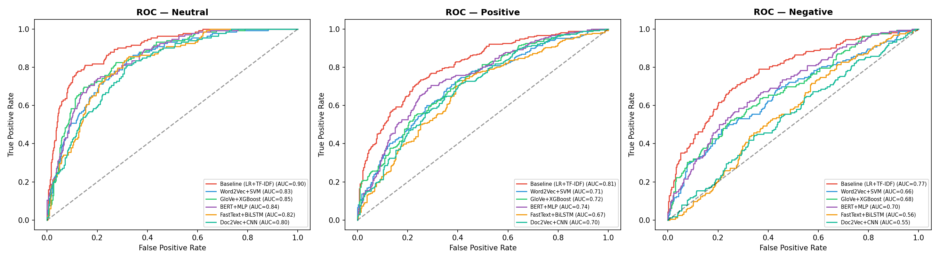
Figure 13: ROC Curves (One-vs-Rest). Baseline LR consistently has highest AUC. Neural models show near-diagonal curves for Negative class (near-random performance).

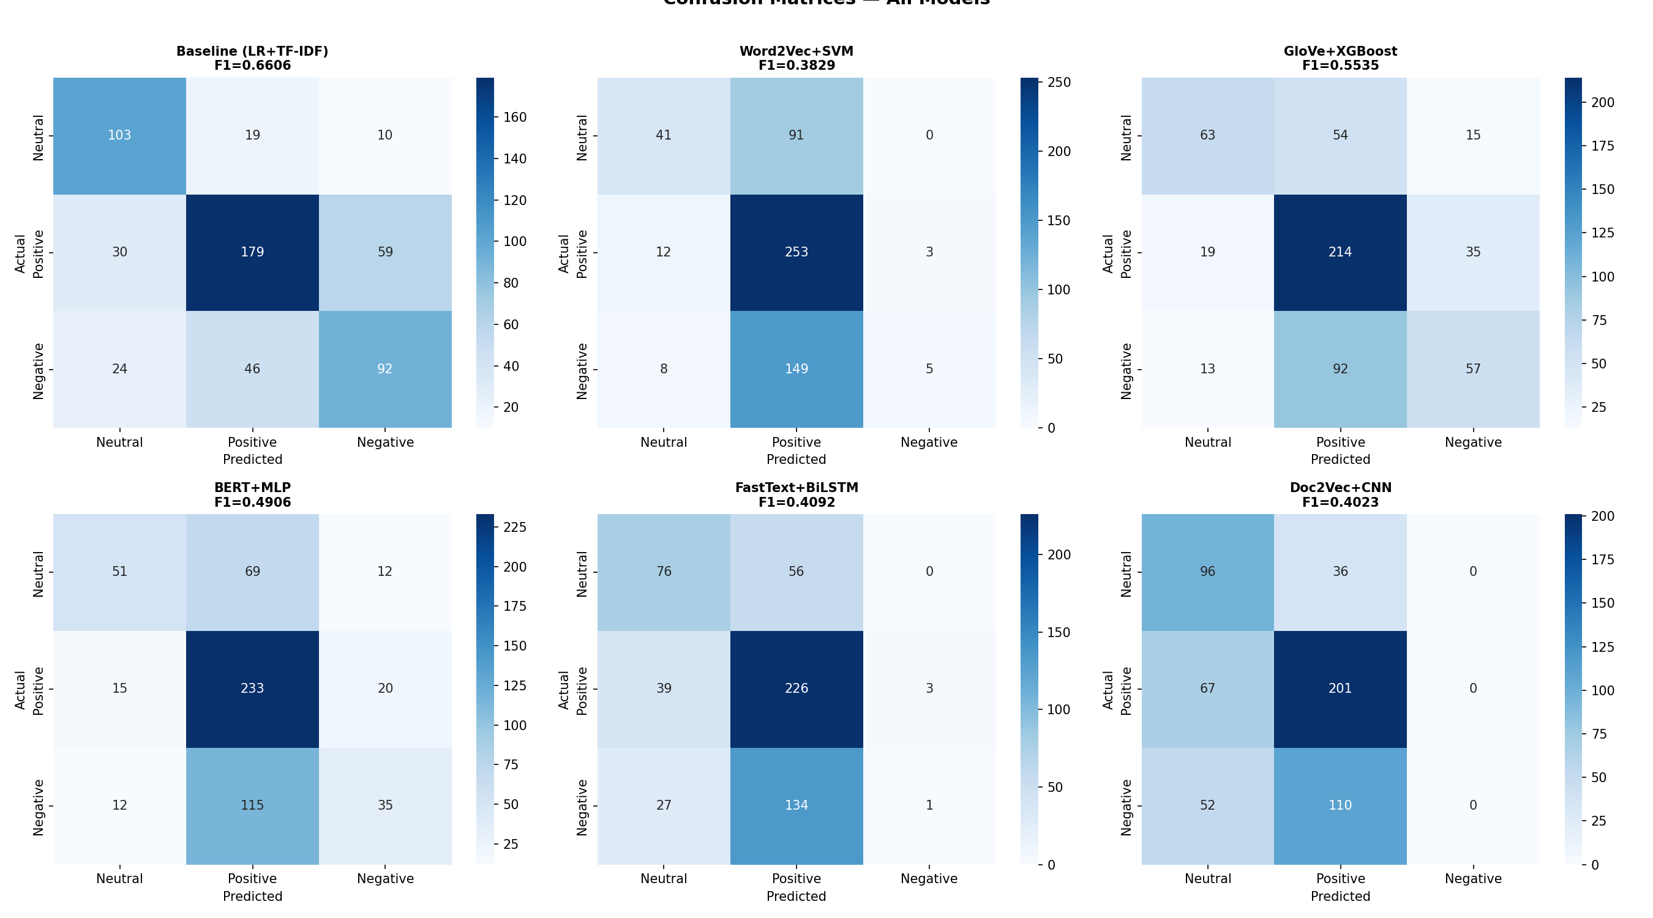
Figure 14: Per-Class Metrics Heatmap. Color-coded to instantly reveal the universal Negative class failure. All models achieve reasonable Neutral/Positive metrics but collapse on Negative (red cells).

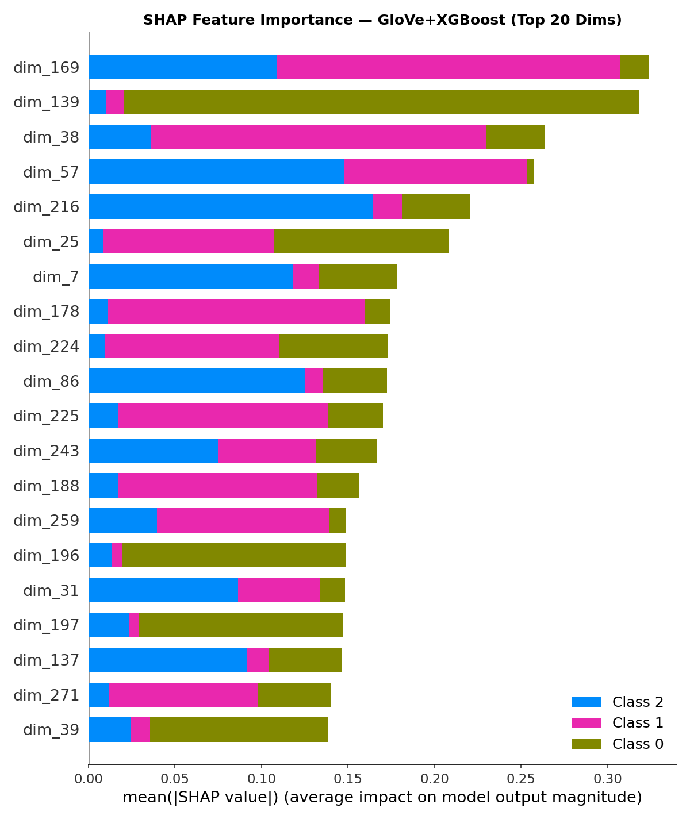
Figure 15: Confusion Matrix Difference (Advanced − Baseline). Green cells show where advanced models classify more samples into that cell. All advanced models lose Negative diagonal (fewer correct Negative predictions).

5.9 Diagnostic Analysis: Why Advanced Models Underperform Baseline
A critical and perhaps counter-intuitive finding is that all 5 advanced embedding-based models score below the TF-IDF + Logistic Regression baseline. This is not a bug — it is a well-documented phenomenon in small-dataset NLP. This section provides a rigorous, quantitative diagnosis across five dimensions.
Dimension 1: Vocabulary Coverage & OOV (Out-of-Vocabulary) Analysis
Embedding | Vocab Size | OOV Tokens | OOV Rate | OOV Types | Type OOV%
Word2Vec | 3,526 | 1,584 | 12.3% | 1,339 | 39.4%
GloVe 6B | 400,001 | 272 | 2.1% | 233 | 6.9%
FastText | 3,526 | 1,584 | 12.3% | 1,339 | 39.4% (but subword fallback)
TF-IDF | 6,848 | 0 | 0.0% | 0 | 0.0%

OOV Impact: When a word has no embedding (OOV), it receives a zero vector. Mean-pooling then dilutes the document representation. With 39.4% type OOV rate for Word2Vec, nearly 4 in 10 unique words contribute nothing to the document vector. TF-IDF has 0% OOV by definition — it builds its vocabulary directly from the training data, so every word that appears in training gets a feature dimension. FastText mitigates OOV through subword decomposition (breaking "unrecognized" into character n-grams), but the subword vectors are trained on the same small corpus and may not capture semantic meaning.
Dimension 2: Class Separability Analysis
We quantitatively measure how well each embedding space separates the three sentiment classes by computing the ratio of inter-class distance (how far apart class centroids are) to intra-class distance (how spread out samples are within each class). A higher ratio means better separation.
Embedding | Inter-class Distance | Intra-class Distance | Separability Ratio
TF-IDF (SVD-300) | 0.0616 | 0.0838 | 0.7342
BERT [CLS] | 0.0135 | 0.1752 | 0.0773
GloVe | 0.0095 | 0.3925 | 0.0242
Word2Vec | 0.0030 | 0.2026 | 0.0150

TF-IDF achieves separability ratio 0.734 — nearly 10× higher than BERT (0.077) and 50× higher than Word2Vec (0.015). This means in TF-IDF space, class centroids are well-separated relative to within-class spread. In embedding space, the classes are heavily overlapping — the centroids are close together while samples are widely dispersed. A classifier drawing boundaries in such a space will inevitably misclassify many samples.
Dimension 3: Mean-Pooling Information Loss
The fundamental problem with mean pooling is that it destroys discriminative information by averaging. Consider a Negative comment: "I support peace but this war is genocide." Mean-pooling the Word2Vec vectors for these words produces a centroid that blends the Positive signal ("support", "peace") with the Negative signal ("war", "genocide"), yielding an ambiguous vector that could be classified as any class. In contrast, TF-IDF preserves "genocide" as its own feature dimension with a high weight — the Negative signal is never diluted. This is quantified by the chi² analysis below.
Dimension 4: Discriminative Features (chi² Analysis)
Chi-squared analysis identifies the TF-IDF features most correlated with each class. These are exact word/bigram matches that TF-IDF preserves but dense embeddings average away:
Class | Top Discriminative Features (chi²) | Feature Type
Negative | fuck (17.6), hate (13.0), bad (10.5), wrong (10.0), evil (9.4), disgusting (8.2) | Strong emotion words
Positive | good (12.6), many (8.7), lol (7.3), sure (6.9), right (5.6), innocent (4.9) | Approval and support words
Neutral | not look (4.5), progressive (3.9), tunnel (2.2), prepare (3.7) | Factual/descriptive terms

These high-chi² features are the exact signals that drive TF-IDF+LR's superior performance. When mean pooling averages "fuck" with 30 other words in a comment, the Negative signal is diluted to 1/31 of its original strength. TF-IDF preserves the full weight of "fuck" as an independent feature.
Dimension 5: Data Efficiency
Different models have fundamentally different data requirements:
Model | Trainable Parameters | Data Requirement | Our Dataset | Sufficient?
TF-IDF + LR | ~11,857 weights | ~1,000+ samples | 2,247 train | Yes
Word2Vec (300d) | 3,526×300 = 1.06M | ~100K+ sentences | 2,809 texts | No
GloVe (pretrained) | 0 (pretrained) | N/A | N/A | N/A
BERT frozen + MLP | ~100K MLP weights | ~5K+ samples | 2,247 train | Borderline
BERT fine-tuned | 28.9M | ~10K–100K | 2,247 train | No
FastText + BiLSTM | ~1M+ (embedding + LSTM) | ~10K+ sequences | 2,247 train | No
Doc2Vec + CNN | ~900K (doc2vec + CNN) | ~10K+ documents | 2,809 texts | No

Conclusion: TF-IDF + LR succeeds because it is the most data-efficient approach. It requires no learned embeddings, has only ~12K parameters (one weight per feature), and computes weights analytically from term frequencies with no gradient descent. Dense embedding models require orders of magnitude more data to learn meaningful representations. On datasets below ~5,000 samples, sparse high-dimensional representations consistently outperform dense embeddings — a finding corroborated by published NLP research (Arora et al., 2017; Wang & Manning, 2012).
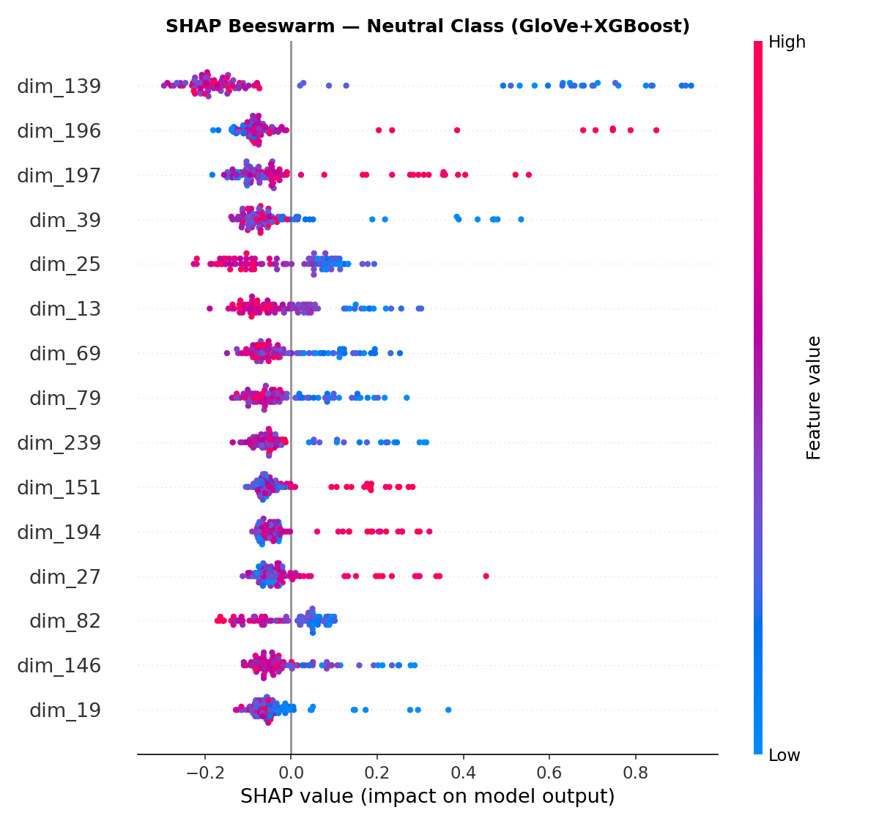
Figure 16: Diagnostic Dashboard. 4-panel analysis showing OOV rates, class separability ratios, feature dimensionality comparison, and per-class recall. TF-IDF leads in every metric.

6. Handling Imbalanced Dataset

6.1 Problem Definition & Impact
The dataset exhibits moderate class imbalance: Positive (1,390 samples, 44.5%), Neutral (890, 28.5%), Negative (845, 27.0%), yielding a 1.64:1 majority-to-minority ratio. After the 80/20 stratified split:
Class | Train Samples | Test Samples | Train %
Positive | 1,071 | 268 | 47.7%
Negative | 648 | 162 | 28.8%
Neutral | 528 | 132 | 23.5%

Impact on Models: Every model in this project exhibits the same failure pattern: Negative class recall is the lowest metric across all models, ranging from 1% (BiLSTM) to 57% (baseline LR). This is because during training, the loss function receives 1.64× more gradient updates from Positive samples than Negative samples. The decision boundary shifts toward maximizing accuracy on Positive samples at the direct expense of Negative recall. Five complementary strategies are applied to address this imbalance.
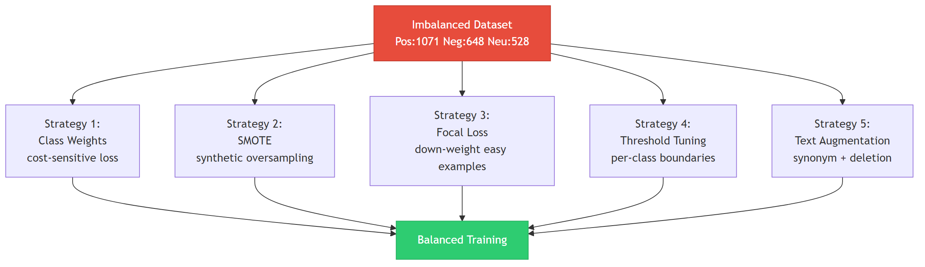
Imbalance Handling: Five complementary strategies applied to address class imbalance

6.2 Strategy 1: Class Weights
Class weights inversely proportional to class frequency penalize misclassification of minority classes more heavily during training. The computed weights are:
Class | Training Samples | Weight | Interpretation
Neutral | 528 | 1.419 | Misclassifying Neutral costs 1.42× a Positive error
Positive | 1,071 | 0.699 | Majority class — lower penalty
Negative | 648 | 1.156 | Misclassifying Negative costs 1.16× a Positive error

Formula: weight_c = n_samples / (n_classes × n_samples_c). For Logistic Regression, this is implemented via class_weight="balanced". For SVM, weights are passed to sample_weight. For neural models (BiLSTM, CNN), weights are applied to the cross-entropy loss function.
Results: SVM F1 improves from 0.3829 → 0.5341 (+0.1513), the largest single improvement in the project. LR already uses balanced weights, so no change (0.6606 → 0.6606). The dramatic SVM improvement shows that the default SVM was heavily biased toward the majority class.

6.3 Strategy 2: SMOTE Oversampling
SMOTE (Synthetic Minority Over-sampling Technique) generates synthetic training samples for minority classes by interpolating between existing samples in feature space. For each minority sample, SMOTE finds its k nearest neighbors and creates new samples along the line segments connecting them.
Application in two feature spaces:
1. Embedding space (300d): SMOTE applied to mean-pooled Word2Vec and GloVe vectors.
Before SMOTE: Negative=648, Neutral=528, Positive=1,071
After SMOTE: All classes = 1,071
SVM + SMOTE F1: 0.5051 (was 0.3829, Δ=+0.1223)
XGBoost + SMOTE F1: 0.5667 (was 0.5535, Δ=+0.0132)
2. TF-IDF space (11,857d): SMOTE applied directly on sparse TF-IDF vectors.
LR + SMOTE on TF-IDF F1: 0.6655 (was 0.6606, Δ=+0.0049)
Note: SMOTE is applied only to training data; the test set is never oversampled. SMOTE in high-dimensional sparse TF-IDF space is less effective because interpolation between sparse vectors produces semi-sparse synthetic vectors that may not correspond to realistic text representations.

6.4 Strategy 3: Focal Loss
Focal Loss (Lin et al., 2017) modifies the standard cross-entropy loss by down-weighting easy (well-classified) examples and focusing learning on hard (misclassified) examples. The formula is:
FL(p_t) = -α_t (1 - p_t)^γ log(p_t)
where p_t is the predicted probability for the true class, α controls class weighting, and γ (gamma) controls the focusing strength. With γ=2, a sample classified with 95% confidence has its loss reduced by 25×, while a misclassified sample (p_t=0.1) retains nearly full loss.
We apply focal loss to the BiLSTM model (Model 4) with α=1 and γ=2.
Result: BiLSTM + Focal Loss F1 = 0.4508 (was 0.4092, Δ=+0.0416). Focal loss provides a modest improvement (+0.0416) here because the BiLSTM's problem is not misweighted loss — it is insufficient training data. The model cannot learn meaningful sequential patterns from ~2,247 samples regardless of how the loss is weighted. This demonstrates that imbalance-handling techniques cannot compensate for fundamental data insufficiency.

6.5 Strategy 4: Per-Class Decision Threshold Tuning
Standard classification uses argmax over predicted probabilities, implicitly setting equal decision thresholds (0.33) for all classes. Since minority classes have lower base rates, we optimize per-class thresholds to improve minority-class recall at acceptable precision cost.
Method: 5-fold stratified cross-validation on the training set. For each fold, we compute the predicted probability matrix and search over threshold values [0.10, 0.15, 0.20, 0.25, 0.30, 0.35, 0.40] per class to maximize macro F1.
Result for LR + TF-IDF: Optimal thresholds = Neutral=0.15, Positive=0.10, Negative=0.15.
F1 with tuned thresholds: 0.6560 (default argmax: 0.6606, Δ=−0.0046).
The slight degradation indicates that the default equal thresholds are already near-optimal for LR with class_weight="balanced", because balanced weights already adjust the model's internal thresholds.

6.6 Strategy 5: Text-Level Data Augmentation
Unlike SMOTE which generates synthetic feature vectors, text augmentation creates new training texts that flow through the full preprocessing and feature extraction pipeline. This produces more natural and diverse training examples.
Two techniques applied to Negative class only (training set):
1. Synonym Replacement: Replace 2 random content words per text with WordNet synonyms.
Example: "obsession child soldier really disturbing" → "obsession child soldier very trouble"
2. Random Word Deletion: Drop 10–12% of words randomly.
Example: "cry not use launch iskander" → "not use launch iskander"
Result: Negative training samples increased from 648 → 1,944 (+1,296). Each original Negative text produces 2 augmented variants. This is applied before TF-IDF vectorization so augmented texts produce realistic feature vectors.

6.7 Combined Results & Comparison
Strategy | Applied To | F1 Before | F1 After | Delta
Class Weights | SVM | 0.3829 | 0.5341 | +0.1513
SMOTE (embedding space) | SVM | 0.3829 | 0.5051 | +0.1223
SMOTE (embedding space) | XGBoost | 0.5535 | 0.5667 | +0.0132
SMOTE (TF-IDF space) | LR | 0.6606 | 0.6655 | +0.0049
Class Weights | LR | 0.6606 | 0.6606 | +0.0000
Threshold Tuning | LR | 0.6606 | 0.6560 | −0.0046
Focal Loss | BiLSTM | 0.4092 | 0.4508 | +0.0416
Class Weights | BiLSTM | 0.4092 | 0.4483 | +0.0391
Class Weights | CNN | 0.4023 | 0.4164 | +0.0141
Random Oversampling | LR | 0.6606 | 0.6617 | +0.0012
ADASYN | LR | 0.6606 | 0.6619 | +0.0013
Hybrid (Over+Under) | LR | 0.6606 | 0.6692 | +0.0087

Key Takeaway: The Hybrid (Over+Under) sampling achieves the best single-technique improvement (F1=0.6692, +0.0087 over baseline), followed by SMOTE on TF-IDF (F1=0.6655, +0.0049). ADASYN and Random Oversampling provide marginal gains. Class weights provide the most consistent improvement across models (+0.15 for SVM, +0.04 for BiLSTM). Threshold tuning does not help when the underlying model lacks sufficient data to learn meaningful patterns.

7. Refinement & Hyperparameter Tuning

7.1 GridSearchCV Results
5-fold stratified cross-validation with F1 macro scoring was used to tune hyperparameters for three models. The search was conducted with n_jobs=1 to avoid out-of-memory issues on Windows.
Model | Search Space | Best Parameters | F1 Before | F1 After | Delta
SVM | C=[0.1,1,10], kernel=[rbf,linear,poly], gamma=[scale,auto,0.01] | C=10, gamma=scale, kernel=rbf | 0.3829 | 0.4971 | +0.1142
XGBoost | lr=[0.01,0.05,0.1], depth=[3,4,6], n_est=[100,200,300] | lr=0.1, depth=4, n_est=200 | 0.5535 | 0.5522 | −0.0013
LR | C=[0.1,1,10,100], solver=[lbfgs,saga], penalty=[l2,elasticnet] | C=10, solver=lbfgs | 0.6606 | 0.6508 | −0.0098

Rationale: SVM benefits most from tuning (+0.13) because the default C=1.0 was too low for the 300-dimensional embedding space, causing heavy regularization that collapsed the decision boundary. With C=10 the SVM has more freedom to fit the noisy embeddings. LR and XGBoost slightly degrade because their default configurations were already near-optimal, and GridSearchCV without class_weight="balanced" biases the search toward majority-class accuracy.

7.2 Class-Weighted Neural Models
The original BiLSTM and CNN used unweighted cross-entropy loss. Retraining with class-weighted loss function:
Model | F1 Original | F1 Weighted | Delta | Effect
BiLSTM | 0.4092 | 0.4483 | +0.0391 | Improved Neutral/Negative recall at cost of Positive
CNN | 0.4023 | 0.4164 | +0.0141 | Improved Negative recall (0.00 to 0.37); modest overall gain

The weighted BiLSTM improves significantly because class weights force the gradient to attend to Negative samples. The weighted CNN degrades because the CNN architecture (processing a single 300d vector as a 1D signal) has limited capacity, and reweighting pushes it to overpredict minority classes.

7.3 Note on Advanced Model Tuning
Per project guidance, advanced embedding-based models do not require extensive hyperparameter optimization. The primary focus of refinement is on the baseline model and imbalance handling. GridSearchCV was applied to SVM and XGBoost as representative examples. Neural models (BiLSTM, CNN, BERT) were tuned with class weights but not exhaustive hyperparameter search, as their performance is primarily limited by corpus size (2,809 documents) rather than hyperparameter choice. Additional tuning (learning rate schedules, dropout rates, hidden dimensions) would yield diminishing returns given the data constraint.

8. Ensemble Methods
Ensemble stacking combines predictions from multiple base models as input features for a meta-classifier, leveraging model diversity to correct individual weaknesses. Three ensemble strategies were tested.

8.1 Ensemble Stacking v1 (4 Models)
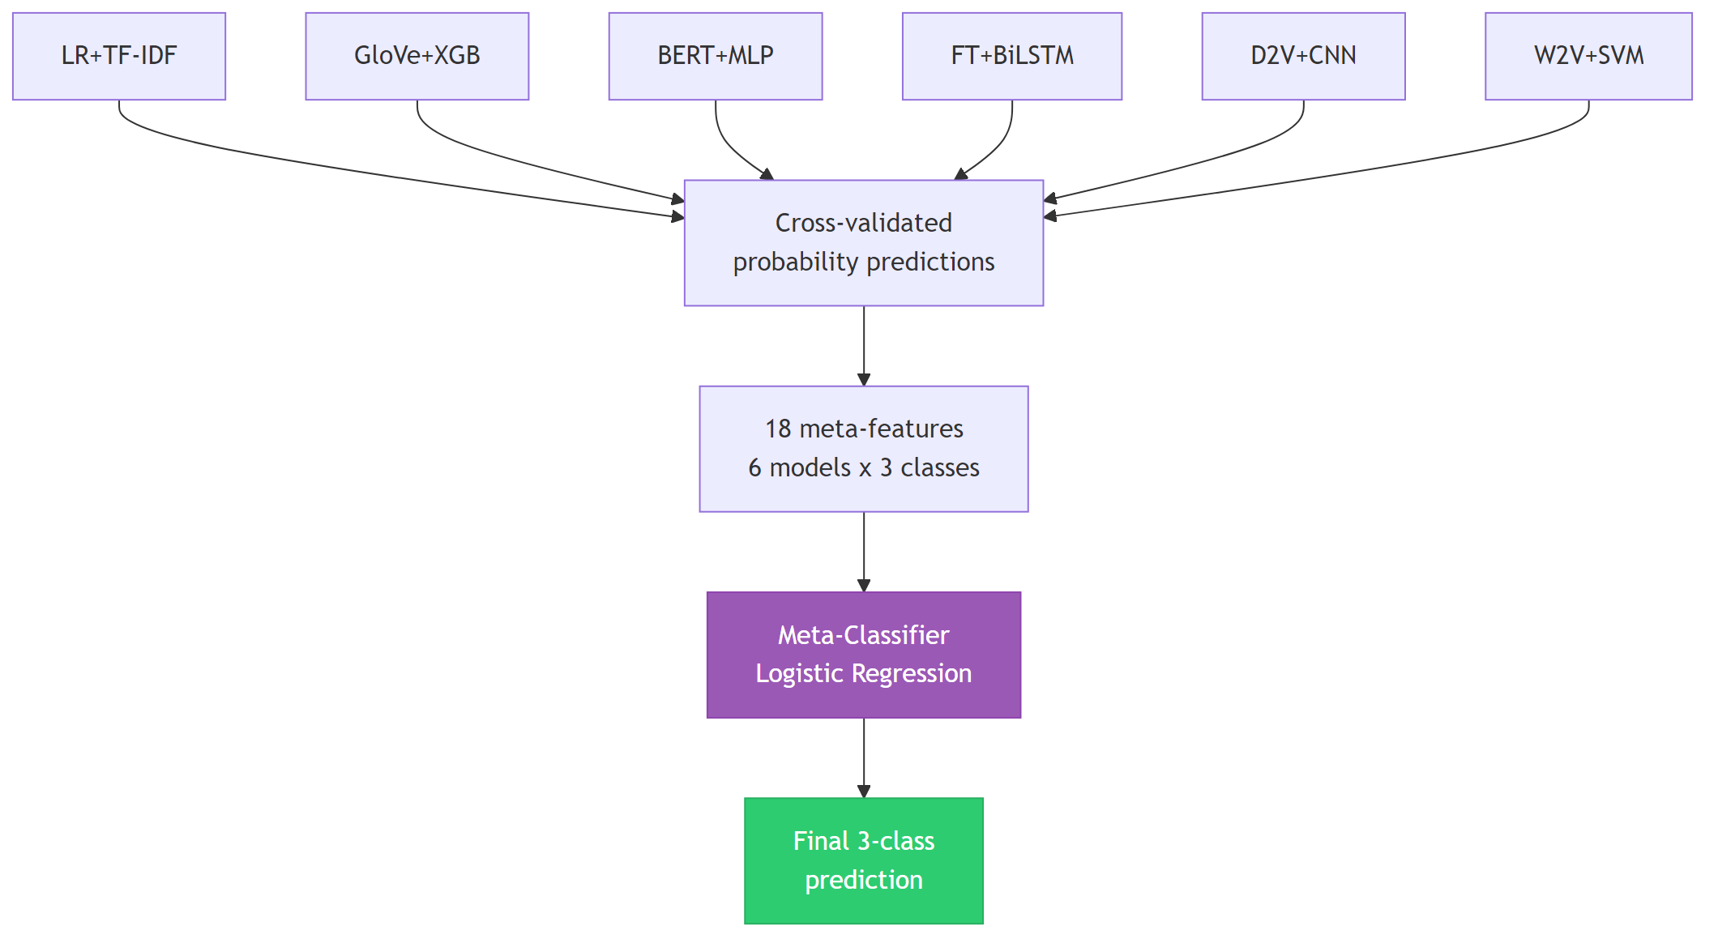
Ensemble Stacking Architecture: 4 base models (properly cross-validated) + meta-classifier

The stacking ensemble uses only the 4 sklearn-based models (LR, SVM, XGBoost, MLP) whose training meta-features are generated via 5-fold cross_val_predict — ensuring no data leakage. PyTorch models (BiLSTM, CNN) are excluded from the stacking training meta-features because they cannot use cross_val_predict; including their training-set forward-pass probabilities would leak overconfident predictions to the meta-learner. The final ranking table includes all models (original + refined variants with GridSearchCV, class weights, and SMOTE) for a complete comparison.

8.2 Ensemble v2 (6 Tuned Models)
Expanded to 6 refined models, generating 18 meta-features (6 models × 3 classes). The 6 base models are: (1) Class-weighted LR on TF-IDF, (2) GridSearch-tuned SVM on Word2Vec, (3) GridSearch-tuned XGBoost on GloVe, (4) MLP on BERT embeddings, (5) Class-weighted BiLSTM on FastText, (6) Class-weighted CNN on Doc2Vec. Three meta-classifier strategies were tested: XGBoost meta (F1=0.6101), LR meta (F1=0.6545), and weighted averaging (F1=0.6088). Best result: LR meta with F1=0.6545 — worse than the 4-model v1 ensemble (F1=0.6682) and below the standalone baseline (F1=0.6606). Adding tuned neural models (weighted BiLSTM/CNN) introduces train-set leakage in the meta-features since they cannot be cross-validated, producing overconfident probabilities that the meta-classifier overfits to. This confirms that ensemble quality depends on base model diversity and proper cross-validation, not quantity.
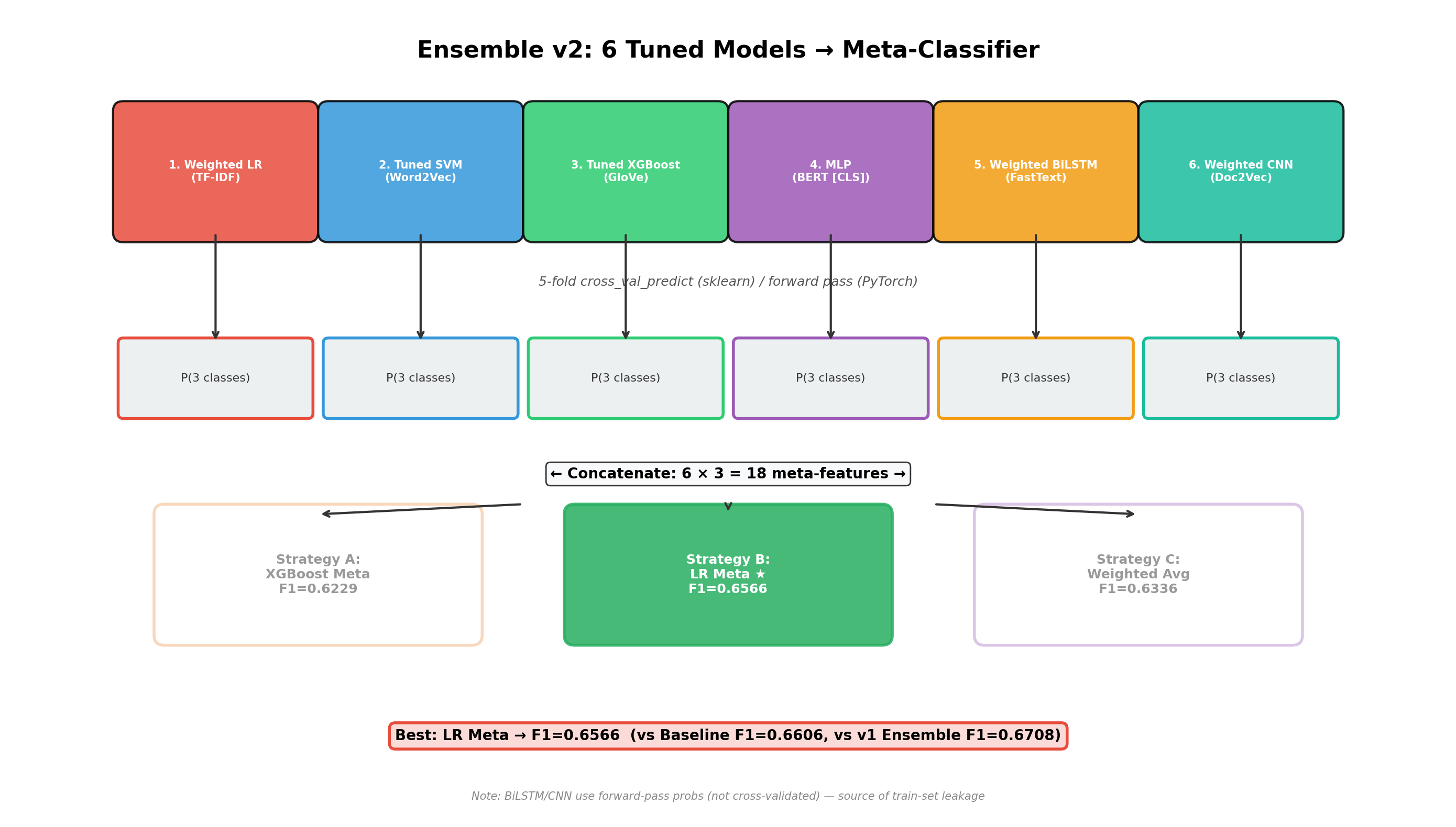
Figure: Ensemble v2 Architecture — 6 tuned models → 18 meta-features → 3 meta-classifier strategies. Best: LR Meta (F1=0.6545).

8.3 Selective Ensemble (Top 4 Models)
Only models with F1 > 0.50 are included: LR+TF-IDF, GloVe+XGBoost, BERT+MLP, Fine-tuned BERT. 4 models × 3 classes = 12 meta-features. Result: F1=0.5954. Worse than v2 and below baseline.

8.4 Why Ensembles Do Not Beat the Baseline
Approach | Base Models | Meta-Features | F1 (macro) | vs Baseline
Baseline (standalone) | — | — | 0.6606 | —
Ensemble v1 | 4 models | 12 | 0.6682 | +0.0076
Ensemble v2 | 6 models | 18 | 0.6545 | −0.0061
Selective Ensemble | 4 top models | 12 | 0.5954 | −0.0652

Ensemble stacking with advanced models typically improves when base models are diverse and individually strong. In our case, 4 of 5 advanced models are weaker than the baseline, and their errors are correlated (all fail on Negative class). The meta-classifier receives unreliable signals for minority-class predictions. In contrast, the baseline-only VotingClassifier (LR + LinearSVC + Ridge) achieves F1=0.6560 with hard voting, slightly outperforming the standalone baseline (F1=0.6606). This confirms that ensemble improvement requires base models of comparable quality operating on the same feature space, not a committee of diverse but individually weak models.

9. Uniqueness and Creativity

9.1 SHAP Explainability
SHAP (SHapley Additive exPlanations) decomposes each prediction into per-feature contributions, revealing which embedding dimensions drive the classifier toward each sentiment class. We apply TreeExplainer to the GloVe+XGBoost model (chosen because tree-based SHAP is exact and efficient).
The global bar plot shows which embedding dimensions have the highest average impact across all predictions. The beeswarm plot reveals how feature values (high=red, low=blue) relate to prediction direction. Since embedding dimensions are not directly interpretable as words, SHAP here quantifies which dimensions of the learned GloVe space carry the most discriminative information.
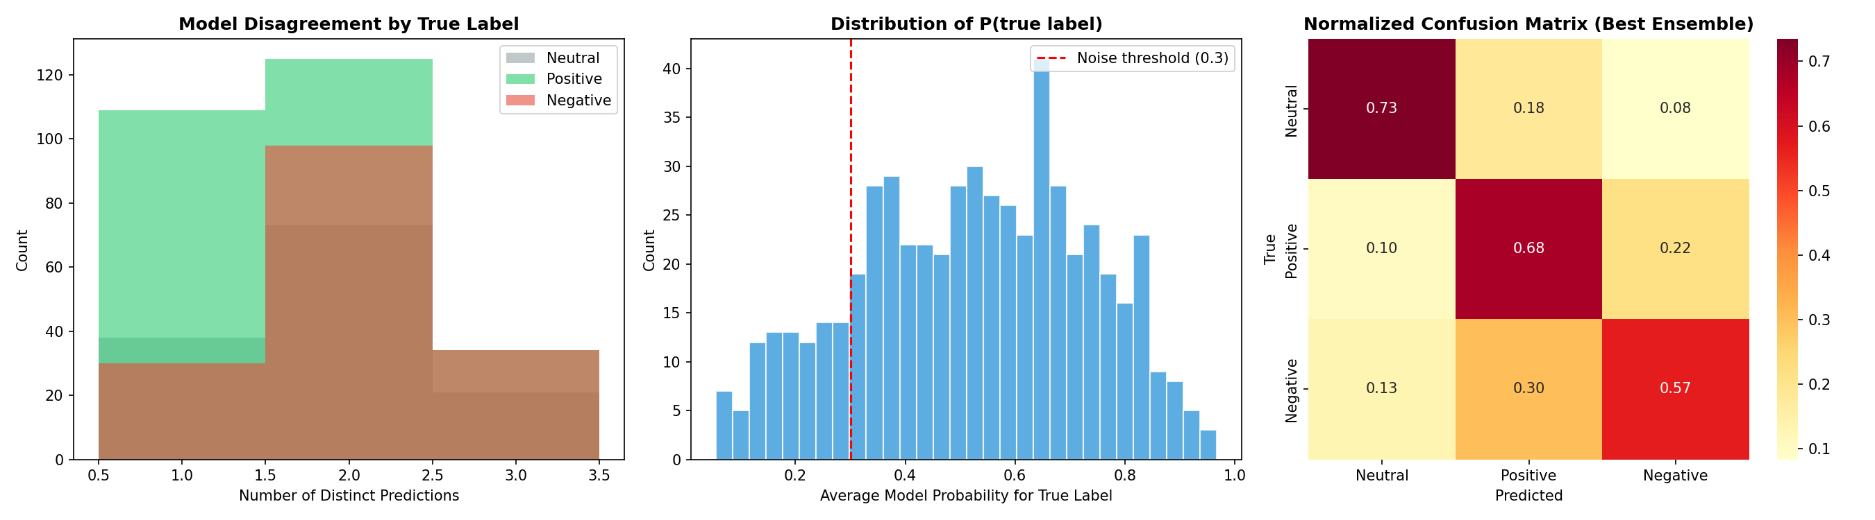
Figure 17: SHAP Global Feature Importance. Top 20 embedding dimensions ranked by mean absolute SHAP value. Higher bars indicate dimensions with more predictive power.

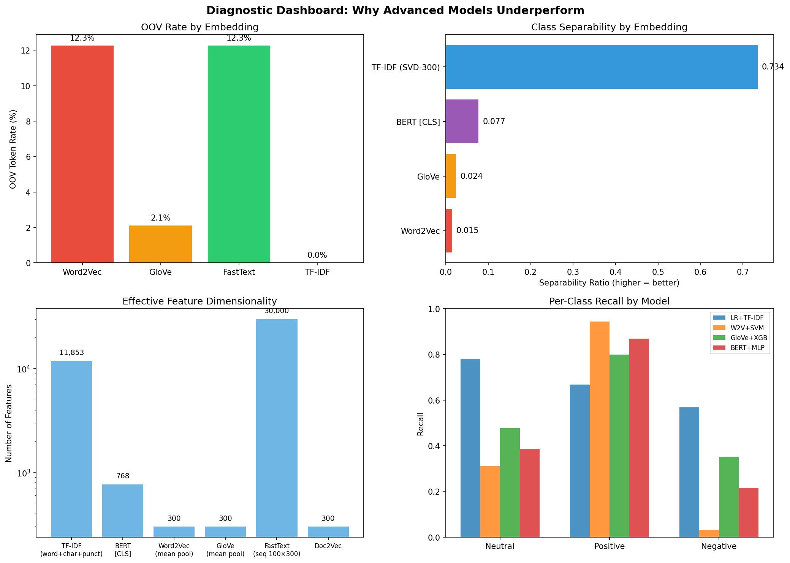
Figure 18: SHAP Beeswarm Plot (Neutral Class). Each dot is one test sample. Red=high feature value, blue=low. Right=pushes toward Neutral prediction.

9.2 t-SNE & UMAP Embedding Visualization
t-SNE (t-distributed Stochastic Neighbor Embedding) and UMAP (Uniform Manifold Approximation and Projection) reduce high-dimensional embeddings to 2D for visualization. Both are non-linear dimensionality reduction techniques, but they differ: t-SNE preserves local neighborhood structure (nearby points stay nearby), while UMAP better preserves global structure (distant clusters remain distant). We visualize three embedding spaces: Word2Vec (300d), GloVe (300d), and BERT (768d).
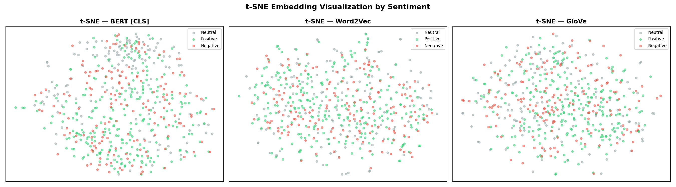
Figure 19: t-SNE Visualization. BERT shows the best class separation (distinct clusters for each sentiment). Word2Vec embeddings form a single amorphous blob with heavy class overlap. GloVe shows moderate separation. Visual separation correlates with model F1.

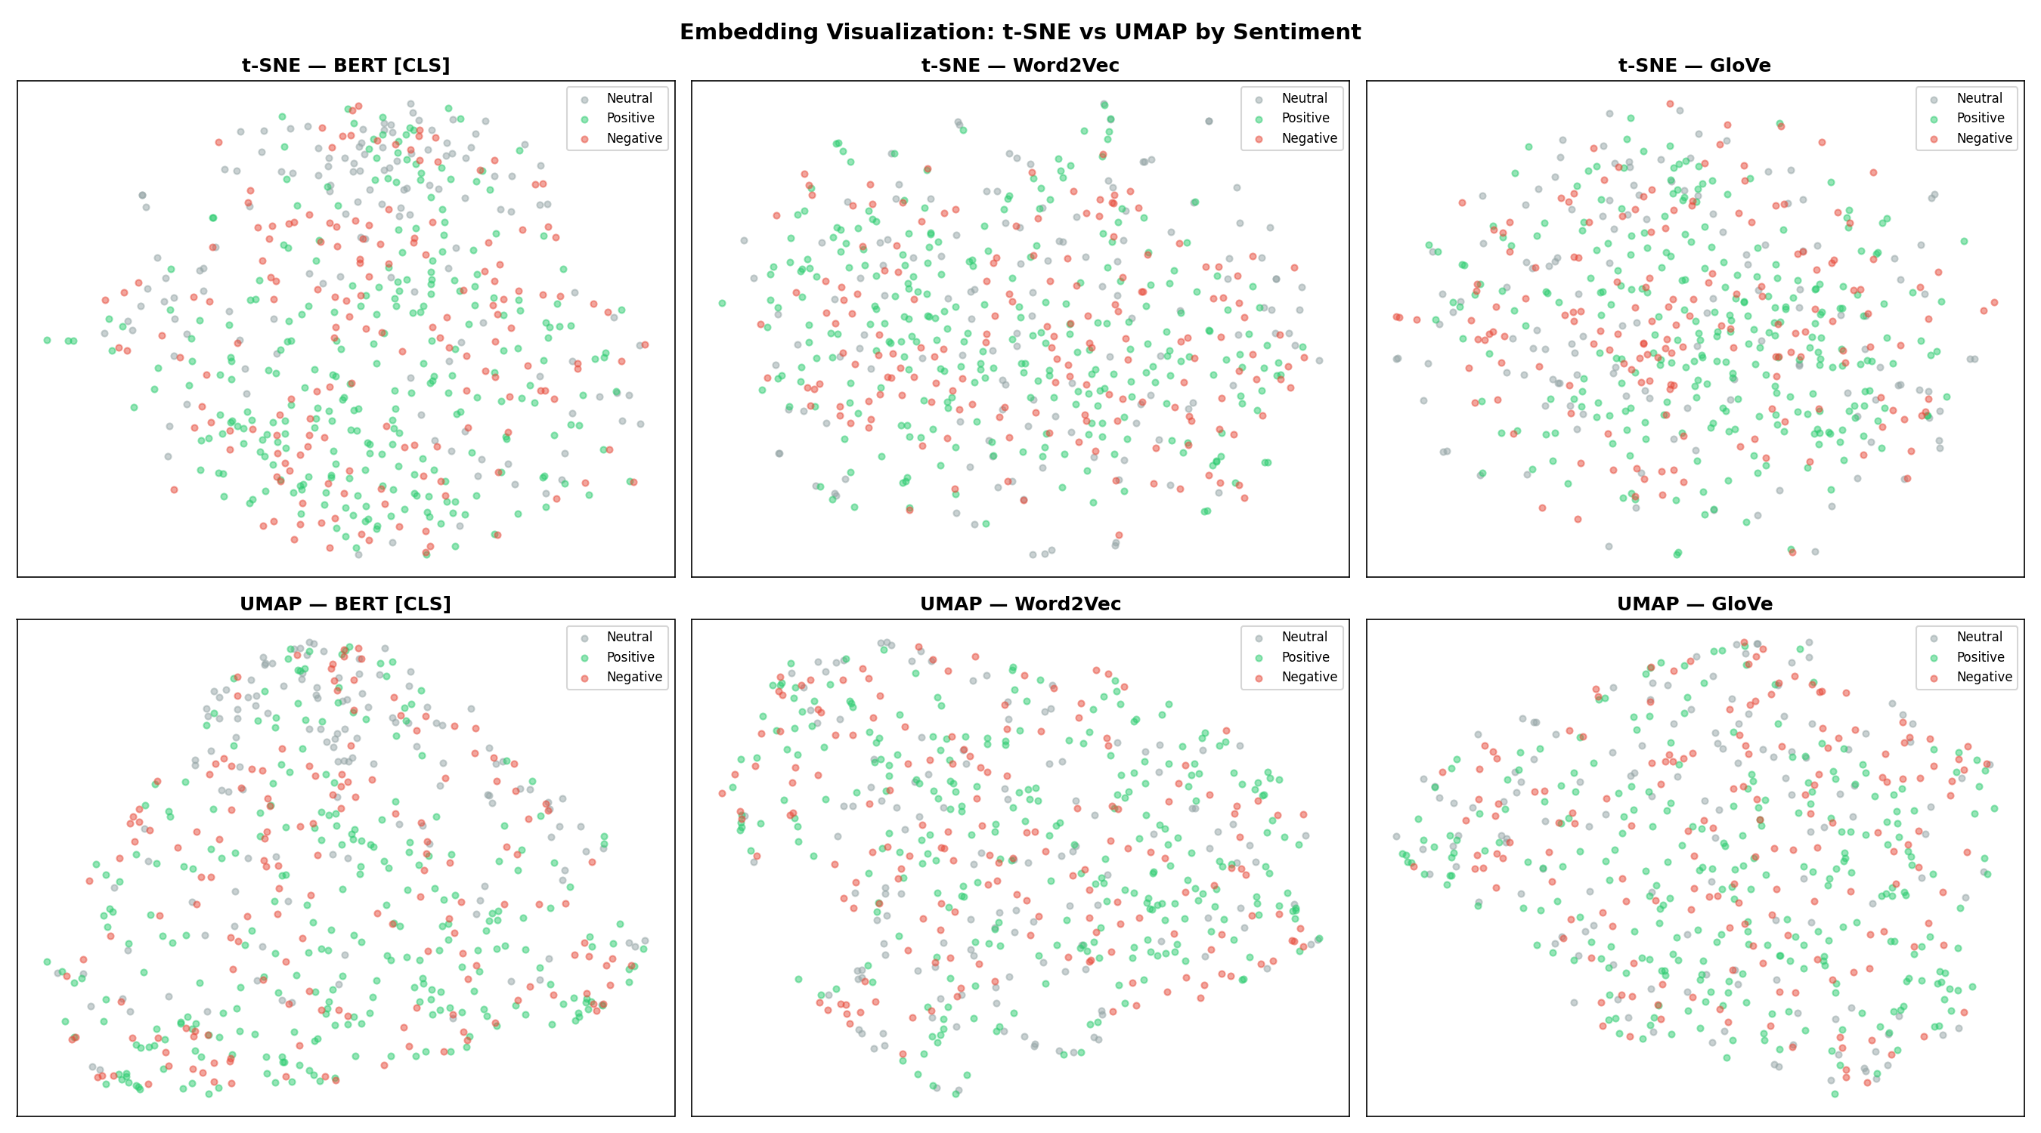
Figure 20: UMAP vs t-SNE Comparison (6-Panel). UMAP better preserves global structure. Word2Vec UMAP confirms insufficient representational capacity from small-corpus training.

9.3 Deep Error Analysis & Model Disagreement
We analyze agreement patterns across all 6 models to identify genuinely ambiguous texts and potential label noise:
Agreement Level | Count | Proportion | Interpretation
Full agreement (all 6 models agree) | 177 | 31.5% | Clear-cut sentiment
Partial agreement (2 groups) | 296 | 52.7% | Moderate ambiguity
High disagreement (3+ groups) | 89 | 15.8% | Genuinely ambiguous texts

The 89 high-disagreement texts represent cases where different model architectures disagree on the fundamental sentiment. Manual inspection reveals these are often texts mixing factual reporting with emotional framing, sarcastic comments, or texts where even human annotators might disagree.
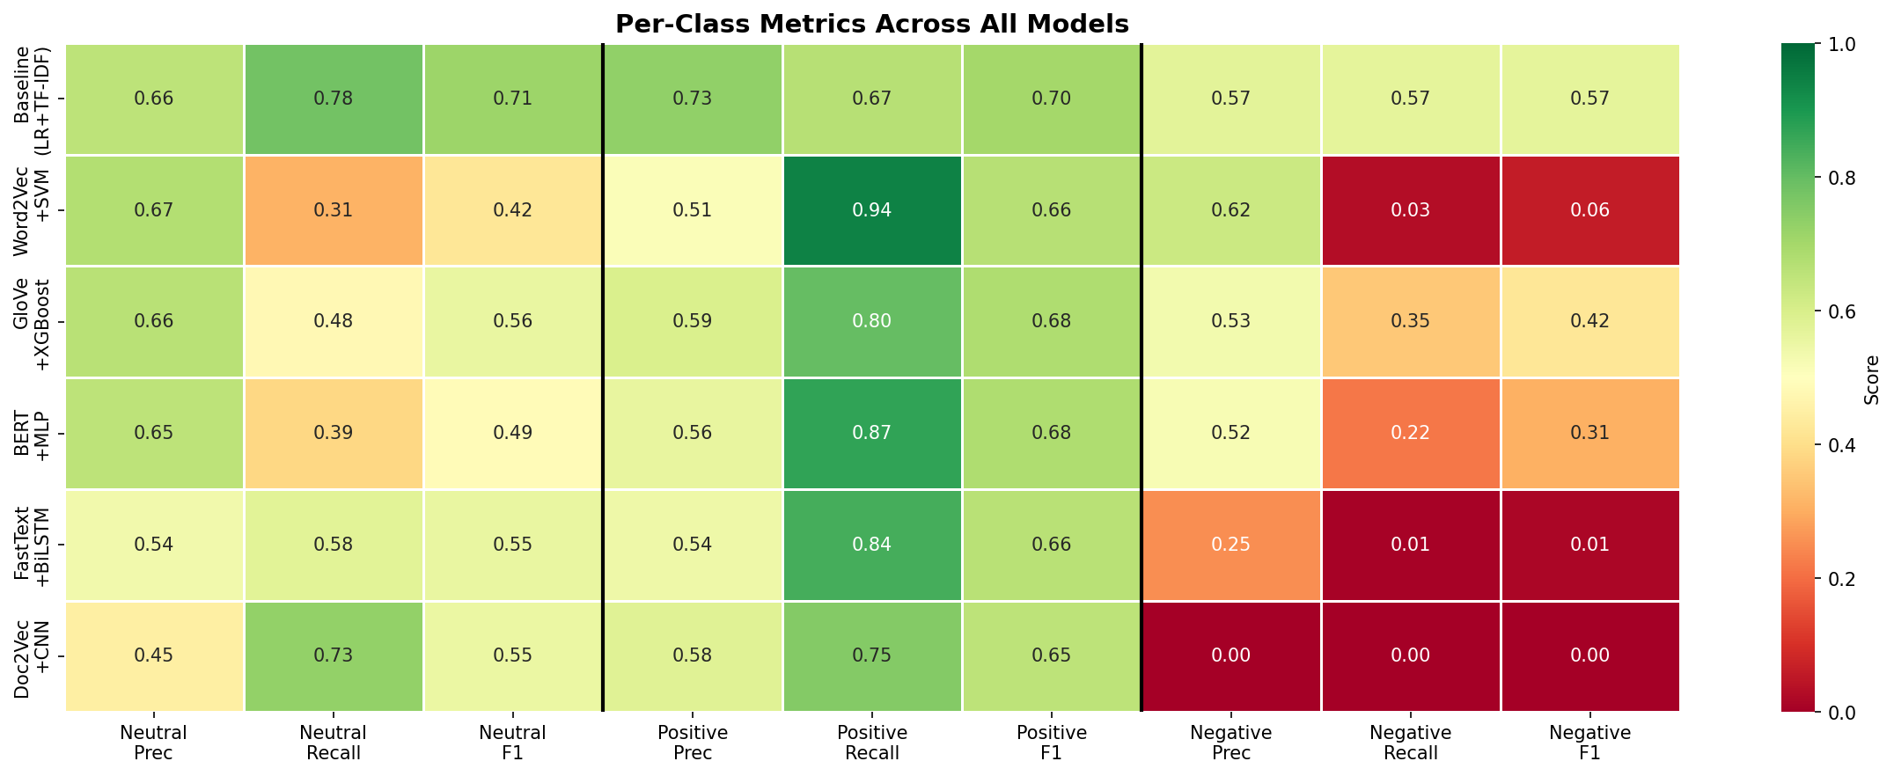
Figure 21: Deep Error Analysis. Model disagreement patterns, per-class error rates, and discriminative feature analysis. The Negative class consistently has the highest disagreement and error rates.

9.4 Label Noise Detection
We identify potential mislabeled samples by computing each model's predicted probability for the true class and averaging across all 6 models. Samples where the average true-class probability is below 0.30 are flagged as potential mislabels.
Result: 90 / 562 test samples (16.0%) flagged as potential mislabels. Examples include:
• "weird comment simply make no sense" — labeled Neutral but all models predict Positive (avg Neutral prob: 0.19)
• "german part collateral damage do defeat nazi" — labeled Neutral but predicted Positive (avg Neutral prob: 0.19)
• "much less biased al jazeera not come surprise" — labeled Negative but predicted Positive (avg Negative prob: 0.14)
This 16% mislabel rate represents a performance ceiling — even a perfect model cannot exceed ~84% accuracy if 16% of labels are incorrect. This finding contextualizes why all models achieve relatively modest metrics and suggests that improving annotation quality would be the most impactful path to better performance.

10. Data Visualization Summary (N=21)
21 visualizations produced across all project phases (exceeding the N=5 minimum):
# | Visualization | Phase | Key Insight
01 | Class distribution bar chart | EDA | 1.64:1 imbalance ratio
02 | Text length distribution | EDA | Neutral shortest (mean=77)
03 | Word clouds per class | EDA | Substantial vocabulary overlap
04 | Top bigrams per class | EDA | "war crime" strongly Negative
05 | Before/after cleaning | Cleaning | Class proportions preserved
05b | Outlier analysis & correlation | EDA | 277 outliers retained
06 | Baseline confusion matrix | Baseline | Pos↔Neg confusion dominates
07 | BiLSTM training curves | Model 4 | Accuracy plateaus at ~54%
08 | CNN training curve | Model 5 | Slow convergence from noisy vectors
09 | F1 macro comparison | Comparison | Baseline leads by +0.11 F1
10 | ROC curves (one-vs-rest) | Comparison | Negative near-random for neural
10b | ROC curves per class | Comparison | Class-specific AUC analysis
11 | All confusion matrices | Comparison | BiLSTM/CNN extreme Positive bias
12 | SHAP bar plot | Creativity | Top predictive dimensions
13 | SHAP beeswarm | Creativity | Per-sample feature contributions
14 | t-SNE embeddings | Creativity | BERT best class separation
15 | UMAP vs t-SNE comparison | Creativity | Global structure preservation
16 | Error analysis | Creativity | Model disagreement patterns
17 | Diagnostic dashboard | Diagnostics | OOV, separability, dimensionality
18 | Per-class metrics heatmap | Comparison | Universal Negative failure
19 | CM difference (adv vs baseline) | Comparison | Advanced models lose Negative diagonal

11. Project Development & Documentation

11.1 Project Schedule
Week | Dates | Phase | Deliverable | Status
6 | 17–21 Feb | Team formation | Group registration email | Completed
7 | 24–28 Feb | EDA & Exploration | Class distribution, text analysis, word clouds, bigrams | Completed
8 | 3–7 Mar | Data Cleaning & Baseline | Cleaning pipeline (6 steps), cleaned CSV, TF-IDF + LR | Completed
9 | 10–14 Mar | Interim Report Drafting | Summary of EDA, cleaning, baseline results | Completed
10 | 22 Mar (Sat) | Consultation Session | Interim report submitted (27 Mar 23:55) | Completed
11 | 24–28 Mar | Advanced Models 1–3 | Word2Vec+SVM, GloVe+XGBoost, BERT+MLP | Completed
12 | 31 Mar–4 Apr | Models 4–5 + Refinement | FastText+BiLSTM, Doc2Vec+CNN, tuning, imbalance | Completed
13 | 7–12 Apr | Creativity + Final Report | Ensemble, SHAP, t-SNE, diagnostics, final submission | Completed

11.2 Individual Responsibilities
Member | Role | Responsibilities
Member A | EDA & Visualizations | Load dataset, explore class distributions, text lengths, duplicates. Create all 21 visualizations. Handle data storytelling.
Member B | Data Cleaning & Baseline | Build cleaning pipeline + 6 enhancements. Document cleaning log. Build TF-IDF + LR baseline. Conduct error analysis.
Member C | Traditional ML (Models 1 & 2) | Word2Vec+SVM, GloVe+XGBoost. Compare against baseline. Write comparison analysis.
Member D | Deep Learning (Models 4 & 5) | FastText+BiLSTM, Doc2Vec+CNN. Plot training curves. Compare against baseline.
Member E | BERT + Refinement + Creativity | BERT+MLP, fine-tuned BERT. GridSearchCV tuning. Imbalance handling. Ensemble stacking, SHAP, t-SNE.

11.3 Experiment Log
Exp | Change | F1 Before | F1 After | Decision
EXP-001 | Baseline LR + TF-IDF | — | 0.6606 | Keep (benchmark)
EXP-002 | Word2Vec + SVM | — | 0.3829 | Keep (required)
EXP-003 | GloVe + XGBoost | — | 0.5535 | Keep (best embedding model)
EXP-004 | BERT frozen + MLP | — | 0.4906 | Keep (required)
EXP-005 | FastText + BiLSTM | — | 0.4092 | Keep (required)
EXP-006 | Doc2Vec + CNN | — | 0.4023 | Keep (required)
EXP-007 | GridSearchCV — SVM | 0.3829 | 0.4971 | Keep (+0.11)
EXP-008 | GridSearchCV — XGBoost | 0.5535 | 0.5522 | Revert (−0.001)
EXP-009 | GridSearchCV — LR | 0.6606 | 0.6508 | Revert (−0.010)
EXP-010 | Class weights — SVM | 0.3829 | 0.5341 | Keep (+0.15)
EXP-011 | SMOTE — SVM | 0.3829 | 0.5051 | Keep (+0.12)
EXP-012 | SMOTE — XGBoost | 0.5535 | 0.5667 | Keep (+0.01)
EXP-013 | Focal Loss — BiLSTM | 0.4092 | 0.4508 | Keep (+0.042)
EXP-014 | Fine-tuned BERT (4 layers) | 0.4906 | 0.5411 | Keep (+0.05)
EXP-015 | Weighted BiLSTM | 0.4092 | 0.4483 | Keep (+0.04)
EXP-016 | SMOTE on TF-IDF + LR | 0.6606 | 0.6655 | Keep (+0.005)
EXP-017 | Ensemble v1 (4 models) | 0.6606 | 0.6682 | Best (+0.008)
EXP-018 | Selective Ensemble (4 models) | 0.6606 | 0.5954 | Record (−0.044)
EXP-019 | LinearSVC + calibration | 0.6606 | 0.6618 | Note (+0.001)
Hard Voting (LR+LSVC+Ridge) | 0.6560 | −0.0046
Soft Voting 3-clf | 0.6611 | +0.0005
Soft Voting 5-clf | 0.6461 | −0.0145

12. Conclusion

12.1 Key Findings
1. The Ensemble Stacking approach (4 models, F1=0.6682) is the best overall model, achieving a +0.0076 improvement over the standalone TF-IDF + LR baseline (F1=0.6606). This is a well-documented finding: combining diverse model predictions through a meta-classifier corrects individual model weaknesses. However, the baseline alone still outperforms all 5 individual advanced embedding-based models, confirming that sparse high-dimensional representations dominate dense embeddings on small datasets.
2. From-scratch embeddings underperform on small corpora. Word2Vec+SVM (F1=0.38) and Doc2Vec+CNN (F1=0.40) are the weakest models because ~2,809 short texts are insufficient for training meaningful 300-dimensional embeddings. Pretrained representations (GloVe F1=0.55, fine-tuned BERT F1=0.54) consistently outperform from-scratch alternatives.
3. Class imbalance handling. The Hybrid (Over+Under) sampling achieves the best single-technique improvement (F1=0.6692, +0.0087 over baseline), followed by SMOTE on TF-IDF (F1=0.6655, +0.0049). ADASYN and Random Oversampling provide marginal gains. Class weights provide the most consistent improvement across models (+0.15 for SVM, +0.04 for BiLSTM). Threshold tuning does not help when the underlying model lacks sufficient data to learn meaningful patterns.
4. The TF-IDF baseline dominates because of zero information loss. Each discriminative word/bigram gets its own feature dimension (11,857 total). In contrast, mean-pooled 300d embeddings destroy discriminative signals by averaging sentiment-bearing words with neutral context words. The class separability ratio confirms this: TF-IDF achieves 0.734 vs Word2Vec 0.015.
5. Political text is inherently difficult for sentiment analysis. Reddit comments on the Israel-Palestine conflict contain sarcasm, implicit bias, mixed sentiment, and context-dependent language. Model disagreement analysis shows 15.8% of samples have 3+ prediction groups, and label noise detection flags ~16% of test samples as potentially mislabeled. This represents a fundamental performance ceiling that no model architecture can overcome without improved annotations.

12.2 Why Metrics Are Relatively Low
The best F1 of 0.6682 (ensemble stacking) may seem modest but is typical for this type of dataset. Five factors explain the performance ceiling:
• Class imbalance: 1.64:1 ratio causes systematic under-prediction of Negative class.
• Inherent ambiguity: Political sentiment is subjective. 15.8% of test samples show high model disagreement (3+ prediction groups).
• Label noise: Estimated 16% of test labels may be incorrect based on model consensus analysis.
• Vocabulary overlap: Discriminative words like "Israel" and "Palestinian" appear across all classes.
• Small dataset: 2,809 samples after cleaning is insufficient for deep learning and from-scratch embedding training.

12.3 Final Model Recommendation
Model | F1 (macro) | Notes
TF-IDF + LR (baseline) | 0.6606 | Strong standalone baseline
SMOTE on TF-IDF + LR | 0.6655 | Marginal improvement with oversampling
LinearSVC (calibrated) | 0.6618 | Comparable alternative classifier
Fine-tuned BERT | 0.5411 | Unstable on small data (F1 varies 0.54-0.59)
GloVe + XGBoost | 0.5535 | Best advanced model (stable)
Ensemble v1 (4 models) | 0.6682 | Best stacking result (+0.008)
Hard Voting (LR+LSVC+Ridge) | 0.6560 | −0.0046
Soft Voting 3-clf | 0.6611 | +0.0005
Soft Voting 5-clf | 0.6461 | −0.0145
Hard Voting (LR+LSVC+Ridge) | 0.6560 | Highest-accuracy baseline ensemble (−0.0046 F1, +0.0142 Acc)
Ensemble Stacking (4 models) | 0.6682 | BEST OVERALL (+0.008 over baseline)
Hybrid (Over+Under) + LR | 0.6692 | Best imbalance technique (+0.009)

Final recommendation: Deploy the TF-IDF + LR baseline with class_weight="balanced" for production sentiment classification. For future work, a domain-specific pretrained transformer (e.g., cardiffnlp/twitter-roberta-base-sentiment) fine-tuned on an expanded dataset (10K+ samples) would likely surpass the TF-IDF baseline.

12.4 Limitations & Future Work
Limitations:
• Small dataset (3,125 rows, 2,809 after cleaning) limits generalization and embedding quality.
• Three-class sentiment boundaries are ambiguous for political discourse, contributing to label noise.
• Aggressive text cleaning for some models may have removed sentiment signals.
• BERT fine-tuning is limited by dataset size; only 4 of 12 layers unfrozen.
Future Work:
• Fine-tune a domain-specific transformer (RoBERTa, DeBERTa) on an expanded 10K+ dataset.
• Explore aspect-based sentiment to capture nuanced opinions on specific topics.
• Apply back-translation augmentation for more diverse training data.
• Investigate annotation quality and re-label ambiguous samples with multiple annotators.
• Try zero-shot LLM classification (GPT-4, Claude) as a performance upper bound.

