Quiz 03 Solution

Name: Student ID:

Explain the differences between hill-climbing search and simulated annealing search using the 8-queen problem shown below. The number in each block indicates the pair of attacks when queen in the same column moves to that block. 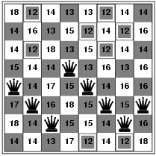

Explain according to the theory shown below:
- Hill-climbing
  - Never makes downhill moves
  - Get stuck on a local maximum
- Simulated annealing
  - Escape local maxima by allowing some "bad" moves but gradually decrease their frequency
  - In metallurgy, annealing is the process used to temper or harden metals and glass by heating them to a high temperature and then gradually cooling them
  - Instead of picking the best move, it picks a random move if the move improves the situation, it is always accepted

