Quiz 04 Solution

Name: Student ID:

Please construct the decision tree to classify the data points with three attributes into two categories according to the information gain. Please write down all the calculation of entropy and information gain.
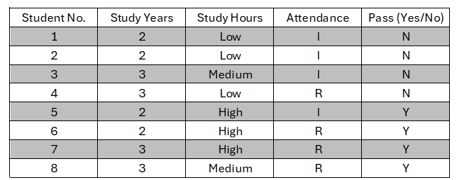

Initial Entropy: 1.0000
Step 1:
Information gain for Study_Years: 0.0000
Information gain for Study_Hours: 0.7500
Information gain for Attendance: 0.1887
Select Study Hours as root.
Step 2:
Study Hours=High, then Y
Study Hours=Low, then N
Study Hours=Medium,
Information gain for Attendance: 1.0000
Select Attendance.
Finally,
Study Hours=High, then Y
Study Hours=Low, then N
Study Hours=Medium and Attendance = I, then N
Study Hours=Medium and Attendance = R, then Y

