About OBS
Registration/ General enquiries
1) Where can I register for my child? | Please refer to the link provided in Parents Gateway for the e-Registration. Do note that SingPass login is required.
2) When does the registration start? | The e-Registration period is from 16 September to 7 October 2022.
3) Is OBS open to all Secondary 3 students or only for selected students? | MOE-OBS Challenge Programme is open to ALL Secondary 3 students in 2023.
4) Will my child be required to wear a mask at all times? | We will adhere to the national posture at the point in time when the MOE-OBS Challenge Programme is taking place. Based on the current status, mask wearing is optional.

About AI
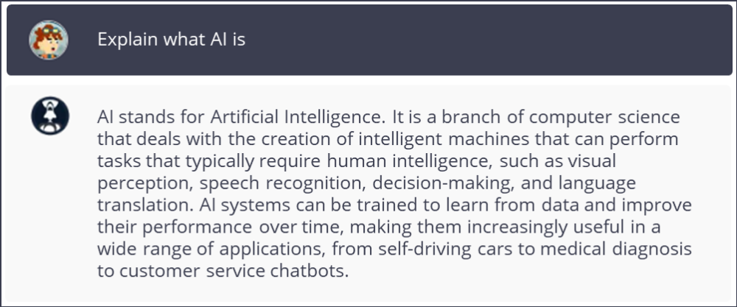
4) Will my child be required to wear a mask at all times? | We will adhere to the national posture at the point in time when the MOE-OBS Challenge Programme is taking place. Based on the current status, mask wearing is optional.

In the context of interacting with an AI, a prompt refers to a piece of text or input provided by a user to initiate a response or action from the AI. A prompt can take many forms, such as a question, a statement, or a command, and is typically used to provide context or direction to the AI's response.

