**CV**

***Name:Yi-Wei Su English Name:Wilson***

***Phone: +886 0975113873*  *E-mail: wilson40219@hotmail.com***

* **Introduction about me**

**Hi, I’m Wilson Su,from Taichung City,graduated from Fengjia University, majoring in Electrical Engineering**

**When I was freshman, firstly I learned about Fundamental Computer Science,I felt strongly interested in computer science and programming .Through I do not major in that but I had still taken some courses in Computer Science department (eg. Data Structure / Computer Orgnazation/Algorithms/Java etc.).I also sometimes practise programming skill on Leetcode in my college life.**

**After undergraduate degree ,I choosed start working at first,I took my first job as a software engineer for one year.**

**Although I learned basic to solve the simple problem by programming in my first job, I’m not satisfied with the status quo.So I decide to study at institute of Computer Science, not only for improving my programming skill,but also want to learn some “domain knowledge” what I want to know .I quitted my job, maked all-out effort to prepare for graduate school entrance exam.**

**I know my weakness is that I did not major in computer science in my college time and lack of taking basic courses,so I will put more effort on covering the such shortage.**

* **Education**
* **Department of Electrical Engineering**

**Fengjia University ,Taichung ,Taiwan**

**(From 2012 .Sep to 2016 Jun)**

* **Working Experience**
* **BIOS (Using C) Software (junior) engineer at**

**Wistron Cooperation(From 2017.Feb to 2018.Feb)**

* **Serval Part Time Job Experience in College life**
* **Skills**
* **C language**
* **Java**
* **Assembly**
* **Projects**

1. **8051 project -Calculator**



1. **C language project -Simple version Gomoku**



1. **Java project -Calculator UI**



1. **8051 course project**



* **Transcripts**
* **College Score: Overall GPA : 3.0**

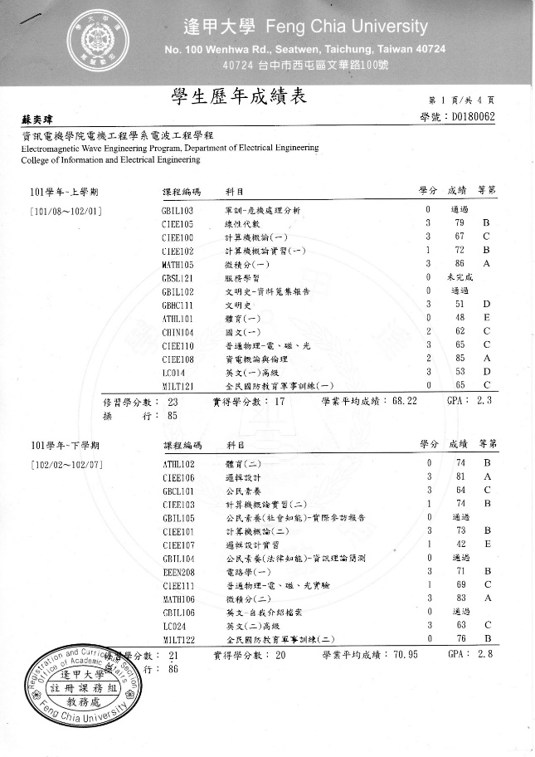

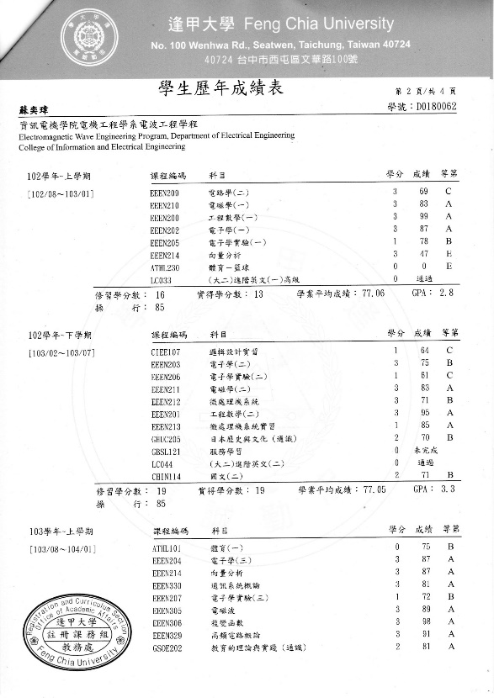

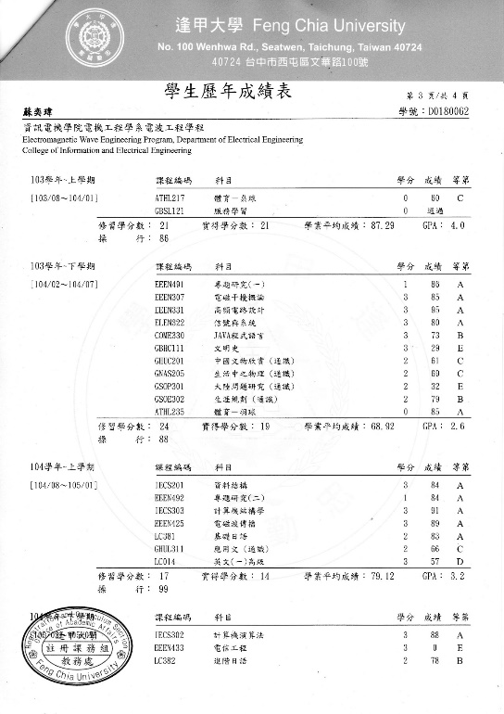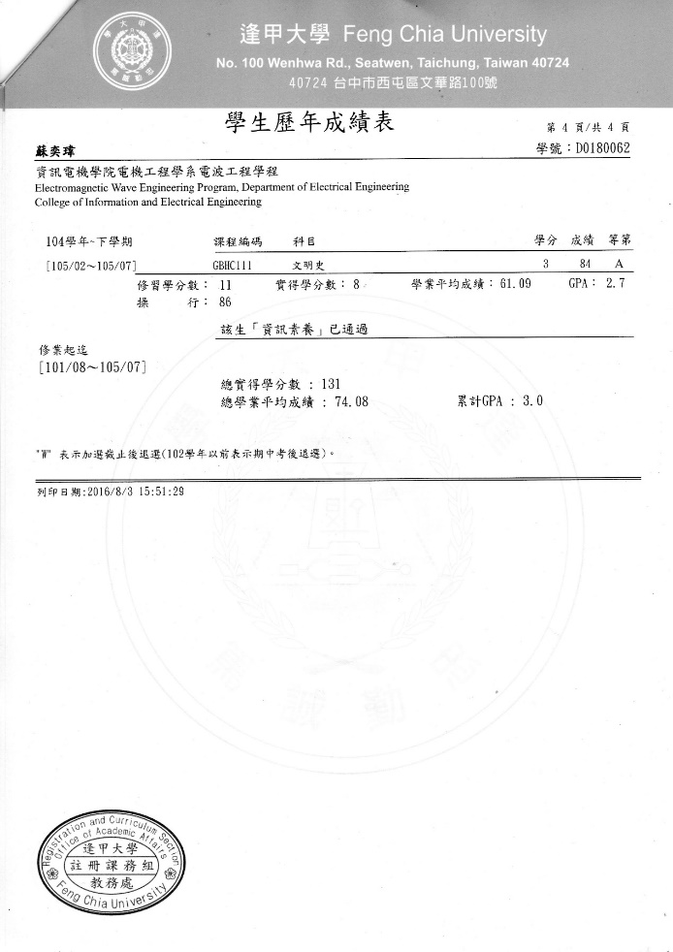

* **Toeic Score:665**

