

RadiusICON Paylink-Web v7

Cardholder NOT Present

Installation and Configuration Guide

Introduction to Document

Document Title
Paylink-Web Installation & Configuration guide

Purpose of this document
To serve as a guide to the owner of third party systems on how to interface to Paylink-Web, and how to configure their system to use it.

Input Requirements
Provide information necessary for installation and configuration of Paylink cardholder not present.

Input documents
Based on Paylink-Web SDS v3.5

History of document
Date | Version | Author | Description
25/01/2005 | 7.0 | Paul Hindle | Re-written for v7

Future of Document
To be maintained as PaylinkWeb is developed.

Review History
Date | Type | By | Result

Home of Document
/tmp/lo/0000.doc

Table of Contents

Introduction to Document 2
Document Title 2
Purpose of this document 2
Input Requirements 2
Input documents 2
History of document 2
Future of Document 2
Review History 2
Home of Document 2
Table of Contents 3
Introduction 4
e-Maintenance 5
Version compatibility 5
MachineId 5
Fund group 5
User 5
PaylinkWEB - Configuration 6
Database Schema 7
Installing Paylink 8
Selecting the database to connect to 9
Existing directory exists 11
Installing the example user interface 11
Example user interface 12
Setup is now ready to install the software. 13
Configuring PaylinkWebCHNOTP Settings.asp 14
Example settings.asp file 14
Configuring PaylinkWebCHNOTP Settings.xml 15
Example settings.xml file 16
Example user interface – Card holder NOT present 17
Validation of payment Account Information 18
Authorising a payment 20
Payment authorised 23
Paylink – User Interface 24
Card Data Entry Page (cardcapt.htm) 25
Address Entry Page (addrcapt.htm) 26
Successful Payment Page (authsucc.htm) 27
Unsuccessful Payment Page (authfail.htm) 28
Paylink – Example Calling Application 29

Introduction
Paylink Card Holder NOT Present (CHNotP) allows the ICON e-payments engine to be used to authorise card payments from 3rd party of customer written user interfaces. These user interfaces can include web pages, crm systems and e-forms. In fact, anything that can invoke an Active Server Page (ASP) can call PaylinkCHNotP.

In its simplest form, a browser will be used to access the Paylink ASP and parameters will be passed to the ASP via the url or web address.

The following pages refer to <Page path> This is the address where the PaylinkCHNotP ASP is installed. The default is:

http://ServerName/PaylinkWebCHNotP/epsp.asp

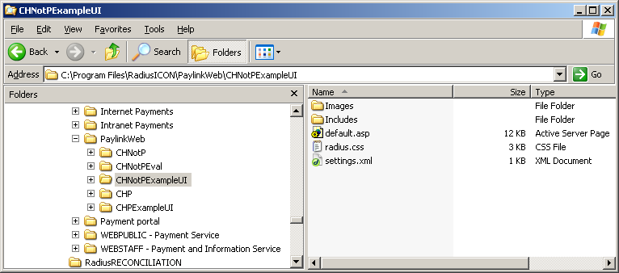
Below shows the directory structure for the installed software if the defaults are used.

The directories relevant to this guide are:
- CHNotP - Paylink software card-holder NOT present
- CHNotPExampleUI - Example user interface for CHNotP

e-Maintenance
Note: e-Maintenance must be available in order to configure PaylinkWEB. You will need the ICON CD to install this if it is not available.

Version compatibility
Ensure that the version of e-Maintenance you install is the same version as the rest of ICON. Paylink is currently compatible with all versions of e-maintenance.

If the current ICON version is pre e-maintenance, use the latest version of e-maintenance but ensure that you install it on a machine that does not have LIVE ICON e-payments software on it.

MachineId
Ensure that a machine Id exists for Paylink. If not, create a new one using the ICON installation CD. Note this facility does not appear on the Paylink CD.

Fund group
You will require a fund group setting up that contains only those funds that are to be made available to Paylink. Also consider that card types you wish to allow when allocating the fund group a card group.

User
You will need a Paylink user. This will be stored on each Paylink transaction and will have the Paylink fund group allocated to it.

PaylinkWEB - Configuration
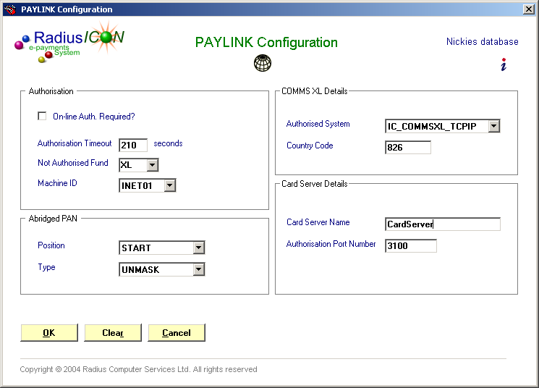
Ensure that the e-Maintenance PaylinkWeb configuration is correct before attempting to install the software.

Parameter | Description
On-Line Auth Required | True – Authorises via the secure card server.  False – Emulates an authorisation locally.
Authorisation timeout | Change this value from 180 to 210.
Not authorised fund | Ensure that this is set up in fund maintenance first. It is the fund that each transaction temporarily holds until the payment is authorised. If the authorisation fails, the transaction remains with this fund otherwise it is replaced by the correct fund.
Machine Id | This should be set up using the setup CD first. This determines the range of transaction reference or receipt numbers that Paylink generates.
Position / Type | Determines how the card number (PAN) is abridged.
Authorisation system | Must be set to IC_COMMSXL_TCPIP
Country code | Must be set to 826
Card Server | The server name of the secure card server – Site specific
Authorisation port number | The port that the authorisation software is listening on – Site specific.

Database Schema
Make sure that the database schema contains the latest Paylink database fields.

The schema changes are on the Paylink setup CD in:
Database/Upgrade/PaylinkCHP_Schema.sql

This is the correct file even though it is named CHP rather than CHNotP.

This may be opened in Microsoft SQLServer – Query Analyser and run.

Note: It doesn’t matter if you run it more than once.

Installing Paylink
To invoke the setup wizard, double click on the following using Windows Explorer:
\Setups\Paylink Setup\Setup.exe

The following screen will be displayed:
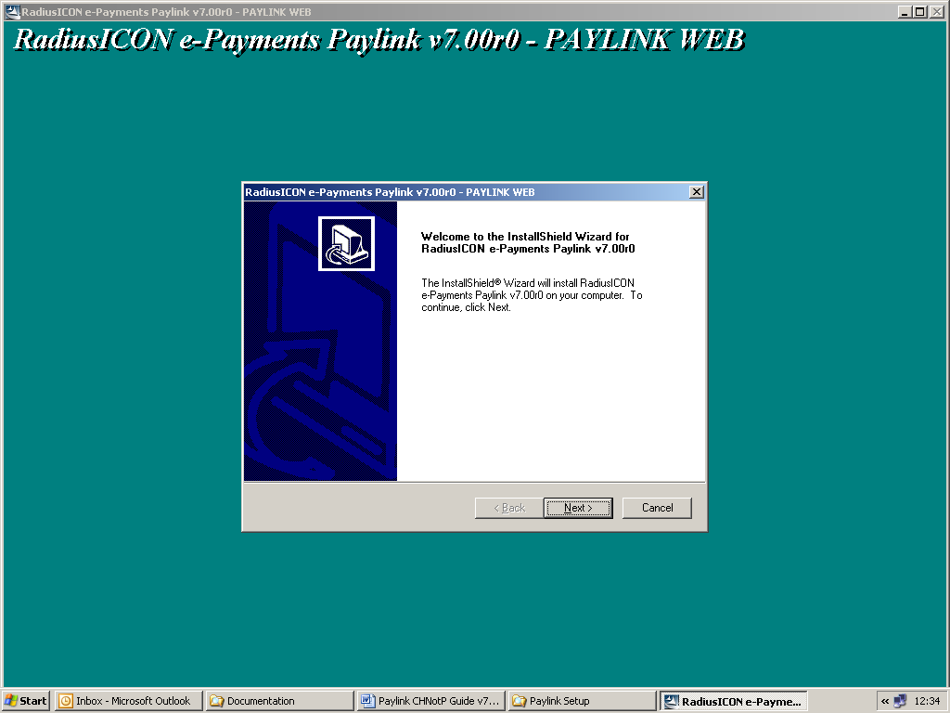

Click the NEXT button to proceed or CANCEL to quit the installation.

The next screen asks you whether you wish to install the customer present or NOT present versions. This guide is the Customer NOT present version so you should click the Customer NOT present option.
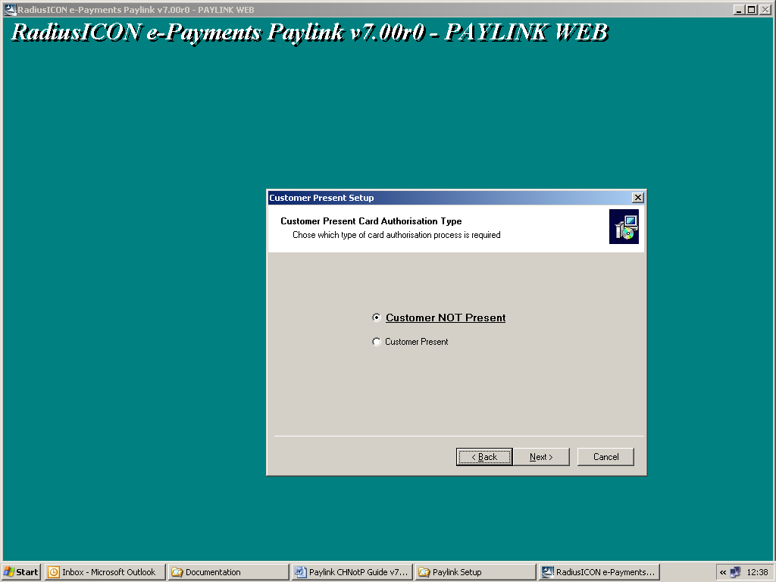

Click ‘Customer NOT Present’

Click the NEXT button to proceed or CANCEL to quit the installation.

The next screen asks you whether you want to install the FULL version or the EVALUATION version. It also gives you the option of installing an example user interface.
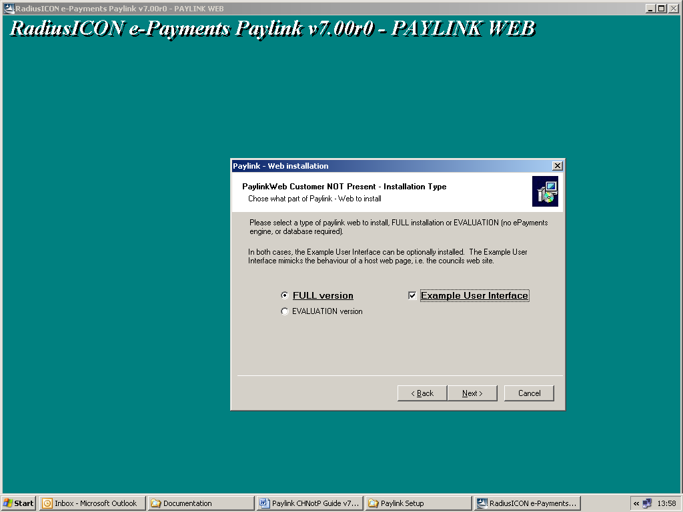

Select ‘Full version and ‘Example user interface’.

Click the NEXT button to proceed or CANCEL to quit the installation.

Selecting the database to connect to
The next screen determines which database PaylinkCHNotP will connect to. You can either, select and existing database from the drop down or create a new connection by entering a new SystemId.
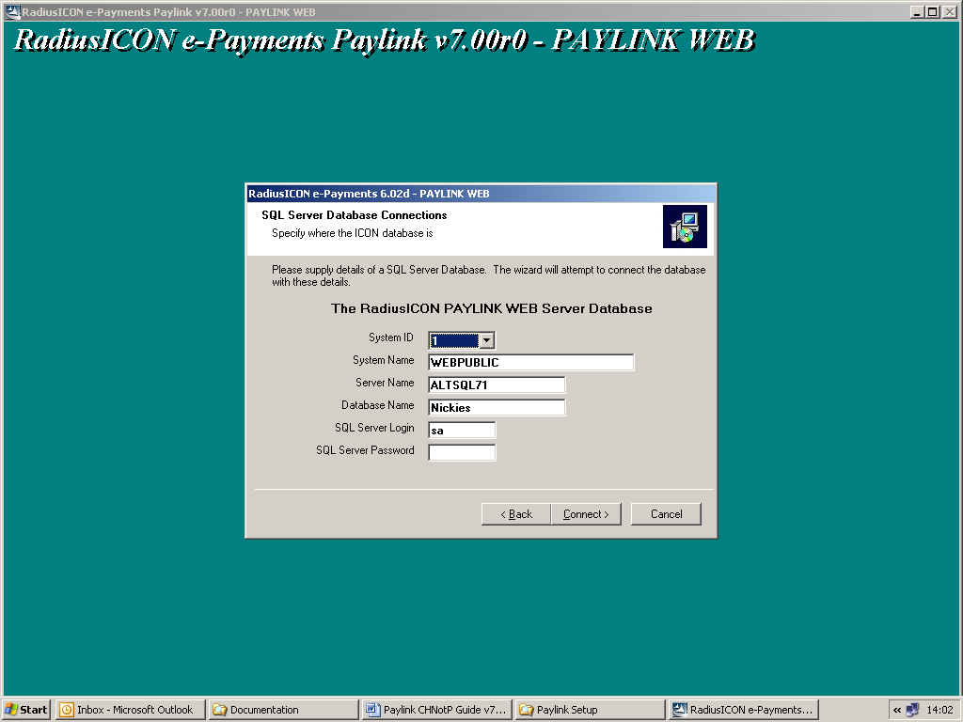

The screen below shows how these installation wizard settings relate to the registry.

Click the CONNECT button to proceed.

The connection details are held in the registry under HKEY_LOCAL_MACHINE/Software/Radius Computer Services. SystemId 1 above relates to Database001 below etc.

Note: You will NOT see the screen below during the installation. The installation process sets them up for you.
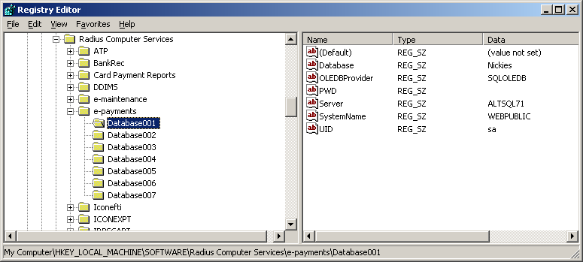

Note: If any of the connection details are incorrect, the following dialogue will be displayed:
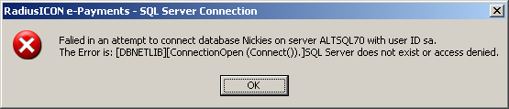

You will now be prompted where you want to install the Paylink software. Use the default unless you have a particular reason for changing it. This will assist the support team if they need to look at your system.
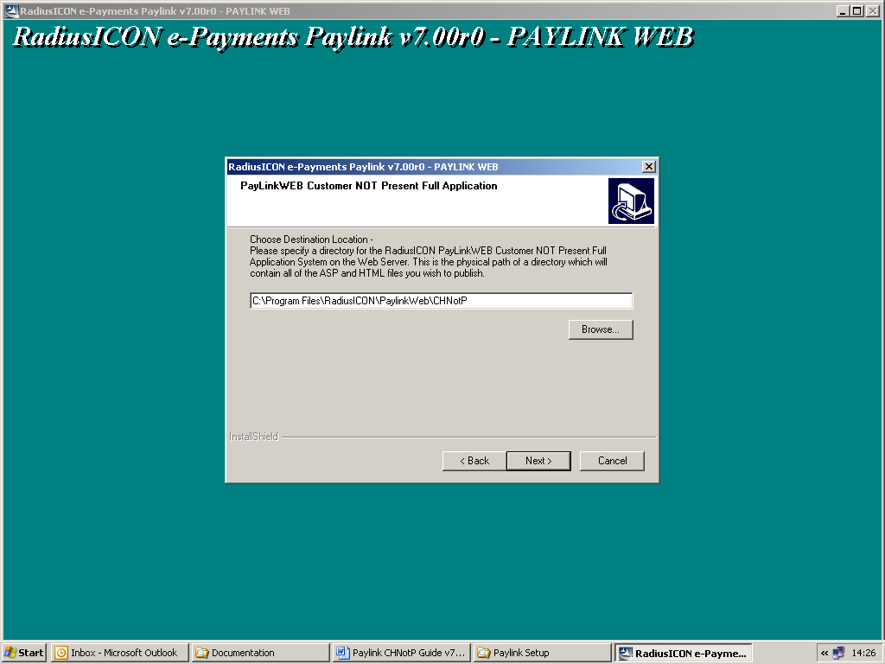

Default is:
C:\Program Files\RadiusICON\PaylinkWeb\CHNotP

Click the NEXT button to proceed or CANCEL to quit the installation.

Next you will be prompted for the website that Paylink will reside under within Internet Information Services (IIS). Leave this at the default unless you have a particular reason for changing it. This will assist the support team if they need to look at your system.
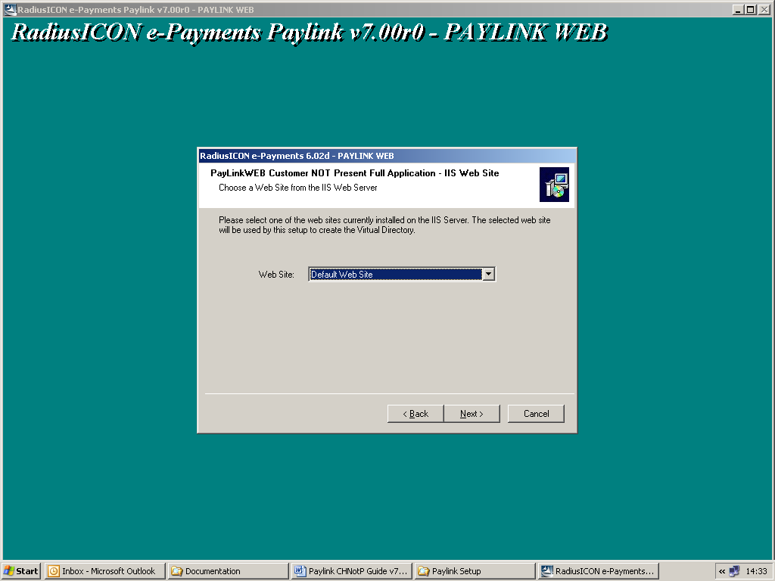

‘Default Web site’ is the default.

Click the NEXT button to proceed or CANCEL to quit the installation.

Next you will be prompted for a Virtual directory name. This is the name that will form part of the address when Paylink is invoked.
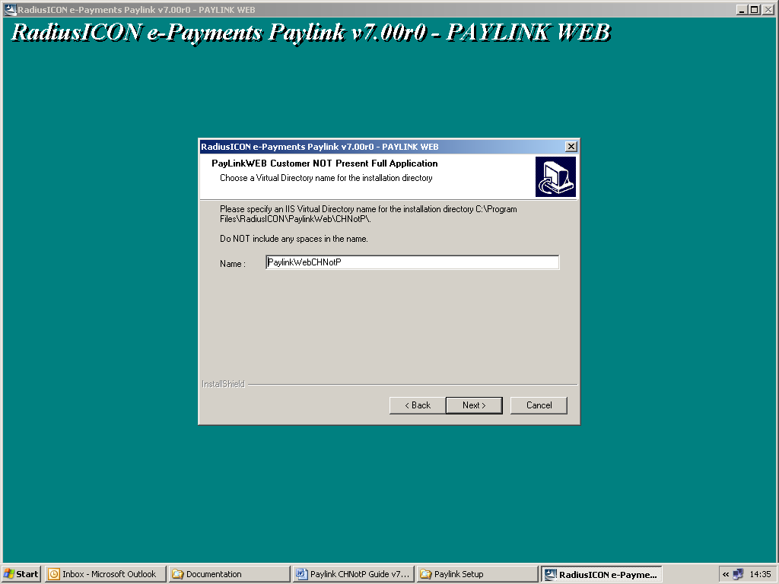

The default is:
PaylinkWebCHNotP

Click the NEXT button to proceed or CANCEL to quit the installation.

Existing directory exists
Note: If the virtual directory already exists, the following dialogue will warn you. If you select Yes, the existing directory will be re-used. Using the default is recommended as it may assist the support team in future.
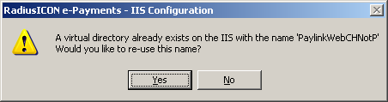

Installing the example user interface
Note: If you have opted to install the example user interface, you will be prompted with the following dialogue:
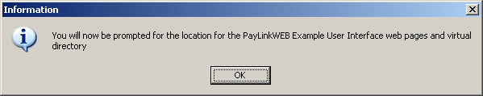

Example user interface
You will now be prompted where you want to install the Paylink example user interface software. Use the default unless you have a particular reason for changing it. This will assist the support team if they need to look at your system.
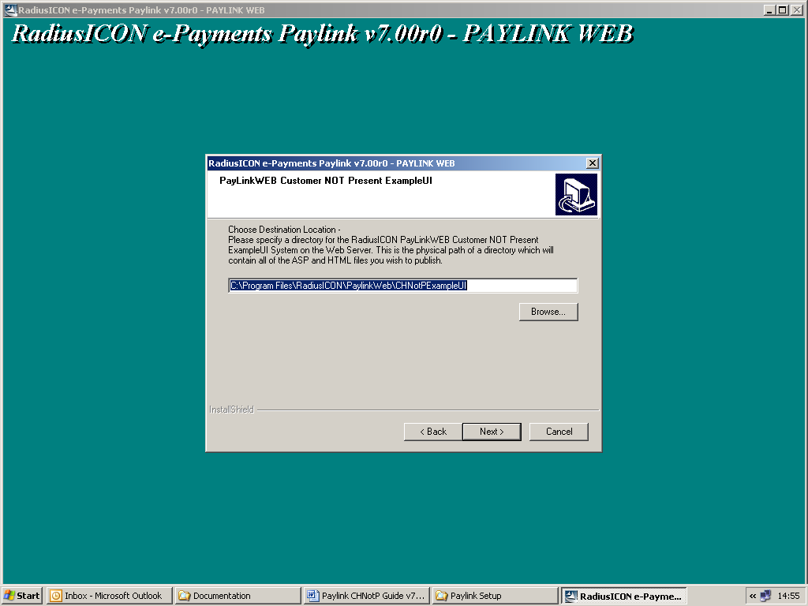

Default is:
C:\Program Files\RadiusICON\PaylinkWeb\CHNotPExampleUI

Click the NEXT button to proceed or CANCEL to quit the installation.

Next you will be prompted for the website that Paylink example user interface will reside under within Internet Information Services (IIS). Leave this at the default unless you have a particular reason for changing it. This will assist the support team if they need to look at your system.
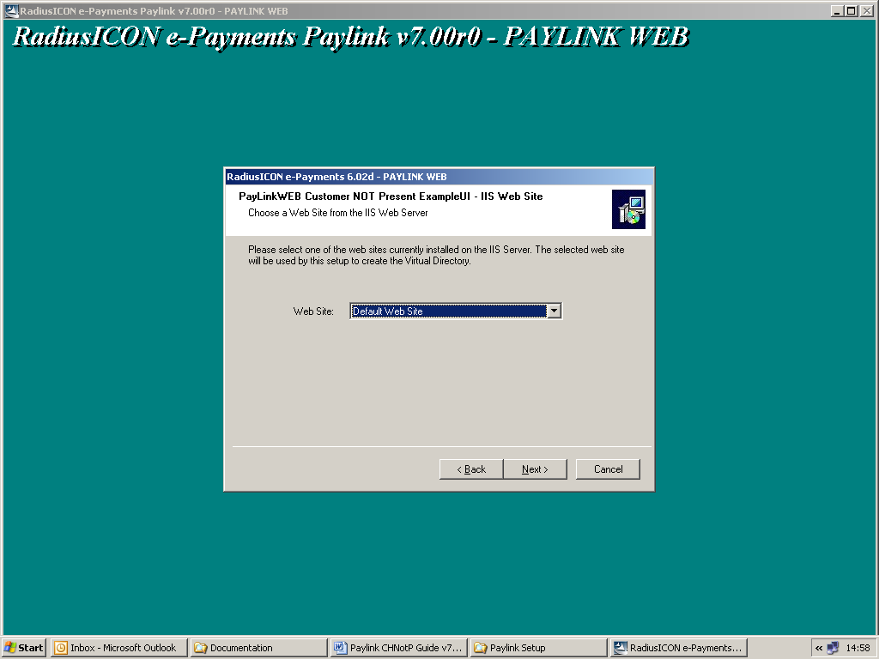

‘Default Web site’ is the default.

Click the NEXT button to proceed or CANCEL to quit the installation.

Next you will be prompted for a Virtual directory name. This is the name that will form part of the address when Paylink example user interface is invoked.
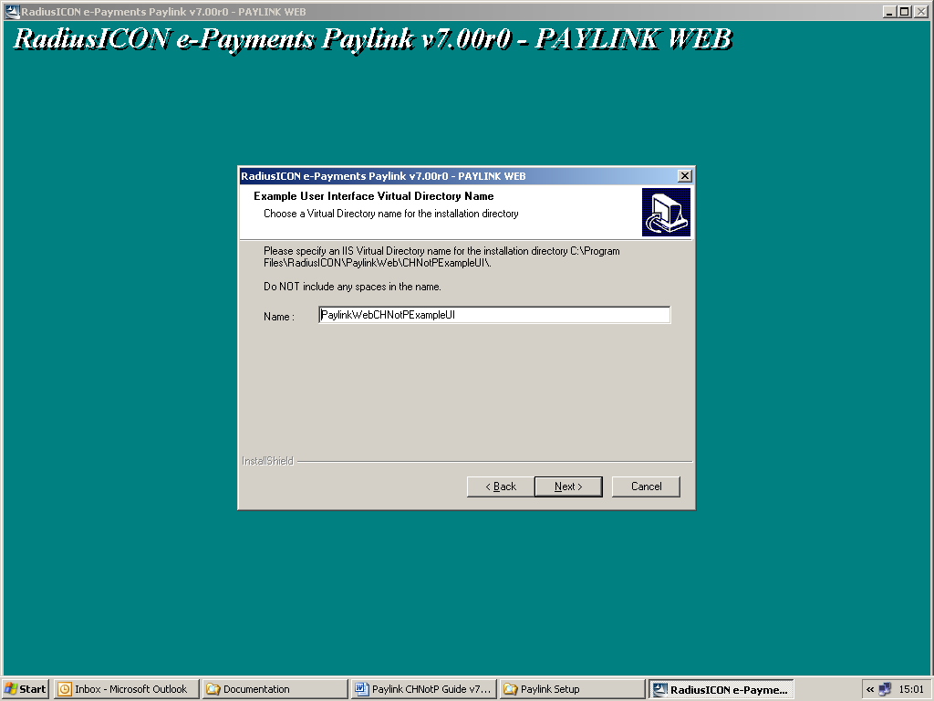

You may also be prompted to re-use this directory if it already exists.

Click the NEXT button to proceed or CANCEL to quit the installation.

Setup is now ready to install the software.

The next screen indicates this.
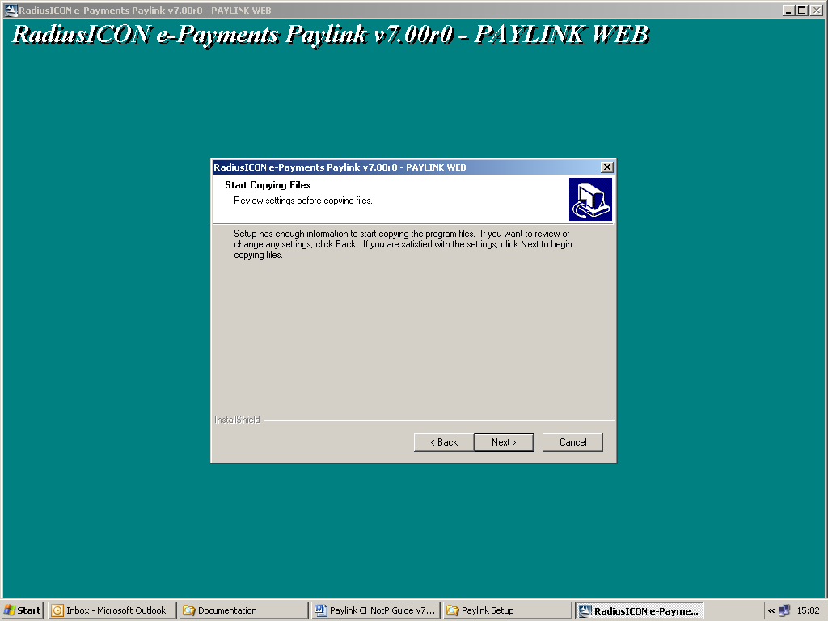

Click the NEXT button to proceed or CANCEL to quit the installation.

Progress of the installation will be indicated by the following screen.
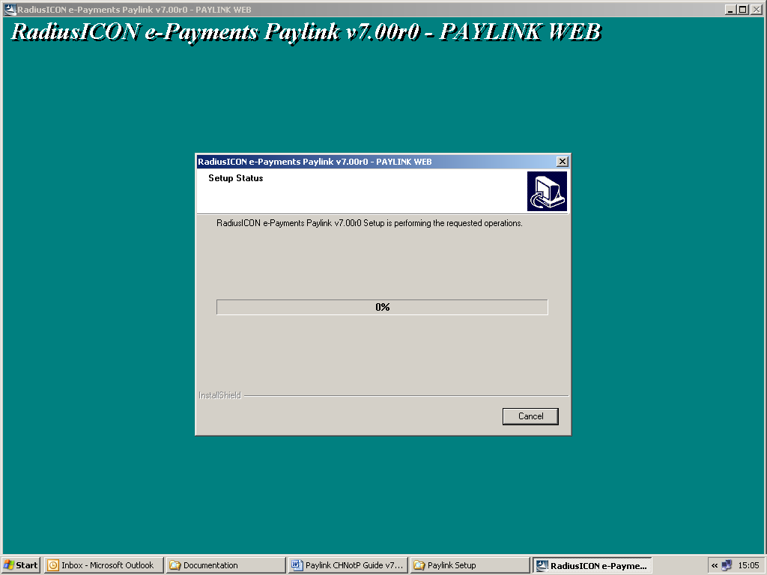

When complete, you may be prompted by the following:
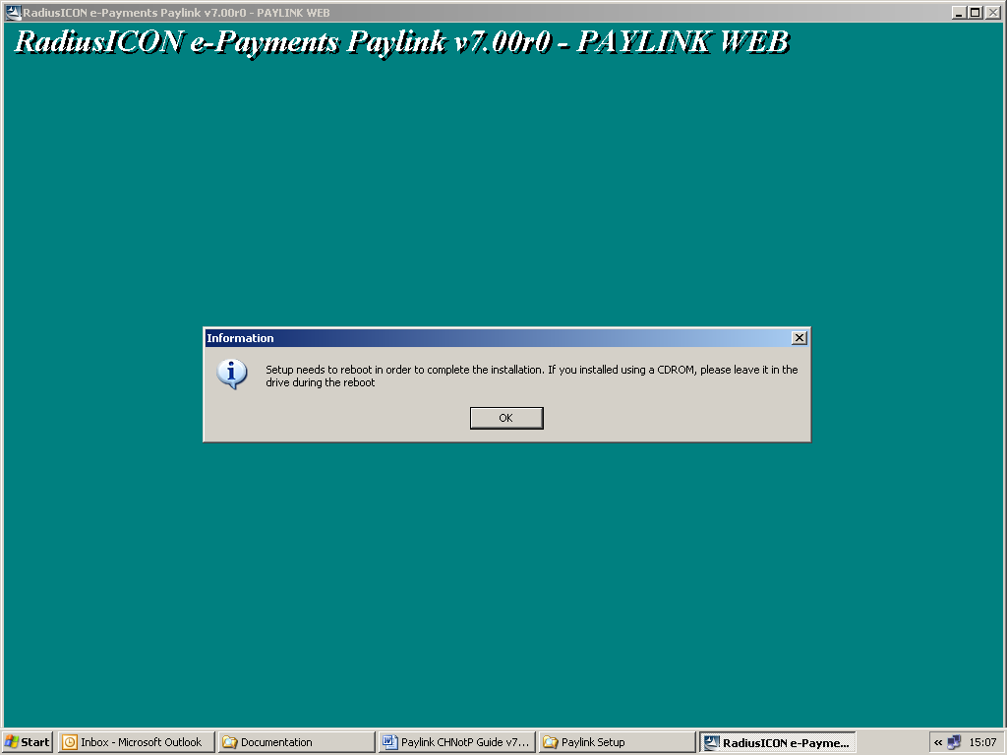

Re-booting the server ensures that the Paylink software is properly installed and ready to use. If you choose not to re-boot, you may experience problems. The first thing the support team will advise is that you re-boot the server and try again. However, you will be given the opportunity to re-boot at a later time.

Configuring PaylinkWebCHNOTP Settings.asp
The following file must be configured:
C:\Program files \RadiusICON \PaylinkWebCHNOTP \Includes \Settings.asp

Edit this file to change the INTERNET_USER to the one you have set up in ICON for Paylink. You must set up a user in ICON and allocate the Paylink fund_group to it before attempting this. Do not change any other settings.

Example settings.asp file
<%
' The user code to use for the internet payments
Const INTERNET_USER = "PLW"

Const DATABASE_NUMBER = 1

Const XML_SETTINGS = "settings.xml"
Const PAF_LOOKUP = False
Const ALLOW_EMAIL = False

' Constant used to determine the source of an e-mailed receipt
Const RECEIPT_FROM_ADDRESS = "Paylink-web@authority.gov.uk"
Const RECEIPT_FROM_NAME = "Paylink-Web"

' The mail server and port to connect to send e-mail...
Const MAIL_SERVER_NAME = "exchange"
Const MAIL_SERVER_PORT = "25"

' List of people to send error e-mails to, separated by semi colons.
Const ERROR_ADDRESSES = "helpdesk@authority.gov.uk"
Const MACHINE_ID_SYS_PARAM = 813

%>

Configuring PaylinkWebCHNOTP Settings.xml
The following file must also be configured:
C:\Program files \RadiusICON \PaylinkWebCHNOTP \Settings.xml

This file tells Paylink which application is calling it and also whether or not to redirect the user’s browser to standard or user-defined response pages.

It is recommended that you test Paylink using the example user interface and the default settings in this file. This will ensure Paylink is creating ICON transactions and Authorising Payments before any user defined pages are used.

You need the following information before configuring this file:
- The server name of the server you have installed Paylink on
- The url to each of the customer response pages to be used

Parameter | Description
ApplicationID | May be any value but MUST be unique.
ApplicationDescription | Textual description of the calling application examples:  Prototype e-forms test system  Planning portal  Environment e-forms live system
ValidationSuccessURL | When calling PaylinkWeb in VALIDATION MODE, the URL to redirect the users browser to in the event of successful validation of the details.
ValidationFailureURL | When calling PaylinkWeb in VALIDATION MODE, the URL to redirect the users browser to in the event of unsuccessful validation of the details.
AuthorisationSuccessURL | The URL to redirect the users browser to the in event of a successful card authorisation. Overrides the standard ICON page if flag set below.
AuthorisationFailureURL | The URL to redirect the users browser to the in event of an unsuccessful card authorisation. Overrides the standard ICON page if flag set below.
SuccessfulAuthPage | Flag used to determine whether or not the standard successful authorisation page should be displayed by Paylink-Web prior to moving to the AuthorisationSuccess URL. This value is either ‘True’ for Paylink to display the built-in page, or false to suppress the standard page.
UnsuccessfulAuthPage | Flag used to determine whether or not the standard unsuccessful authorisation page should be displayed by Paylink-Web prior to moving to the AuthorisationFailure URL. This value is either ‘True’ for Paylink to display the built-in page, or ‘False’ to suppress the standard page.

An example file is shown on the next page.

Example settings.xml file
The following example consists of two applications. There is no limit to the number of applications you can configure. Note:

The example on the CD shows http://localhost/ as the start of each url. If you leave this as it is, no client browsers will be able to access Paylink. Only the browser on the server will recognise it. You must use the correct server name for your site e.g. http://IconIISServer/

The example also shows the example user interface, default.asp for each of the response pages. If you leave this as it is, the example user interface will be used to display the results. These should be changed to the correct urls for the customer pages to be used. The response fields will be passed as part of the url and can be read by the response pages.

<ePSP_Calling_Application>
<Application>
<ApplicationID>E1A29BE1-1BB1-11D6-94AB-00A02447CFAD</ApplicationID>
<ApplicationDescription>Live Skip Hire form</ApplicationDescription>
<ValidationSuccessURL>http://ServerName/PaylinkWebCHNotPExampleUI/default.asp</ValidationSuccessURL>
<ValidationFailureURL>http://ServerName/PaylinkWebCHNotPExampleUI/default.asp</ValidationFailureURL>
<AuthorisationSuccessURL>http://ServerName/PaylinkWebCHNotPExampleUI/default.asp</AuthorisationSuccessURL>
<AuthorisationFailureURL>http://ServerName/PaylinkWebCHNotPExampleUI/default.asp</AuthorisationFailureURL>
<SuccessfulAuthPage>True</SuccessfulAuthPage>
<UnsuccessfulAuthPage>True</UnsuccessfulAuthPage>
</Application>
<Application>
<ApplicationID>FRED</ApplicationID>
<ApplicationDescription>Live Wasp removal</ApplicationDescription>
<ValidationSuccessURL>http://ServerName/PaylinkWebCHNotPExampleUI/default.asp</ValidationSuccessURL>
<ValidationFailureURL>http://ServerName/PaylinkWebCHNotPExampleUI/default.asp</ValidationFailureURL>
<AuthorisationSuccessURL>http://ServerName/PaylinkWebCHNotPExampleUI/default.asp</AuthorisationSuccessURL>
<AuthorisationFailureURL>http://ServerName/PaylinkWebCHNotPExampleUI/default.asp</AuthorisationFailureURL>
<SuccessfulAuthPage>True</SuccessfulAuthPage>
<UnsuccessfulAuthPage>True</UnsuccessfulAuthPage>
</Application>
</ePSP_Calling_Application>

Example user interface – Card holder NOT present
The following files must be configured:
C:\Program files \RadiusICON \PaylinkWebCHNotPExampleUI\Settings.xml

The example user interface only actually uses the Application ID and Description from this file.

Calling PaylinkCHNotP
Using Paylink-Web the following functions are available:
- Validation of payment account information.
- Authorising a payment.

It is recommended that you test Paylink using the example user interface first to ensure that everything is working ok.

Validation of payment Account Information
To cause account details to be validated, the following Name/ Value pairs should be set within the URL. Where a name in the list below is followed by an * this indicates that multiple instances may occur. Where this happens, an encoded semi-colon (%3B) should separate the instances, and the number of entries should be balanced. (In Visual Basic Scripting for ASP URL’s can be encoded using the Server.URLEncode method.)

For example the following URL (with shortened ‘AppID’ GUID) is valid:
http://ServerName/PaylinkWebCHNotP/epsp.asp?AppID=12345&Mode=1&VT=20020420005012&AccRef=123456%3B654321&FundCode=01%3B02&Amt=599%3B1250

However the following URL is not valid because the second set of account details is missing the FundCode value:
http://ServerName/PaylinkWebCHNotP/epsp.asp?AppID=12345&Mode=1&VT=20020420005012&AccRef=123456%3B654321&FundCode=01&Amt=599%3B1250

Name | Value
AppID | The GUID of the calling application.
Mode | 1
VT (Optional) | A date and time until which the URL should be considered valid in the format YYYYMMDDSSMMHH. E.g. 12:50pm on the 20th April 2002 would be 20020420005012.
AccRef * | The account reference.
FundCode * | The type of account, as a code.
Amt * | The amount to be paid to the account, to be written as pence, e.g. £10 = 1000  Where Amt is set to 0 (zero) it will be ignored, and not validated.

Within the configuration of the Paylink-Web application, the following parameters should be set. These parameters determine the page that is displayed to the user, and the page that the user is sent to depending on success or failure:

Parameter | Description
ValidationSuccessURL | The URL to redirect the users browser to in the event of successful validation of the details.
ValidationFailureURL | The URL to redirect the users browser to in the event of unsuccessful validation of the details.

Where multiple accounts are to be checked they will be checked in sequential order, with checking stopping at the first error.

N.B. The RadiusICON e-payments engine is highly configurable, and expandable. As such it is possible to configure specific account types to have no, very light, or very strict reference validation.
On successful validation the users browser will be returned to the ‘ValidationSuccessURL’ address. To allow the calling application to determine which user session the user is returning to, the first reference from the original request will be included. The request string will be in the following format:
http://ServerName/PaylinkWebCHNotPExampleUI/default.asp?OrigRef=XXXXXXX

The following is a list of the possible error codes that can be returned after validating the accounts.
In a situation where an error has occurred the error number will be passed back to the failure page, along with the first reference from the original request. The request string will be in the following format:
http://ServerName/PaylinkWebCHNotPExampleUI/default.asp?Err=n&OrigRef=XXXXXXX

When error eight (8) occurs three extra Get parameters are added to the request string; FundCode, MinAmt and MaxAmt. These parameters inform the calling application of the problem fund, and the minimum and maximum amount of money that can be paid to an account. Where error eight occurs the format will be similar to the following:
http://ServerName/PaylinkWebCHNotPExampleUI/default.asp?Err=8&OrigRef=XXXXXXXX&FundCode=xx&MinAmt=nnn&MaxAmt=nnn

Error Value | Meaning | Sample Client Message
1 | The e-PSP software was unable to retrieve the information needed to connect to the RadiusICON database. | An error has occurred with the payment collection software, please try again later.
2 | The e-payments engine failed to connect to the specified database.
3 | An unexpected error occurred whilst accessing the database.
4 | The type of account supplied was not recognised within the RadiusICON system. | Unable to process the payment details please check and try again later.
5 | The reference supplied did not pass the validation criteria. (No specific reason supplied.)
6 | The account type is set such that account details must pre-exist within the RadiusICON system. An account matching the reference could not be found.
7 | The user has chosen to block payments to the specific account within RadiusICON. | The payments software is unable to accept this payment, please contact…
8 | The amount supplied is outside the acceptable limits of the account type.  (N.B. When error eight occurs, either two or three extra ‘get’ parameters are passed back to the calling application; FundCode, MinAmt and MaxAmt.  These three parameters are the problem fund, minimum and maximum payment amounts as pence.  If FundCode is not present, or is blank, then the payment has been rejected because it breaches either the minimum or maximum amount for the type of payment.) | An error has occurred, please try again later.  Fund xxxx can only accept payments between £nn.nn and £nn.nn.
16 | The RadiusICON system administrator has put the system into a mode that causes payments not to be accepted. (i.e. ‘Slamdown’ or ‘Scheduler Started’.) | The system is currently unavailable, please try again later.

Authorising a payment
In order to obtain a card authorisation, and store transaction data within the RadiusICON database, the following Name/ Value pairs should be set within the URL. Before obtaining the authorisation all of the data is validated. The accounts are validated first in sequential order, validation stops at the first error encountered.

In the list below, where a name is followed by an * this indicates that multiple instances may occur. Where this happens, an encoded semi-colon (%3B) should separate the instances, and the number of entries should be balanced. (In Visual Basic Scripting for ASP URL’s can be encoded using the Server.URLEncode method.)

For example the following URL (with shortened GUID) is valid:
http://ServerName/PaylinkWebCHNotP/epsp.asp?AppID=12345&Mode=0&VT=20020420005012&AccRef=123456%3B654321&FundCode=01%3B02&Amt=599%3B1250&PaymentRef=REF111111&PaymentNarrative=Narrative

However the following URL is not valid because the second set of account details is missing the FundCode value:
http://ServerName/PaylinkWebCHNotP/epsp.asp?AppID=12345&Mode=0&VT=20020420005012&AccRef=123456%3B654321&FundCode=01&Amt=599%3B1250&PaymentRef=REF111111&PaymentNarrative=Narrative

Name | Value
AppID | The GUID of the calling application
Mode | 0
VT (Optional) | A date and time until which the URL should be considered valid in the format YYYYMMDDSSMMHH. E.g. 12:50pm on the 20th April 2002 would be 20020420005012.
AddrCapt (Optional) | Capture address details from the user. Either Y (yes) or N (no). If the parameter is not included considered to be set to N.
AccRef * | The account reference
FundCode * | The type of account, as a code
Amt * | The amount to be paid to the account, to be written as pence, e.g. £10 = 1000  Amt must not be set to 0 (zero) when the Mode is set to 0 (zero).
PaymentRef | Optional. Reference generated by the calling application.
PaymentNarrative | Optional. Narrative passed by calling application.

Within the configuration of the Paylink-Web application the following parameters should be set. These parameters determine the various pages that are displayed to the user, and the page that the user is sent to depending on success or failure:

Parameter | Description
ValidationFailureURL | The URL to redirect the users browser to in the event of unsuccessful validation of the details.
AuthorisationFailureURL | The URL to redirect the users browser to the in event of an unsuccessful card authorisation.
AuthorisationSuccessURL | The URL to redirect the users browser to the in event of a successful card authorisation.

The following is a list of the possible error codes that can be returned after validating the accounts.

In a situation where an error has occurred the error number will be passed back to the failure page, along with the first reference from the original request. The request string will be in the following format:
http://ServerName/PaylinkWebCHNotPExampleUI/default.asp?Err=n&OrigRef=XXXXXXX

Where the error is 15 (payment declined) the message will take the format:
http://ServerName/PaylinkWebCHNotPExampleUI/default.asp?Err=n&Str=message+string&OrigRef=XXXXXXXX

The ‘Str’ portion of the request string is the string sent back by the acquiring bank.

Error Value | Meaning | Sample Client Message
1 | The Paylink-Web software was unable to retrieve the information needed to connect to the RadiusICON database. | An error has occurred with the payment collection software, please try again later.
2 | The e-payments engine failed to connect to the specified database.
3 | An unexpected error occurred whilst accessing the database.
4 | The type of account supplied was not recognised within the RadiusICON system. | Unable to process the payment details please check and try again later.
5 | The reference supplied did not pass the validation criteria. (No specific reason supplied.)
6 | The account type is set such that account details must pre-exist within the RadiusICON system. An account matching the reference could not be found.
7 | The user has chosen to block payments to the specific account within RadiusICON. | The payments software is unable to accept this payment, please contact…
8 | The amount supplied is outside the acceptable limits of the account type.  (N.B. When error eight occurs, either two or three extra ‘get’ parameters are passed back to the calling application; FundCode, MinAmt and MaxAmt.  These three parameters are the problem fund, minimum and maximum payment amounts as pence.  If FundCode is not present, or is blank, then the payment has been rejected because it breaches either the minimum or maximum amount for the type of payment.) | An error has occurred, please try again later.  Fund xxxx can only accept payments between £nn.nn and £nn.nn.
9 | The RadiusICON e-payments engine uses a three phase authorisation process. In the first phase the transaction is created in the database. In the second phase the payment is authorised. In the final phase the transaction is updated with the authorisation details.  This error is reporting that the final phase was not completed successfully. | There has been a failure within the payments collection application. Your card has not been debited. Please try again later.
10 | The final phase database update was not completed, but the payment authorisation was successfully reversed.
11 | The final phase database update was not completed and the payment authorisation could not be successfully reversed. | There has been a failure within the payments collection application. Your card may have been debited. Please contact…
12 | The e-payments engine has successfully contacted the authorisation server, but no response was received within the specified time. | There has been a failure within the payments collection application. Your card has not been debited. Please try again later.
13 | The e-payments engine was unable to connect to the authorisation server, the specific reason is logged on the e-payments server.
14 | The authorisation refused the request, usually because there are already too many connections to the server.
15 | The acquiring bank has declined the transaction for the reason specified in the string – examples include:  NOT AUTHORISED  DECLINED  EXPIRED CARD | The acquiring bank has declined the transaction for the following reason - <Error Message>
16 | The RadiusICON system administrator has put the system into a mode that causes payments not to be accepted. (i.e. ‘Slamdown’ or ‘Scheduler Started’.) | The system is currently unavailable, please try again later.

Payment authorised
When a payment has been successfully authorised the Paylink-Web application will construct a request string with the authorisation code, the unique RadiusICON transaction reference and the first reference from the original request string.

Also as part of the request will be a hash total, to ensure the security of the returned values. The hash total will be based on the final six digits of the unique transaction reference, and the total value of the transaction. The total value will be used as weightings to the final six digits of the transaction reference, where the total value is less than six digits it will be repeated to the right as often as is necessary. The results of applying the weightings to each digit are then added together, and the remainder of dividing by 16 is converted to a Hex value.

For example, transactions that totalled £40.50, are authorised with a code of 12345, and are recorded with a unique reference of IP0101015326.

The hash total is calculated thus:
Final six digits of transaction reference: 0 1 5 3 2 6
Total amount (repeated as necessary): 5 0 4 0 5 0
Result of applying weightings: 0 0 20 0 10 0
The remainder of 30 / 16: 14
14 in hex: E

So the request string sent to the response page is:
http://ServerName/PaylinkWebCHNotPExampleUI/default.asp?TranRef=IP0101015326&AuthCode=12345&OrigRef=XXXXXXXX&H=E&PaymentRef=REF111111

Paylink – User Interface
The Paylink-Web application will collect card data, and optionally, address data from the user. The users may also see some of these additional pages:

- Validating data
- Successful completion of the payment
- Failure of the payment.

The following sections provide sample pages, and the information that will be available for displaying on those pages. Also, where appropriate the names of the controls that data is entered into will be provided.

Because of the nature of the application it is expected that the pages that will be displayed by the application will be heavily modified to fit in with the calling application. However, it will be necessary for the re-designed pages to include a Radius logo and the ‘Copyright © yyyy Radius Computer Services Ltd.’ legend on the page.

Card Data Entry Page (cardcapt.htm)
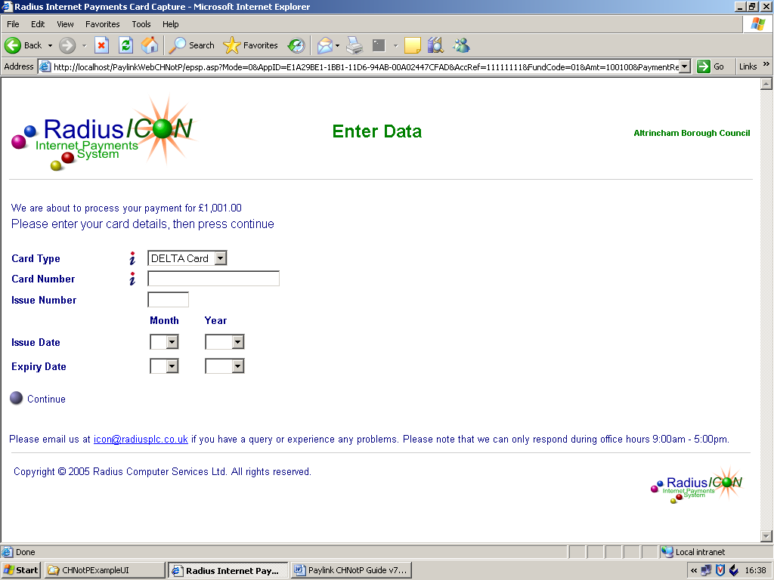
This is page is used to capture the users card data:

The page consists of a number of fields, listed below:

Additionally several extra values will be checked by the processing software. These values will allow applications that access the RadiusICON e-payments engine through Paylink-Web to submit data that would not be normally collected via a web-browser. The values are listed below:

Label | Control Name | Description
Card Type | CardType | The type of card the user is making their payment with. E.g. Visa, MasterCard or Maestro. Data to be passed back is an identification code derived from a RadiusICON e-payments object.
Card Number | CardNumber | The actual card number.
Issue Number | IssueNumber | The issue number of the card, if present.
Start Date | StartMonth | If present, the month that the card is valid from. Passed as two digits, e.g. 01 = January, 12 = December.
Start Date | StartYear | If present, the year that the card is valid from. Passed as four digits, e.g. 2000, 2001, 2002.
Expiry Date | ExpiryMonth | The month the card expires. Passed as two digits, e.g. 01 = January, 12 = December.
Expiry Date | ExpiryYear | The year the card expires. Passed as four digits, e.g. 2000, 2001, 2002.

In the event of a validation failure the Session variables ErrControl will be set with the name of the control that contains the failing data, ErrCode will be set with a non-zero value and ErrString will be set with a string detailing the actual reason for validation failure.

Additionally the total value of the transaction will be available in the variable TotalAmount.
Clicking on the ‘Continue’ button should supply a name/ value pair of ‘Action’ and ‘Continue’ to the Paylink-Web application.

When it is necessary to re-display a page because of a validation failure, the data originally entered by the user will be held in variables of the same name as the control.

Address Entry Page (addrcapt.htm)
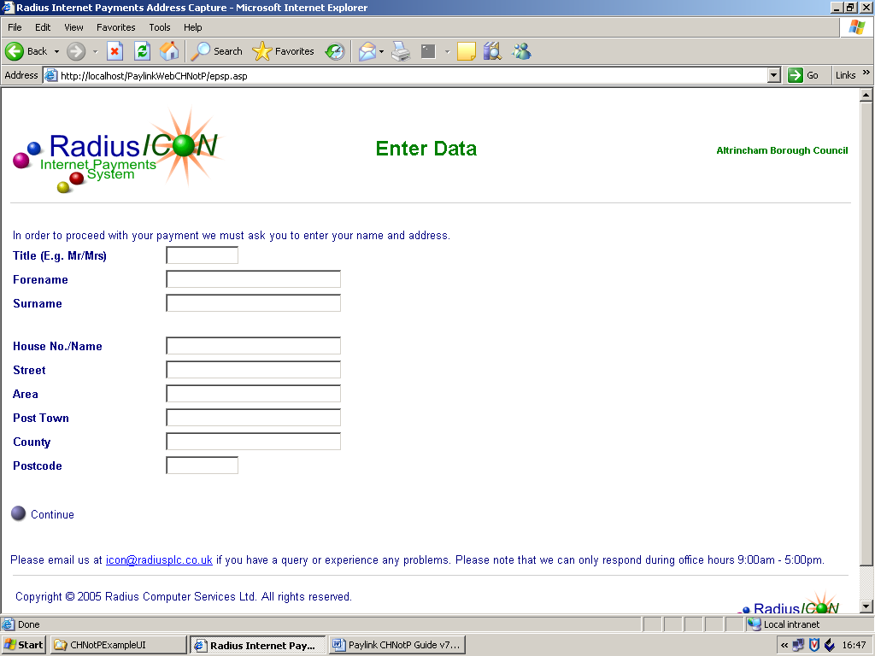
This is page is used to capture the users address data:

The page consists of a number of fields, listed below:

Label | Control Name | Description
Title | PayerTitle | Self-explanatory.
Forename | PayerForename | Self-explanatory.
Surname | PayerSurname | Self-explanatory.
Postcode | PayerPostcode | Self-explanatory.
House No./Name | PayerHouse | Self-explanatory.
Street | PayerStreet | Self-explanatory.
Area | PayerArea | Self-explanatory.
Post Town | PayerTown | Self-explanatory.
County | PayerCounty | Self-explanatory.
Postcode | PayerPostcode | Self-explanatory.

In the event of a validation failure the Session variables ErrControl will be set with the name of the control that contains the failing data, ErrCode will be set with a non-zero value and ErrString will be set with a string detailing the actual reason for validation failure.

Clicking on the [Continue] button should supply a name/ value pair of ‘Action’ and ‘Continue’ to the Paylink-Web application.

When it is necessary to re-display a page because of a validation failure, the data originally entered by the user will be held in variables of the same name as the control.

Successful Payment Page (authsucc.htm)
The calling application can choose to by-pass this page and use an equivalent page of its own. This page can be switched off by setting the SuccessfullAuthPage to FALSE in PaylingWebCHNotP/settings.xml

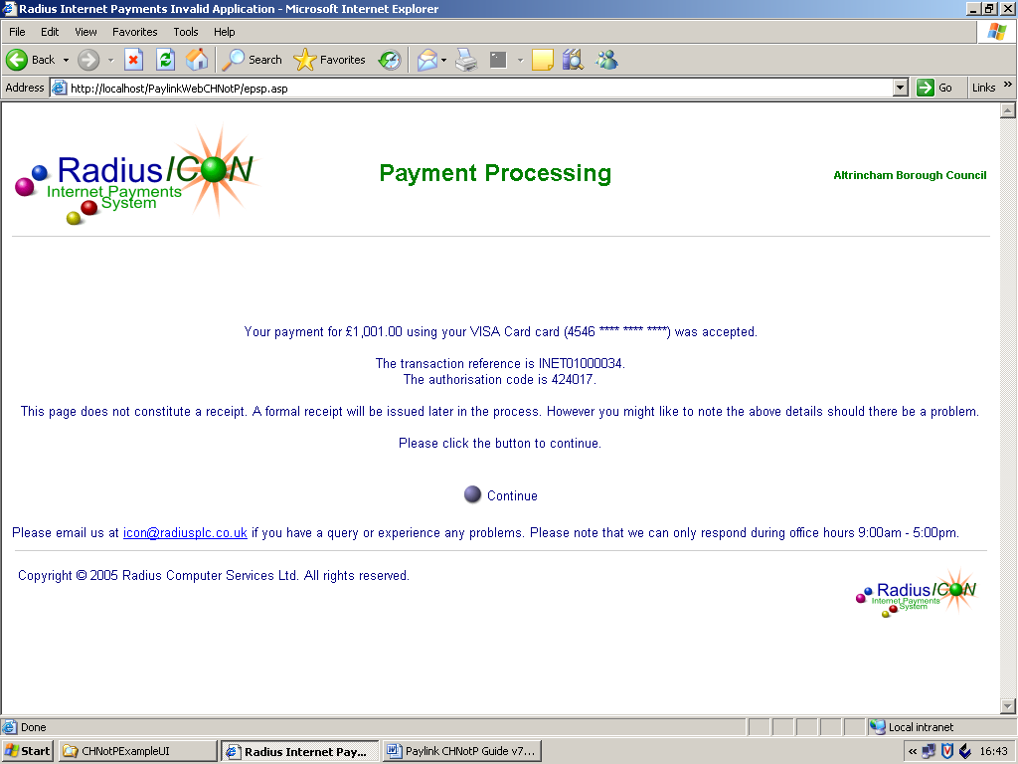
The Successful Payment page will have the total amount of the payment, the generic name of the type of card, an abridged version of the card number, the RadiusICON transaction reference and the payment authorisation code available to it.

The following variables will make information available to the page:
- TotalAmount
- CardTypeString
- CardPAN
- TransactionReference
- AuthorisationCode.

The URL that the browser should continue on to is supplied in the variable ReturnPath. Clicking on the [Continue] button will take the users browser to this address.

Unsuccessful Payment Page (authfail.htm)
The calling application can choose to by-pass this page and use an equivalent page of its own. This page can be switched off by setting the UnsuccessfullAuthPage to FALSE in PaylingWebCHNotP/settings.xml
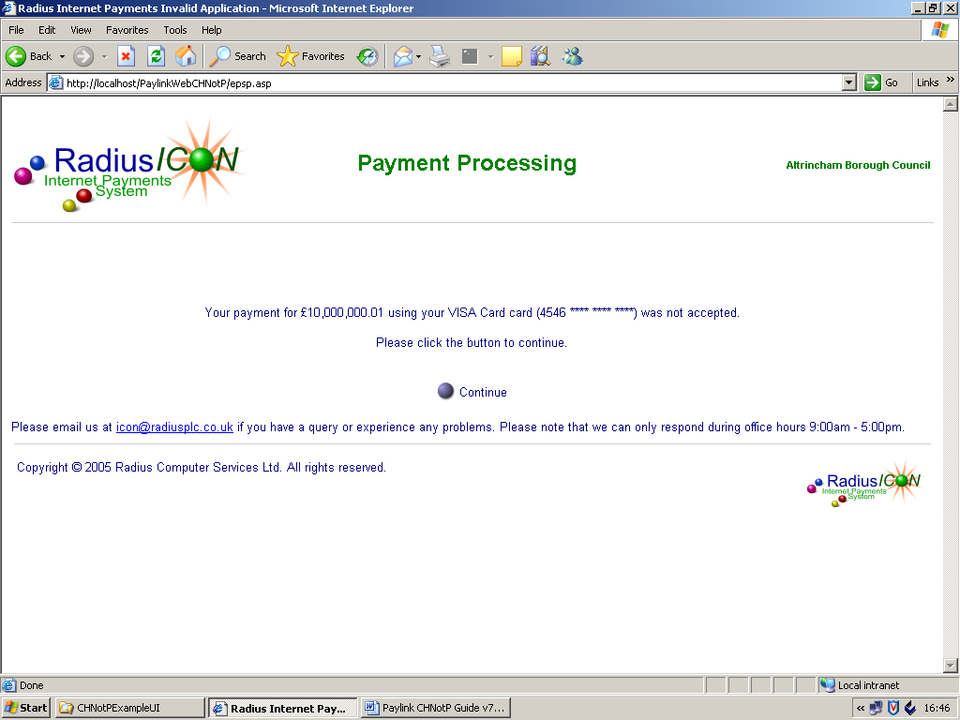
The Unsuccessful Payment page will have the total amount of the payment, the generic name of the type of card, and an abridged version of the card number available to it.

The following variables will make information available to the page:
- TotalAmount
- CardPAN.

The URL that the browser should continue on to is supplied in the variable ReturnPath. Clicking on the [Continue] button will take the users browser to this address.

Paylink – Example Calling Application
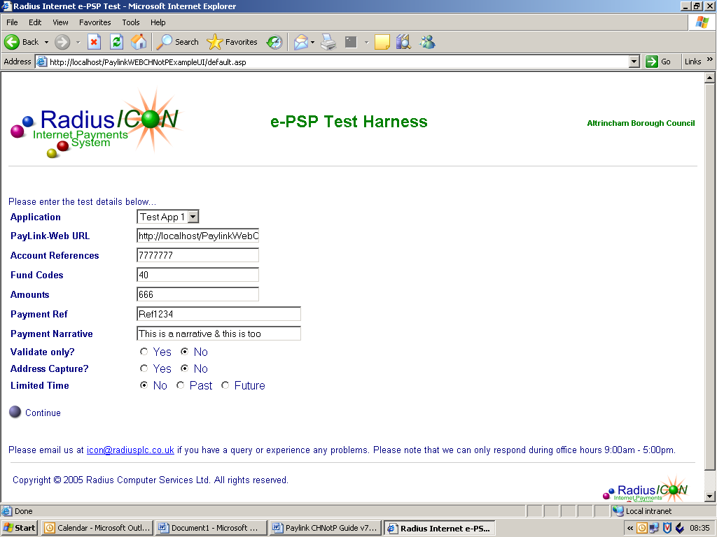
The following screen is the example calling application provided on the CD. This emulates an application that is using Paylink to authorise card payments. It is usefull for testing that Paylink is properly installed and configured before attempting to integrate with customer calling applications.

The following fields are available on this page:

Label | Description
Application | This is a drop down list of each calling application configured in the settings.xml file for the CHNotPExampleUI
PaylinkWEB Url | This points to the directory where the paylink software is installed.  For CHNotP it points to http://ServerName/PaylinkWEBCHNotP/  If you wanted to use the evaluation/non-database version of Paylink, you would change this to http://ServerName/PaylinkWEBCHNotPEval
Account References | e.g. Council tax reference – 12345678  or multiple references – 12345678;5432167
Fund codes | e.g. Council Tax – 01  or multiple funds – 01;02
Amounts | e.g. £10.00 – 10.00  or multiple amounts – 1000;1200  Use PENCE only otherwise will fail with an error.
PaymentRef | Optional – Unique reference generated by the calling application. This is stored on the transaction table in Paylink_Payment_Ref
Payment Narrative | Optional – Free text narrative  e.g. Skip hire  or multiple narratives – Skip hire;Wasp nest
Validate only | True – Validates the Account References, Fund codes and Amounts only. Not card authorisation performed.
Address capture | True – Forces the address capture screen to be displayed.
Limited time | Simulates the VT parameter page expiry

