Installing Contender Public Web Customer Care Forms Application ( Menu Setup )

1) Create the menu items in the W/O menu for the scheduling items. This involves two steps, defining the runners, and then linking them to the new menu items.

Goto the menu options and search for the menu items needed based on Wycombe’s W/O menu system:

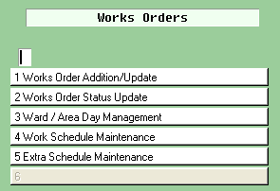

System_Admin -> Menu Maintenance -> Option_Admin

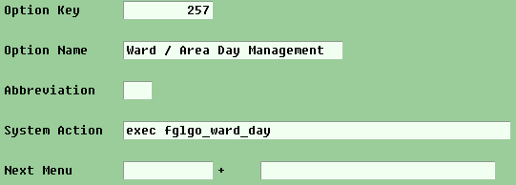

If an item doesn’t exist in the Wandsworth system, create it. From the items above, only the last one ‘Extra Schedule Maintenance’ was not found.

