Installing Contender Public Web Customer Care Forms Application ( User Manual )

Notation:

In this document, a linked list of bold names shows the steps taken to reach a specific menu within Contender.

i.e. Customer_Care/Complaints – Customer_Care-Demo – Join, means the user should select the Customer_Care/Complaints button, then the Customer_Care-Demo button and then the Join button to get to where the document is referring.

Short hands will be used for obvious steps, i.e. getting to the Join menu is different from the Customer Care form than from the Works Order from. Therefore [CC]Join, denoted the user should be in the customer care screen when doing a join, and [W/O]Join means the user should be in the Works Order screen when doing a join.

[W/O] = Works_Orders – Works_Order_Addition/Update
[CC] = Customer_Care/Complaints – Customer_Care-Demo

Installation:

1. Setup Contender Works Orders configuration

Customer_Care/Complaints – Customer_Care-Demo – Join - System_Admin -System_Configuration - Works_Orders

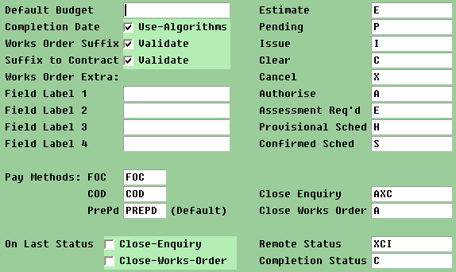

2. Setup the Works Orders Status Levels for all the statuses we setup in step 1.

[W/O] Join – Status_Levels

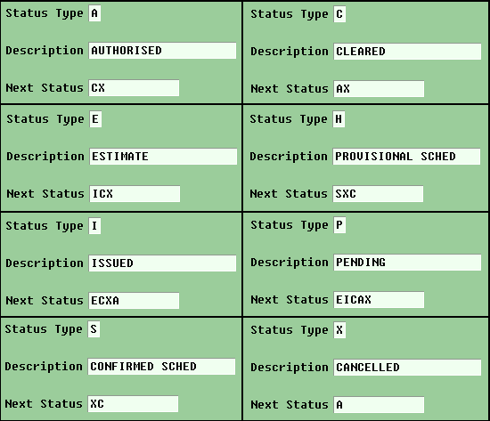

3. Create a new service for Scheduling

[CC]Join - System_Admin - Service Maintenance

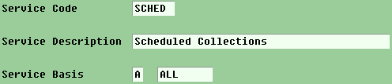

4) Create a new contract for Scheduling Service. This will involve setting up a Contractor for the service is a new one is needed.

Static_Information -> Contract_Information -> Contract_Details

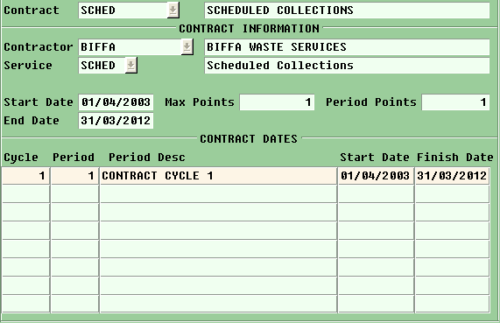

5) Create the new Works Order Type that will be used for the domestic waste scheduled collection service.

[W/O]Joins -> W/O Types

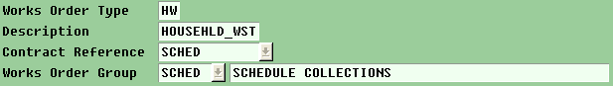

6) Create a new lookup for the Works Order Tasks

[WO]Joins -> Lookups -> insert

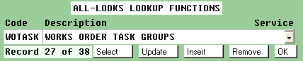

After creating the lookup, press ‘Select’ on the lookup menu to add the ‘SCHED’ code.

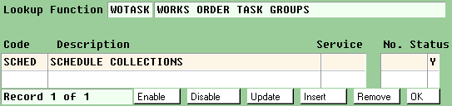

7) Create the new WO Suffixes for the Household Waste WO type

[WO]Join -> Order Suffixes

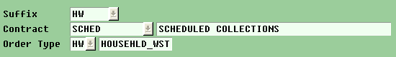

8) Create the Tasks needed for the Household Waste scheduling service. We will need to create a task for each of the surcharges we wish to use, one for the standard rate, i.e. first 1-4 items, and one for the additional item charge rate. In the specification given we have 2 surcharges, one for the ground floor and one for any other floor, so in total we would need to create 4 tasks.

For the Public Web Application to know which rates are for surcharging we need to set the Category in the task to ‘SURCHG’. This is then picked up through a System key in Contender to identify the surcharge tasks for the Household Waste Works Order Type.

Static_Information -> Generic_Information-> Task_Detail -> Add

Ground Floor Surcharge Task
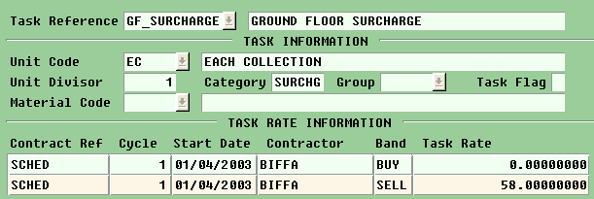

Other Floor Surcharge Task
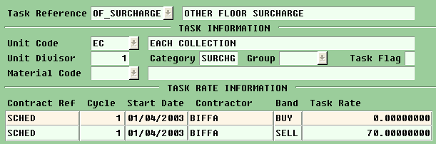

First 4 Items are priced the same Task
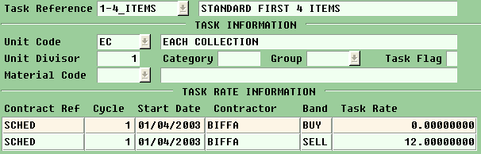

Again, the Public Web Application knows which task to use by a System key that points to this task for charging the first ‘n’ items. The ‘n’ is therefore also configurable through another System key with a number field that defines what ‘n’ should be, in our case the number 4. If we ever change the standard charge rate, the System key would need to be altered as well.

Additional Items Task
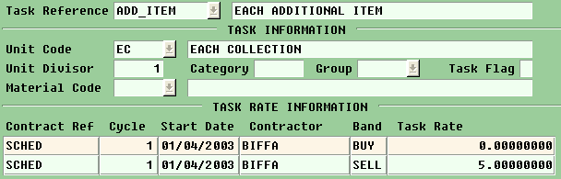

Again the Public Web Application knows this task through the use of a System key. Any number of items above the standard charge rate will be charged using this task.

9) Add the new Item_Type to the lookup table for item type.

[CC] Join -> Lookups -> Item -> Select -> Insert new

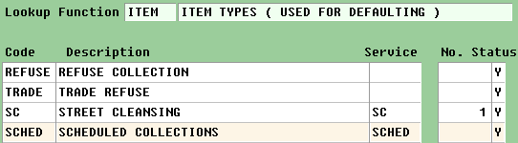

10) Create the new ITEM

Static_information -> Generic -> Item_Details -> Add

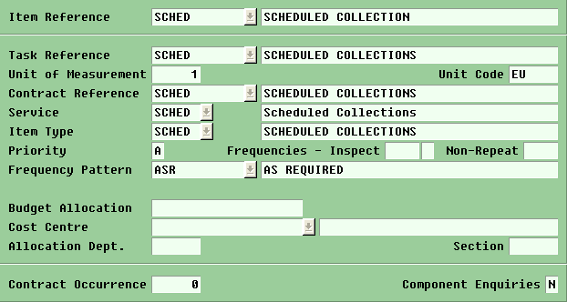

Note: to setup the ASR, you may need to check the Pattern_Date_Details to ensure that the Year we are working under extends to todays date
Static_information -> Generic -> Pattern_Date_Details

11) Go to the lookups and select COMPLA. Insert SCHED code and description if it is not already created

[CC] Join -> Lookups -> COMPLA -> Insert

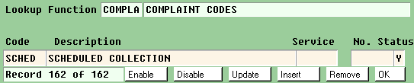

Once created select SCHED and add Item Ref and Description

[CC] Join -> Lookups -> COMPLA -> Select-> Detail (on the right hand menu)

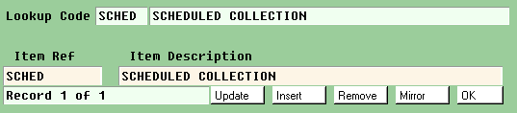

12) Go to the lookups and select DEFRN, find ‘SCHED’ and either delete the entry for defaults or set its value to ‘N’. Same as above

13) Setup the Collection Algorithm Maintenance for the Works Order Type we created, Household Waste.

[CC] Join -> System_Admin -> Collection Algorithm Maintenance -> Add

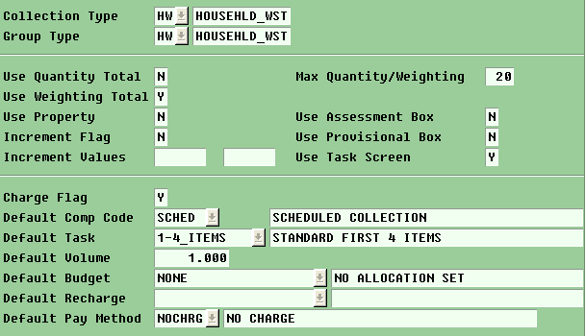

We need to set the weighting total to Y, and the Max Weighting to however many items can be collected on one schedule.

The default task can be set to any of the related task we created earlier, so I have set it to the standard rate which we are sure we will have to charge for any collection.

The default pay method can be set to whatever value is required; otherwise all the other fields should look like the example screen above.

14) We now need to create the Collection Item. Normally there would be several items that would be available for collection, but since we are referring to items by quantity, we will only need to setup one generic collection item.

[CC] Join -> System_Admin -> Collection Item Maintenance -> Add

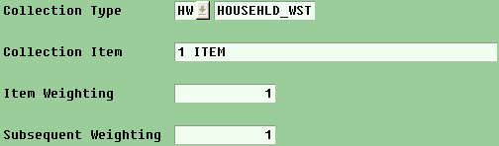

15) To configure what is displayed to the users for this collection item we need to setup a public description.

[CC] Join -> System_Admin -> Public_Descriptions -> Query

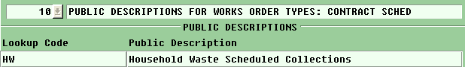

Note that the heading reference is set to 10. This is not as important as when adding the lookup code and description in the ‘PUBLIC DESCRIPTIONS FOR WORKS ORDER TYPES: CONTRACT SCHED’ Heading.

This setting will appear in the first page of the Public Web Application:

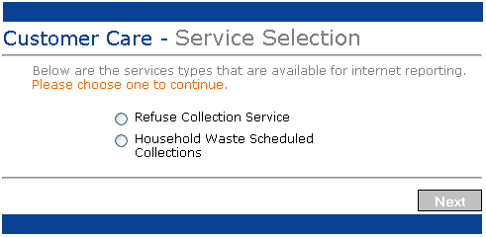

16) Create the public descriptions for the SURCHG Tasks we created previously. Note: The description “Public Descriptions for Tasks” is more important than the ID of 9 which can be different.

[CC] Join -> System_Admin -> Public_Descriptions -> Query

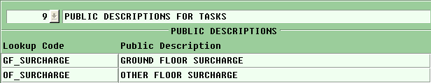

These will be used to display the location for where the SURCHG will be applied.

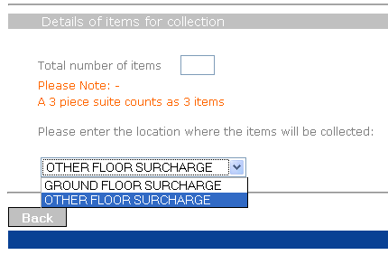

17) Create the Schedule Groups for the Household Waste Collections. A Schedule Group dictates what day a collection is on and which wards/areas will be collected.

It also holds important details on the maximum number of collections that are available on a schedule and the type of waste that is being collected, in our case we will setup several Schedule Groups for our Household Waste Works Order Type, one for each day of the week we need.

[WO] -> Ward/Area_Day_Managment -> Groups -> Add

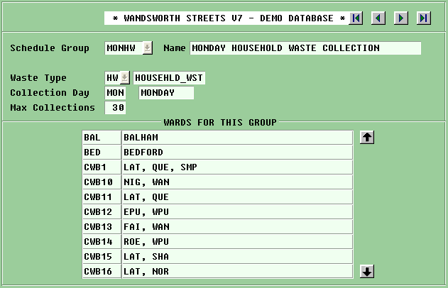

It is important to select Groups upon entering the Collection Day screen, as the Groups menu allows you to enter multiple Collection Days in one go for all the Wards/Areas you want.

The schedule group name should describe the schedule, i.e. Mondays household waste collections is abbreviated to MONHW, you only have 6 characters to play with. You can be more elaborate in the name field.

Once you have entered the Schedule Group Information you will be prompted to add the Wards/Areas for this group. Here click on ‘select All’ in the side menu, to get all the wards/areas, or make a selection of the wards/areas you would like this Schedule to apply to.

Once you are finished select the OK and the Schedule Group will be created.
18) We now have to create the actual Schedules for each day of the year.

[WO] -> Extra_Schedule_Maintenance -> Query

If you enter the name of a Schedule Group you created in the group field, Contender should prompt you with an alert message asking you if you would like to create schedules for this group as there are currently none setup.

Select the dates you wish to schedule the collections for and select ok. This will create the actual Schedule within Contender.

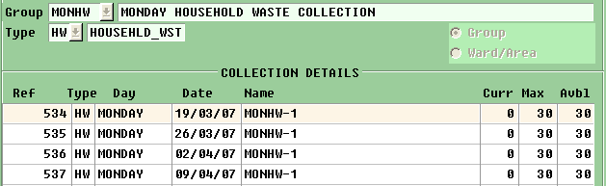

Once you have finished, your screen should display the collection group along with the dates you have created collections for.

These collections will appear in the Public Web Application when a user is selecting the date they wish for their collection.

