**Candidate: 44445**

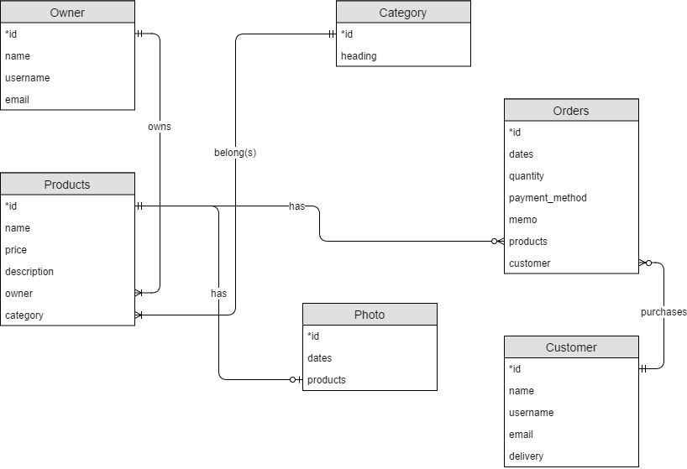

**Description:**

Amazon is one of the online stores which have the earth's biggest selection of books, magazines, music, DVDs, videos, electronics, computers, software, etc. On the one hand, the business model of the Amazon can be robust and well organized. The basic function of this platform is "trade", thus, there are owners, products, ordering sheets and customers that involve in this activity. On the other hand, each product has its own photo which can be a rough demo to display to those customers who want to purchase it. In addition, there are a wide variety of categories which arrange products in that they provide convenience to the owner or customer whether to examine or search.

**Two use cases:**

This query shows the order id and dates in case that the seller can send parcel in time. In addition, the seller can check how much money should he collect and how many items he should prepare via price and quantity. Moreover, delivery can be important before sending to the right customer. Finally, this query can search for a specific customer such as WHERE Customer.name = '?' to examine how many orders does the seller have for now from the same customer:

**SELECT Orders.id, Orders.dates, Customer.name AS customer, Products.name AS product, Products.price, Orders.quantity, Customer.email, Customer.delivery FROM Orders**

**INNER JOIN Customer ON Customer.id = Orders.customer**

**INNER JOIN Products ON Products.id = Orders.products**

**WHERE Customer.name = '?'**

**ORDER BY Orders.dates ASC;**

Comparison can be one of the most important functions in online store, like many people have different kinds of standard. First, a customer must have a desire product, and this product should belong to a specific “category”. As customer can start comparing the price after choosing the category, while Products.price < ? and ORDER BY Products.price DESC or ASC can be easy to sort out the desirable products from a bunch of products which belong to the same category.

**SELECT Owner.name AS owner, Products.name AS product, Products.price, Products.description, Category.heading AS category FROM Owner**

**INNER JOIN Products ON Owner.id = Products.owner**

**INNER JOIN Category ON Products.category = Category.id**

**WHERE Category.heading = '?' AND Products.price > ?**

**ORDER BY Products.price DESC;**