Reproduction Report
Sherman: A Write-Optimized Distributed B+Tree Index on Disaggregated Memory
CS6204 Spring 2026 | Chen-Wei (Wilson) Chang

Abstract
This report begins with a reproduction attempt for Sherman's main performance experiments on c6525-100g CloudLab nodes and then explains why the study had to pivot to r650 for the later stages. On c6525-100g, throughput still increased with read ratio, but we did not observe the uniform/skewed separation shown in the paper. When we later tried to extend the study with CXL-style remote-memory emulation, we found that c6525-100g is single-socket and therefore cannot expose a remote NUMA node. That constraint motivated a move to dual-socket r650 nodes. The r650 follow-up then served two purposes: it enabled the remote-memory experiment and it created a cross-platform comparison with c6525-100g, including a larger HOCL lock table (16,384 versus 8,192 entries). Across both platforms, the missing uniform/skewed separation remained, while the r650 CXL emulation showed a 99.9% cache hit rate and little measurable difference from the baseline. These results should therefore be read as a two-stage study: initial reproduction on c6525-100g, followed by an r650-based dual-socket analysis.

1. Overview
Sherman is a write-optimized distributed B+Tree index designed for disaggregated memory. Its main idea is Hardware-Offloaded Concurrent Locks (HOCL), which use the on-chip SRAM of RDMA NICs as a lock table and thereby reduce remote RDMA round-trips during lock acquisition. In the paper, this design yields 24.7x higher throughput on write-only workloads and 23.6x higher throughput on write-intensive skewed workloads relative to FG+.

This report has a two-stage goal structure. First, it reproduces Sherman's main experiments for Figures 10 and 11 as closely as CloudLab allows on c6525-100g. Second, after c6525-100g proved unable to support CXL-style emulation because it is single-socket, it pivots to r650 to continue the study on a dual-socket platform. That second stage is not only about remote-memory sensitivity; it also provides a direct cross-platform comparison with c6525-100g, letting us ask whether the behavior seen in the initial reproduction persists after the platform changes.

2. Experimental Setup and Why the Platform Changed

2.1 Hardware, Software, and Workload Comparison
We used a reduced two-node CloudLab deployment, with one memory server and one compute server per node, instead of the paper's 16-node setup. The study started on c6525-100g machines in the Utah cluster, where we collected the main reproduction results. Later, when the project turned to CXL-style remote-memory emulation, we moved that follow-up stage to r650 machines in the Clemson cluster because only the dual-socket r650 exposes a remote NUMA node.

CXL emulation requires two physical CPU sockets. The c6525-100g platform is single-socket (AMD EPYC 7402P) and therefore has no remote NUMA node, which made it suitable for the initial reproduction but not for the later remote-memory study. The r650 is dual-socket (2x Intel Xeon Platinum 8360Y), so placing the Memory Server on the remote socket across the Intel UPI interconnect provides a coarse analog for CXL. This hardware difference is the main reason the study pivots from c6525-100g to r650.

2.2 Why c6525 Led Us to r650 and What That Changed
Table 1 separates the paper's setup from the two platforms used in this report and makes their roles explicit. c6525-100g is the initial reproduction platform. r650 becomes the dual-socket follow-up platform after the CXL question appears, and that move also creates a useful cross-platform comparison for interpreting the c6525-100g results.
The workload structure still follows Figures 10 and 11 in the paper: uniform (zipfian=0) and skewed (zipfian=0.99) access patterns, each tested at 0%, 50%, and 95% reads. However, our runs used 44 total threads rather than the paper's 176, so absolute throughput should be read as a reduced-scale reproduction rather than a direct paper-scale comparison.

Table 1. Original paper setup versus the two platforms used across the study.
Component | Paper | Reproduction (c6525-100g) | Extended Analysis (r650)
Nodes | 8 MSs + 8 CSs (16 total) | 2x CloudLab c6525-100g (Utah) | 2x CloudLab r650 (Clemson)
CPU | 2x Intel Xeon E5-2650 v4 @ 2.2GHz | 24-core AMD EPYC 7402P @ 2.80GHz | 2x 36-core Intel Xeon Platinum 8360Y @ 2.4GHz
RAM | 128GB per node | 128GB ECC | 256GB ECC DDR4
NIC (experiment) | ConnectX-5, 100Gbps | ConnectX-5 Ex 100GbE (mlx5_2) | ConnectX-6 100GbE (mlx5_2)
On-chip memory | 256KB | 64KB | 128KB
Lock table entries | 131,072 | 8,192 | 16,384
NUMA nodes | N/A | 1 (no CXL emulation) | 2 (supports CXL emulation)
OS | CentOS 7.7, kernel 3.10.0 | Ubuntu 20.04, MLNX_OFED 4.9 | Ubuntu 20.04, MLNX_OFED 4.9
Threads | 22/node (176 total) | 22/node (44 total) | 22/node (44 total)
Role in report | Original system evaluated in the paper | Initial reproduction platform and first source of mismatch observations | Dual-socket follow-up platform for CXL-style emulation and cross-platform comparison

3. Environment Issues That Affected Benchmark Correctness and Stability
Before we could collect benchmark data, we had to resolve several environment problems that affected correctness, network-path selection, run stability, or the interpretation of the extended CXL-style experiment. Appendix A keeps the command-level details; here we retain only the issues needed to understand the reported results.

3.1 MLNX_OFED Library Version Conflict
Sherman depends on the ibv_exp_* experimental API (MLNX_LIBS version 41mlnx1), whereas the default MLNX_OFED installation provides UPSTREAM_LIBS (version 50mlnx1), which lacks that API and conflicts with Ubuntu's ibverbs-providers package. We therefore switched to the MLNX_LIBS libibverbs path required by Sherman.

3.2 On-Chip Memory Size Detection
The original code hardcodes kLockChipMemSize = 256 * 1024, but ibv_exp_alloc_dm() could allocate only 64KB on c6525-100g and 128KB on r650. To handle this, setup.sh probes the actual allocatable limit and patches kLockChipMemSize automatically. Combined with the open-source repository's uint64_t lock entries, this leaves 8,192 lock entries on c6525-100g and 16,384 on r650.

3.3 RDMA Network Interface Selection
On every node type we used, mlx5_2 maps to the 100Gbps experiment network. However, src/rdma/Resource.cpp selects the first device whose name ends in '0', which defaults to the control network. We patched the selection logic to use the device ending in '2' and confirmed the traffic path with mlx5 port counters.

3.4 memcached Coordination State
Sherman uses memcached_increment on the key serverNum to assign node IDs. If that key is missing, the benchmark hangs. After each run, stale QP connection keys can also prevent the next run's Queue Pairs from reaching Ready-to-Send (RTS) state. We therefore initialized serverNum before each run and cleared stale coordination state between runs.

3.5 Execution Controls
Running setup.sh with sudo can leave build artifacts owned by root, which blocks later rebuilds until ownership is fixed. The benchmark also inserts about 50 million key-value pairs before measurement; on both platforms, warmup took about 17-18 seconds, so we used a 150-second total timeout.

3.6 Cross-NUMA Hugepage Migration for CXL Emulation
Using numactl --cpunodebind=0 --membind=1 on the Memory Server caused a bus error during RDMA initialization. One possible explanation is that ibv_reg_mr() fails when hugepages are allocated on a NUMA node other than the one attached to the NIC's PCIe path, but we did not instrument the failure path directly. We therefore implemented the r650 CXL-style experiment by migrating hugepages to node 1 at the OS level before launch.

4. Reproduction Results and Comparison with the Paper (c6525-100g, Utah Cluster)
This section reports the reproduction of the paper's original results on c6525-100g. All benchmarks used mlx5_2 (ens1f0, 10.10.1.x, 100Gbps). Because our deployment uses 44 total threads rather than the paper's 176, absolute throughput comparisons should be interpreted with that scale difference in mind.

4.1 Uniform Workloads (Figure 11)
Workload: zipfian=0, 22 compute threads per node (44 total).

Table 2. c6525-100g uniform workloads versus the paper (paper Figure 11 comparison).
Workload | Read Ratio | Our Tput (Mops) | Paper (Mops) | Our p50 (us) | Paper p50 (us) | Our p99 (us) | Paper p99 (us)
Write-only | 0% | 3.06 | 16.04 | 8.0 | 10.7 | 173 | 17.5
Write-intensive | 50% | 5.57 | 21.53 | 6.5 | 8.0 | 45 | 15
Read-intensive | 95% | 9.75 | 32.4 | 4.1 | 5.0 | 12.9 | 12.1

Throughput rises from 3.06 to 9.75 Mops as the read ratio increases, matching the paper's overall trend. One possible explanation for the higher p99 latency on write-heavy workloads, around 173 us, is the lack of PFC configuration for RoCE v2 on CloudLab's experiment network, although we did not directly measure retransmissions.
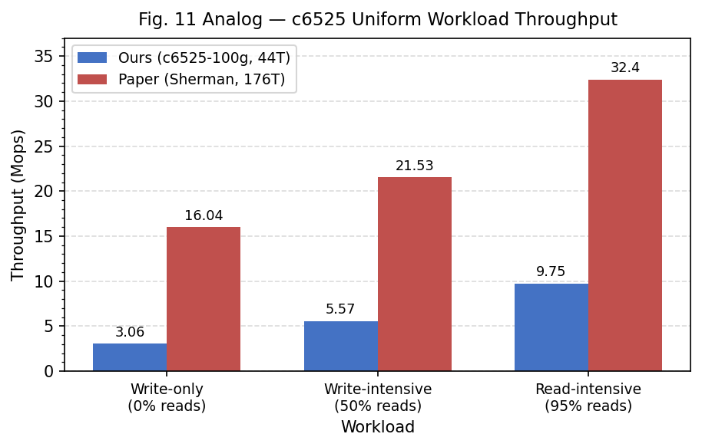
Figure 1. c6525-100g uniform workload throughput versus the paper.
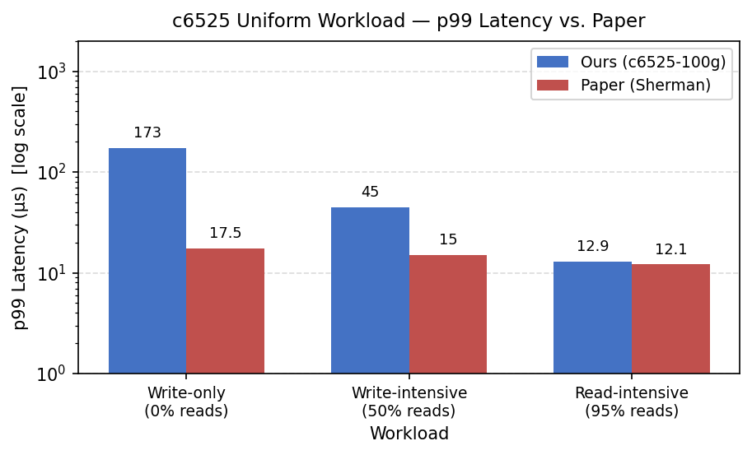
Figure 2. c6525-100g uniform workload p99 latency versus the paper.

4.2 Skewed Workloads (Figure 10)
Workload: zipfian=0.99, 22 compute threads per node (44 total).

Table 3. c6525-100g skewed workloads versus the paper (paper Figure 10 comparison).
Workload | Read Ratio | Our Tput (Mops) | Paper (Mops) | Our p50 (us) | Paper p50 (us) | Our p99 (us) | Paper p99 (us)
Write-only | 0% | 3.06 | 4.14 | 8.4 | 9.6 | 174 | 1136
Write-intensive | 50% | 5.57 | 8.02 | 6.5 | 6.9 | 44 | 209
Read-intensive | 95% | 9.77 | 33.8 | 4.0 | 4.8 | 12.9 | 47

The skewed results are almost identical to the uniform ones. Our p99 latency differs by barely anything between the two workloads (174 us versus 173 us), whereas the paper reports a much larger gap (1136 us versus 17.5 us). In our setup, this pattern is consistent with the reduced 8,192-entry lock table approaching saturation under both access patterns, which would obscure the separation seen in the paper.
Because the main mismatch in our reproduction is the missing separation between uniform and skewed write-heavy workloads, the next subsection asks whether reduced lock-table capacity is a plausible explanation within our environment.
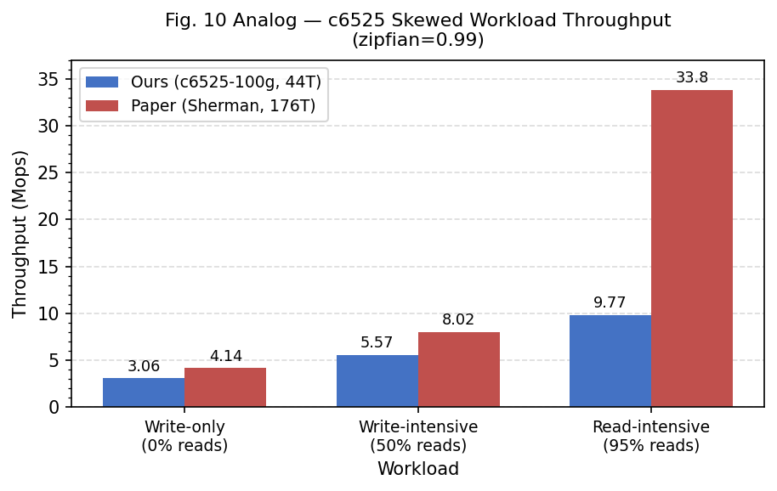
Figure 3. c6525-100g skewed workload throughput versus the paper.
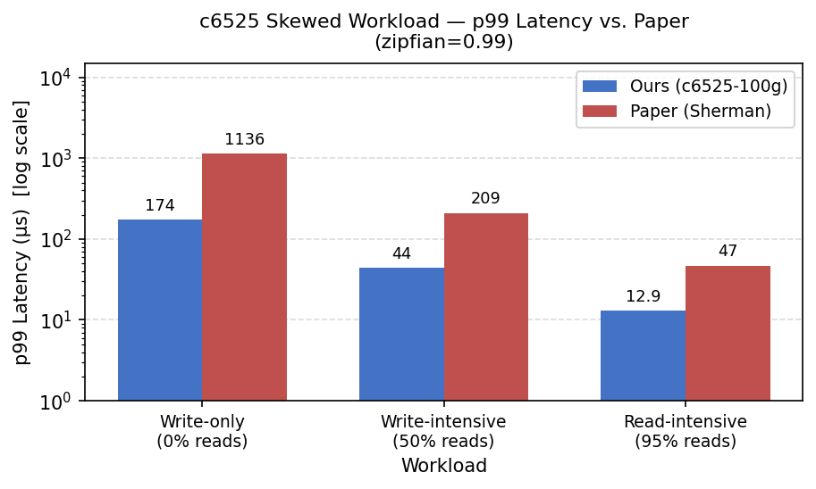
Figure 4. c6525-100g skewed workload p99 latency versus the paper.

4.3 Observed Limitation: Lock Table Saturation
The lock table contains far fewer entries in our setup: kLockChipMemSize = 64KB, so kNumOfLock = 64*1024 / sizeof(uint64_t) = 8,192 entries, which is 16x fewer than the paper's 131,072. Part of that reduction comes from the open-source repository using uint64_t rather than the paper's 16-bit CAS-based representation.

Figure 5. Source-level lock-table size used in the open-source code.

Uniform and skewed write-only workloads produced essentially the same result: 3.06 Mops cluster throughput in both cases, with p99 latency of 173 us versus 174 us, a difference below 0.3%. That is consistent with nearly the same lock-contention behavior under the constraints of our setup.

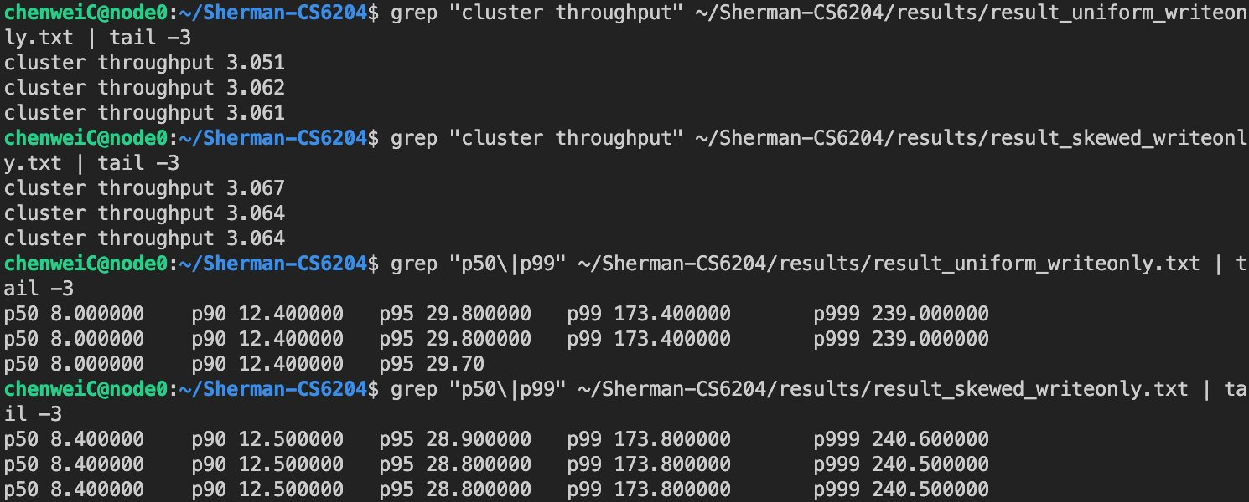
Figure 6. Result excerpt showing nearly identical uniform and skewed write-only throughput and p99 latency on c6525-100g.

Git history provides an additional sanity check. Commit bb57f76 (2026-02-15) changes zipfian from 0 to 0.99 in test/benchmark.cpp. The uniform results were collected before this commit and the skewed results after it, confirming that the two workloads were run from separate binaries.

4.4 Reproduction Summary: Matches, Differences, and Explanations
Several parts of the reproduction still track the paper. First, throughput increases monotonically with read ratio for both uniform and skewed workloads (write-only < write-intensive < read-intensive), which matches Sherman's design. Second, p50 latency remains close to the paper for write-only (8.0 us versus 10.7 us) and write-intensive (6.5 us versus 8.0 us) workloads, both within 15%. This is consistent with some fast-path behavior being close to the paper, but we did not directly instrument RDMA verb counts or B+Tree traversal depth, so the latency match alone cannot establish those mechanisms. Third, read-intensive p99 latency (12.9 us) is nearly identical to the paper's 12.1 us, which is consistent with reads bypassing the lock table.
The differences are just as clear. Absolute throughput is 4 to 5x lower across all workloads; for example, uniform write-only reaches 3.06 Mops here versus 16.04 Mops in the paper. The most direct reason is scale: the paper uses 8 Memory Servers and 8 Compute Servers, for 176 total threads, while our setup uses 2 nodes and 44 threads. A 4x reduction in thread count would be expected to lower aggregate throughput accordingly. The second gap is that the paper's uniform/skewed throughput separation, such as 16.04 versus 4.14 Mops for write-only, disappears in our results, where both cases are 3.06 Mops. That behavior is consistent with lock-table saturation. With only 8,192 HOCL entries, or 16x fewer than the paper's 131,072, both access patterns may hit the same bottleneck and therefore lose the separation reported in the paper. A third difference is the elevated p99 latency for uniform write-heavy workloads (173 us versus 17.5 us). One plausible reason is that Priority Flow Control was not configured for RoCE v2 on the CloudLab experiment network, which could increase RDMA retransmission and inflate tail latency; the much less affected p50 is consistent with that explanation. Overall, we were not able to reproduce the paper's large separation between uniform and skewed write-heavy workloads, and reduced HOCL capacity remains the most plausible explanation supported by our setup and measurements.

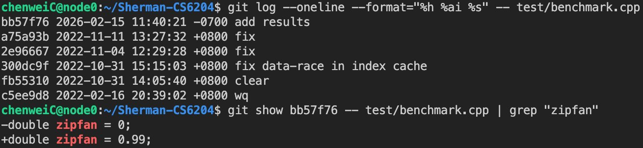
Figure 7. Git history showing the zipfian change used for the skewed runs.

5. Why We Moved from c6525 to r650: Dual-Socket Follow-Up and Cross-Platform Analysis
Section 4 established the main reproduction behavior on c6525-100g, but it also exposed the next question: could we examine remote-memory sensitivity more directly? The answer on c6525-100g was no, because the machine is single-socket and cannot provide a remote NUMA node. That limitation forced a pivot to r650. The move is important for two reasons. First, it enables the dual-socket CXL-style emulation that c6525-100g cannot support. Second, it turns the later stage of the project into a cross-platform comparison, because r650 changes socket topology, CPU family, NIC generation, and HOCL on-chip memory size at the same time.

5.1 Why r650 Became the Follow-Up Platform
Table 4. r650 baseline and CXL-emulated setup parameters.
Parameter | Value
Node type | CloudLab r650 (Clemson cluster)
CPU | 2x 36-core Intel Xeon Platinum 8360Y @ 2.4GHz
NUMA nodes | 2 (interleaved per-core: even cores on node 0, odd on node 1)
NUMA distance | 10 (local) / 20 (remote), ratio 2.0x
On-chip memory | 128KB (16,384 lock entries)
NIC (experiment) | ConnectX-6 100GbE (mlx5_2, ens2f0, 10.10.1.x)
CXL emulation method | Hugepage migration to node 1 (numactl --membind=1 caused bus error)

On the r650, the NUMA distance ratio is 2.0x (20/10). Sherman itself required no code changes; the emulation is performed entirely at the OS level. Group 1, the r650 baseline, runs without NUMA binding. Group 2, the r650 CXL-emulated configuration, uses hugepage migration to place the Memory Server's data on node 1 (see Section 3.6). Just as importantly, the r650 baseline is not only a pre-CXL control. Because the project arrived at r650 after the initial c6525-100g reproduction, it also serves as a second platform for checking whether the c6525-100g behavior was tied to that single-socket machine alone.

5.2 r650 Baseline Results

5.2.1 Uniform Workloads (zipfian=0)
Table 5. r650 baseline uniform workloads versus the paper.
Workload | Read Ratio | Our Tput (Mops) | Paper (Mops) | Our p50 (us) | Paper p50 (us) | Our p99 (us) | Paper p99 (us)
Write-only | 0% | 2.39 | 16.04 | 9.5 | 10.7 | 241 | 17.5
Write-intensive | 50% | 4.42 | 21.53 | 7.5 | 8.0 | 67 | 15
Read-intensive | 95% | 8.26 | 32.4 | 4.1 | 5.0 | 16.6 | 12.1

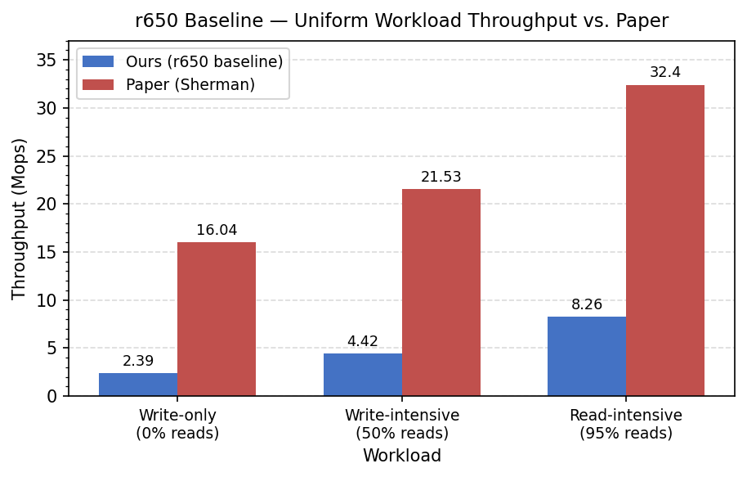
Figure 8. r650 baseline uniform workload throughput versus the paper.

5.2.2 Skewed Workloads (zipfian=0.99)
Table 6. r650 baseline skewed workloads versus the paper.
Workload | Read Ratio | Our Tput (Mops) | Paper (Mops) | Our p50 (us) | Paper p50 (us) | Our p99 (us) | Paper p99 (us)
Write-only | 0% | 2.40 | 4.14 | 9.5 | 9.6 | 238 | 1136
Write-intensive | 50% | 4.40 | 8.02 | 7.6 | 6.9 | 68 | 209
Read-intensive | 95% | 8.29 | 33.8 | 4.1 | 4.8 | 16.5 | 47

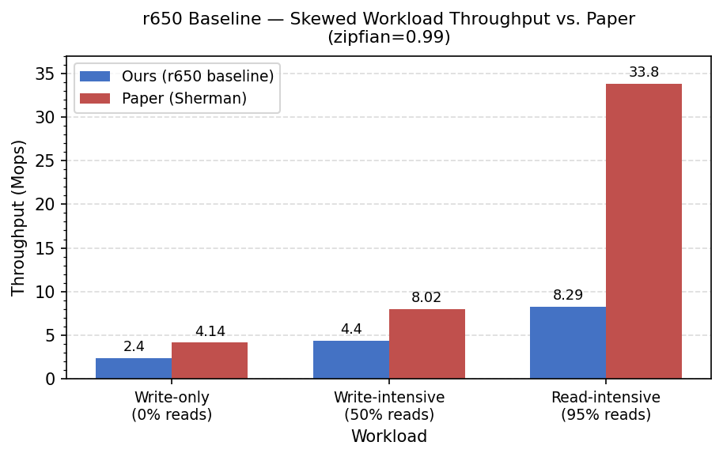
Figure 9. r650 baseline skewed workload throughput versus the paper.

5.3 Cross-Platform Comparison: What Changed After the Move to r650
Table 7. Cross-platform lock-table behavior on c6525-100g and the r650 baseline.
Workload | c6525-100g Tput | r650 Baseline Tput | c6525-100g p99 (us) | r650 Baseline p99 (us)
Write-only uniform | 3.06 | 2.39 | 173 | 241
Write-intensive uniform | 5.57 | 4.42 | 45 | 67
Read-intensive uniform | 9.75 | 8.26 | 12.9 | 16.6
Write-only skewed | 3.06 | 2.40 | 174 | 238
Write-intensive skewed | 5.57 | 4.40 | 44 | 68
Read-intensive skewed | 9.77 | 8.29 | 12.9 | 16.5

Because the move to r650 was motivated by the CXL question rather than by reproduction alone, the r650 baseline also becomes a natural cross-platform check against c6525-100g. It changes several factors at once: socket topology, CPU family, NIC generation, and HOCL lock-table capacity. That means the comparison does not isolate one variable, but it is still informative. The r650 baseline has a larger lock table than c6525-100g, 16,384 entries versus 8,192, yet it still shows lower absolute throughput. One possible explanation is higher per-operation RDMA latency on the Intel Xeon 8360Y platform, or cross-socket overhead even for nominally local memory accesses in a dual-socket machine. We did not isolate these factors, so they should be read as hypotheses rather than direct measurements.

The same uniform/skewed convergence also appears on r650: write-only throughput is 2.39 Mops for uniform and 2.40 Mops for skewed, with p99 latency of 241 us versus 238 us, a difference below 1.5%. This mirrors the c6525-100g reproduction, where both cases reached 3.06 Mops. Even with twice as many lock entries, r650 shows the same pattern. That makes the missing separation harder to dismiss as a c6525-only artifact. At the same time, Figure 13 shows that moving to r650 does not simply improve the baseline across the board: throughput is lower and p99 latency is higher for every workload. The cross-platform comparison therefore supports a narrower claim. The convergence pattern persists across both nodes, while the absolute performance level remains platform-sensitive.
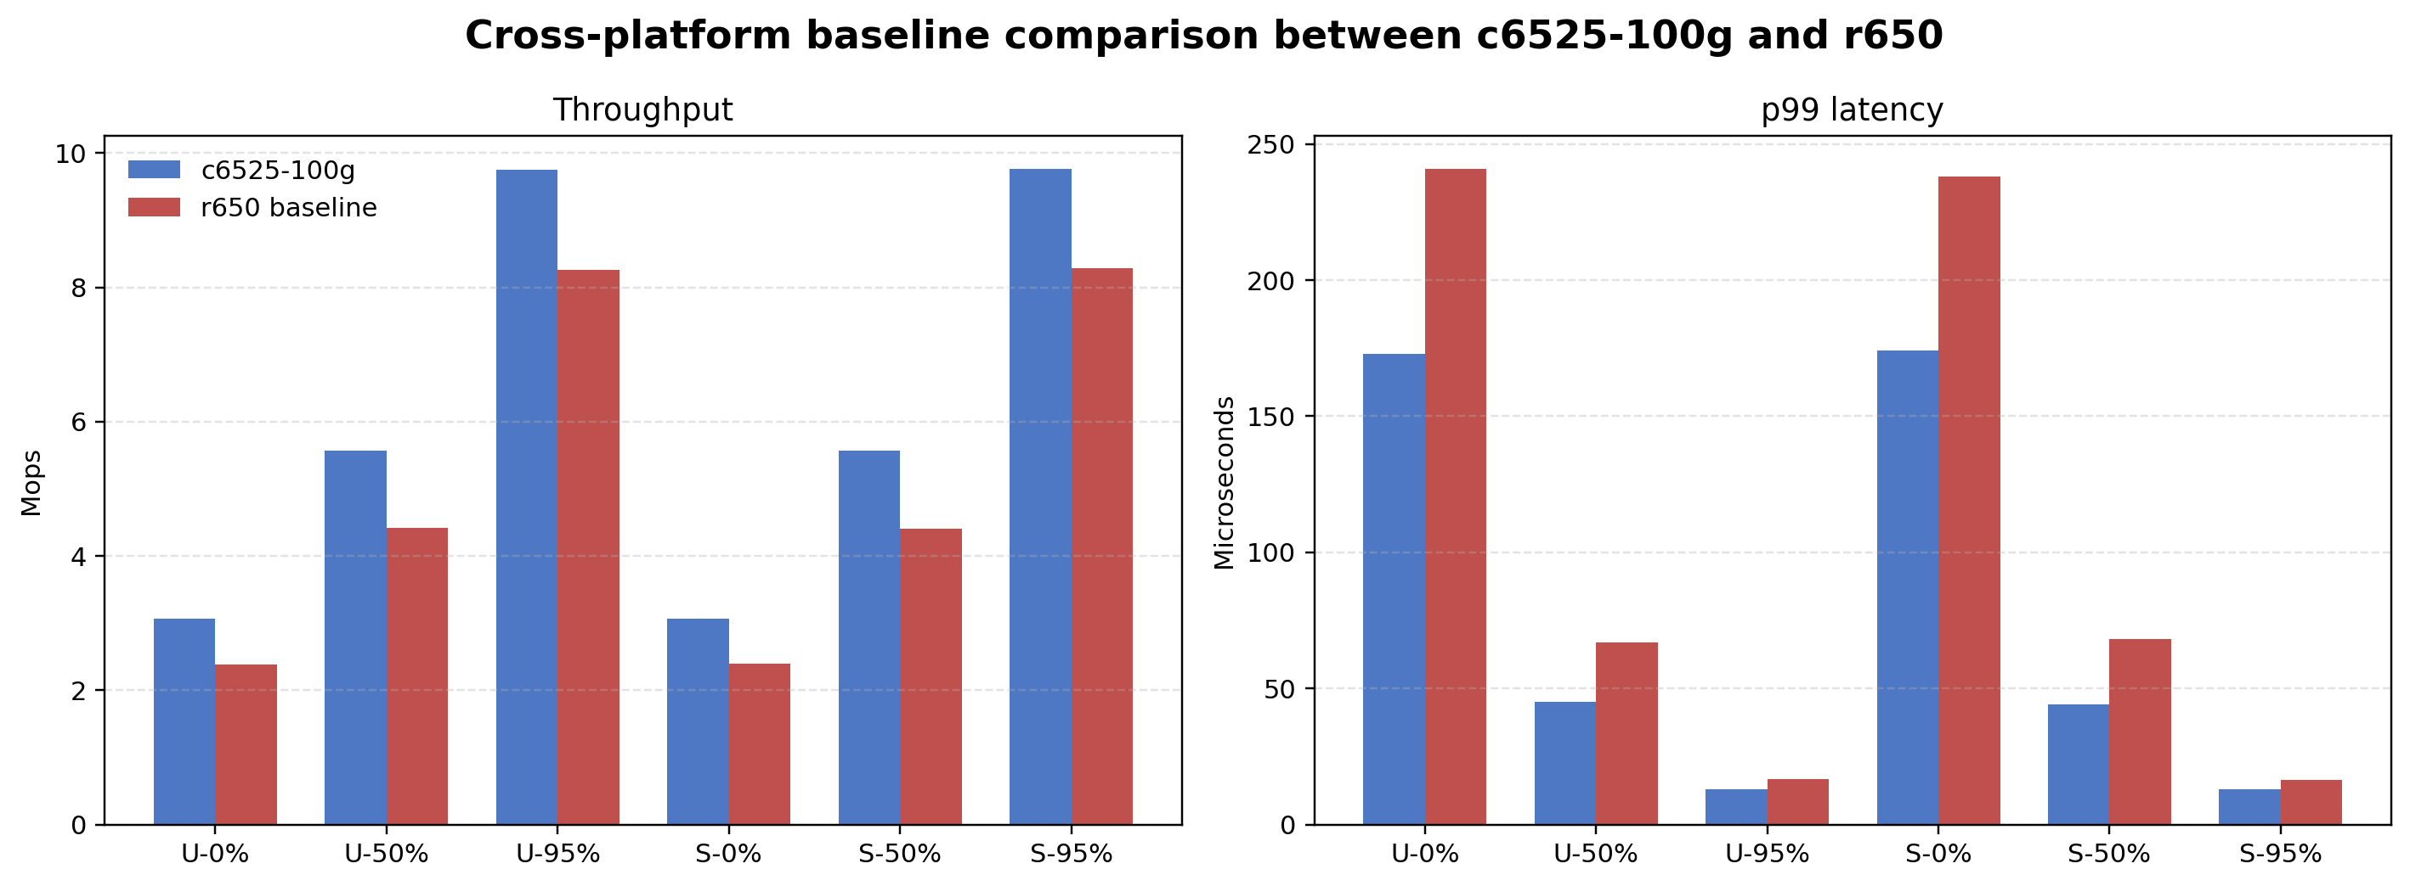
Figure 13. Cross-platform baseline comparison between c6525-100g and r650.
This visual comparison is useful because it shows both sides of the platform change at once. Switching from c6525-100g to r650 doubled the available lock-table entries, but it did not recover the uniform/skewed split reported in the paper. Instead, the move mainly changed the absolute throughput and latency level. That is why the r650 stage should be read as both a necessary dual-socket follow-up for CXL-style emulation and a cross-platform check on the earlier c6525-100g observations.
Having shown that the convergence pattern persists after the move to r650, the next subsection asks whether remote-memory placement produces a measurable performance change under the CXL-style emulation.

5.4 CXL-Emulated Results

5.4.1 Uniform Workloads (zipfian=0)
Table 8. r650 CXL-emulated uniform workloads versus the r650 baseline.
Workload | Read Ratio | CXL Tput (Mops) | Baseline Tput (Mops) | CXL p50 (us) | Baseline p50 (us) | CXL p99 (us) | Baseline p99 (us)
Write-only | 0% | 3.46 | 2.39 | 10.6 | 9.5 | 19.2 | 241
Write-intensive | 50% | 4.96 | 4.42 | 7.7 | 7.5 | 18.0 | 67
Read-intensive | 95% | 8.28 | 8.26 | 5.4 | 4.1 | 16.5 | 16.6

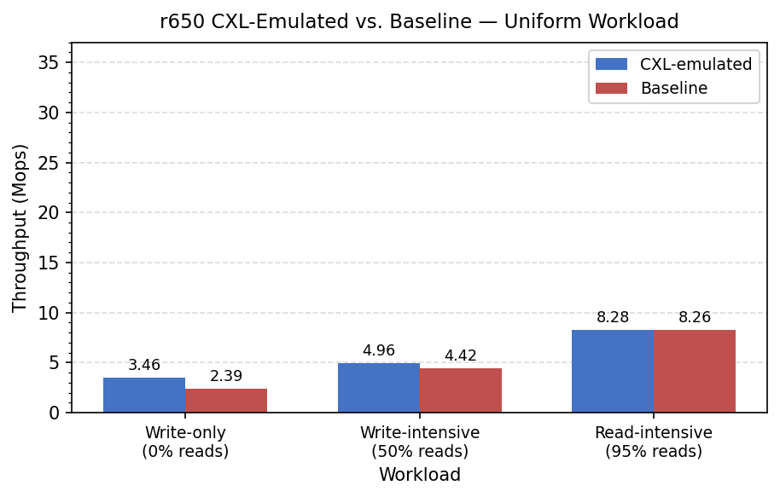
Figure 10. r650 CXL-emulated uniform workload throughput versus the r650 baseline.

5.4.2 Skewed Workloads (zipfian=0.99)
Table 9. r650 CXL-emulated skewed workloads versus the r650 baseline.
Workload | Read Ratio | CXL Tput (Mops) | Baseline Tput (Mops) | CXL p50 (us) | Baseline p50 (us) | CXL p99 (us) | Baseline p99 (us)
Write-only | 0% | 2.39 | 2.40 | 9.4 | 9.5 | 242 | 238
Write-intensive | 50% | 4.43 | 4.40 | 7.5 | 7.6 | 67 | 68
Read-intensive | 95% | 8.30 | 8.29 | 4.1 | 4.1 | 16.5 | 16.5

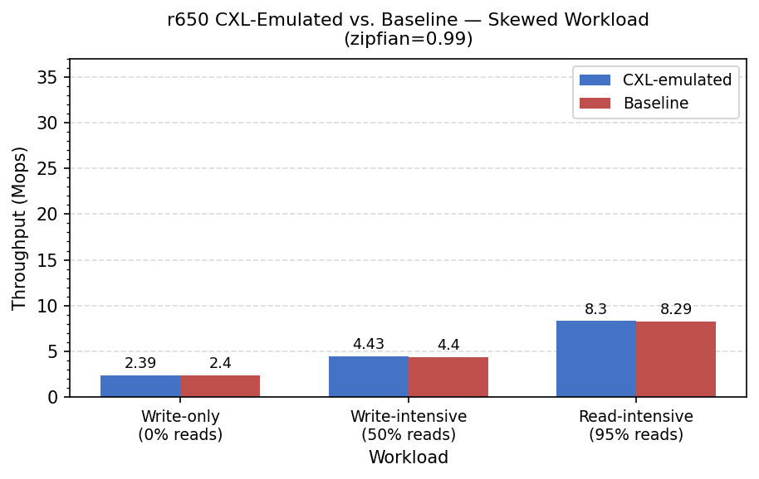
Figure 11. r650 CXL-emulated skewed workload throughput versus the r650 baseline.
A key observation is that the cache hit rate stabilized at 99.9% across all six workloads. Under that condition, the CXL emulation introduced little observable overhead, which is consistent with Sherman's index cache absorbing most of the added remote-memory latency once the tree is warm. One anomaly is that the CXL uniform write-only run, at 3.46 Mops and 19.2 us p99, appears better than the baseline, which is 2.39 Mops and 241 us p99. One plausible explanation is run-to-run variance across separately provisioned sessions; the skewed workloads, collected within the same session, remain nearly identical at 2.39 versus 2.40 Mops. We therefore interpret the overall CXL overhead in this experiment as small, while noting that the conclusion rests on limited runs and does not directly prove the underlying mechanism.

5.5 Sensitivity Analysis of CXL Emulation
Relative to the baseline, the CXL throughput results can be summarized simply. For uniform workloads, the CXL-emulated runs are equal to or slightly above the baseline: write-only 3.46 versus 2.39 Mops, write-intensive 4.96 versus 4.42 Mops, and read-intensive 8.28 versus 8.26 Mops. For skewed workloads, all differences stay below 0.03 Mops. The uniform write-only anomaly, where CXL appears 45% faster than the baseline, is more consistent with run-to-run variance across separately provisioned CloudLab sessions than with a real CXL benefit. The skewed experiments, collected within a single session, show no directional bias, which is consistent with that interpretation, although it does not prove it.
The lack of measurable CXL overhead in this study is plausibly related to cache behavior. Sherman's index cache maintained a 99.9% hit rate across all six workloads after warmup. At that level, fewer than 1 in 1,000 operations fetch a page from the Memory Server's hugepage region on NUMA node 1. The NUMA latency penalty, with a distance ratio of 2.0x and roughly 80-120 ns of added access latency, is therefore mostly absorbed by the cache and does not show up at the cluster-throughput level. Measuring CXL overhead more sensitively would likely require a working set larger than the 1 GB cache, or an intentional cache-bypass mode. This should be read as a limitation of the current experimental design rather than a defect in the emulation method.

6. Conclusion
This report has two scopes: a reduced-scale reproduction of Sherman's main benchmark trends on CloudLab, and a broader but still limited analysis of lock-table capacity and remote-memory sensitivity. Across both parts, the core RDMA B+Tree functionality operated successfully on the available platforms.

The main deviation from the paper is the lock-table size: 8,192 entries on c6525-100g and 16,384 on r650, versus 131,072 in the paper. The study therefore unfolds in two linked stages rather than one fixed platform. c6525-100g provides the initial reproduction and exposes the missing uniform/skewed separation. r650 then becomes necessary for the dual-socket follow-up and, in doing so, also provides a cross-platform check. In both environments, uniform and skewed write-heavy workloads converge to nearly the same throughput and latency instead of diverging as reported in the paper. That pattern is consistent with lock-table saturation masking HOCL's advantage. Observing the same behavior on two platforms makes a purely hardware-specific artifact less likely, although our experiments do not isolate lock-table size as the only cause.

In the extended analysis, CXL emulation via hugepage migration produced a 99.9% cache hit rate across all workloads and little measurable performance difference from the baseline. That outcome is broadly consistent with Sherman's design goal of minimizing remote-memory round-trips through caching. These results should be read as limitation and sensitivity analysis rather than as a dedicated attempt to break the index. They suggest that Sherman's HOCL advantage is sensitive to NIC on-chip memory capacity and the lock-entry representation used in the open-source code, while the cache design appears relatively robust to moderate cross-socket memory latency once the system is warmed up.

7. Reproduction Artifacts
Table 10. Reproduction artifacts and repository locations.
Artifact | Description | Location
setup.sh | Automated node configuration script | github.com/wilsonchang17/Sherman-CS6204
RUNBOOK.md | Step-by-step experiment execution guide | github.com/wilsonchang17/Sherman-CS6204
results/c6525_baseline/ | Reproduction raw benchmark output (6 workloads) | github.com/wilsonchang17/Sherman-CS6204
results/r650_baseline/ | Extended-analysis baseline output (6 workloads) | github.com/wilsonchang17/Sherman-CS6204
results/r650_cxl/ | Extended-analysis CXL-emulated output (6 workloads) | github.com/wilsonchang17/Sherman-CS6204

All result files: https://github.com/wilsonchang17/Sherman-CS6204/tree/main/results

Appendix A. Selected Command-Level Setup Notes
This appendix gathers representative command snippets and screenshots retained from the original environment-setup writeup.

A.1 MLNX_OFED Library Version Conflict
The commands below are reproduced exactly as they were used in the original writeup.
sudo dpkg --remove --force-depends ibverbs-providers python3-pyverbs
sudo apt-mark hold ibverbs-providers python3-pyverbs
sudo dpkg -i ${MLNX_LIBS}/libibverbs1_41mlnx1-*.deb

A.2 On-Chip Memory Size Detection
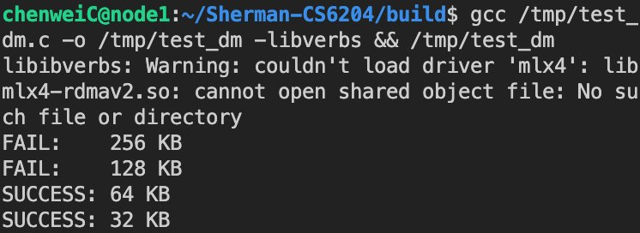
Figure A1. Detected on-chip memory allocation limit on c6525-100g.

A.3 RDMA Network Interface Verification
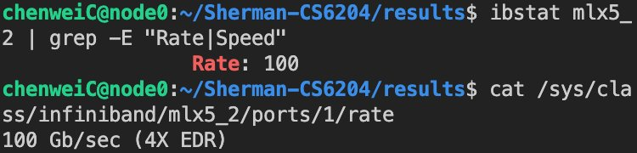
Figure A2. Verification that mlx5_2 maps to the 100 Gbps experiment network.

A.4 memcached Reset Before Each Run
The original writeup used the following reset commands before rerunning the benchmark.
echo -e "flush_all\r\n" | nc 10.10.1.1 11211
echo -e "set serverNum 0 0 1\r\n0\r" | nc 10.10.1.1 11211

A.5 Cross-NUMA Hugepage Migration for CXL Emulation
The original writeup used the following hugepage migration commands for the r650 CXL-style experiment.
echo 0 | sudo tee /sys/devices/system/node/node0/hugepages/hugepages-2048kB/nr_hugepages
echo 5120 | sudo tee /sys/devices/system/node/node1/hugepages/hugepages-2048kB/nr_hugepages

