Reproduction Report
Sherman: A Write-Optimized Distributed B+Tree Index on Disaggregated Memory
CS6204 Spring 2026 | Chen-Wei (Wilson) Chang

Abstract
This report begins with a reproduction attempt for Sherman's main performance experiments on c6525-100g CloudLab nodes and then explains why the study had to pivot to r650 for the later stages. On c6525-100g, throughput still increased with read ratio, but we did not observe the uniform/skewed separation shown in the paper. When we later tried to extend the study with CXL-style remote-memory emulation, we found that c6525-100g is single-socket and therefore cannot expose a remote NUMA node. That constraint motivated a move to dual-socket r650 nodes. The r650 follow-up then served two purposes: it enabled the remote-memory experiment and it created a cross-platform comparison with c6525-100g, including a larger HOCL lock table (16,384 versus 8,192 entries).
Across both platforms, the missing uniform/skewed separation remained. The initial r650 NUMA-based CXL emulation measured about a 99.9% index-cache hit rate. Most skewed workloads showed little measurable difference from the baseline, while the uniform write-only run showed an anomalous improvement that is more likely due to run-to-run variance than a real CXL benefit. A later cache-size sensitivity run reduced kIndexCacheSize from 1000 MB to 4 MB after a 64 MB trial still produced near-99% hit rates. With 4 MB, the in-run cache hit rates dropped to roughly 32-65% and latency increased, but the hit rates were still rising after 150 seconds, so those numbers should be interpreted as non-steady-state sensitivity evidence rather than final stable performance.

1. Overview
Sherman is a write-optimized distributed B+Tree index designed for disaggregated memory. Its main idea is Hierarchical On-Chip Lock (HOCL), which use the on-chip SRAM of RDMA NICs as a lock table and thereby reduce remote RDMA round-trips during lock acquisition. In the paper, this design yields 24.7x higher throughput on write-only workloads and 23.6x higher throughput on write-intensive skewed workloads relative to FG+.

This report has a two-stage goal structure. First, it reproduces Sherman's main experiments for Figures 10 and 11 as closely as CloudLab allows on c6525-100g. Second, after c6525-100g proved unable to support CXL-style emulation because it is single-socket, it pivots to r650 to continue the study on a dual-socket platform. That second stage is not only about remote-memory sensitivity; it also provides a direct cross-platform comparison with c6525-100g, letting us ask whether the behavior seen in the initial reproduction persists after the platform changes.

2. Experimental Setup and Why the Platform Changed

2.1 Hardware, Software, and Workload Comparison
We used a reduced two-physical-node CloudLab deployment, with one Memory Server role and one Compute Server role per node. In contrast, the Sherman paper used 8 physical servers and emulated one MS and one CS on each server, giving 8 MSs + 8 CSs as logical roles and 176 total client threads. The study started on c6525-100g machines in the Utah cluster, where we collected the main reproduction results. Later, when the project turned to CXL-style remote-memory emulation, we moved that follow-up stage to r650 machines in the Clemson cluster because only the dual-socket r650 exposes a remote NUMA node.

CXL emulation requires two physical CPU sockets. The c6525-100g platform is single-socket (AMD EPYC 7402P) and therefore has no remote NUMA node, which made it suitable for the initial reproduction but not for the later remote-memory study. The r650 is dual-socket (2x Intel Xeon Platinum 8360Y), so placing the Memory Server on the remote socket across the Intel UPI interconnect provides a coarse analog for CXL. This hardware difference is the main reason the study pivots from c6525-100g to r650.

2.2 Why c6525 Led Us to r650 and What That Changed
Table 1 separates physical server count from MS/CS logical roles, then compares the paper's Section 5.1 setup with the two platforms used in this report. c6525-100g is the initial reproduction platform. r650 becomes the dual-socket follow-up platform after the CXL implementation, and that move also creates a useful cross-platform comparison for interpreting the c6525-100g results.
The workload structure still follows Figures 10 and 11 in the paper: uniform (zipfian=0) and skewed (zipfian=0.99) access patterns, each tested at 0%, 50%, and 95% reads. However, our runs used 44 total threads rather than the paper's 176, so absolute throughput should be read as a reduced-scale reproduction rather than a direct paper-scale comparison.

Table 1. Original paper setup versus the two platforms used across the study.
Component | Paper | Reproduction (c6525-100g) | Extended Analysis (r650)
Physical servers / logical roles | 8 physical servers; 8 MS + 8 CS logical roles (1 MS + 1 CS per server) | 2 physical c6525-100g nodes; 2 MS + 2 CS roles (1 MS + 1 CS per node) | 2 physical r650 nodes; 2 MS + 2 CS roles (1 MS + 1 CS per node)
CPU | 2x Intel Xeon E5-2650 v4 @ 2.2GHz | 24-core AMD EPYC 7402P @ 2.80GHz | 2x 36-core Intel Xeon Platinum 8360Y @ 2.4GHz
RAM | 128GB per node | 128GB ECC | 256GB ECC DDR4
NIC (experiment) | ConnectX-5, 100Gbps | ConnectX-5 Ex 100GbE (mlx5_2) | ConnectX-6 100GbE (mlx5_2)
On-chip memory | 256KB | 64KB | 128KB
Lock table entries | 131,072 | 8,192 | 16,384
NUMA nodes | N/A | 1 (no CXL emulation) | 2 (supports CXL emulation)
OS | CentOS 7.7, kernel 3.10.0 | Ubuntu 20.04, MLNX_OFED 4.9 | Ubuntu 20.04, MLNX_OFED 4.9
Threads | 22 per CS (176 total) | 22/node (44 total) | 22/node (44 total)
Role in report | Original system evaluated in the paper | Initial reproduction platform and first source of mismatch observations | Dual-socket follow-up platform for CXL-style emulation and cross-platform comparison

3. Environment Issues That Affected Benchmark Correctness and Stability
Before we could collect benchmark data, we had to resolve several environment problems that affected correctness, network-path selection, run stability, or the interpretation of the extended CXL-style experiment. Appendix A keeps the command-level details; here we retain only the issues needed to understand the reported results.

3.1 MLNX_OFED Library Version Conflict
Sherman depends on the ibv_exp_* experimental API (MLNX_LIBS version 41mlnx1), whereas the default MLNX_OFED installation provides UPSTREAM_LIBS (version 50mlnx1), which lacks that API and conflicts with Ubuntu's ibverbs-providers package. We therefore switched to the MLNX_LIBS libibverbs path required by Sherman.

3.2 On-Chip Memory Size Detection
The original code hardcodes kLockChipMemSize = 256 * 1024, but ibv_exp_alloc_dm() could allocate only 64KB on c6525-100g and 128KB on r650. To handle this, setup.sh probes the actual allocatable limit and patches kLockChipMemSize automatically. Combined with the open-source repository's uint64_t lock entries, this leaves 8,192 lock entries on c6525-100g and 16,384 on r650.

3.3 RDMA Network Interface Selection
On every node type we used, mlx5_2 maps to the 100Gbps experiment network. However, src/rdma/Resource.cpp selects the first device whose name ends in '0', which defaults to the control network. We patched the selection logic to use the device ending in '2' and confirmed the traffic path with mlx5 port counters.

3.4 memcached Coordination State
Sherman uses memcached_increment on the key serverNum to assign node IDs. If that key is missing, the benchmark hangs. After each run, stale QP connection keys can also prevent the next run's Queue Pairs from reaching Ready-to-Send (RTS) state. We therefore initialized serverNum before each run and cleared stale coordination state between runs.

3.5 Execution Controls
Running setup.sh with sudo can leave build artifacts owned by root, which blocks later rebuilds until ownership is fixed. The benchmark also inserts about 50 million key-value pairs before measurement; on both platforms, warmup took about 17-18 seconds, so we used a 150-second total timeout.

3.6 Cross-NUMA Hugepage Migration for CXL Emulation
For the r650 CXL-style experiment, process-level NUMA binding was not sufficient. When we tried to force the Memory Server process onto NUMA node 1 with numactl --membind=1, the CXL-style run failed with a bus error. Separately, in the RDMA initialization path, incorrect or incompatible memory placement can also surface around RDMA memory registration, such as ibv_reg_mr() failure. The practical workaround for the CXL-style experiment was therefore to configure hugepage placement directly through sysfs: clear the 2MB hugepage pool on NUMA node 0, allocate 5120 2MB hugepages on NUMA node 1, and then launch Sherman normally. Because the NIC PCIe path remains attached to node 0 while the Memory Server's hugepages come from node 1, Sherman transparently uses remote DRAM without requiring code changes.

4. Reproduction Results and Comparison with the Paper (c6525-100g, Utah Cluster)
This section presents our reproduction of the paper's original results on c6525-100g. All benchmarks used mlx5_2 (ens1f0, 10.10.1.x, 100Gbps). Our deployment uses 44 total threads, whereas the paper uses 176, so absolute throughput should be compared with that scale difference in mind.

4.1 Uniform Workloads (Figure 11)
Workload: zipfian=0, 22 compute threads per node (44 total).

Table 2. c6525-100g uniform workloads versus the paper (paper Figure 11 comparison).
Workload | Read Ratio | Our Tput (Mops) | Paper (Mops) | Our p50 (us) | Paper p50 (us) | Our p99 (us) | Paper p99 (us)
Write-only | 0% | 3.06 | 16.04 | 8.0 | 10.7 | 173 | 17.5
Write-intensive | 50% | 5.57 | 21.53 | 6.5 | 8.0 | 45 | 15
Read-intensive | 95% | 9.75 | 32.4 | 4.1 | 5.0 | 12.9 | 12.1

Throughput rises from 3.06 to 9.75 Mops as the read ratio increases, in the same direction as the paper. The write-heavy workloads also show higher p99 latency, around 173 us. One possible explanation is the lack of PFC configuration for RoCE v2 on CloudLab's experiment network, although we did not directly measure retransmissions.
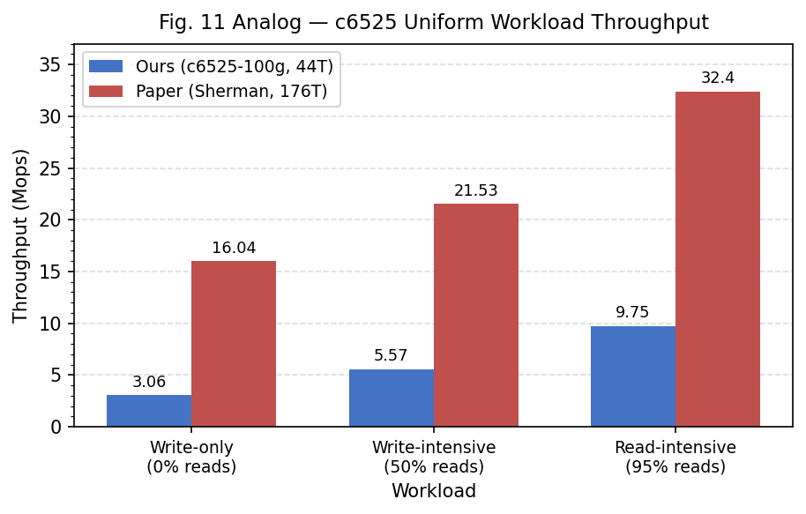
Figure 1. c6525-100g uniform workload throughput versus the paper.
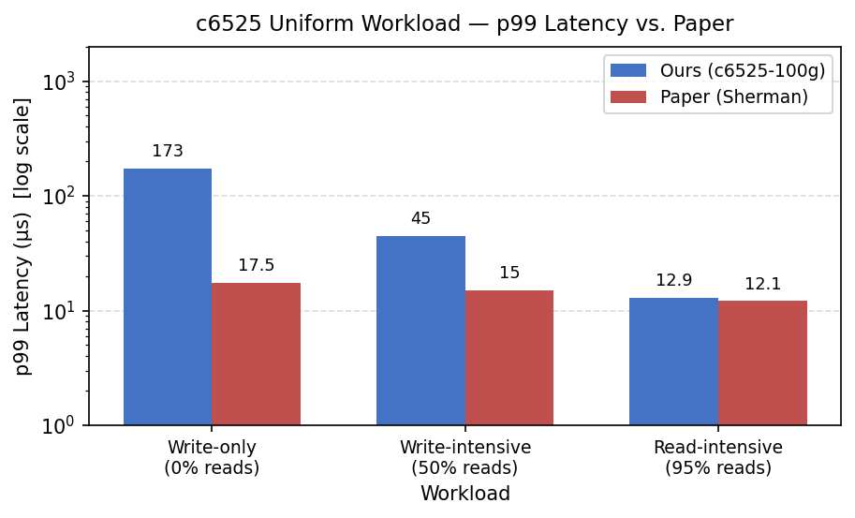
Figure 2. c6525-100g uniform workload p99 latency versus the paper.

4.2 Skewed Workloads (Figure 10)
Workload: zipfian=0.99, 22 compute threads per node (44 total).

Table 3. c6525-100g skewed workloads versus the paper (paper Figure 10 comparison).
Workload | Read Ratio | Our Tput (Mops) | Paper (Mops) | Our p50 (us) | Paper p50 (us) | Our p99 (us) | Paper p99 (us)
Write-only | 0% | 3.06 | 4.14 | 8.4 | 9.6 | 174 | 1136
Write-intensive | 50% | 5.57 | 8.02 | 6.5 | 6.9 | 44 | 659
Read-intensive | 95% | 9.77 | 33.8 | 4.0 | 4.8 | 12.9 | 12.3

The skewed results are almost identical to the uniform ones. Our p99 latency differs by barely anything between the two workloads (174 us versus 173 us), whereas the paper reports a much larger gap (1136 us versus 17.5 us). In our setup, this pattern is consistent with the reduced 8,192-entry lock table approaching saturation under both access patterns, which would obscure the separation seen in the paper.
Because the main mismatch in our reproduction is the missing separation between uniform and skewed write-heavy workloads, the next subsection asks whether reduced lock-table capacity is a plausible explanation within our environment.
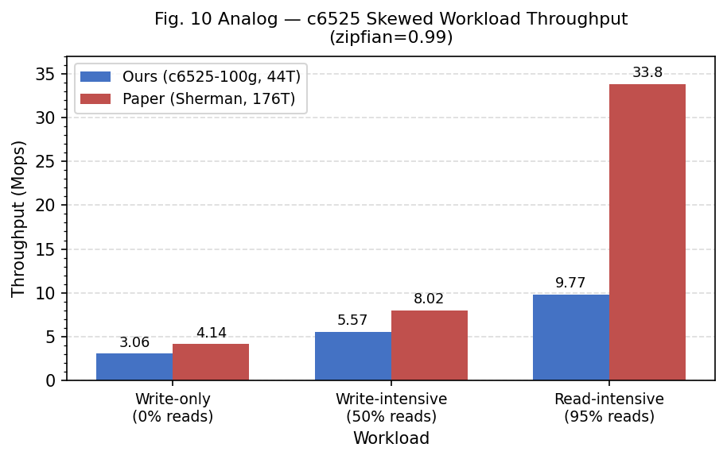
Figure 3. c6525-100g skewed workload throughput versus the paper.
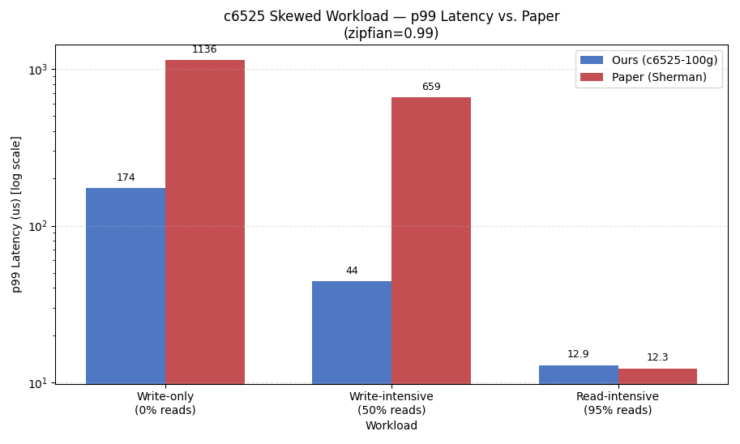
Figure 4. c6525-100g skewed workload p99 latency versus the paper.

4.3 Observed Limitation: Lock Table Saturation
The lock table contains far fewer entries in our setup: kLockChipMemSize = 64KB, so kNumOfLock = 64*1024 / sizeof(uint64_t) = 8,192 entries, which is 16x fewer than the paper's 131,072. Part of that reduction comes from the open-source repository using uint64_t rather than the paper's 16-bit CAS-based representation.

Figure 5. Source-level lock-table size used in the open-source code.

Uniform and skewed write-only workloads produced essentially the same result: 3.06 Mops cluster throughput in both cases, with p99 latency of 173 us versus 174 us, a difference of about 0.6%. That is consistent with nearly the same lock-contention behavior under the constraints of our setup.

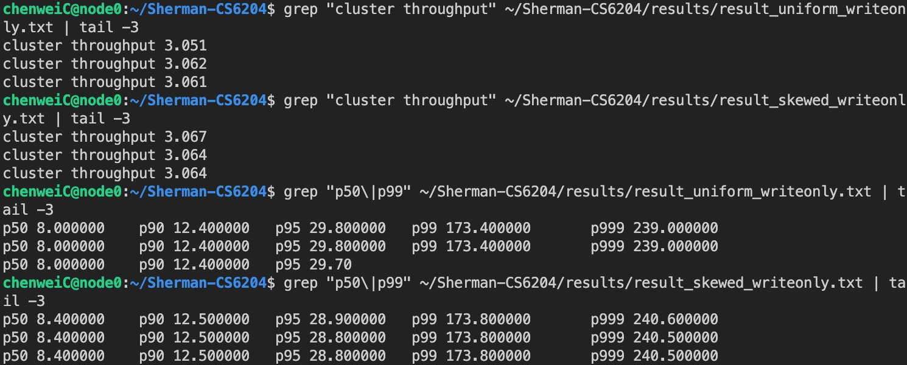
Figure 6. Result excerpt showing nearly identical uniform and skewed write-only throughput and p99 latency on c6525-100g.

Git history provides an additional sanity check. Commit bb57f76 (2026-02-15) changes zipfian from 0 to 0.99 in test/benchmark.cpp. The uniform results were collected before this commit and the skewed results after it, confirming that the two workloads were run from separate binaries.

4.4 Reproduction Summary: Matches, Differences, and Explanations
Several parts of the reproduction remain close to the paper. Throughput increases monotonically with read ratio for both uniform and skewed workloads (write-only < write-intensive < read-intensive), which matches Sherman's design. In the uniform table, p50 latency is also in the same single-digit-microsecond range as the paper for write-only (8.0 us versus 10.7 us) and write-intensive (6.5 us versus 8.0 us) workloads, with gaps of roughly 19-25% relative to the paper values. That is consistent with some fast-path behavior being close to the paper, but we did not directly instrument RDMA verb counts or B+Tree traversal depth, so latency alone cannot establish those mechanisms. Uniform read-intensive p99 latency (12.9 us) is likewise very close to the paper's 12.1 us, which is consistent with reads bypassing the lock table.
The differences are also substantial. Absolute throughput is lower in every c6525 workload, but the size of the gap varies by workload; for example, uniform write-only reaches 3.06 Mops here versus 16.04 Mops in the paper. The clearest reason is scale: the paper uses 8 physical servers that emulate 8 Memory Server roles and 8 Compute Server roles, with 176 total client threads, while our setup uses 2 physical nodes and 44 threads. A 4x reduction in thread count would be expected to lower aggregate throughput accordingly. Another difference is that the paper's uniform/skewed throughput separation, such as 16.04 versus 4.14 Mops for write-only, disappears in our results, where both cases are 3.06 Mops. That pattern is consistent with lock-table saturation. With only 8,192 HOCL entries, or 16x fewer than the paper's 131,072, both access patterns may hit the same bottleneck and therefore lose the separation reported in the paper. We also see elevated p99 latency for uniform write-heavy workloads (173 us versus 17.5 us). One plausible explanation is that Priority Flow Control was not configured for RoCE v2 on the CloudLab experiment network, which could increase RDMA retransmission and inflate tail latency; the much less affected p50 is consistent with that explanation. Overall, we were not able to reproduce the paper's large separation between uniform and skewed write-heavy workloads, and reduced HOCL capacity remains the most plausible explanation supported by our setup and measurements.

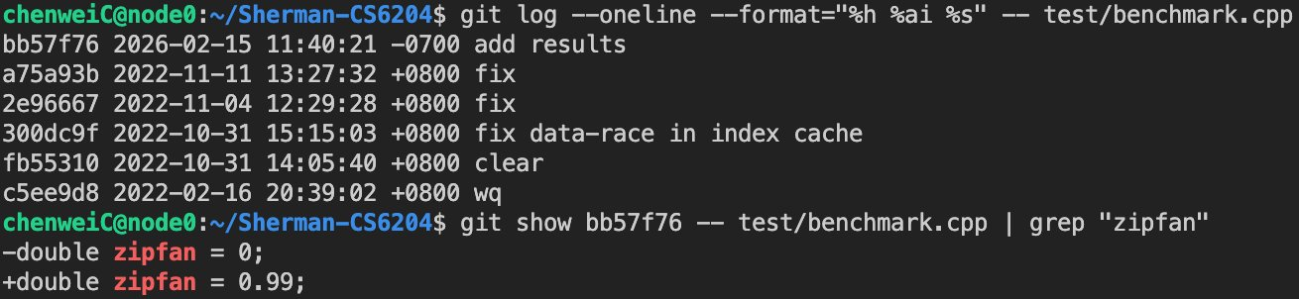
Figure 7. Git history showing the zipfian change used for the skewed runs.

5. Why We Moved from c6525 to r650: Dual-Socket Follow-Up and Cross-Platform Analysis
Section 4 established the main reproduction behavior on c6525-100g, but it also exposed the next question: could we examine remote-memory sensitivity more directly? The answer on c6525-100g was no, because the machine is single-socket and cannot provide a remote NUMA node. That limitation forced a pivot to r650. The move is important for two reasons. First, it enables the dual-socket CXL-style emulation that c6525-100g cannot support. Second, it turns the later stage of the project into a cross-platform comparison, because r650 changes socket topology, CPU family, NIC generation, and HOCL on-chip memory size at the same time.

5.1 Why r650 Became the Follow-Up Platform
Table 4. r650 baseline and CXL-emulated setup parameters.
Parameter | Value
Node type | CloudLab r650 (Clemson cluster)
CPU | 2x 36-core Intel Xeon Platinum 8360Y @ 2.4GHz
NUMA nodes | 2 (interleaved per-core: even cores on node 0, odd on node 1)
NUMA distance | 10 (local) / 20 (remote), ratio 2.0x
On-chip memory | 128KB (16,384 lock entries)
NIC (experiment) | ConnectX-6 100GbE (mlx5_2, ens2f0, 10.10.1.x)
CXL emulation method | Hugepage migration to NUMA node 1; numactl-based memory binding caused a bus error in the CXL-style run, so remote-memory placement was enforced through sysfs hugepage allocation instead.

On the r650, the NUMA distance ratio is 2.0x (20/10). Sherman itself required no code changes; the emulation is performed entirely at the OS level. Group 1, the r650 baseline, runs without NUMA binding. Group 2, the r650 CXL-emulated configuration, uses hugepage migration to place the Memory Server's data on node 1 (see Section 3.6). The r650 baseline also serves as more than a pre-CXL control. Because the project moved to r650 after the initial c6525-100g reproduction, it also provides a second platform for checking whether the c6525-100g behavior was tied to that single-socket machine alone.

5.2 r650 Baseline Results

5.2.1 Uniform Workloads (zipfian=0)
Table 5. r650 baseline uniform workloads versus the paper.
Workload | Read Ratio | Our Tput (Mops) | Paper (Mops) | Our p50 (us) | Paper p50 (us) | Our p99 (us) | Paper p99 (us)
Write-only | 0% | 2.39 | 16.04 | 9.5 | 10.7 | 241 | 17.5
Write-intensive | 50% | 4.42 | 21.53 | 7.5 | 8.0 | 67 | 15
Read-intensive | 95% | 8.26 | 32.4 | 4.1 | 5.0 | 16.6 | 12.1

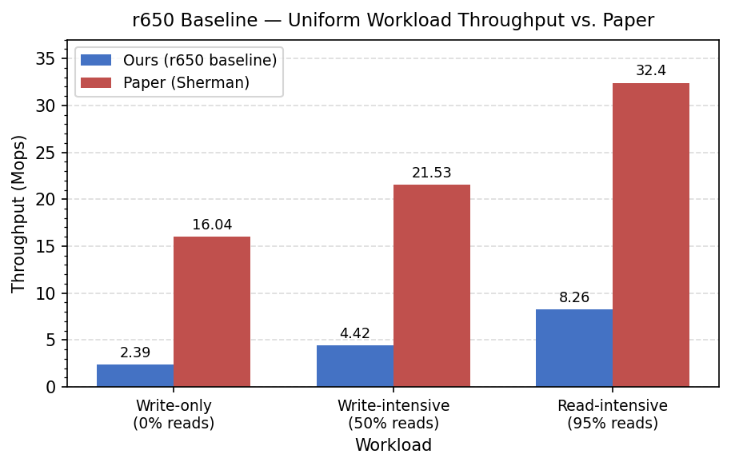
Figure 8. r650 baseline uniform workload throughput versus the paper.

5.2.2 Skewed Workloads (zipfian=0.99)
Table 6. r650 baseline skewed workloads versus the paper.
Workload | Read Ratio | Our Tput (Mops) | Paper (Mops) | Our p50 (us) | Paper p50 (us) | Our p99 (us) | Paper p99 (us)
Write-only | 0% | 2.40 | 4.14 | 9.5 | 9.6 | 238 | 1136
Write-intensive | 50% | 4.40 | 8.02 | 7.6 | 6.9 | 68 | 659
Read-intensive | 95% | 8.29 | 33.8 | 4.1 | 4.8 | 16.5 | 12.3

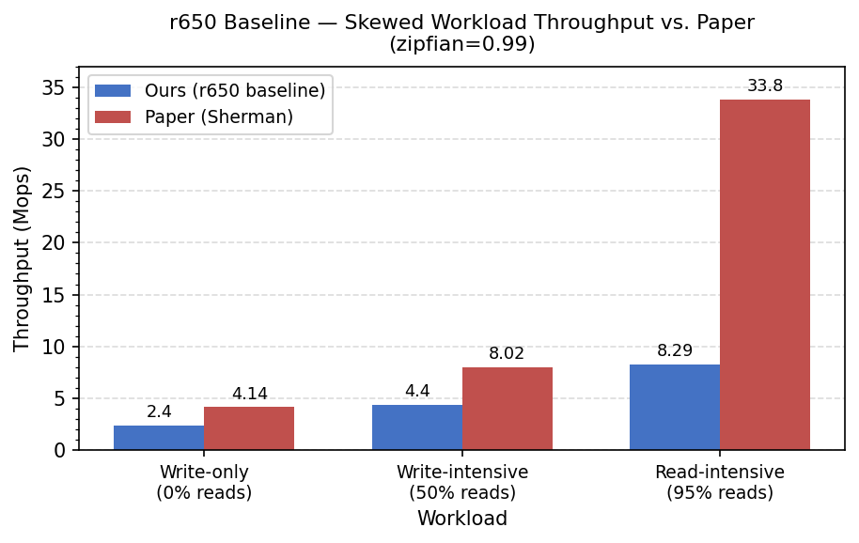
Figure 9. r650 baseline skewed workload throughput versus the paper.

5.3 Cross-Platform Comparison: What Changed After the Move to r650
Table 7. Cross-platform lock-table behavior on c6525-100g and the r650 baseline.
Workload | c6525-100g Tput | r650 Baseline Tput | c6525-100g p99 (us) | r650 Baseline p99 (us)
Write-only uniform | 3.06 | 2.39 | 173 | 241
Write-intensive uniform | 5.57 | 4.42 | 45 | 67
Read-intensive uniform | 9.75 | 8.26 | 12.9 | 16.6
Write-only skewed | 3.06 | 2.40 | 174 | 238
Write-intensive skewed | 5.57 | 4.40 | 44 | 68
Read-intensive skewed | 9.77 | 8.29 | 12.9 | 16.5

The move to r650 was motivated by the CXL question, but the r650 baseline also gives us a useful cross-platform check against c6525-100g. Several factors change at once: socket topology, CPU family, NIC generation, and HOCL lock-table capacity. The comparison therefore does not isolate a single variable, but it is still informative. The r650 baseline has a larger lock table than c6525-100g, 16,384 entries versus 8,192, yet it still shows lower absolute throughput. One possible explanation is higher per-operation RDMA latency on the Intel Xeon 8360Y platform, or cross-socket overhead even for nominally local memory accesses in a dual-socket machine. We did not isolate these factors, so they should be read as hypotheses rather than direct measurements.

The same uniform/skewed convergence appears on r650: write-only throughput is 2.39 Mops for uniform and 2.40 Mops for skewed, with p99 latency of 241 us versus 238 us, a difference below 1.5%. This mirrors the c6525-100g reproduction, where both cases reached 3.06 Mops. Even with twice as many lock entries, r650 shows the same pattern, which makes the missing separation harder to dismiss as a c6525-only artifact. Figure 13 also shows that moving to r650 does not simply improve the baseline across the board: throughput is lower and p99 latency is higher for every workload. The cross-platform comparison therefore supports a narrower claim. The convergence pattern persists across both nodes, while the absolute performance level remains platform-sensitive.
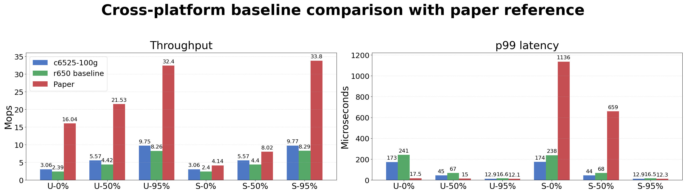
Figure 13. Cross-platform baseline comparison among the paper, c6525-100g, and r650.
This visual comparison is useful because it shows both sides of the platform change at once. Switching from c6525-100g to r650 doubled the available lock-table entries, but it did not recover the uniform/skewed split reported in the paper. Instead, the move mainly changed the absolute throughput and latency level. That is why the r650 stage should be read as both a necessary dual-socket follow-up for CXL-style emulation and a cross-platform check on the earlier c6525-100g observations.
Having shown that the convergence pattern persists after the move to r650, the next subsection asks whether remote-memory placement produces a measurable performance change under the CXL-style emulation.

5.4 CXL-Emulated Results

5.4.1 Uniform Workloads (zipfian=0)
Table 8. r650 CXL-emulated uniform workloads versus the r650 baseline.
Workload | Read Ratio | CXL Tput (Mops) | Baseline Tput (Mops) | CXL p50 (us) | Baseline p50 (us) | CXL p99 (us) | Baseline p99 (us)
Write-only | 0% | 3.46 | 2.39 | 10.6 | 9.5 | 19.2 | 241
Write-intensive | 50% | 4.96 | 4.42 | 7.7 | 7.5 | 18.0 | 67
Read-intensive | 95% | 8.28 | 8.26 | 5.4 | 4.1 | 16.5 | 16.6

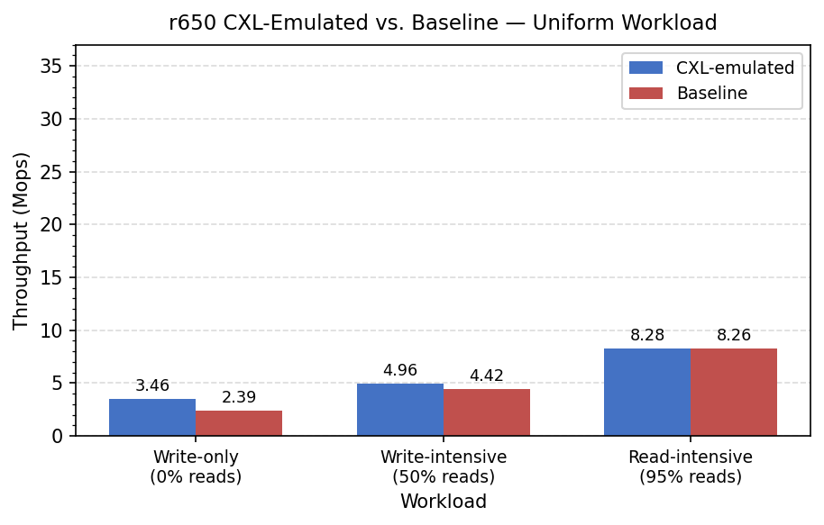
Figure 10. r650 CXL-emulated uniform workload throughput versus the r650 baseline.

5.4.2 Skewed Workloads (zipfian=0.99)
Table 9. r650 CXL-emulated skewed workloads versus the r650 baseline.
Workload | Read Ratio | CXL Tput (Mops) | Baseline Tput (Mops) | CXL p50 (us) | Baseline p50 (us) | CXL p99 (us) | Baseline p99 (us)
Write-only | 0% | 2.39 | 2.40 | 9.4 | 9.5 | 242 | 238
Write-intensive | 50% | 4.43 | 4.40 | 7.5 | 7.6 | 67 | 68
Read-intensive | 95% | 8.30 | 8.29 | 4.1 | 4.1 | 16.5 | 16.5

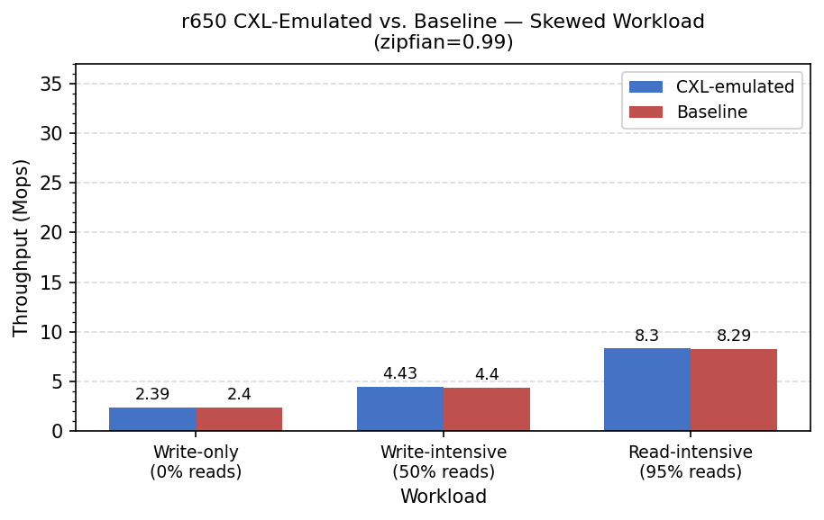
Figure 11. r650 CXL-emulated skewed workload throughput versus the r650 baseline.
In our initial r650 NUMA-based CXL emulation, the index-cache hit rate stabilized at about 99.9% across all six workloads with the original 1000 MB index-cache setting. Under that condition, the emulated run introduced little observable throughput overhead. This is consistent with the original paper's design goal of using CS-side index caching to reduce remote accesses during tree traversal, but it should be read as an interpretation rather than proof of the underlying mechanism. One anomaly is that the CXL uniform write-only run, at 3.46 Mops and 19.2 us p99, appears better than the baseline, which is 2.39 Mops and 241 us p99. One plausible explanation is run-to-run variance across separately provisioned sessions; the skewed workloads, collected within the same session, remain nearly identical at 2.39 versus 2.40 Mops. We therefore interpret the overall CXL overhead in this high-hit-rate experiment as small, while noting that the conclusion rests on limited runs and does not directly prove the underlying mechanism.

5.5 Sensitivity Analysis of CXL Emulation
With the original 1000 MB index-cache setting, the CXL throughput results are straightforward. For uniform workloads, the CXL-emulated runs are equal to or slightly above the baseline: write-only 3.46 versus 2.39 Mops, write-intensive 4.96 versus 4.42 Mops, and read-intensive 8.28 versus 8.26 Mops. For skewed workloads, all differences stay below 0.03 Mops. The uniform write-only anomaly, where CXL appears 45% faster than the baseline, is more consistent with run-to-run variance across separately provisioned CloudLab sessions than with a real CXL benefit. The skewed experiments, collected within a single session, show no directional bias, which is consistent with that interpretation, although it does not prove it. This initial run therefore shows that the default index-cache size can hide most of the emulated remote-memory effect.
To test that interpretation directly, we reduced define::kIndexCacheSize from 1000 MB to 4 MB. A preliminary 64 MB trial still produced near-99% cache hit rates, so the final cache-size sensitivity run used 4 MB. The r650 placement was otherwise the same NUMA-based CXL emulation: node0 ran the Memory Server and one Compute Server, node1 ran the second Compute Server, hugepages were placed on node1, and the NUMA distance ratio was 20/10 = 2.0x. Table 10 reports the last observed values from the 150-second runs. Because the cache hit rates were still rising through the end of each run, these values are not steady-state measurements.
Table 10. r650 CXL-emulated cache-size sensitivity results with kIndexCacheSize = 4 MB.
Workload | Cluster Throughput (Mops) | p99 (us) | Cache Hit Rate
Uniform write-only | 2.38 | 69.6 | ~32%
Uniform write-intensive | 3.37 | 61.6 | ~37%
Uniform read-intensive | 5.48 | 51.9 | ~45%
Skewed write-only | 2.35 | ~79.0 | ~58%
Skewed write-intensive | 3.55 | ~61.0 | ~60%
Skewed read-intensive | 5.73 | 61.9 | ~65%
The reduced-cache run changes the interpretation of the earlier 99.9% result. With the larger index cache, all six workloads reached about 99.9% cache hit rate and the CXL-emulated throughput stayed close to the original high-hit-rate CXL run. With the 4 MB index cache, the hit rates dropped to roughly 32-65%, p99 latency increased for most workloads, and throughput was lower than the original CXL run for most workloads. Figures 12a and 12b compare the two CXL settings directly. This is consistent with the teacher's suggestion that the 1000 MB cache was absorbing most of the remote-DRAM effect. Because the 4 MB cache was still warming up, the result should be treated as sensitivity evidence rather than a final stable performance point.
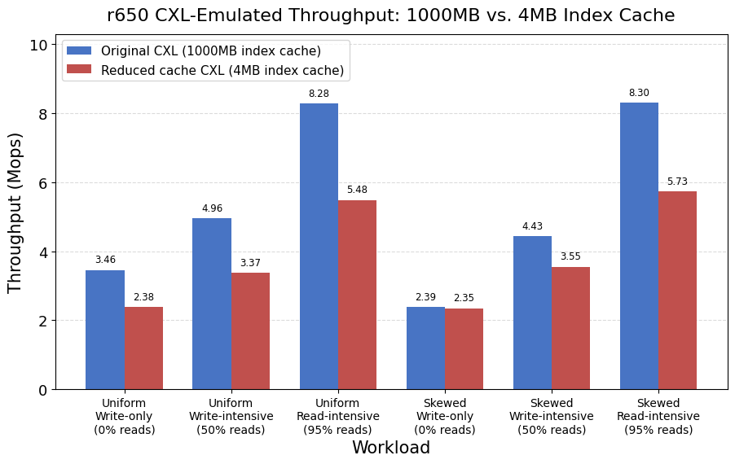
Figure 12a. r650 CXL-emulated throughput comparison between the original 1000 MB index cache and the reduced 4 MB index cache.
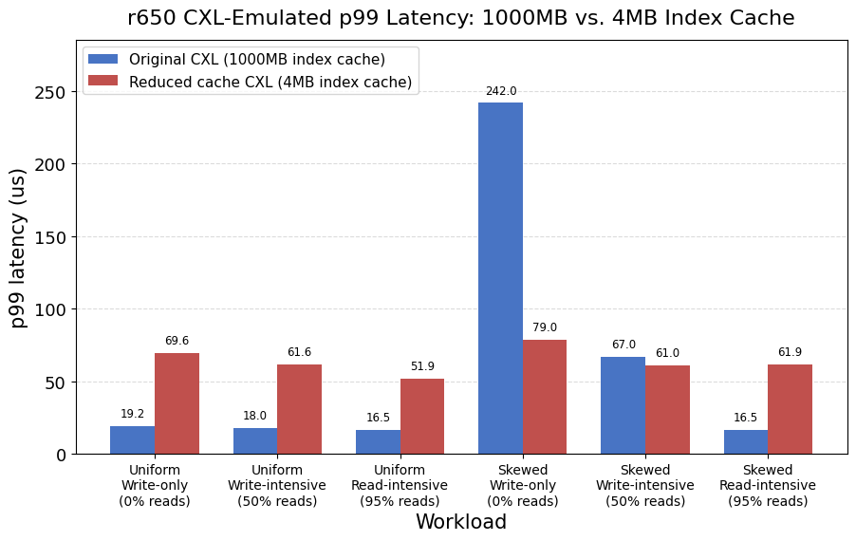
Figure 12b. r650 CXL-emulated p99 latency comparison between the original 1000 MB index cache and the reduced 4 MB index cache.

6. Conclusion
This report has two scopes: a reduced-scale reproduction of Sherman's main benchmark trends on CloudLab, and a broader but still limited analysis of lock-table capacity and remote-memory sensitivity. Across both parts, the core RDMA B+Tree functionality operated successfully on the available platforms.

The main deviation from the paper is the lock-table size: 8,192 entries on c6525-100g and 16,384 on r650, versus 131,072 in the paper. As a result, the study proceeds in two linked stages rather than on one fixed platform. c6525-100g provides the initial reproduction and exposes the missing uniform/skewed separation. r650 then becomes necessary for the dual-socket follow-up and, in doing so, also provides a cross-platform check. In both environments, uniform and skewed write-heavy workloads converge to nearly the same throughput and latency instead of diverging as reported in the paper. That pattern is consistent with lock-table saturation masking HOCL's advantage. Seeing the same behavior on two platforms makes a purely hardware-specific artifact less likely, although our experiments do not isolate lock-table size as the only cause.

In the extended analysis, NUMA-based CXL emulation via hugepage migration first measured about a 99.9% index-cache hit rate across all workloads and little measurable performance difference from the baseline. After reducing the index cache to 4 MB, the hit rate fell to roughly 32-65% during the 150-second runs and the remote-memory effect became more visible in latency and throughput. However, because the cache hit rates were still climbing, the 4 MB results should be interpreted as sensitivity evidence, not as steady-state performance. Overall, the results suggest that Sherman's HOCL behavior is sensitive to NIC on-chip memory capacity and the lock-entry representation used in the open-source code, while remote-memory sensitivity depends strongly on how much of the tree traversal the CS-side index cache absorbs.

7. Reproduction Artifacts
Table 11. Reproduction artifacts and repository locations.
Artifact | Description | Location
setup.sh | Automated node configuration script | github.com/wilsonchang17/Sherman-CS6204
RUNBOOK.md | Step-by-step experiment execution guide | github.com/wilsonchang17/Sherman-CS6204
results/c6525_baseline/ | Reproduction raw benchmark output (6 workloads) | github.com/wilsonchang17/Sherman-CS6204
results/r650_baseline/ | Extended-analysis baseline output (6 workloads) | github.com/wilsonchang17/Sherman-CS6204
results/r650_cxl/ | Extended-analysis CXL-emulated output (6 workloads) | github.com/wilsonchang17/Sherman-CS6204
results/r650_cxl_cache4m/ | Reduced-index-cache CXL-emulated output (6 workloads) | github.com/wilsonchang17/Sherman-CS6204

All result files: https://github.com/wilsonchang17/Sherman-CS6204/tree/main/results

Appendix A. Selected Command-Level Setup Notes
This appendix gathers representative command snippets and screenshots retained from the original environment-setup writeup.

A.1 MLNX_OFED Library Version Conflict
The commands below are reproduced exactly as they were used in the original writeup.
sudo dpkg --remove --force-depends ibverbs-providers python3-pyverbs
sudo apt-mark hold ibverbs-providers python3-pyverbs
sudo dpkg -i ${MLNX_LIBS}/libibverbs1_41mlnx1-*.deb

A.2 On-Chip Memory Size Detection
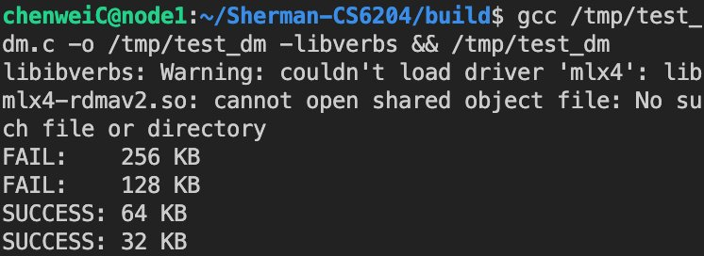
Figure A1. Detected on-chip memory allocation limit on c6525-100g.

A.3 RDMA Network Interface Verification
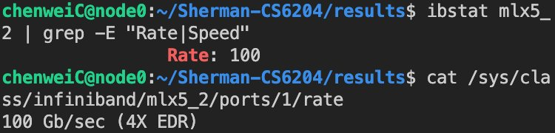
Figure A2. Verification that mlx5_2 maps to the 100 Gbps experiment network.

A.4 memcached Reset Before Each Run
The original writeup used the following reset commands before rerunning the benchmark.
echo -e "flush_all\r\n" | nc 10.10.1.1 11211
echo -e "set serverNum 0 0 1\r\n0\r" | nc 10.10.1.1 11211

A.5 Cross-NUMA Hugepage Migration for CXL Emulation
The final r650 CXL-style setup used sysfs-level hugepage placement rather than numactl --membind=1. When the Memory Server process was forced onto NUMA node 1 with numactl --membind=1, the CXL-style run failed with a bus error. Separately, incorrect or incompatible memory placement can also surface around RDMA memory registration, such as ibv_reg_mr() failure. Moving the hugepage pool itself let Sherman allocate remote DRAM transparently for the CXL-style experiment.
numactl --hardware
sudo bash -c 'echo 0 > /sys/devices/system/node/node0/hugepages/hugepages-2048kB/nr_hugepages'
sudo bash -c 'echo 5120 > /sys/devices/system/node/node1/hugepages/hugepages-2048kB/nr_hugepages'
cat /sys/devices/system/node/node0/hugepages/hugepages-2048kB/nr_hugepages # expected: 0
cat /sys/devices/system/node/node1/hugepages/hugepages-2048kB/nr_hugepages # expected: 5120
The verification output showed node0 hugepages set to 0 and node1 hugepages set to 5120, confirming that the Memory Server's 2MB hugepages were allocated on the remote NUMA node used for the emulation.
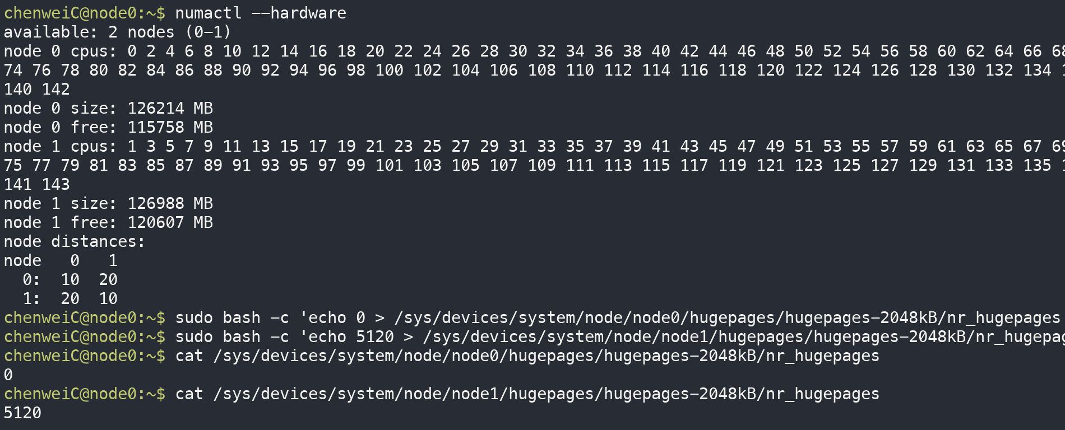
Figure A3. r650 NUMA topology and sysfs hugepage placement check for the CXL-style emulation. The host exposes two NUMA nodes with distance 20 across sockets; after migration, node0 reports 0 hugepages and node1 reports 5120.

