**PROJECT DOCUMENTATION**

1. BACKGROUND

Company Lockers Pvt. Ltd. Has aimed to digitize their products and choose LockedMe.com as their first project to start with.

1. PROJECT GOAL

To develop a prototype of the application.

1. Target Audience

To the relevant stakeholder for budget approval

1. SPRINT PLANNING

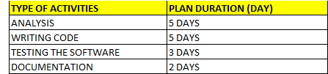

Refer to attached Appendix A for detail Sprint planning.

1. TOOLS

The prototype of the application will be develop by using the JAVA programming language and the IDE will be Eclipse.

1. CONCEPT

As mentioned above, the Java programming will be deployed to develop the protype of the application.

Among the concept involved in the Java programming are as following:

* OOP programming
* Objects and Classes
* Exception handling
* File handling

1. FUNCTIONALITIES

The generic features and three operations are as following:

* Retrieving the file names in an ascending order
* Business-level operations:
* Option to add a user specified file to the application
* Option to delete a user specified file from the application
* Option to search a user specified file from the application
* Navigation option to close the current execution context and return to the main context
* Option to close the application

1. FLOW CHART

Refer to the Appendix 1 attached.

1. FINAL WORD

The project is merely a prototype of the application.

Further input from the relevant stakeholder is highly sought to improve the relevant feature and functionalities of the software.

*** END ***