Monthly Production of Clay Bricks

Claudius Taylor, Tom Wilson, Junpu Zhao

10/19/2018

# Required R Packages

library(dplyr)  
library(data.table)

[](https://raw.githubusercontent.com/wilsonify/TimeSeries/master/images/clay.jpg)

# Introduction

Bricks are used for building and pavement all throughout the world. In the USA, bricks were once used as a pavement material, and now it is more widely used as a decorative surface rather than a roadway material.(“‘Brick Manufacturing from Past to Present’” 1990) A healthy living environment especially requires the use of the right building material. In general building materials are strongly influencing the indoor climate and quality of living.

(“‘Clay Brick Association of South Africa’,” n.d.)

# Problem

The complexity of planning and constructing using clay bricks has increased in recent years.

(“‘Wienerberger Clay Building Materials Europe’,” n.d.)

# Purpose

# Result and Discussion

The data for the project was obtained from the Time Series Data library at datamarket.com. A snapshot of the table and line graph is shown in Figures 1 & 2. (“‘Trends in Brick Plant Operations’” 1992)

data = ("https://raw.githubusercontent.com/wilsonify/TimeSeries/master/data/claybrick.csv")  
columnNames = c("month", "production")   
brick = read.csv(file = data,  
 comment.char = "",  
 header = TRUE,  
 col.names = columnNames)  
brick = ts(brick$production, start = 1956, frequency = 12)  
ts.plot(brick)

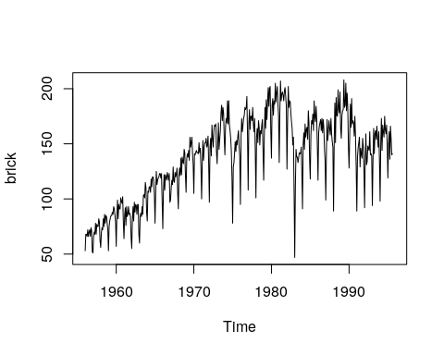

# Conclusion

Currently, the use of brick has remained steady, at around seven to nine billion a year, down from the 15 billion used annually during the early 1900s. In an effort to increase demand, the brick industry continues to explore alternative markets and to improve quality and productivity. Fuel efficiency has also improved, and by the year 2025 brick manufacturers may even be firing their brick with solar energy. However, such changes in technology will occur only if there is still a demand for brick. (“‘Monthly Production of Clay Bricks: Million Units. Jan 1956 – Aug 1995’,” n.d.)

# References

“‘Brick Manufacturing from Past to Present’.” 1990. *The American Ceramic Society Bulletin*, May, 807–13.

“‘Clay Brick Association of South Africa’.” n.d. <www.claybrick.org>.

“‘Monthly Production of Clay Bricks: Million Units. Jan 1956 – Aug 1995’.” n.d. <https://datamarket.com/data/set/22lv/monthly-production-of-clay-bricks-million-units-jan-1956-aug-1995>.

“‘Trends in Brick Plant Operations’.” 1992. *The American Ceramic Society Bulletin*, 69–74.

“‘Wienerberger Clay Building Materials Europe’.” n.d. <https://clay-wienerberger.com>.