Monthly Production of Clay Bricks

Claudius Taylor, Tom Wilson, Junpu Zhao

10/19/2018

# Required R Packages

library(dplyr)  
library(data.table)

[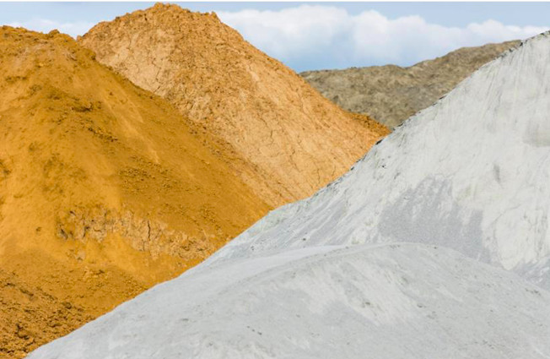](https://raw.githubusercontent.com/wilsonify/TimeSeries/master/images/clay.jpg)

# Introduction

Bricks are used for building and pavement all throughout the world. In the USA, bricks were once used as a pavement material, and now it is more widely used as a decorative surface rather than a roadway material.(“‘Brick Manufacturing from Past to Present’” 1990) A healthy living environment especially requires the use of the right building material. In general building materials are strongly influencing the indoor climate and quality of living.

(“‘Clay Brick Association of South Africa’,” n.d.)

# Problem

The complexity of planning and constructing using clay bricks has increased in recent years.

(“‘Wienerberger Clay Building Materials Europe’,” n.d.)

# Purpose

# Result and Discussion

The data for the project was obtained from the Time Series Data library at datamarket.com. A snapshot of the table and line graph is shown in Figures 1 & 2. (“‘Trends in Brick Plant Operations’” 1992)

data = ("https://raw.githubusercontent.com/wilsonify/TimeSeries/master/data/claybrick.csv")  
columnNames = c("month", "production")   
brick = read.csv(file = data,  
 comment.char = "",  
 header = TRUE,  
 col.names = columnNames)  
brick = ts(brick$production, start = 1956, end = 1994 ,frequency = 12)  
ts.plot(brick)

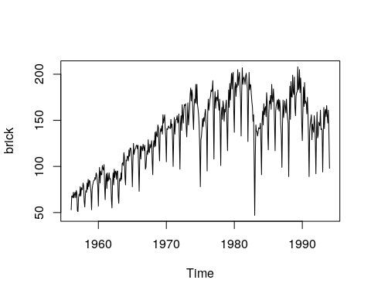

brick

## Jan Feb Mar Apr May Jun Jul Aug Sep Oct Nov Dec  
## 1956 53 68 68 66 72 66 70 72 66 74 71 52  
## 1957 51 66 70 68 78 68 77 75 75 82 79 62  
## 1958 56 69 74 72 82 75 86 78 85 84 78 72  
## 1959 53 75 80 83 85 85 88 86 93 91 85 79  
## 1960 57 86 99 82 95 91 91 101 98 96 102 79  
## 1961 64 85 92 76 93 84 86 93 86 87 84 65  
## 1962 55 81 93 80 97 88 95 94 86 95 95 68  
## 1963 60 84 87 84 93 86 103 104 101 115 110 88  
## 1964 80 107 106 111 111 106 118 111 120 120 116 104  
## 1965 78 106 125 113 117 119 120 123 123 119 123 98  
## 1966 73 107 122 108 122 120 117 124 121 117 123 97  
## 1967 99 110 117 113 129 116 115 124 120 123 128 106  
## 1968 91 122 128 121 137 122 138 134 132 145 142 122  
## 1969 106 136 141 138 144 135 156 147 151 156 141 131  
## 1970 105 141 140 142 144 142 142 141 151 142 146 129  
## 1971 100 132 153 135 147 151 151 155 147 149 157 130  
## 1972 97 147 155 139 167 155 147 162 167 166 168 143  
## 1973 132 151 169 145 154 162 178 185 171 183 178 155  
## 1974 140 165 173 169 189 168 189 167 162 155 143 119  
## 1975 78 129 133 142 152 143 153 149 157 162 148 139  
## 1976 95 156 173 161 167 173 176 183 181 183 193 157  
## 1977 108 168 181 163 175 175 171 183 168 161 173 144  
## 1978 101 156 164 151 171 165 149 162 159 167 172 143  
## 1979 117 158 183 164 190 172 188 201 184 200 202 161  
## 1980 137 185 191 176 189 186 205 188 196 202 187 175  
## 1981 133 179 207 189 195 197 194 189 198 201 193 184  
## 1982 127 171 202 183 189 188 178 170 164 149 156 107  
## 1983 47 111 145 138 138 133 137 142 141 141 147 125  
## 1984 91 149 160 145 168 156 163 165 154 180 169 135  
## 1985 118 158 171 168 177 162 189 174 170 184 173 146  
## 1986 117 160 166 169 172 162 173 160 172 164 145 134  
## 1987 99 144 172 153 161 171 164 158 173 159 152 147  
## 1988 89 151 187 151 192 176 175 199 181 178 197 164  
## 1989 155 176 180 181 208 183 185 205 180 196 183 147  
## 1990 128 158 186 165 191 168 171 169 157 175 156 129  
## 1991 89 138 146 151 156 129 146 141 137 155 147 128  
## 1992 92 136 159 131 134 148 146 144 161 140 141 139  
## 1993 94 136 164 141 159 162 154 166 156 147 161 135  
## 1994 98

acf(brick)

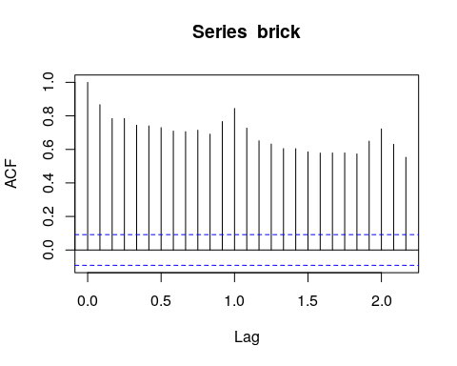

pacf(brick)

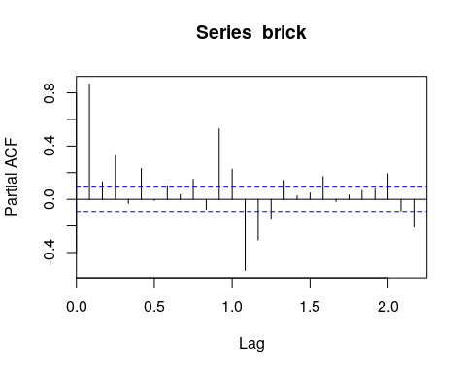

avg_brick <- mean(brick)

dbrick <- diff(brick)

acf(dbrick)

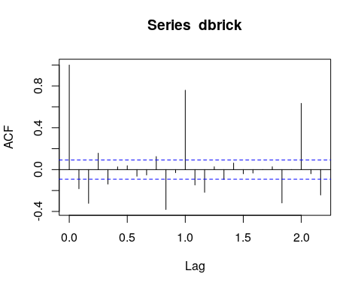 # Conclusion

Currently, the use of brick has remained steady, at around seven to nine billion a year, down from the 15 billion used annually during the early 1900s. In an effort to increase demand, the brick industry continues to explore alternative markets and to improve quality and productivity. Fuel efficiency has also improved, and by the year 2025 brick manufacturers may even be firing their brick with solar energy. However, such changes in technology will occur only if there is still a demand for brick. (“‘Monthly Production of Clay Bricks: Million Units. Jan 1956 – Aug 1995’,” n.d.)

# References

“‘Brick Manufacturing from Past to Present’.” 1990. *The American Ceramic Society Bulletin*, May, 807–13.

“‘Clay Brick Association of South Africa’.” n.d. <www.claybrick.org>.

“‘Monthly Production of Clay Bricks: Million Units. Jan 1956 – Aug 1995’.” n.d. <https://datamarket.com/data/set/22lv/monthly-production-of-clay-bricks-million-units-jan-1956-aug-1995>.

“‘Trends in Brick Plant Operations’.” 1992. *The American Ceramic Society Bulletin*, 69–74.

“‘Wienerberger Clay Building Materials Europe’.” n.d. <https://clay-wienerberger.com>.