Stat 5309 HW 1

Tom Wilson

January 31, 2019

# 1

A new filtering device is installed ina chemical unit. Before its installation, a random sample yielded the following information about the percentage of impurity: $\overline{y_{1}}=12.5$, $S_{1}^{2}=101.17$, and $n_{1}=8$. After installation, a random sample yielded $\overline{y_{2}}=10.2$, $S_{2}^{2}=94.73$, $n_{2}=9$

## a

Can you conclude that the two variances are equal? Use $α=0.05$

The null hypothesis is that the two variances are equal, $σ_{1}^{2}=σ_{2}^{2}$. The ratio of the sample variances is F-distributed with n-1 and n-2 degrees of freedom.

bar_y_1 <- 12.5  
s_1_squared <- 101.17  
n_1 <- 8  
nu_1 <- n_1 - 1  
#After installation  
bar_y_2 <- 10.2  
s_2_squared <- 94.73  
n_2 <- 9  
nu_2 <- n_2 - 1  
  
f_stat <- s_1_squared / s_2_squared  
left_tail <- pf(1/f_stat,nu_1,nu_2)  
right_tail <- 1 - pf(f_stat,nu_1,nu_2)   
p_value <- left_tail + right_tail  
p_value

## [1] 0.9307519

Under the null hypothesis, we would expect a difference in means at least this extreme 93% of the time. At a confidence level of 5%, we would fail to reject the null hypothesis and conclude that the variances are equal.

## b

Has the filtering device reduced the percentage of impurity significantly? Use $α=0.05$.

The null hypothesis is that the two averages are equal, $μ_{1}=μ_{2}$. The distribution of differences is t-distributed with pooled variance and $n_{1}+n_{2}−2=15$ degrees of freedom.

mean_difference <- bar_y_1 - bar_y_2  
pooled_variance <- ((n_1-1)*s_1_squared + (n_2-1)*s_2_squared)/(n_1+n_2-2)  
t_stat <- mean_difference/(pooled_variance*sqrt(1/n_1 + 1/n_2))  
df <- n_1 + n_2 - 2  
  
alpha <- 0.05  
half_alpha <- alpha/2  
t_critical_left <- qt(half_alpha,df)  
t_critical_right <- qt(1-half_alpha,df)   
p_value <- pt(-abs(t_stat),df) + 1-pt(abs(t_stat),df)

Under the null hypothesis, we would expect a difference in means at least this extreme 96% of the time. At a confidence level of 5%, we fail to reject the null hypothesis and conclude that the filtering device has not significantly reduced impurity.

# 2

Twenty observations on etch uniformity on silicon wafers are taken during a qualification experiment for a plasma etcher. The data are as follows.

uniformity <- c(5.34,6.65,4.76,5.98,7.25,  
 6.00,7.55,5.54,5.62,6.21,  
 5.97,7.35,5.44,4.39,4.98,  
 5.25,6.35,4.61,6.00,5.32  
 )

## a

construct a 95% confidence interval estimate of $σ^{2}$.

Assuming that the population is normally distributed, $\frac{SS}{σ^{2}}$ will be $χ^{2}$ distributed with n-1 degrees of freedom.

n <- length(uniformity)  
df <- n-1  
bar_x <- mean(uniformity)  
s_squared <- var(uniformity)  
s <- sqrt(s_squared)  
sum_of_squares <- df*s_squared  
chi_stat <- sum_of_squares/s_squared  
alpha <- 0.05  
half_alpha <- alpha/2  
chi_critical_left <- qchisq(half_alpha,df)  
chi_critical_right <- qchisq(1-half_alpha,df)  
  
right_bound = sum_of_squares/chi_critical_left  
left_bound = sum_of_squares/chi_critical_right  
  
paste(left_bound,right_bound)

## [1] "0.457152397856341 1.68623951130305"

The best estimate of $sigma^{2}$ is the sample variance of 0.79. If this experiment were repeated, we can expect 95% of the sample variances to be between 0.4571 and 1.6892

## b

test the hypothesis that $σ^{2}=1.0$. Use $α=0.05$. What are your conclusions?

s_0 <- 1.0  
chi_stat_right <- sum_of_squares/s_0  
chi_stat_left <- s_0/sum_of_squares  
alpha <- 0.05  
half_alpha <- alpha/2  
left_tail <- pchisq(chi_stat_left,df)  
right_tail <- 1 - pchisq(chi_stat_right,df)  
p_value <- left_tail + right_tail  
p_value

## [1] 0.7214195

Given the null hypothesis that the true variance is 1.0, we would expect to observe a $χ^{2}$ statistic that is at least this extreme 72% of the time. at a confidence level of 5%, we fail to reject the null hypothesis and conclude that the variance is not significantly different from 1.0.

## c

Discuss the normality assumption and its role in this problem.

In order to know the distribution of $SS/σ^{2}$ we must make some assumption about the distribution of the measurement itsself. The most reasonable assumption is that the population is normally distributed because uniformity is a function of many inputs.

## d

Check normality by constructing a normal probability plot. What are your conclusions?

qqnorm(uniformity)  
qqline(uniformity)

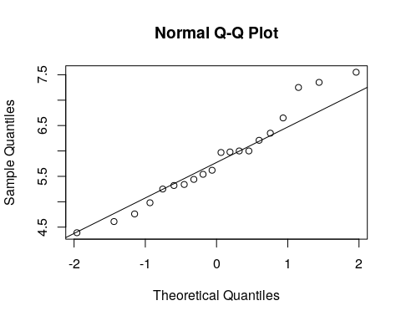

The quantiles of the uniformity measurements very nearly match that of a normal distribution. The three largest values are larger than expected, but not significantly.

# 3

The diameter of a ball bearing was measured by 12 inspectors, each using two different kinds of calipers. The results were:

bearings <- data.frame(inspector = seq(1,12),  
 caliper1 = c(0.265,0.265,0.266,0.267,0.267,0.265,0.267,0.267,0.265,0.268,0.268,0.265),  
 caliper2 = c(0.264,0.265,0.264,0.266,0.267,0.268,0.264,0.265,0.265,0.267,0.268,0.269)  
 )

## a

Is there a significant difference between the means of the population of measurements from which the two samples were selected? Use $α0.05$.

Since each pair of measurements is taken by the same inspector a paired t-test is appropriate.

paired_differences <- bearings$caliper1 - bearings$caliper2  
hist(paired_differences)

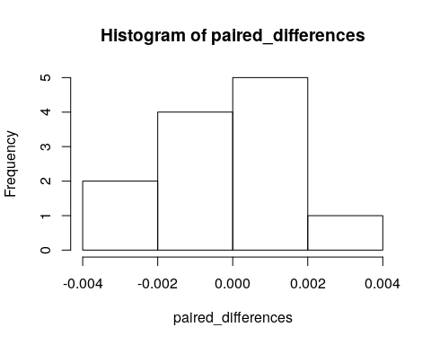

The null hypothesis is that the paired difference is zero, $δ=0$. The distribution of differences is t-distributed with variance estimated by the variance of the differences and $n−1=11$ degrees of freedom.

bar_d <- mean(paired_differences)  
n <- length(bearings$caliper1)  
s_d <- sd(paired_differences)  
nu <- n-1  
SE <- s_d/sqrt(n)  
t_stat <- bar_d/(SE)  
alpha <- 0.05  
half_alpha <- alpha/2  
t_critical_left <- qt(half_alpha,nu)  
t_critical_right <- qt(1-half_alpha,nu)   
t_stat

## [1] 0.4317878

paste(t_critical_left,t_critical_right)

## [1] "-2.20098516009164 2.20098516009164"

The t-statistic of 0.43 is between the critical t-statistics of $±2.201$. Therefore, we fail to reject the null hypothesis and conclude that the measurements from the two calipers are not significantly different.

## b

Find the p-value for the test in part a.

p_value <- pt(-abs(t_stat),nu) + 1-pt(abs(t_stat),nu)  
p_value

## [1] 0.6742372

The p-value is about 67%. Given that there is no difference, we can expect a difference at least this large 67% of the time.

## c

Construct a 95% confidence interval on the difference in mean diameter measurements for the two types of calipers.

t_critical_left <- qt(half_alpha,nu)  
t_critical_right <- qt(1-half_alpha,nu)   
left_bound <- t_critical_left * SE  
right_bound <- t_critical_right * SE  
paste(left_bound,right_bound)

## [1] "-0.00127434431630026 0.00127434431630026"

At a confidence level of 95%, a mean difference with magnitude larger than 0.0012 is statistically different from zero.