Stat 5309 Lab 0

Tom Wilson

January 18, 2019

# Exercise 1.

## Distributions

### Histogram of normally distributed sample data

s1 <- rnorm(100,0,1)  
hist(s1)

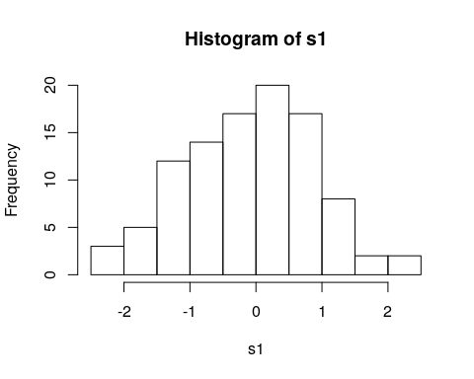

### density curve of normal distribution

x <- seq(-4,4,0.1)  
hx <- dnorm(x,0,1)  
plot(x,hx,pch=16,cex=0.01)

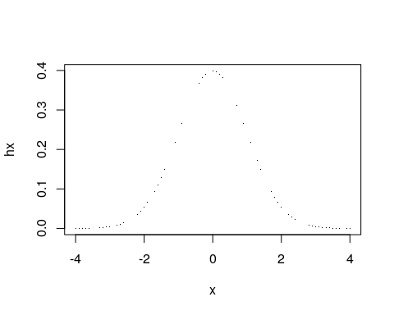

### density curve of some t-distribution

t_ <- x  
ht <- dt(t_,10)  
plot(t_,ht,cex=0.01)

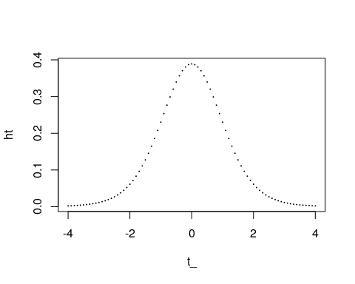

### density curve of some chi-squared distributions

chi_sq <- seq(0,50,0.5)  
hchi_sq <- dchisq(chi_sq,5)  
plot(chi_sq,hchi_sq,pch=16,cex=0.01)

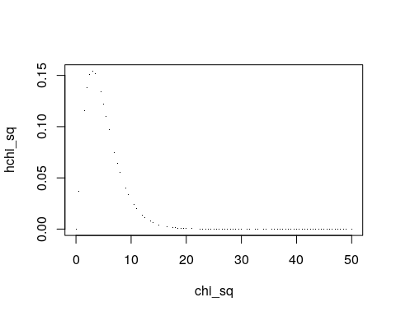

### density curve of some F-distributions

f_ <- seq(0,50,0.5)  
hf <- df(f_,3,20)  
plot(f_,hf,pch=16,cex=0.1)

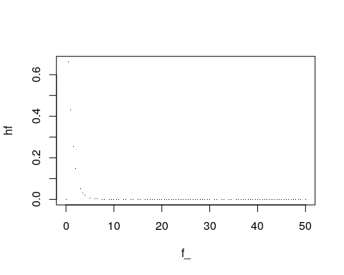

# Exercise 2.

## Check normality of data

data <- c( 26.4  
,23.5  
,25.4  
,22.9  
,25.2  
,39.2  
,25.5  
,31.9  
,26.0  
,44.6  
,35.5  
,38.6  
,30.1  
,31.0  
,30.8  
,32.8  
,47.7  
,39.1  
,55.3  
,50.7  
,73.8  
,71.1  
,68.4  
,77.1  
,19.4  
,19.3  
,18.7  
,19.0  
,23.2  
,21.3  
,23.2  
,19.9  
,18.9  
,19.8  
,19.6  
,21.9  
)  
hist(data)

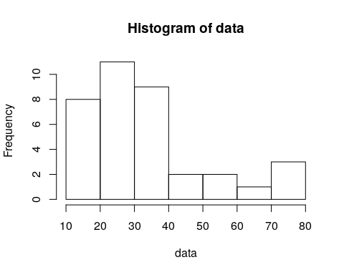

data_s <- sort(data)  
rank_data <- rank(data_s)  
size_data <- length(data_s)  
p_ <- (rank_data-0.5)/size_data  
z_quantile <- qnorm(p_)  
plot(z_quantile,data_s,pch=16)

