Stat 5309 Lab 1

Tom Wilson

January 18, 2019

# 1.

Data: Bottle Filling Machines. Two machines are used to fill plastic bottles with a volume of 16.0 onces. The process can be assumed to be normal, with $σ_{1}=0.015$, $σ_{2}=0.018$. An experiment is performed.

machine_1 <- c(16.03, 16.01, 16.04, 15.96, 16.05,  
 15.98, 16.05, 16.02, 16.02, 15.99  
 )  
  
machine_2 <- c(16.02, 16.03, 15.97, 16.04, 15.96,  
 16.02, 16.01, 16.01, 15.99, 16.00  
 )

## a

Test hypothesis: $H_{0}:μ_{1}=μ_{2}$.

use a z-test because the process is normal and the variance(s) are known.

n <- length(machine_1)  
machine_1_sigma <- 0.015  
machine_2_sigma <- 0.018  
pooled_sigma <- sqrt(machine_1_sigma^2 + machine_2_sigma^2)  
SE = pooled_sigma/sqrt(n)  
  
machine_1_mu <- mean(machine_1)  
machine_2_mu <- mean(machine_2)  
mu_diff <- machine_1_mu - machine_2_mu  
  
CL <- 0.95  
alpha = 1 - CL  
half_alpha = alpha/2  
z = mu_diff/SE  
p_value = 1 - pnorm(z)  
mu_diff

## [1] 0.01

p_value

## [1] 0.08856779

The difference between the means is 0.01. Given the null hypothesis, the probability of observing a difference at least this extreme is 8.8%. at a confidence level of 5% we would fail to reject the null hypothesis and conclude that there is no difference between machine 1 and machine 2.

## b

Find the P-value for the test.

The p-value is calculated above as 8.8%

## c

Find the 95%-CI for the difference of the population means.

z_critical <- qnorm(1-half_alpha)  
CI=c(mu_diff-z_critical*SE , mu_diff+z_critical*SE)  
CI

## [1] -0.004522262 0.024522262

the difference between the means is between -0.0045 and 0.0245. Since this interval contains 0, it is consistent with the conclusion in part a.

## d

Perform a boxplot and a stripchart with line connecting means.

y <- data.frame(machine_1,machine_2)  
names(y) <-c("machine_1", "machine_2")  
y.means <- apply(y,2,mean)  
stripchart(y, xlab="oz", vertical=TRUE,pch=16)  
lines(y.means)

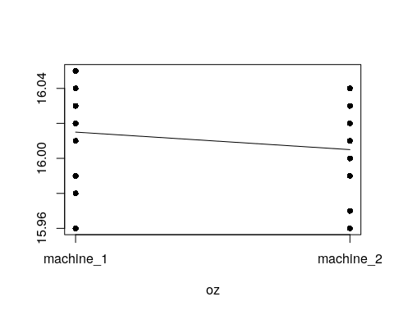

boxplot(y)

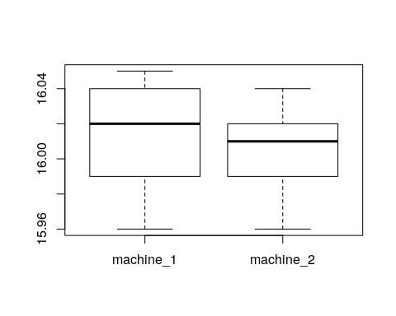

# 2.

Data: Burning times of Chemical Flares.

type_1 <- c(65,82,81,67,57,59,66,75,82,70)  
  
type_2 <- c(64,56,71,69,83,74,59,82,65,79)

**Perform by R . Only use var.test() to check**

## a

Test the hypothesis that the two variances are equal. $α=0.05$

var.test(type_1,type_2)

##   
## F test to compare two variances  
##   
## data: type_1 and type_2  
## F = 0.97822, num df = 9, denom df = 9, p-value = 0.9744  
## alternative hypothesis: true ratio of variances is not equal to 1  
## 95 percent confidence interval:  
## 0.2429752 3.9382952  
## sample estimates:  
## ratio of variances   
## 0.9782168

under the null hypothesis of equal variance, we would expect would expect an F stat this extreme 97% of the time. At a confidence of 5%, we fail to reject the null hypothesis and conclude that the variance of test1 is the same as that of test2.

## b

Test the hypothesis that the burning times are equal.

t.test(type_1,type_2,var.equal = TRUE)

##   
## Two Sample t-test  
##   
## data: type_1 and type_2  
## t = 0.048008, df = 18, p-value = 0.9622  
## alternative hypothesis: true difference in means is not equal to 0  
## 95 percent confidence interval:  
## -8.552441 8.952441  
## sample estimates:  
## mean of x mean of y   
## 70.4 70.2

Test statistics, t = 0.048 with 18 degrees of freedom

P-value = 0.9622

Conclusion.

Given that the means are equal, we would expect a difference at least this great 96% of the time. At a confidence level of 5% we would fail to reject the null hypothesis and conclude that the means are indeed the same.

## c

Check the normality assumption for both types of flares.

qqnorm(type_1,main="Quantile-Quantile plot for Type 1")  
qqline(type_1)

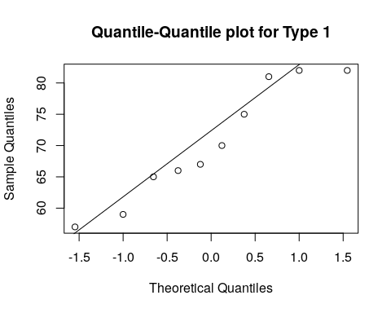

qqnorm(type_2,main="Quantile-Quantile plot for Type 1")  
qqline(type_2)

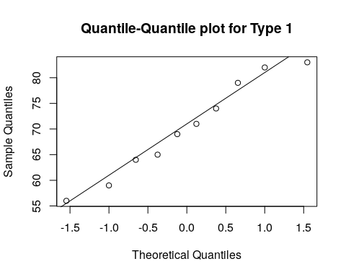

Visually, the quantiles of both type1 and type2 closely match that of a normal distribution.