Pinning the Wage to Scarcity and Technology
Replacement, exit, and the rents of non-produced inputs in a task economy
Abstract
We connect technological change to wages by jointly pricing labor’s machine substitute and workers’ outside options. Combining task assignment with a production network identifies two automation channels: improved machine capability and reduced labor requirements within machine production. Both can lower wages relative to rents on non-produced inputs. At an interior task margin, we derive bounds on wage purchasing power: embodied rent costs impose a ceiling, while feasible human production supplies a lower bound. Technological progress can expand productive capacity while reducing wage purchasing power over housing and other scarce services. The same prices connect participation to household or public support, living costs, and preferences. U.S. wage measures deflated by durables and shelter prices diverged by a factor of 4.8 over 1964–2024. Uniform transfers financed from pure rents redistribute purchasing power while preserving fixed-factor supply and avoiding benefit withdrawal upon employment.
Keywords: automation; artificial intelligence; wages; land rent; production networks; labor force participation; rent taxation
JEL codes: J31, O33, E25, J22, R31, H21

1 Introduction
Suppose a firm can perform a task with a worker or with a machine. For the tasks where the firm is indifferent, the worker’s wage is tied to the cost of the machine substitute. That mechanism is established and used by the factor-price condition at the task margin in Acemoglu and Restrepo (2018), with the same threshold logic in Zeira (1998) and, for offshoring, in Grossman and Rossi-Hansberg (2008). This paper examines that mechanism with two questions around that margin.
What prices the substitute? A machine is itself produced — from other machines, labor, energy, sites, minerals, permissions. Its rental belongs to the same cost system as the goods and services households consume. Tracing input costs through production leads to human hours and to non-produced inputs: resources whose supply is not generated by the production process. Land and mineral deposits are examples. A grid connection or fabrication bottleneck can occupy the same position over a horizon on which its capacity is fixed. While machine production employs labor, wages remain part of the substitute’s cost. As the production chain sheds labor, rents can account for a larger share of the replacement price.
What prices the alternative to working at all? Life outside employment still requires somewhere to live, food, energy, and care. We focus on dependence: support from a household or public institution provides a living standard, and a wage buys consumption beyond it. The choice to work depends on that gain and the value of non-work time. The cost of support traces back through the same production network as the firm’s machine substitute.
This paper endogenizes the two sides of the labor margin. On the demand side,
$$\text{labor demand} → \text{replacement cost} → \text{rents on non-produced inputs};$$
on the supply side,
$$\text{labor supply} → \text{outside option} → \text{rents on non-produced inputs}.$$
Both chains trace prices back to non-produced inputs. The same cost system prices the machine substitute and the household’s living basket. Participation depends on wage purchasing power, the support available outside employment, and preferences. Technological change affects relative capability at tasks (“task automation”), the labor embodied in machine services (“recursive automation”), and the prices of the inputs on which production and consumption depend.
At an interior task margin, the wage relative to rent links automation to purchasing power. Holding the selected input requirements fixed, a fall in relative human productivity at the margin lowers the wage relative to rent; reducing the labor embodied in machine services lowers it further. Every good’s price resolves into its direct and indirect labor and non-produced input requirements. The embodied rent bill places an upper bound on what an hour’s wage can buy. A feasible human production method supplies a complementary lower bound through its labor cost and rent bill. If the wage–rent ratio tends to zero, wage purchasing power tends to zero for goods whose embodied requirement for the non-produced input stays bounded away from zero. A feasible method requiring bounded human hours and no non-produced input anywhere in its chain preserves a positive lower bound.
Combining the task margin of Acemoglu and Restrepo with the input–output price logic of Leontief (1936) and Sraffa (1960) yields these purchasing-power bounds. Pricing the household’s living basket through the same network connects replacement to participation through labor-market clearing. With support maintained and positive work costs, vanishing wage purchasing power also brings participation toward zero. The distinction between wage and ownership income then motivates the policy pair associated with George (1879): a tax on pure rents funding a uniform transfer.
The next section locates the contribution in the wage-determination literature. The main text then develops the task and outside-option closures, derives the interior purchasing-power and income results, and turns to history, measurement, stabilizers, and AI. The appendices provide the general environment, transition results, and extensions.

2 Existing characterizations of the wage
Accounts of the aggregate wage organize its determination around different objects: marginal products, bargaining endpoints, task thresholds, institutions, and growth paths. Sections 3–4 connect these objects to the costs of the firm’s substitute and the worker’s outside option.

2.1 Marginal product
The textbook answer sets the wage equal to the marginal product of labor. Its level depends on the capital stock and the technology, two variables constantly changing. Applied work often proceeds under Cobb–Douglas, which imposes fixed factor shares and requires an aggregate capital measure. Both assumptions become fragile when factor shares and capital prices are themselves moving rapidly (Sraffa 1960; Samuelson 1966). In growth theory the wage’s growth rate is pinned along a balanced path, but Uzawa (1961) shows the balanced path requires technical change to be labor-augmenting in form — and the form of technical change is precisely what is at issue under automation.

2.2 Search, matching, and bargaining
The search-and-matching framework (Diamond 1982; Mortensen and Pissarides 1994; Pissarides 2000) places the wage between the worker’s outside option and the value of the match, dividing the surplus by a bargaining parameter. Determining the wage level therefore requires values for both endpoints and the bargaining parameter.
Shimer (2005) showed that the calibrated model generates almost none of the observed volatility — in U.S. data the vacancy–unemployment ratio is roughly twenty times as volatile as labor productivity, while the calibrated search model makes them comparable. Hagedorn and Manovskii (2008) resolve the puzzle by setting the value of non-market activity close to productivity, so that the surplus workers and firms split is small; Hall (2005) resolves it with rigid wages; and Ljungqvist and Sargent (2017) show that these and the other proposed resolutions operate through one channel, the fundamental surplus — “an upper bound on the fraction of a job’s output that the invisible hand can allocate to vacancy creation” — which every successful calibration makes small, and whose leading deduction from productivity is the value of non-work. The central calibration debate of modern macro-labor is, in other words, a debate about the level of an object the framework treats as a parameter.
Our contribution is to endogenize both endpoints — the firm’s machine alternative and the worker’s outside option — and to show that both depend partly on the same scarcity market.

2.3 Task and assignment models
The task framework (Zeira 1998; Acemoglu and Autor 2011; Acemoglu and Restrepo 2018, 2022) determines the wage at the threshold task and is the direct ancestor of what follows. Its equilibrating force is the creation of new labor tasks: displacement met by reinstatement (Acemoglu and Restrepo 2018; Autor 2015). The threshold links the wage to the machine rental and the outside option. This paper endogenizes both and abstracts from the creation of new labor tasks, a modeling choice motivated by our reading of history and recent U.S. measures. Acemoglu and Restrepo (2026) add institutional wage wedges and show that automation is directed at the tasks where wedges are largest. Cross-border trade is treated similarly: a tradable task stays domestically only while the wage beats both the machine rental and the foreign wage, so the foreign wage is a second machine rental with a different cost composition. Offshoring is still a temporary condition: once the machine undercuts the foreign worker, the task shifts onward to machines wherever they sit.

2.4 Institutional accounts
Efficiency wages (Shapiro and Stiglitz 1984), monopsony (Manning 2003), and firm-level rent sharing (Card, Cardoso, Heining, and Kline 2018) explain why individual wages depart from a common base and why the dispersion moves. In the notation below they are accounts of a multiplicative wedge on particular tasks. Our model takes these wedges as given and studies the common base.

2.5 The classical accounts
The wage was pinned to land and to the cost of subsistence before it was pinned to anything else. Ricardo (1817) priced land at the margin and the wage at its natural price, Malthus (1798) supplying the mechanism; the machinery chapter added in 1821 concedes that machinery can injure the laboring class. Marx priced labor power at its cost of reproduction and read enclosure — the legal extinction of common access to land — as the manufacture of a labor supply. Lewis (1954) pinned the modern-sector wage to what the traditional sector affords — a close antecedent to our participation mechanism. His traditional sector supplies an outside option until its surplus labor is absorbed. Polanyi (1944) recorded the institutional half of the same event. George (1879) drew the fiscal consequence derived below inside our model. These accounts describe configurations in which subsistence and access to scarce inputs strongly constrain wage bargains. Uneven machine capability across tasks adds the replacement margin developed below.

2.6 Automation and the wage
Korinek and Stiglitz (2019) pose the below-subsistence scenario explored here through dependence and exit; Korinek and Suh (2024) is the closest formal predecessor on wage collapse under transformative AI. Our account connects that collapse to non-produced factors and the cost of the outside option. Susskind (2017) and Sachs and Kotlikoff (2012) reach technological immiseration through other channels; Moll, Rachel, and Restrepo (2022) route automation’s gains to wealth-holders, where this model identifies the fixed-supply input to which the residual income accrues. Aghion, Jones, and Jones (2019) supply the strongest stabilizer — expenditure concentrating on whatever remains human-required — granted a theorem in Appendix E. Caselli and Manning (2019) prove that real wages cannot fall in terms of goods produced entirely from reproducible inputs; Section 6 gives a lower bound from feasible human production and shows how persistent requirements for non-produced inputs constrain wage purchasing power. Hémous and Olsen (2022) endogenize automation’s direction.

2.7 Empirical measures
Three empirical objects meet our model below. Factor shares: the labor share’s decline is documented and global (Karabarbounis and Neiman 2014), and its capital-side counterpart resolves substantially into housing — which is to say land (Rognlie 2015; Knoll, Schularick, and Steger 2017; Piketty and Zucman 2014). The long wage record: real wages measured against the cost of a subsistence basket — welfare ratios in the sense of Allen (2001), extended for England by Clark (2005) — measure the wage relative to a costed living basket. This measures affordability; a reservation wage also reflects available support and preferences. Payroll incidence: the quasi-experimental literature (Gruber 1997; Kugler and Kugler 2009; Saez, Schoefer, and Seim 2019) provides evidence about labor-demand and participation elasticities. Interpreting incidence in terms of schedule slope requires accounting for responses in machine prices, output, and participation.

3 The model: task assignment and the cost system
The model connects task assignment, production costs, and participation through a common price system. Proofs of the main price and participation results are collected in Appendix A.2.

3.1 Tasks and the assignment margin
Tasks. Producing one unit of the final good requires a continuum of tasks $x∈\left[0,1\right]$, each in equal amount (Leontief aggregation over tasks): the good’s unit cost is the sum of its tasks’ unit costs. One human-hour completes $γ_{L}\left(x\right)$ units of task $x$; one machine-hour completes $γ_{M}\left(x\right)$. Relative human productivity is
$$γ\left(x\right)=γ_{L}\left(x\right)/γ_{M}\left(x\right). \left(1\right)$$
A machine-hour rents for $p_{m}$, the machine-service price in the goods and services vector introduced below. The assignment condition compares labor with this rental; the production network determines the rental itself. Institutional wage wedges — union premia, licensing rents, efficiency wages — are set aside until Section 10.
People and non-produced inputs. Each of $N$ workers can supply one hour per period. A worker’s reservation wage $s$ is the payment that makes work as attractive as the best available arrangement without that hour’s earnings. Section 4 derives it from support, living costs, and preferences. The baseline has one non-produced input, with rental $r$ and fixed service endowment $T$ per period. Land services provide a concrete example.
Labor, at wage $w$, holds task $x$ when it is the cheaper input: $w/γ_{L}\left(x\right)≤p_{m}/γ_{M}\left(x\right)$, i.e. $w≤p_{m}⋅γ\left(x\right)$. The right-hand side is labor’s replacement value at task $x$: the wage at which labor and the machine alternative cost the same there. Relabel tasks so $γ$ increases, and assume the relabeled schedule is continuous and strictly increasing where labor is employed (ties permit more than one cost-minimizing assignment). Some tasks cannot be performed by machines at any price: $γ_{M}\left(x\right)=0$ there, so relative human productivity is unbounded. Let $H$ denote the set of tasks closed to machines. The relabeling places these tasks last, and Figure 1 represents them as a wall at the right edge of the schedule. Where labor holds at least one machine-contestable task, $x^{∗}$ denotes the marginal such task and the usual indifference condition applies. If labor holds only tasks in $H$, there is no machine-contestable marginal task and the machine comparison does not pin the wage; Section 5 treats that boundary case. On the machine-contestable set, competitive assignment gives a threshold: machines take the tasks below $x^{∗}$ and labor the tasks above it, while labor performs the required tasks in $H$. We call the threshold the task-assignment margin, or task margin. An active contestable margin can coexist with human-required tasks in $H$. Appendix E treats the case in which human-required services determine the wage.
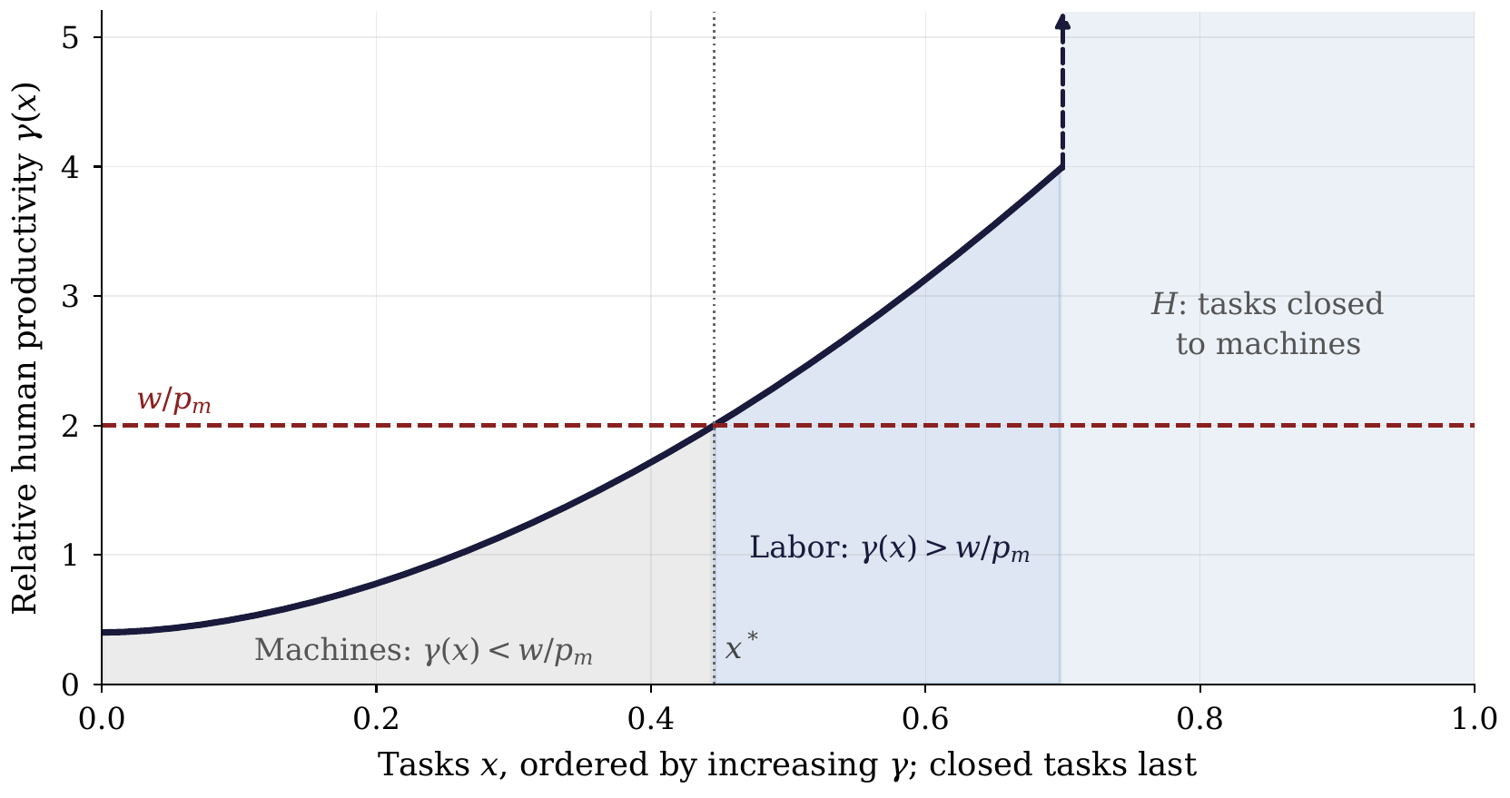
Figure 1. The task-assignment schedule. Tasks are ordered so $γ\left(x\right)$ increases. On the machine-contestable set, the ratio $w/p_{m}$ divides tasks: machines hold tasks with $γ\left(x\right)<w/p_{m}$, labor holds tasks with $γ\left(x\right)>w/p_{m}$, and an interior margin $x^{∗}$ satisfies equality. Tasks in $H$ are closed to machines and appear as a wall at the right edge. If labor holds no machine-contestable task, the wall marks the boundary assignment in which wages are determined within the human-required sector. A cheaper machine or a lower $γ$ near an interior margin shifts tasks toward machines. Drawn by code written with Claude (Anthropic).
Proposition 1 (the task margin). (i) At an interior machine-contestable task margin,
$$w=p_{m}γ\left(x^{∗}\right).$$
(ii) Holding the machine rental fixed, movement of the margin changes the wage at rate $dw/dx^{∗}=p_{m}γ′\left(x^{∗}\right)$. Where a fixed-output labor-demand schedule absorbs additional final-task hours by lowering $x^{∗}$, a steeper capability schedule requires a larger wage change for the same movement of the margin. (iii) A worker supplies the market hour only if its wage reaches the reservation value $s$.
Suppose a loom weaves four meters per hour and a worker weaves one. At $p_{m}=\$80$ per loom-hour, the two methods have the same weaving cost when the hourly wage is $20. If the loom improves to five meters per hour, labor’s replacement value falls to $16 at the same rental, with the worker’s productivity unchanged. Improvements can differ across weaving, pattern preparation, and repair, changing relative capability unevenly across tasks. This comparison holds the rental and the task fixed; in equilibrium both $p_{m}$ and the assignment margin may move.

3.2 The cost recursion
Let $p_{i}$ be the price of one unit of good or service $i$. Producing that unit requires $a_{ij}$ units of each input $j$, $λ_{i}$ human hours, and $b_{i}$ units of the non-produced input’s services. Under constant returns and competitive free entry, an active production method satisfies the unit-cost equation
pi=j​aijpj+λiw+bir. 2
The intermediate-input term records the goods and services used to supply $i$. A steam engine delivering the same useful power with less coal uses fewer units of an intermediate input. Coal’s price includes extraction and transport, which use labor, machinery, and access to deposits. Tracing these costs through successive rows reaches the human hours and non-produced services in the full chain. Housing services similarly combine structures and maintenance with site access. Each input payment is counted once.
These are prices per unit. Quantities supplied or consumed per period turn them into expenditure flows. The economy is a stationary flow benchmark, with $p_{m}$ pricing the use of machine services. Appendix A.4 treats timing and durability.
Collecting the equations gives the input–output price system of Leontief (1936) and Sraffa (1960):
$$p=Ap+λw+br, p={\left(I−A\right)}^{−1}\left(λw+br\right). \left(3\right)$$
Row $i$ of $A$ records inputs per unit of output $i$. The coefficients are nonnegative, and the spectral radius of $A$ is below one, so intermediate production can deliver positive net output. Define the total requirements, including all intermediate rounds, by
$$\tilde{λ}={\left(I−A\right)}^{−1}λ, \tilde{b}={\left(I−A\right)}^{−1}b. \left(4\right)$$
Thus $p_{i}=w{\tilde{λ}}_{i}+r{\tilde{b}}_{i}$. The tilde distinguishes the full production chain from the direct requirements in one row. A directly rented non-produced service can also be recorded in $p$ with price $p_{h}=r$, zero intermediate and labor requirements, and $b_{h}=1$. Its quantity is drawn from the fixed endowment.
Equation (2) is a cost equation. The technology determines which input combinations are feasible, and firms choose the cheapest. With fixed recipes the coefficients are technological constants; with substitution they describe the methods selected at the prevailing prices. Task assignment determines the human and machine coefficients in the relevant rows. Automation can therefore change $A$, $λ$, and $b$, as well as the task margin.
We call the tracing of prices through intermediate inputs the cost recursion. An input is terminal over a horizon when its supply cannot expand through production within that horizon. Land is a lasting example; installed grid connections or fabrication capacity may be terminal temporarily. Electricity, structures, and extraction are activities whose input costs are traced through the system. We reserve pure rent for income due to fixed supply and site rent for the land component of real-estate income, excluding structures. Several non-produced inputs enter as $Br$ in Appendix A. Long-run applications require persistent non-produced inputs.

3.3 Closing the replacement price
The task margin prices labor against machine services, and the machine-service row prices the substitute against the human hours and non-produced inputs embodied in it.
Proposition 2 (replacement closure). At an active contestable margin with $r>0$, suppose $γ\left(x^{∗}\right)>0$, ${\tilde{b}}_{m}>0$, and $1−γ\left(x^{∗}\right){\tilde{λ}}_{m}>0$. The conditions $w=p_{m}γ\left(x^{∗}\right)$ and $p_{m}=w{\tilde{λ}}_{m}+r{\tilde{b}}_{m}$ imply
$$\frac{p_{m}}{r}=\frac{{\tilde{b}}_{m}}{1−γ\left(x^{∗}\right){\tilde{λ}}_{m}}, \frac{w}{r}=\frac{γ\left(x^{∗}\right){\tilde{b}}_{m}}{1−γ\left(x^{∗}\right){\tilde{λ}}_{m}}. \left(5\right)$$
Holding the other total requirements fixed, the wage–rent ratio rises with $γ\left(x^{∗}\right)$ and with ${\tilde{λ}}_{m}$.
The denominator measures the feedback from the wage into the cost of its substitute. At the margin, $γ\left(x^{∗}\right){\tilde{λ}}_{m}$ is the labor share of machine-service cost. A positive rent bill requires this share to be below one. The closure is a price condition at the equilibrium assignment; household choices and market clearing also determine $x^{∗}$ and the selected recipes.

3.4 Two margins of automation
Task automation improves machine capability at tasks near the assignment margin, lowering relative human productivity there. A faster loom reduces the machine time needed to replace an hour of weaving. Recursive automation reduces the human hours embodied in machine services, ${\tilde{λ}}_{m}$. Automating the manufacture and maintenance of looms can lower the labor required to supply a loom-hour. Software developers illustrate how the two channels can meet: generating code automatically changes the machine alternative to a programming task; when that work builds or maintains systems supplying machine services, fewer developer hours can also reduce the labor embodied in those services.
Holding the other terms in (5) fixed, either channel lowers the wage supported by a given rent. With labor in the machine supply chain, task automation also cheapens that chain’s labor. Actual technological changes may alter several coefficients and move the margin together. Figure 2 traces both channels from a common starting point.
When the labor requirement of the full machine-service chain vanishes and $γ\left(x^{∗}\right){\tilde{λ}}_{m}→0$, equation (5) gives
$$\frac{p_{m}/r}{{\tilde{b}}_{m}}→1. \left(6\right)$$
The service price is then accounted for by its embodied claim on the non-produced input. Interest and institutional rents introduce additional income components outside the two-factor flow benchmark.
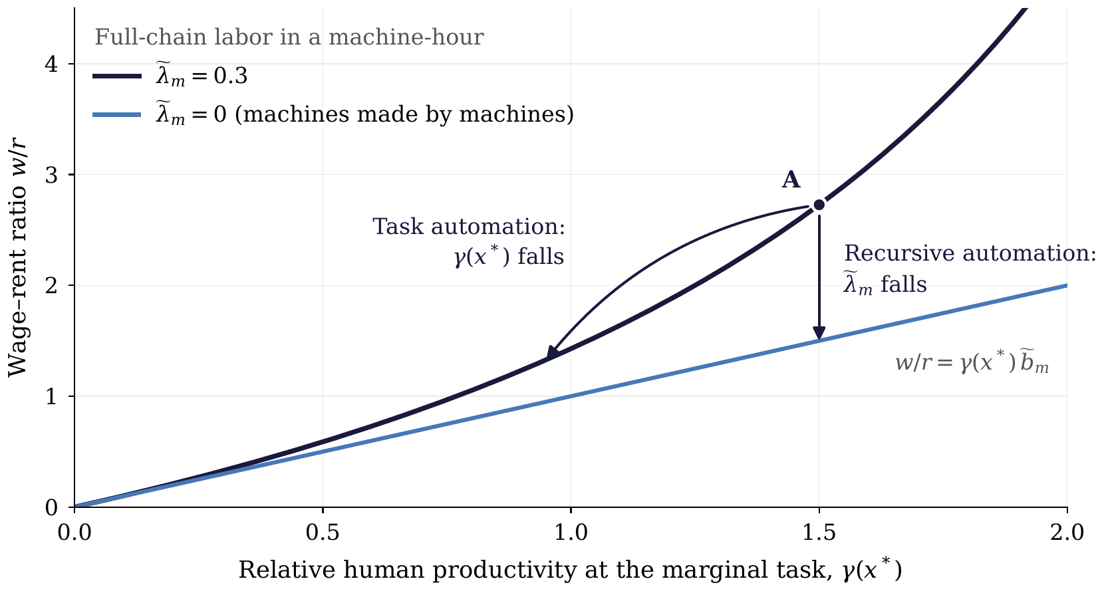
Figure 2. The replacement closure (5), with ${\tilde{b}}_{m}=1$ and illustrative values. Each curve holds the full-chain labor in a machine-hour, ${\tilde{λ}}_{m}$, fixed. The gap between a curve and the line ${\tilde{λ}}_{m}=0$ is the feedback from the wage into the cost of its substitute. From A, task automation lowers $γ\left(x^{∗}\right)$ and moves the economy along its curve; recursive automation lowers ${\tilde{λ}}_{m}$ and moves it down to the line, where $w/r=γ\left(x^{∗}\right){\tilde{b}}_{m}$. Drawn by code written with Claude (Anthropic).

4 The outside option: pricing exit
A person who declines paid work still needs somewhere to live, food, energy, and care. Our participation benchmark focuses on dependence: a household or public institution provides the living standard available outside employment. For example, an adult may live with parents who provide housing and basic consumption while the adult decides whether to take paid work. If support continues during employment, earnings buy additional consumption. The parents may themselves finance that support from wages. Access to support, its security, and the obligations it carries help determine the value of exit.
Let $z$ specify a basket of goods and services supplied per person per period. Its cost is
Ps=zTp=i​zipi. 7
The production network therefore prices both the machine substitute and the support on which a person can live. Housing services include their site costs; a direct rental of space enters at $p_{h}=r$ and is counted once.
Suppose the provider maintains one basket in both work and exit, and consumption expands in the same proportions as the basket. Earnings purchase additional consumption. A person chooses whether to supply one market hour, $n∈\{0,1\}$, with utility
$$u_{n}=log\left(1+\frac{wn}{P_{s}}\right)−χn, χ≥0. \left(8\right)$$
Consumption is measured in baskets, with one supplied through support. The parameter $χ$ is the utility cost of the market hour, including the value of time it displaces. Non-work time is valuable and heterogeneous (Mas and Pallais 2019).
Proposition 3 (dependence, living costs, and participation). Suppose $P_{s}>0$ and the supported basket remains available in both states. Under (8), work is optimal exactly when
$$w≥s, s=\left(e^{χ}−1\right)P_{s}. \left(9\right)$$
For $χ>0$, the reservation wage rises with the cost of the basket.
At a fixed wage, a higher basket price reduces the consumption gained from working. With support maintained, participation weakly falls. The condition depends on the wage relative to living costs, so a proportional rescaling of prices leaves the choice unchanged.
Maintaining that support requires resources from the provider. Rising housing or care costs can strain a family budget or the capacity of public provision, changing the support available. Appendix B gives a fully funded household example, and Appendix D.3 measures how much support rents can finance. Payments that change upon employment are treated in Appendix D.1.
Personal assets, pensions, and savings can also support life outside employment. These sources, together with preferences and the nonpecuniary value of work, influence participation and the prospect of an independent life. The benchmark isolates the choice faced by someone whose living standard is sustained through dependence.
Access to common land is a historical example of support through shared resources. Enclosure could remove that access and increase the need for wage income, the mechanism emphasized by Marx, Lewis (1954), and Polanyi (1944). In a modern economy, housing arrangements, household support, and public provision shape the corresponding outside option.

5 Replacement meets participation
Replacement pricing and participation jointly determine the wage and task assignment. For $N$ potential workers facing the same wage and funded support, let $F$ be the continuous distribution function of the work cost $χ$, with $F\left(0\right)=0$. Aggregating Section 4’s choice gives employed hours
$$N_{a}=NF\left(log\left[1+\frac{w}{P_{s}}\right]\right). \left(10\right)$$
In the flow benchmark, the production network prices the basket through its total human hours $L_{s}=z^{T}\tilde{λ}$ and non-produced services $B_{s}=z^{T}\tilde{b}$, so $P_{s}=wL_{s}+rB_{s}$. With durable machines, $P_{s}$ also pays interest on the machines that supply the basket (Appendix B).
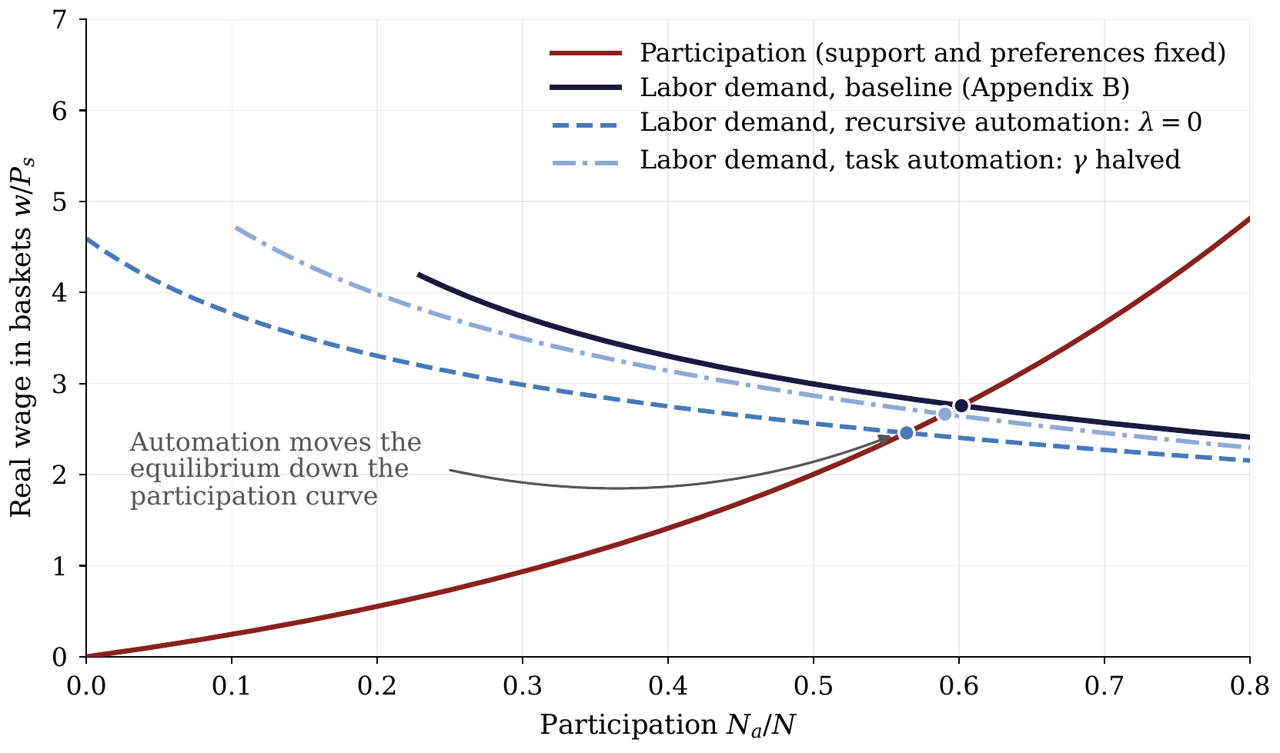
Figure 3. Labor-market clearing in the numerical economy of Appendix B ($N=1$, $T=0.01$, $h=0.0017$, $a=1.4$, $b=0.4$, $δ=0.05$, $ρ=0.09$, $χ$ uniform on $\left[0,2.2\right]$). The participation curve $N_{a}/N=log\left(1+w/P_{s}\right)/2.2$ holds support and preferences fixed. Each demand curve traces labor demand $n_{D}/N$ against $w/P_{s}$ as the task margin moves over the tasks open to machines. At baseline ($λ=7.3$, $γ\left(x\right)=0.01+0.99x^{4.4}$), the equilibrium has $w/P_{s}≃2.76$ and $N_{a}/N≃0.60$. Recursive automation ($λ=0$) moves it to about $2.46$ and $0.56$; task automation, which halves $γ$ at every task, moves it to about $2.66$ and $0.59$. Drawn by code written with Claude (Anthropic).
For a transparent equilibrium, suppose all households consume in the basket’s proportions, support is fully funded, and the endowment $T$ is fully used at $r>0$. With $B_{s}>0$, total production supports $T/B_{s}$ baskets and requires $TL_{s}/B_{s}$ human hours. Labor-market clearing is therefore
$$\underset{\text{hours required}}{\underset{⏟}{\frac{TL_{s}}{B_{s}}}}=\underset{\text{hours supplied}}{\underset{⏟}{NF\left(log\left[1+\frac{w}{P_{s}}\right]\right)}}. \left(11\right)$$
The requirements $L_{s}$ and $B_{s}$ depend on task assignment. Together with replacement pricing in (5), this condition links participation to the equilibrium margin $x^{∗}$. Appendix B constructs the household budgets and proves existence and uniqueness under explicit funding conditions.
In that economy, labor demand falls with $x^{∗}$, while $w/r$ and $w/P_{s}$ rise. Holding technology and support fixed, a lower willingness to work weakly raises $x^{∗}$ and $w/r$, provided an interior equilibrium remains. Workers occupy tasks at which their relative productivity is higher. This participation response can cushion a wage decline from automation; the overall effect depends on how technology changes replacement costs and the living basket. Figure 3 draws this market for the numerical economy of Appendix B. With support and preferences fixed, participation depends only on $w/P_{s}$, so technology moves only the demand side. In that example, both automation channels lower the real wage and participation together.
Heterogeneity and skill premia. Workers differ in task productivity, access to support, living costs, and preferences. An active contestable margin prices each type’s wage against machine services. For a type employed only at human-required tasks in $H$, demand, supply, institutions, and participation determine the wage. Relative wages also reflect substitution between worker types and their relative supplies. Training takes time and resources; open entry disciplines the long-run premium through those costs, while shortages can sustain a higher return. These comparisons guide the historical discussion. A full account of skill premia would jointly determine assignment, training, and household labor supply.

6 Purchasing power at an interior margin
Equation (5) links technology to the wage relative to rent. What that wage buys also depends on the labor and non-produced inputs embodied in each good.

6.1 What an hour’s wage buys
For every good or service, the total requirements in (4) give an exact price. A feasible alternative method also bounds that price from above. Where the entire production chain can be performed by a human method, let ${\overset{‾}{L}}_{i}∈\left(0,∞\right)$ and ${\overset{‾}{b}}_{i}≥0$ be its total human hours and non-produced services per unit of output. The barred coefficients describe this feasible alternative’s complete chain, including its intermediate inputs; the tilde coefficients describe the selected method.
Proposition 4 (the real-wage fork at an interior margin). At positive wages and rents, every positively priced good or service in the two-factor cost system satisfies
$$p_{i}=w{\tilde{λ}}_{i}+r{\tilde{b}}_{i}, \frac{w}{p_{i}}=\frac{1}{{\tilde{λ}}_{i}+{\tilde{b}}_{i}\left(r/w\right)}. \left(12\right)$$
At an active contestable margin, (5) determines $r/w$. If the stated human method is feasible and ${\tilde{b}}_{i}>0$,
$$\frac{1}{{\overset{‾}{L}}_{i}+{\overset{‾}{b}}_{i}\left(r/w\right)}≤\frac{w}{p_{i}}≤\frac{w/r}{{\tilde{b}}_{i}}. \left(13\right)$$
A feasible human method with ${\overset{‾}{b}}_{i}=0$ gives $w/p_{i}≥1/{\overset{‾}{L}}_{i}$. The price identity and bounds hold also at boundary task assignments, with their corresponding selected recipes.
The rent bound counts the whole supply chain. An hour’s wage buys $w/r$ units of the non-produced service; a unit of output embodies ${\tilde{b}}_{i}$ units. A good with no direct requirement may still use that input through electricity, materials, or machinery. The human-method bound likewise counts its entire chain. For cloth, consider a feasible hand-production method covering the fibers, spinning, weaving, tools, and workspace. The wage and rent bill for that complete chain caps the competitive price of cloth. Cheaper machine production raises what an hour’s wage can buy above the lower bound. Ownership income and transfers fund consumption in addition to wages. Appendix A.3 gives the task-level representation of these costs.
Changes in purchasing power depend jointly on the wage–rent ratio and the requirements embodied in each good. Building taller can supply more floor space on a given site, lowering direct site area per unit. Higher crop yields can reduce the acreage needed for a given number of calories. These changes also alter requirements for structures, machinery, fertilizer, and energy; ${\tilde{b}}_{i}$ counts the non-produced inputs throughout those supply chains. At given wages, rents, and total human requirements, a lower ${\tilde{b}}_{i}$ reduces the price. Equilibrium affordability also depends on the wage–rent ratio. The ratio ${\overset{‾}{b}}_{i}/{\overset{‾}{L}}_{i}$ describes how strongly rents enter the human-method lower bound; ordering actual price changes requires the selected recipes.
Corollary (vanishing wage purchasing power and participation). Along a sequence of equilibria with an active contestable margin, suppose
$$γ\left(x^{∗}\right){\tilde{b}}_{m}→0, 1−γ\left(x^{∗}\right){\tilde{λ}}_{m}≥ε>0.$$
Then $w/r→0$. Wage purchasing power tends to zero for every good whose total non-produced input requirement stays bounded away from zero. A persistent unavoidable direct requirement is sufficient. A feasible human method with no non-produced input and uniformly bounded human hours preserves a positive lower bound on wage purchasing power.
If $B_{s}$ stays bounded away from zero, one basket remains funded in work and exit, and the distribution $F$ of work costs is fixed and continuous with $F\left(0\right)=0$, then
$$\frac{w}{P_{s}}→0, \frac{N_{a}}{N}→0. \left(14\right)$$
Proof. Equation (5) bounds $w/r$ above by $γ\left(x^{∗}\right){\tilde{b}}_{m}/ε→0$. If ${\tilde{b}}_{i}≥{\underline{b}}_{i}>0$, then $0<w/p_{i}≤\left(w/r\right)/{\underline{b}}_{i}→0$. The human-method lower bound with ${\overset{‾}{b}}_{i}=0$ remains positive when human hours are uniformly bounded. For the basket, $P_{s}≥rB_{s}$ gives $0<w/P_{s}≤\left(w/r\right)/B_{s}→0$. Equation (10) and continuity of $F$ at zero then give $N_{a}/N→0$. □
The conditions concern replacement at the equilibrium margin. At fixed positive $γ\left(x^{∗}\right)$ and ${\tilde{b}}_{m}$, eliminating embodied labor from machine services leaves $w/r=γ\left(x^{∗}\right){\tilde{b}}_{m}>0$. Human-required work can sustain a boundary assignment, and falling non-produced input requirements can sustain purchasing power. Appendix B gives a complete interior equilibrium and a sequence with a persistent hundred-to-one capability ratio across tasks.
The participation conclusion depends on maintaining the outside option. As wages buy less additional consumption, fewer people choose work when their basic support remains available. If providers’ resources shrink and support falls, the participation response can change. Section 7 connects the funded basket to the income available for redistribution.

6.2 Factor income while labor remains employed
Proposition 5 (labor’s share). In the competitive flow economy with human hours and one non-produced input as the two primary factors, let $N_{a}≤N$ be total employed hours, including labor in machine production, and let $T$ be the fixed, fully employed service endowment of the non-produced input. Final expenditure and factor income satisfy
$$I=wN_{a}+rT, \frac{wN_{a}}{I}=\frac{\left(w/r\right)N_{a}}{\left(w/r\right)N_{a}+T}. \left(15\right)$$
At given $N_{a}$ and $T$, a lower wage–rent ratio lowers labor’s share. With bounded total hours and fixed $T>0$, $w/r→0$ implies that labor’s share tends to zero.
Proof. Intermediate payments cancel when final expenditure is traced through the cost system, leaving the payments for all human hours and non-produced services. Appendix C gives the cancellation explicitly. Divide by $r$ for the share formula; bounded hours give the limit. □
Ownership of the non-produced input receives the non-wage component of income in this two-factor flow benchmark. The wage bill includes work throughout the network; eliminating labor from machine services leaves any human hours used elsewhere in the income identity. Interest, institutional rents, and transitional capacity rents add income components outside this benchmark. Labor’s share responds jointly to the wage–rent ratio and employment, so increased employment can offset a local fall in $w/r$. When the funded-support conditions for (14) also hold, both the wage–rent ratio and the employed fraction tend to zero.

7 Distribution: rent taxation and a uniform transfer
The income identity separates two sources of purchasing power: hours sold and ownership claims. A lower wage–rent ratio increases the importance of ownership at given employment. Rent taxation and transfers determine how this income is distributed across households.
Let non-produced inputs supply fixed service endowments $T_{j}$ at gross competitive rents $r_{j}$, and write R=j​rjTj. A tax at rate $τ_{R}$ on pure ownership rents finances a uniform per-person transfer $d=τ_{R}R/N$, paid identically in and out of work.
Proposition 6 (sharing rents while labor remains employed). (i) The physical supply of the fixed factor is invariant to a tax on its pure ownership rent. Producers continue to pay the gross competitive rental for using it.
(ii) An unconditional transfer pays the same amount in work and exit. Its direct payment differential at the participation boundary is zero, while participation can respond through income effects.
(iii) At given gross prices and hours, aggregate receipts remain $wN_{a}+R$, since
$$\left(1−τ_{R}\right)R+Nd=R.$$
The tax redistributes the rent component toward an equal per-person allocation.
Proof. (i) The taxed stock is fixed by assumption, and its user pays the gross rental regardless of the owner’s after-tax receipt. (ii) The common payment enters both budgets equally, leaving their monetary difference unchanged. (iii) Add after-tax rents and total transfers, using $Nd=τ_{R}R$. □
Rent revenue can finance the basket underlying the participation choice. Define coverage by $κ=R/\left(NP_{s}\right)$, with $R>0$. Funding exactly one basket per person requires $d=P_{s}$, hence
$$τ_{R}=\frac{NP_{s}}{R}=\frac{1}{κ}. \left(16\right)$$
A tax rate between zero and one can meet this budget exactly when $κ≥1$, evaluated at equilibrium prices. Appendix D.3 relates coverage to the basket’s input requirements.
Replacing existing household or public financing while maintaining total support and prices leaves the participation comparison unchanged. If the payment supplements the existing basket, Section 4’s preferences instead give the reservation wage $\left(e^{χ}−1\right)\left(P_{s}+d\right)$: the extra consumption available in both states reduces the gain from work. Redistribution can also change demand, rents, and the resources of support providers. These equilibrium effects determine whether the promised basket remains funded.
A wage-funded transfer draws on the labor market as both a financing base and a participation margin. Its incidence depends on demand and supply elasticities. The limiting case also constrains how much support that base can finance.
Corollary (fiscal capacity as wage income vanishes). In the one-input economy, let $N,T>0$ be fixed and $N_{a}≤N$. Along a sequence of equilibria with $w/r→0$, revenue from any wage tax with a rate between zero and one becomes a vanishing fraction of total income, while $R/I→1$. If the basket’s total non-produced input requirement $B_{s}$ stays bounded away from zero, that revenue also funds a vanishing fraction of one basket per person.
In a fully automated economy, $\tilde{λ}=0$. With $r>0$ and $B_{s}>0$, full rent capture yields coverage
$$κ=\frac{T}{NB_{s}}. \left(17\right)$$
It funds one basket per person exactly when $NB_{s}≤T$, the physical feasibility condition for the basket under these recipes.
As the wage–rent ratio tends to zero, maintaining access to a living basket with a persistent non-produced input requirement increasingly depends on ownership income or transfers. Support financed by another household member’s wage faces the same aggregate constraint. A system funded entirely from wages becomes unable to sustain a fixed positive basket entitlement for everyone sufficiently far along the path, while labor may still be employed. A uniform rent dividend gives each person a claim on the income that remains. Broad ownership, collective funds, and other transfer arrangements can also distribute those claims. The financing constraint establishes the need for income beyond wages; institutions determine its distribution and the pace of adjustment.
Appendix D proves the corollary and develops payroll-tax incidence and rent-base coverage while labor remains employed. The fiscal lineage is George (1879); the Henry George theorem of Arnott and Stiglitz (1979) is related but distinct.

8 History as four configurations of the model
The model can be applied to the long record as four configurations of the relative-productivity schedule (Figure 4). Because schedules may differ across worker types, the figure shows each configuration for both an untrained entrant and a worker with accumulated training or experience. The comparison illustrates differences in worker-specific task mixes; a joint determination of their wages and training decisions requires the extension described in Section 5.
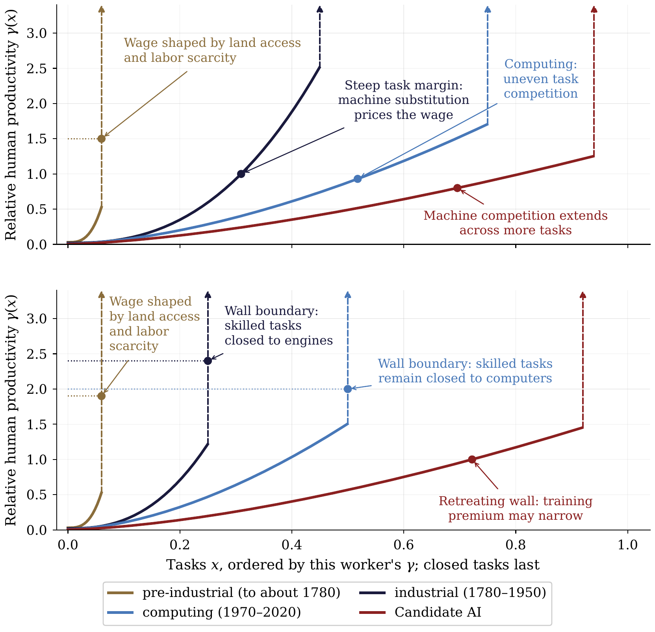
Figure 4. Four schematic configurations of the task schedule, shown for an untrained entrant (top) and a worker with accumulated training or experience (bottom). Each panel uses a different worker-specific task mix, held fixed across eras within that panel; differences in wall location reflect these mixes. Closed tasks appear as a wall at the right edge. Dot heights are illustrative wage–machine-rental ratios $w/p_{m}$. A dot on the contestable schedule marks an interior margin satisfying $w/p_{m}=γ\left(x^{∗}\right)$; a dot on the wall marks employment confined to human-required tasks, whose wage also depends on demand, labor supply, and institutions. Industrialization opens physical tasks; computing extends competition into cognitive tasks while many trained tasks remain closed. Relative human advantage continues to vary across the open task range. In the candidate AI configuration, machine competition extends across more tasks, while the schedules keep rising and retain an illustrative positive training premium. The chosen curvatures illustrate differences in relative capability across tasks. Drawn by code written with Claude (Anthropic).
Pre-industrial: land access and labor scarcity. With machines scarcely present, nearly every task is closed to them; the margin sits at the wall for entrant and master alike, so the machine prices no one’s hour. Demand for human services, labor scarcity, institutions, and participation then determine wages. A configuration with wages near the outside option additionally invokes demographic adjustment, with the outside option tracking access to land — the world Ricardo and Malthus wrote down, and the one long-run estimates describe: pre-industrial English real wages strongly shaped by population and land, with productivity growth beginning well before wages escaped Malthusian pressure (Bouscasse, Nakamura, and Steinsson 2025). The classical account is one configuration of our model. The entrant is the farm servant hired by the year; the trained worker is the craftsman after a seven-year apprenticeship, whose premium over the servant is the cost of those years, recovered.
Industrial: comparative advantage widens. The Industrial Revolution created a large and uneven productivity gap across tasks: engines were far better than muscle at physical tasks but ineffective at cognitive ones. The schedule became enormously dispersed and steep. It did so for the entrant first: the young mill hand or hand-loom weaver held the tasks engines were reaching one by one, and the margin sat on the steep stretch, where what the engine cost at the next task priced the hour. The trained worker, the millwright, the engineer, the clerk, held tasks closed to engines; that margin stayed at the wall, with the wage a scarcity price on trained hands and heads, kept scarce by the years the training took. That dispersion opened high-productivity tasks to labor and could support a higher wage; by Proposition 1(ii), steepness also makes employment less responsive to a given wage change and the wage more responsive to shifts in labor supply. Meanwhile machine production itself remained labor-intensive: both relative human productivity at the margin and the labor embodied in machine services supported the wage. The escape was neither immediate nor smooth — real wages grew slowly in the early decades as capital deepening and urbanization preceded substantial wage growth (Crafts 2022).
Post-industrial: machine competition broadens. Computerization reached the simple-cognitive region of the schedule — the routine-task evidence of Autor, Levy, and Murnane (2003) and the polarization it produced (Autor and Dorn 2013) are the cross-sectional trace. The entrant is the young clerk, cashier, or assembler whose routine tasks software and machines reached at similar cost: an interior machine-contestable margin could price the wage on a schedule of uneven relative capability. The trained worker, the developer, the physician, the engineer, held tasks computers could not: the margin stayed at the wall, and the premium for training was what the period’s expansion of higher education chased. AI is a candidate extension of machine competition to further tasks, including those previously closed to machines. It may also reduce ${\tilde{λ}}_{m}$, the labor embodied in machine services. As trained tasks become contestable, skill premia depend on the replacement costs and labor supplies of the different worker types. The interior result connects these replacement costs to wage purchasing power.

9 Measurement
In this section we observe three empirical objects: the real-wage fork, the size of the rent base relative to the cost of a subsistence bundle, and the separation between the origin of consumption finance and the human effort embodied in production.
The fork. Over 1964–2024, the durables-to-shelter real-wage ratio reaches $4.8×$ (Figure 5). This descriptive comparison is consistent with the distinction in Proposition 4 between task costs and persistent requirements for non-produced inputs. Identifying the underlying task schedules and attributing the price changes require additional task-level evidence. Food lies between the endpoints. Deflated by the food CPI, the same paycheck rose 13 percent over 1964–2024, compared with 277 percent for durables and a decline of 21 percent for shelter. The intermediate result is consistent with food production combining acreage, processing labor, and rising yields. Energy is volatile, consistent with the importance of world oil-price shocks in the series.
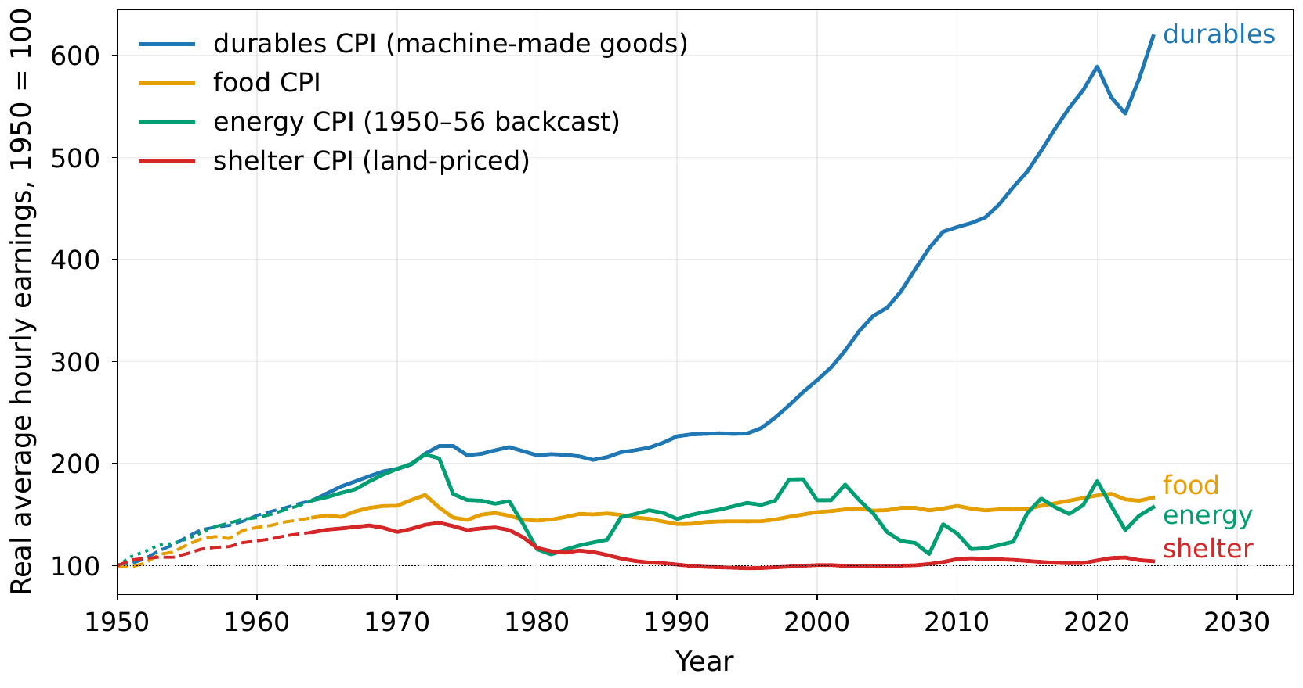
Figure 5. U.S. average hourly earnings for production and nonsupervisory workers deflated by the consumer-price indexes for durables, food, energy, and shelter, 1950 = 100, through the last complete calendar year, 2024. Values before 1964 (dashed) use the spliced wage series. The energy index begins in 1957; its 1950–1956 values are a linear backcast estimated over 1957–1966. Over 1964–2024 the ratio of the durables-deflated to the shelter-deflated wage reaches $4.8×$, a ratio invariant to the index base. Drawn by code written with Claude (Anthropic).
Coverage of basic living costs. The coverage ratio $κ$ is the fraction of one subsistence bundle that a full tax on site rents could finance per person. Figure 6 measures aggregate site-rent flow against population times a costed subsistence bundle. The 2025 estimate is $κ=0.30$ [0.15–0.59], up from roughly 0.05 in the 1950s. The measures are intended as lower-bound constructions. The underlying resource constraint is the non-produced input required by the basket relative to its available supply per person.
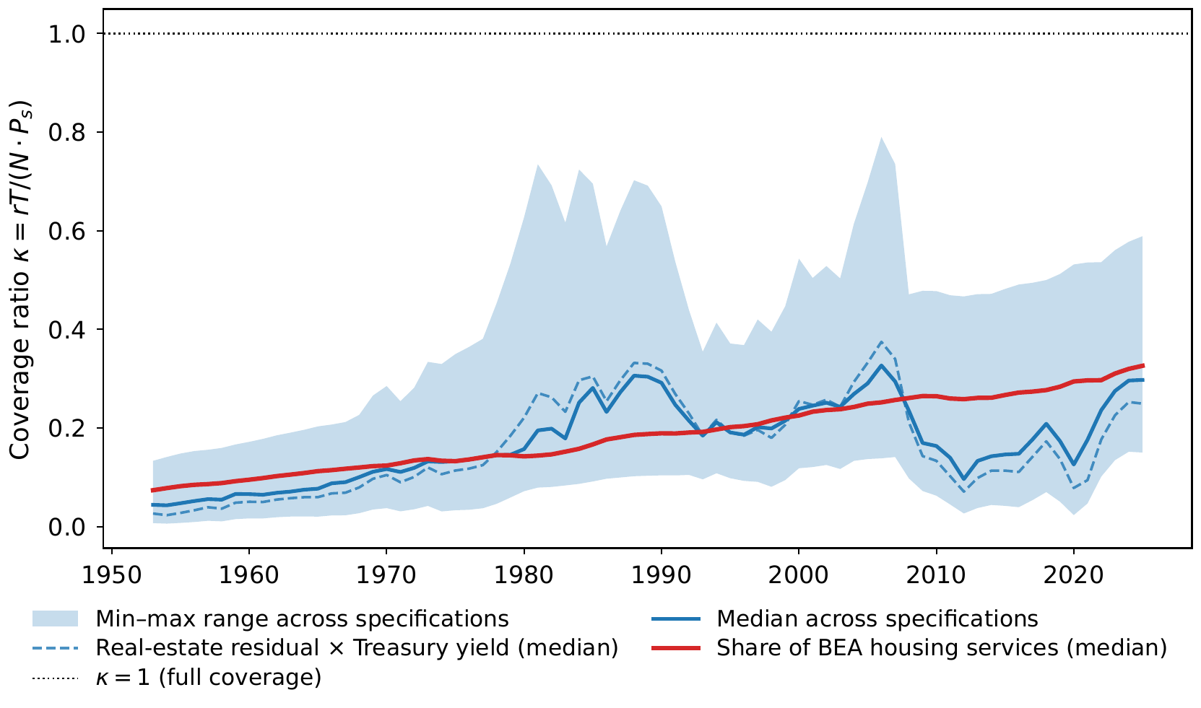
Figure 6. The coverage ratio $κ=rT/\left(N⋅P_{s}\right)$ is aggregate site-rent flow divided by the cost of providing the specified subsistence bundle to every person; U.S., 1953–2025. The line is the median and the band is the min–max range across specifications combining land sources, capitalization rates, and subsistence bundles. The dashed specifications subtract residential structures at replacement cost (Z.1, BOGZ1LM155012665Q) from household real estate at market value (Z.1, FRED HOOREVLMHMV) and convert the residual to an annual flow using the 10-year Treasury yield (GS10), with a +150 basis-point variant and household and economy-wide scopes. The red specifications apply land shares of 0.30 and 0.50 to PCE housing services (BEA, DHSGRC1A027NBEA). Every specification uses population times the Orshansky 1963 subsistence bundle as the denominator. Drawn by code written with Claude (Anthropic).
Financing versus production. Consumption remains substantially more labor-financed than production is labor-intensive. In the common benchmark-data window, labor-origin resources finance 69.6% of consumption in 2004 and 65.8% in 2023, while full-chain human effort accounts for 48.9% and 47.2% of consumed production in the same years — a gap of about nineteen percentage points at the end of the overlap (Figure 7). The production account is the aggregate counterpart of the recursion: the human-effort share declines as machine-producing and machine-operating chains shed labor. Appendix F gives the two accounts’ construction and bounds.
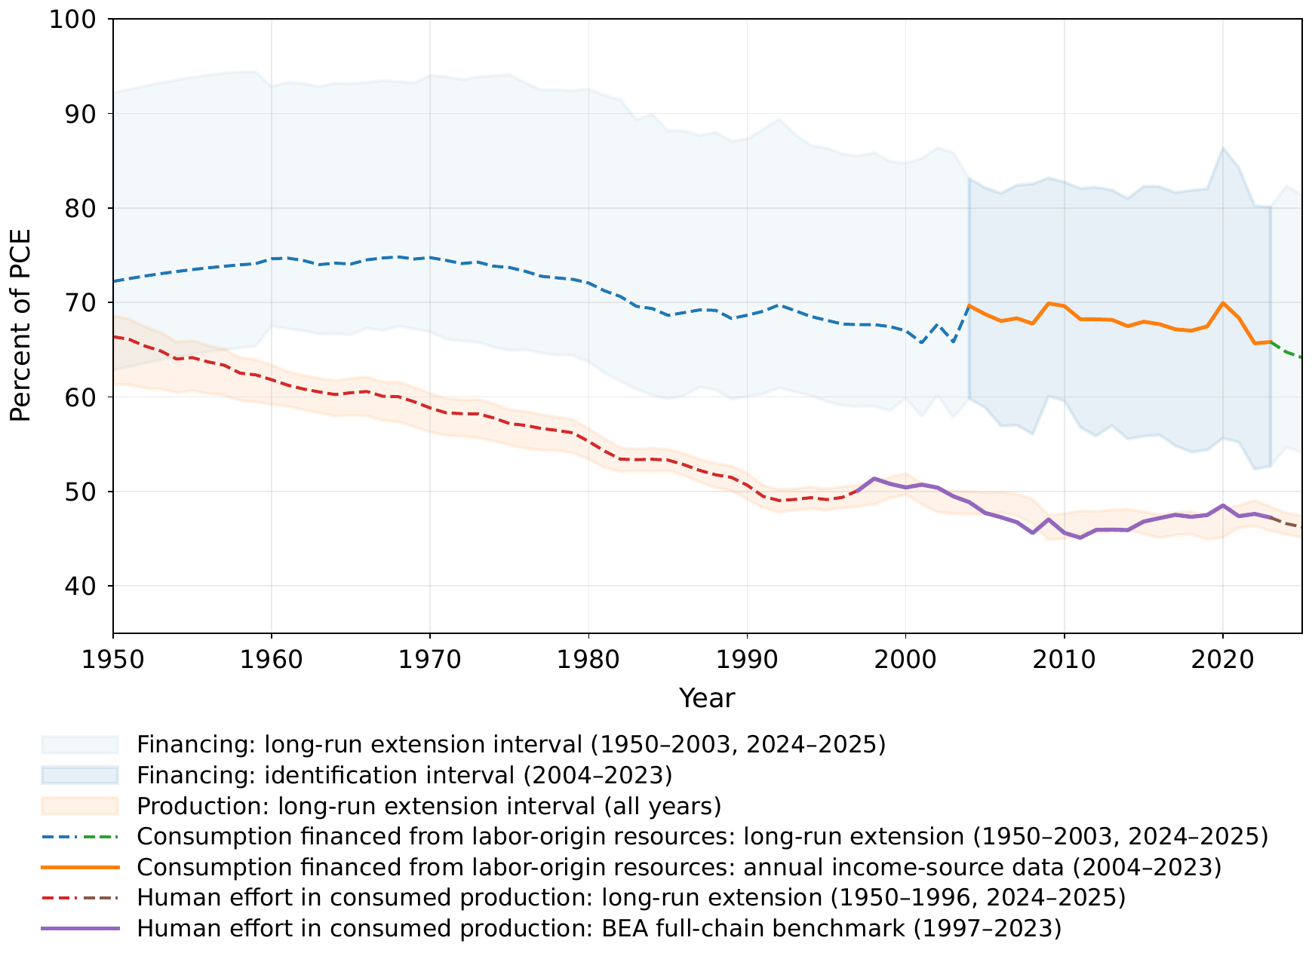
Figure 7. Two labor linkages in U.S. consumption, 1950–2025. The upper series is the share of consumption financed from labor-origin resources; the lower is the share of consumed production that resolves into human effort through the full production chain. Markers identify the benchmark-data windows: annual BEA income-source profiles for financing in 2004–2023 and the BEA full-chain production benchmark in 1997–2023. Values outside those windows are model-based extensions. In the common benchmark-data window, consumption is substantially more labor-financed than production is labor-intensive. Drawn by code written with Claude (Anthropic).

10 Possible stabilizers
Several mechanisms can sustain purchasing power as technology changes. Human-required tasks can persist by preference or by law; Appendix E shows that this can preserve aggregate labor income while leaving the median worker exposed. Institutions can reserve tasks for people outright, protecting employment through an allocation rule. Supply expansion — building, densifying, powering — works through the cost system by expanding services or reducing the scarce inputs required to supply them. Lower living costs can improve affordability, while cheaper machine services also affect replacement values.
Substitution can also change the services people choose. Replacing a journey and an in-person meeting with a video call changes the bundle of transport, space, equipment, and electricity used to communicate. Its resource requirements depend on those services’ full production chains and on how well they meet the same need. The participation comparison holds the living basket fixed; consumer substitution can change its composition across equilibria.
Acemoglu and Restrepo’s (2026) wedge result clarifies the role of wage premia. Let a task pay a premium over the base wage — a union premium, a licensing rent, an efficiency wage — as a multiplicative wedge $μ\left(x\right)>1$. Labor then holds the task only while $w≤p_{m}⋅γ\left(x\right)/μ\left(x\right)$: allocation runs on the wedge-deflated schedule, a premium raises its own task’s flip priority one-for-one, and automation is directed at the best-paid versions of each job — their targeting result, with the documented losses concentrated in the 70th–95th within-group percentiles. A wage premium therefore increases the incentive to automate the protected task; protection survives only in quantity form — a scope-of-practice rule extended to software, an enforceable automation ban, a mandated human in the loop. Under pressure, nothing moves while the saving from flipping runs below the cost of confrontation with a legal or strike risk; past it, everything the rule covers flips at once.

11 Artificial intelligence and conclusion
AI may move both automation margins at once. It can lower $γ\left(x^{∗}\right)$ where models become effective substitutes at tasks, and it can lower ${\tilde{λ}}_{m}$ because software generation, chip design, datacenter operation, logistics, and research contribute to the machine-service supply chain. Either change lowers $w/r$ when the other terms in the replacement closure are held fixed; the equilibrium effect also depends on demand, participation, and changes in the recipes. Section 6 translates that ratio into purchasing power through the labor and non-produced inputs embodied in goods and services. If replacement at the active margin drives $w/r$ toward zero while an embodied non-produced input requirement remains bounded away from zero, wage command over that output falls toward zero. For the AI buildout, the relevant scarcity may lie in sites, water, mineral deposits, grid access, or legally protected rights. Electricity and equipment are themselves outputs whose costs trace through the same system.
On the household side, falling wage purchasing power reduces the consumption gained from employment relative to a supported living standard. Participation helps determine which task is marginal and, with support maintained and positive work costs, tends to zero as wages buy vanishing additional consumption. Maintaining that standard depends on the resources of families and public institutions. Rent income provides a potential fiscal base. For the measured U.S. site-rent base, full capture covers about 30 percent of the specified subsistence bundle in 2025, while 0.68 of tax revenue is raised from labor-income bases. A tax on pure fixed-factor rents can fund a payment paid equally in and out of work; the coverage ratio determines whether it can finance the full basket. Its scale, income effects, and equilibrium consequences remain empirical questions.
The remaining empirical question is whether the machine-production recursion is paying a smaller share of cost to wages and a larger share to terminal-input rents, and whose resources are keeping pace with the resulting cost of living outside paid work.
We close with a conjecture that the model suggests but does not establish. Wages finance most consumption, and most benefits are conditioned on work or means. When consumption depends on earning a wage, a lower wage need not reduce the labor offered, so the economy has little way to signal that it wants less labor, as it can for oil in a glut or for capital when returns approach zero. Labor may then have been behaving for decades as a large market distortion: jobs are created at cost, behind institutional wedges or at wages barely above living costs. If the conjecture holds, it would connect developments usually studied separately, including polarized job growth, youth unemployment, delayed household formation, persistent fiscal strain, and slow growth despite rapid advances in computing. Each needs its own test. The first is whether machine production is shifting its costs from wages to rents.
The mechanism also joins older lines of thought. The classical economists tied wages to subsistence and scarcity, George drew the fiscal consequences of rent, and Keynes put employment and demand at the center of the economy. Automation that reaches the machines’ own supply chains gives them a common setting, and perhaps a common wage equation.

12 Future Work
There is much still to be done. The static model describes prices and limiting configurations. A dynamic extension could ask whether automation arrives smoothly or in waves, how quickly rents adjust, and what happens when wages fall faster than institutions can respond. It may also have implications for monetary policy. When machine-made goods become cheaper while housing, energy, and other scarce necessities become more expensive, a single inflation rate can hide significant nuances. Can one interest rate stabilize both sides of a divide? Do low interest rates support employment and demand, or do they mainly raise scarce-asset rents and accelerate the replacement of labor? The relative-price structure developed here provides a starting point for these questions.
Participation also invites further study. The benchmark holds real support fixed. A richer account would let families and public institutions adjust provision as living costs and their own resources change. Personal assets, pensions, and savings would add further ways to sustain life outside employment. Richer household structure would open further questions. If wages buy ever more manufactured goods but ever less housing, energy, and care, then forming a household may become harder even while measured productivity rises. Delayed household formation, adult children remaining with their parents, and declining fertility may therefore reflect changing preferences alongside a growing separation between wages and the scarce goods required to begin an independent life.
The model also suggests avenues for choosing the tax mix as automation changes the sources of income. Labor and ownership both finance consumption, and site rents may cover only part of a desired transfer. The relevant question is the best mixture of value-added, income, corporate, land-value, and other pure-rent taxes. Our input-output and consumption financing measurements may help significantly with this. Sovereign wealth funds may provide another instrument. A country with little land, energy, or mineral wealth of its own cannot tax rents earned elsewhere, but it can acquire claims on them. For resource-poor countries, owning part of the world’s scarce-resource base may eventually matter as much as taxing the domestic one.
Finally, structuring a society that no longer orbits around labor is not a trivial problem. Work provides more than a wage. It provides structure to the day, social contact, status, a sense of contribution, and an understanding of the complexity of the real economy. An income transfer can replace a wage; it cannot by itself replace all of those functions. Some may emerge naturally through family, community, education, art, care, or voluntary work. Others may have to be deliberately nurtured. The economic problem may be how to distribute purchasing power without labor. The larger human problem is how to distribute purpose, status, and a meaningful place in society once labor is no longer the institution that provides them.

Appendix A. The environment and supporting results
The price system in Section 3 applies to goods and services throughout production and consumption. This appendix states the equilibrium conditions, proves the main results, and develops the task-level cost representation and timing extensions.

A.1 Environment and equilibrium
Tasks and technology. A unit of a task-produced good requires tasks $x∈\left[0,1\right]$ in equal amounts. One human-hour completes $γ_{L}\left(x\right)$ units of task $x$, one machine-hour $γ_{M}\left(x\right)$; relative human productivity is $γ=γ_{L}/γ_{M}$. Tasks in $H$ are closed to machines by capability, preference, or law. Firms select the least-cost feasible method for every task. With several machine types, the relevant alternative minimizes delivered task cost; an active margin satisfies $w/γ_{L}\left(x^{∗}\right)=\min_{ℓ}p_{m_{ℓ}}/γ_{M_{ℓ}}\left(x^{∗}\right)$.
The cost system. For many non-produced inputs with rental vector $r$, let $B_{ik}$ be the direct requirement of input $k$ per unit of output $i$. Then
$$p=Ap+λw+Br, p=w\tilde{λ}+\tilde{B}r, \tilde{B}={\left(I−A\right)}^{−1}B.$$
The selected recipes are nonnegative and productive, with spectral radius of $A$ below one. Unused feasible methods have unit costs at least as high as the equilibrium output price. The matrix records which good or service each activity uses; it changes when firms switch methods. At an active margin against machine $m$, the replacement closure is
w=γx∗k​Bmkrk1−γx∗λm.
One rental ratio can summarize the closure only after specifying a common input or rental benchmark.
Non-produced inputs. Input $k$ supplies a fixed service endowment $T_{k}$ at rental $r_{k}$. Its services enter production and household use. A direct household rental can be included as a pass-through service in $p$, with its endowment use counted in $B$. Horizon matters: installed capacity can be fixed temporarily and expanded later, while land supplies a persistent non-produced input.
People. Each of $N$ workers supplies one hour or exits. Types may differ in task productivity, access to support, living requirements, and preferences. Section 4’s log-utility example gives $s=\left(e^{χ}−1\right)z^{T}p$ when a provider maintains the same real support in work and exit. Appendix B specifies the provider’s budget and market clearing for a complete interior example.
Government. The instruments are a payroll tax $τ_{w}$; a tax $τ_{R}$ on pure ownership rents, returned as a uniform transfer $d=τ_{R}R/N$; a uniform consumption tax; and a transfer program paying $\left(m_{w},m_{e}\right)$ per period in work and exit.
Equilibrium. Prices, gross outputs $y$, final consumption $f$, task assignment, and participation form an equilibrium when firms choose cost-minimizing methods, active activities satisfy the cost equations, and households choose their preferred affordable consumption and work arrangements. Commodity clearing requires $f=\left(I−A^{T}\right)y$, labor clearing requires $N_{a}=λ^{T}y$, and fully employed non-produced inputs satisfy $T=B^{T}y$. Unused fixed inputs have zero rent. Pass-through services ensure direct household rentals enter these accounts once. Output, participation, and the assignment margin are jointly determined; the replacement closure alone supplies a price condition. Table A.1 lists the configuration each part of the paper uses.
Table A.1. Configurations of the environment and where the paper uses them.
Where | Configuration
Sections 3–5 | goods and services in a common cost system; one wage and one non-produced input; capability-closed tasks permitted
Section 6 | an active contestable margin; embodied input requirements and feasible-method price bounds
Section 7 | pure-rent taxation and a uniform transfer
Appendix B | strictly increasing capability; household participation and market clearing
Appendix D | conditional transfers, payroll incidence, and fiscal coverage
Appendix E | a positive human-required set while machine costs vanish outside it
Heterogeneous workers. With type-specific schedules, replacement applies at each type’s active contestable margin. Cross-type assignment, relative labor supplies, and training determine skill premia jointly. Reservation wages depend on each type’s support, living costs, and preferences. The eras figure illustrates distinct worker-specific task mixes with schematic wage ratios.

A.2 Proofs of the main results
Proof of Proposition 1. (i) At the boundary between human and machine assignment, continuity and cost minimization give $w/γ_{L}\left(x^{∗}\right)=p_{m}/γ_{M}\left(x^{∗}\right)$. (ii) Differentiate the equality at fixed $p_{m}$. If output is $Y$, final-task labor demand is $Y\int_{x^{∗}}^{1}{d}x/γ_{L}\left(x\right)$, including the human-required tail. Thus $dN_{F}/dx^{∗}=−Y/γ_{L}\left(x^{∗}\right)$ and $dw/dN_{F}=−p_{m}γ′\left(x^{∗}\right)γ_{L}\left(x^{∗}\right)/Y$. (iii) is the participation condition. Output, the rental, and labor used in machine production also respond in a full equilibrium; Appendix B supplies a complete interior example under stated conditions. □
Proof of Proposition 2. Substitute $w=p_{m}γ\left(x^{∗}\right)$ into the machine-service row to obtain $p_{m}\left(1−γ\left(x^{∗}\right){\tilde{λ}}_{m}\right)=r{\tilde{b}}_{m}$. The conditional derivatives are
$$\frac{∂\left(w/r\right)}{∂{\tilde{λ}}_{m}}=\frac{{\left(γ\left(x^{∗}\right)\right)}^{2}{\tilde{b}}_{m}}{{\left(1−γ\left(x^{∗}\right){\tilde{λ}}_{m}\right)}^{2}}, \frac{∂\left(w/r\right)}{∂γ\left(x^{∗}\right)}=\frac{{\tilde{b}}_{m}}{{\left(1−γ\left(x^{∗}\right){\tilde{λ}}_{m}\right)}^{2}},$$
both positive. □
Proof of Proposition 3. Exit provides utility zero. Work provides $log\left(1+w/P_{s}\right)−χ$, which is nonnegative exactly when (9) holds. Holding the supported basket and preferences fixed, differentiation along a change in rents gives
$$\frac{ds}{dr}=\left(e^{χ}−1\right)\frac{dP_{s}}{dr}. \left(A.1\right)$$
□
Proof of Proposition 4. Equation (12) follows from the cost system. All total requirements are nonnegative, so the rent bill is a lower bound on price. The feasible human method costs $w{\overset{‾}{L}}_{i}+r{\overset{‾}{b}}_{i}$, and competitive production selects a method costing at most that amount. Thus
$$r{\tilde{b}}_{i}≤p_{i}≤w{\overset{‾}{L}}_{i}+r{\overset{‾}{b}}_{i}. \left(A.2\right)$$
Dividing by $w$ and inverting proves the purchasing-power bounds. □

A.3 Task-level costs
Task assignment determines the selected requirements in the common cost system. Consider a good supplied by a task list $X_{i}$, using human or machine services, with direct requirement $b_{i}$ and no other intermediate inputs. Machine services are priced by $p_{m}$. At an active margin,
pi=rbi+wXi​1γLixmin1,γixγx∗dx, γi=γLiγMi. A.3
The minimum is one on human-required tasks. The all-human method has Li=Xi​dx/γLix and ${\overset{‾}{b}}_{i}=b_{i}$. Actual machine use can embody additional non-produced services through the machine supply chain. A persistent direct requirement alone gives the price bound $p_{i}≥rb_{i}$, since ${\tilde{b}}_{i}≥b_{i}$.
Uniform relative capability. If $γ_{i}\left(x\right)=\overset{‾}{γ}$ throughout the task list in (A.3) and $w=p_{m}\overset{‾}{γ}$, every task is at cost parity. Then $p_{i}=w{\overset{‾}{L}}_{i}+rb_{i}$, so $w/p_{i}=1/\left[{\overset{‾}{L}}_{i}+b_{i}\left(r/w\right)\right]$. For $b_{i}=0$, an hour’s wage buys exactly $1/{\overset{‾}{L}}_{i}$ units.

A.4 Timing and institutional rents
The main cost system prices contemporaneous service flows. A dated construction process requires an additional user-cost relation. Let $a$, $λ$, and $b$ be the machine-service, labor, and non-produced input requirements for construction, respectively. If all inputs are advanced one period to deliver one unit of service, $p_{m}=\left(1+ρ\right)\left(ap_{m}+λw+br\right)$, with interest rate $ρ$. At the task margin,
$$p_{m}=\frac{\left(1+ρ\right)br}{1−\left(1+ρ\right)\left(a+λγ\left(x^{∗}\right)\right)}.$$
For a durable asset costing $V_{m}=ap_{m}+λw+br$ to build and supplying one service unit per period, suppose there are no separate operating costs or capital gains. With depreciation $δ$, the user cost is $p_{m}=\left(ρ+δ\right)V_{m}$, giving
$$p_{m}=\frac{\left(ρ+δ\right)br}{1−\left(ρ+δ\right)\left(a+λγ\left(x^{∗}\right)\right)}.$$
Each expression requires a positive denominator. These are distinct timing conventions for the construction coefficients; interest introduces an income component beyond the main two-factor flow accounting.
Ideas and institutional rents. An idea’s reproduction requires approximately nothing of anything, so its competitive reproduction cost is approximately zero. Legal exclusion can sustain a positive price and help finance fixed creation costs (Romer 1990). These institutional rents are revocable and policy-dependent; the income accounting in Section 6 treats them as additional claims when present.

Appendix B. Equilibrium with heterogeneous tasks
This example funds dependence through a supporting household that owns the non-produced endowment and the machines. Task assignment, output, and participation are solved jointly, with machines priced at the user cost of Appendix A.4. The input is land, used both for living space and in machine production.
There are $N$ potential workers and one nonworking supporting household. Each consumption basket contains one unit of a final good and $h>0$ units of space. The household owns $T$ units of land and the machine stock, commits to providing one basket to each worker in both work and exit, and consumes its remaining income in the same proportions. Workers spend their wages on additional baskets and have the preferences in (8), with $χ$ continuously distributed on $[0,∞)$ according to $F$. Normalize $r=1$ and write $v=w/r$. At final-good price $p$, a basket costs $P_{s}=p+h$.
The final good requires one unit of each task on $\left[0,1\right]$ per unit of output. Set $γ_{L}\left(x\right)=1$ and $γ_{M}\left(x\right)=1/γ\left(x\right)$, where $γ$ is positive, continuously differentiable, and $γ′\left(x\right)>0$ for $x>0$. Building a machine requires $a$ units of machine service, $λ$ human hours, and $b>0$ units of land service, so it costs $V_{m}=ap_{m}+λw+br$. A machine supplies one unit of service per period and depreciates at rate $δ∈(0,1]$. Its owner requires the return $ρ≥0$, so a unit of service rents at the user cost $p_{m}=\left(ρ+δ\right)V_{m}$. Assume $a,λ≥0$ and $\left(ρ+δ\right)\left(a+λγ\left(0\right)\right)<1$. With $ρ=0$ and $δ=1$ the economy is the main text’s flow benchmark.
Tasks at which $\left(ρ+δ\right)\left(a+λγ\left(x\right)\right)≥1$ are closed to machines at every wage: the machine services that would replace an hour there cost more than the hour, because building them takes labor and machine services of their own. Let $x_{c}$ be the first such task, or $x_{c}=1$ if there is none. At an interior threshold $x<x_{c}$, machines perform tasks below $x$ and people those above it. The task condition and the user cost give
$$J\left(x\right)=\int_{0}^{x}{γ}\left(t\right) dt, p_{m}\left(x\right)=\frac{\left(ρ+δ\right)b}{1−\left(ρ+δ\right)\left(a+λγ\left(x\right)\right)}, v\left(x\right)=γ\left(x\right) p_{m}\left(x\right). \left(B.1\right)$$
The final-good and basket prices are
$$p\left(x\right)=v\left(x\right)\left(1−x\right)+p_{m}\left(x\right)J\left(x\right), P_{s}\left(x\right)=p\left(x\right)+h. \left(B.2\right)$$
If final-good output is $Y$, total consumption contains $Y$ baskets and uses $hY$ units of space. In a stationary state a machine stock $X$ supplies $X$ units of service: $YJ\left(x\right)$ to final tasks and $aδX$ to rebuilding the $δX$ machines that wear out each period. Machine and land clearing give
$$Y\left(x\right)=\frac{T}{h+bδJ\left(x\right)/\left(1−aδ\right)}, X\left(x\right)=\frac{Y\left(x\right)J\left(x\right)}{1−aδ}. \left(B.3\right)$$
Labor demand and supply are
$$n_{D}\left(x\right)=Y\left(x\right)\left[1−x+\frac{λδJ\left(x\right)}{1−aδ}\right], n_{S}\left(x\right)=NF\left(log\left[1+\frac{v\left(x\right)}{P_{s}\left(x\right)}\right]\right). \left(B.4\right)$$
The two components of demand are final-task and machine-sector hours. As $x$ rises to $x_{c}<1$, $v$ and $P_{s}$ grow without bound while $v/P_{s}$ tends to $γ\left(x_{c}\right)/\left[γ\left(x_{c}\right)\left(1−x_{c}\right)+J\left(x_{c}\right)\right]$; $n_{S}\left(x_{c}\right)$ denotes the corresponding limit.
These equations are a three-row instance of the common cost system. Ordering the final good, machine services, and directly rented space, the prices satisfy (3) with the user cost scaling the machine row,
$$p=\left(\begin{matrix}p \\ p_{m} \\ r\end{matrix}\right), A=\left(\begin{matrix}0 & J\left(x\right) & 0 \\ 0 & \left(ρ+δ\right)a & 0 \\ 0 & 0 & 0\end{matrix}\right), λ=\left(\begin{matrix}1−x \\ \left(ρ+δ\right)λ \\ 0\end{matrix}\right), b=\left(\begin{matrix}0 \\ \left(ρ+δ\right)b \\ 1\end{matrix}\right),$$
while stationary quantities use the replacement rate $δ$ in place of $ρ+δ$. Gross output is ${\left(Y,X,hY\right)}^{T}$, and final consumption is ${\left(Y,0,hY\right)}^{T}$. Applied to the replacement coefficients with $z={\left(1,0,h\right)}^{T}$, (4) gives the basket’s total requirements of hours and land, $L_{s}=1−x+λδJ\left(x\right)/\left(1−aδ\right)$ and $B_{s}=h+bδJ\left(x\right)/\left(1−aδ\right)$. Thus $Y=T/B_{s}$ and $n_{D}=TL_{s}/B_{s}$, giving (11). The price coefficients add the return $ρ$ to replacement, so $P_{s}=wL_{s}+rB_{s}+ρV_{m}X/Y$: the basket also pays interest on the machines that supply it. In the flow benchmark the two sets of coefficients coincide, and $P_{s}=wL_{s}+rB_{s}$ as in Section 5. Structures and maintenance could enter the space-service row through their own input requirements.
Lemma B.1 (Interior equilibrium with funded support). Suppose
$$T>Nh, n_{S}\left(x_{c}\right)>n_{D}\left(x_{c}\right). \left(B.5\right)$$
Then there is a unique interior threshold $x^{∗}∈\left(0,x_{c}\right)$ satisfying $n_{D}\left(x^{∗}\right)=n_{S}\left(x^{∗}\right)$. If the provider’s rent and interest cover the support there, $T+ρV_{m}X≥NP_{s}$, the prices and quantities in (B.1)–(B.4) give a competitive equilibrium with the promised support fully funded.
Proof. The function $Y\left(x\right)$ is decreasing. Below $x_{c}$, $δ\left(a+λγ\left(x\right)\right)≤\left(ρ+δ\right)\left(a+λγ\left(x\right)\right)<1$, so the bracket in labor demand is positive and has derivative $−1+λδγ\left(x\right)/\left(1−aδ\right)<0$; $n_{D}\left(x\right)$ is strictly decreasing. Meanwhile $v′\left(x\right)>0$ and
$$\begin{matrix}p′\left(x\right)=v′\left(x\right)\left[1−x+\frac{\left(ρ+δ\right)λJ\left(x\right)}{1−\left(ρ+δ\right)a}\right]>0, \\ \frac{d}{dx}\left(\frac{v\left(x\right)}{P_{s}\left(x\right)}\right)=\frac{v′\left(x\right) \left[h+\left(ρ+δ\right)bJ\left(x\right)/\left(1−\left(ρ+δ\right)a\right)\right]}{P_{s}{\left(x\right)}^{2}}>0\end{matrix}$$
for $0<x<x_{c}$. Thus $n_{S}\left(x\right)$ is continuous and nondecreasing up to its limit at $x_{c}$. Since $J\left(0\right)=0$, demand at $x=0$ is $T/h>N$, above supply; at $x_{c}$ it lies below supply by assumption. There is exactly one crossing.
At the crossing, assignment is cost-minimizing because $v/p_{m}=γ\left(x^{∗}\right)$ and machines cannot undercut labor above $x_{c}$; machines, labor, and land clear. The provider rebuilds the $δX$ worn machines out of their rentals and keeps the interest $ρV_{m}X$. The cost equations imply
$$P_{s}Y=\left(p+h\right)Y=v\left[Y\left(1−x^{∗}\right)+λδX\right]+bδX+hY+ρV_{m}X=vn_{S}+T+ρV_{m}X,$$
so income is wages, rent, and interest. Workers consume $N+vn_{S}/P_{s}$ baskets, including support. The provider consumes $\left(T+ρV_{m}X\right)/P_{s}−N≥0$ baskets from its remaining income. Their sum is $Y$, so final-good and space demand also clear. Continuity of $F$ gives zero mass at the participation tie. □
At fixed technology and support, a distribution $\hat{F}≤F$ lowers labor supply at every $x$. If the interior conditions continue to hold, decreasing labor demand and nondecreasing supply imply ${\hat{x}}^{∗}≥x^{∗}$, hence a weakly higher $w/r$ and $w/P_{s}$. The inequalities are strict if supply falls at the original crossing.
For a numerical instance, take $N=1$, $T=0.01$, $h=0.0017$, $a=1.4$, $b=0.4$, $λ=7.3$, $δ=0.05$, $ρ=0.09$, $γ\left(x\right)=0.01+0.99x^{4.4}$, and $χ$ uniform on $\left[0,2.2\right]$. These values are illustrative. They are chosen so that cost shares are of the order seen in U.S. data: labor is about half of a machine’s build cost and of the full-chain cost of consumption, machine services are about a fifth of a machine’s build cost, and site rent is 6.5 percent of the basket; participation is 60 percent. The solution has $x^{∗}≃0.82987$, below the ceiling $x_{c}≃0.94634$, $v≃0.07165$, $Y≃3.01320$, and $N_{a}≃0.60165$: about $0.51264$ hours at final tasks and $0.08902$ in machine production. Support costs $NP_{s}≃0.02599$ out of the provider’s rent and interest of $0.03520$. The accompanying check_interior.py compares output with an independently specified discretized production optimization, including both uses of labor and land.
For an illustrative automation path, retain these parameters and set $λ=0$ and $γ_{η}\left(x\right)=η\left(0.01+0.99x^{4.4}\right)$, with $0<η≤1$; at $η=1$ this is the recursive-automation economy of Figure 3. The conditions in (B.5) hold throughout. The equilibrium wage satisfies $0<v≤η\left(ρ+δ\right)b/\left[1−\left(ρ+δ\right)a\right]→0$. Relative capability remains a hundred times as high at the last task as at the first. Since $P_{s}≥h>0$, participation tends to zero through (B.4): it is $0.56$ at $η=1$ and $0.13$ at $η=0.01$. The provider’s rent and interest fund the support throughout. The purchasing-power and income results apply at every interior equilibrium along the sequence.

Appendix C. Factor income and expenditure shares
Let $y$ be gross output and $f=\left(I−A^{T}\right)y$ final consumption. Direct household rentals are included as pass-through services. With the row convention of (2), aggregate final expenditure is
$$\begin{matrix}I=p^{T}f & =p^{T}\left(I−A^{T}\right)y \\ & ={\left(p−Ap\right)}^{T}y \\ & =wλ^{T}y+rb^{T}y=wN_{a}+rT.\end{matrix}$$
Intermediate payments cancel, while human hours and non-produced services are counted at every stage. This proves Proposition 5. With several non-produced inputs, the same identity is $I=wN_{a}+r^{T}T$. At zero rent, an unused part of a fixed endowment contributes no income. The accounting is independent of which cost-minimizing task assignment supplies the coefficients.
A conditional expenditure comparison. Consider CES preferences over a consumption good priced at $p$ and a directly rented non-produced service priced at $r$. With weight $α$ on that service, elasticity $σ$, and relative price $q=r/p$, its expenditure share is
$$α\left(q\right)=\frac{α^{σ}q^{1−σ}}{{\left(1−α\right)}^{σ}+α^{σ}q^{1−σ}}. \left(C.1\right)$$
If $q→∞$, the share tends to one for $σ<1$, to $α$ for $σ=1$, and to zero for $σ>1$. These demand responses are conditional on the price path. If the consumption good has a feasible human method with ${\overset{‾}{b}}_{0}=0$ and bounded ${\overset{‾}{L}}_{0}$, Proposition 4 gives $r/p≥1/\left[\left(w/r\right){\overset{‾}{L}}_{0}\right]$, so a vanishing wage–rent ratio is sufficient for that path. The input requirements embodied in each good continue to bound what wages can buy.

Appendix D. Fiscal transition while labor remains employed
The main text states the rent-tax and transfer comparison while labor remains employed and the fiscal capacity result as wage income vanishes. This appendix proves the fiscal corollary and develops conditionality, payroll-tax incidence, rent-base coverage, and a reduced-form index of the residual distortionary financing need.
Proof of the fiscal corollary in Section 7. Wage-tax revenue is bounded by $wN_{a}$. Proposition 5 gives $wN_{a}/I→0$ and hence $R/I→1$. Since $P_{s}≥rB_{s}$ and $N_{a}≤N$,
$$0≤\frac{wN_{a}}{NP_{s}}≤\frac{w/r}{B_{s}}→0$$
when $B_{s}$ stays bounded away from zero. In the fully automated economy, the cost system gives $P_{s}=rB_{s}$ and $R=rT$, proving (17). Producing $N$ baskets requires gross outputs $y={\left(I−A^{T}\right)}^{−1}Nz≥0$, which use $b^{T}y=NB_{s}$ units of the sole primary input and no labor. Thus $NB_{s}≤T$ is also necessary and sufficient for physical feasibility under these recipes. □

D.1 Conditionality
Let a program pay nonnegative amounts $\left(m_{w},m_{e}\right)$ in work and exit in addition to the supported basket. Write $Δ=m_{w}−m_{e}$. Under (8), the utility comparison is
$$log\left(\frac{P_{s}+w+m_{w}}{P_{s}+m_{e}}\right)≥χ,$$
or equivalently
$$w≥\left(e^{χ}−1\right)\left(P_{s}+m_{e}\right)−Δ. \left(D.1\right)$$
Holding exit support fixed, a larger work payment lowers the reservation wage one-for-one. An out-of-work payment withdrawn on employment introduces a negative $Δ$. An unconditional payment $m_{w}=m_{e}=d$ gives $Δ=0$ and the reservation wage $\left(e^{χ}−1\right)\left(P_{s}+d\right)$.
Within this two-payment class, equal payments uniquely give a zero work–exit differential. In a labor market with downward-sloping demand, an outward participation shift can lower the gross wage; output, machine prices, and support can also respond. The compensated comparison holds exit support fixed to isolate the effect of conditionality.

D.2 Payroll-tax incidence and schedule slope
For a small tax in a partial-equilibrium labor market, payroll-tax incidence depends on the relative elasticities of labor demand and participation: let $ε_{D}$ and $ε_{S}$ denote labor-demand and participation elasticities in absolute value. Workers bear
$$\frac{ε_{D}}{ε_{D}+ε_{S}}$$
of a payroll tax, so the same fraction of a wage-funded transfer is circular: it is taken from the net wage and returned as the transfer. Schedule slope contributes to labor demand, but the machine rental, output, and machine-sector labor costs can respond as well. Identifying the slope requires accounting for these responses. Under a tax on pure rents, the factor’s fixed physical supply is preserved while redistribution can change demand and the equilibrium allocation.

D.3 Feasibility: the coverage ratio
Use the same basic living basket as in Section 4, with cost $P_{s}=z^{T}p$. Full capture of pure rents $R$ pays $R/N$ per person. The coverage ratio is
$$κ=\frac{R}{NP_{s}}. \left(D.2\right)$$
In the flow benchmark with one non-produced input, the basket requirements defined in Section 5 give
$$P_{s}=wL_{s}+rB_{s}, κ=\frac{T}{N\left[L_{s}\left(w/r\right)+B_{s}\right]}.$$
At the stated prices and recipes, full coverage requires $T≥N\left[L_{s}\left(w/r\right)+B_{s}\right]$. The physical requirement $NB_{s}≤T$ is necessary; when $L_{s}>0$ and wages are positive, full coverage requires strict slack. Technological change can alter both total requirements. A lower wage–rent ratio raises coverage holding them fixed.
For a two-item illustration, let the basket contain $g_{s}>0$ units of a consumption good and $h_{s}>0$ units of directly rented space. With $q=r/p$,
$$P_{s}=pg_{s}+rh_{s}, κ=\frac{qT}{N\left(g_{s}+qh_{s}\right)}.$$
At fixed quantities this expression increases with $q$ and is bounded above by $T/\left(Nh_{s}\right)$. Full coverage at a finite positive $q$ requires $T>Nh_{s}$ and
$$q≥q^{∗}=\frac{Ng_{s}}{T−Nh_{s}}.$$
Whether equilibrium reaches such a relative price depends on the production of the consumption good, including its own embodied input requirements. The U.S. estimates divide the measured site-rent base by the cost of the specified basket; other pure rents lie outside that measured numerator.
For illustration, set $T=100$ and $g_{s}=h_{s}=1$. At $q=10/9$, fifty people are covered with room to spare $\left(κ=20/19\right)$; with eighty people, full coverage requires $q≥4$; with 120 people, even the direct space requirement exceeds the endowment.

D.4 Dependence and fiscal coverage
The cost $P_{s}$ enters both the participation comparison and the budget of whoever provides support. A household may finance a dependent’s basket from another member’s earnings; public provision may draw on several tax bases. Rising living costs can strain those arrangements before pure rents can fund a full basket for everyone. When $κ<1$, a rent-funded program needs complementary resources to reach that standard.
The timing depends on the rents available for taxation, the basket promised, and the resources of existing providers. Shared housing and public services can change the basket’s requirements. Personal assets, pensions, and savings can also sustain independent living. These arrangements shape how dependence changes during the transition, and the coverage ratio measures the contribution available from the specified rent base.

D.5 Financing the transition
For the measured U.S. site-rent base, $κ<1$ means that full capture finances only part of the subsistence transfer. A tax on site rents reaches this income whether saved or consumed; other bottleneck profits and royalties lie outside that tax base. A broad consumption tax reaches those other financing sources as they fund consumption, but its labor-origin slice is distortionary in the same direction as a wage tax.
For a descriptive transition index, let $φ_{C}$ be the labor-origin financing share of consumption and normalize the full subsistence transfer to one. If the distortionary cost of the residual consumption-tax requirement is quadratic in the rate, filling the non-distortionary rent base first leaves an index proportional to
$$D=φ_{C}{\left(1−κ\right)}^{2}.$$
Using the 2025 model-based-extension central values $φ_{C}=0.64$ and $κ=0.30$ gives $D=0.31$; at $\left(φ_{C},κ\right)=\left(0.50,0.60\right)$ it would be 0.08. The index summarizes the assumed financing pattern; estimating welfare requires a structural model of behavioral responses. As $κ$ rises and labor-origin financing falls, the residual distortionary financing need shrinks; Proposition 5 accounts for both wage and rent income throughout. The financing mix depends on the available bases and the desired transfer. Table D.1 collects the U.S. measures.
Table D.1. U.S. measures of labor-origin financing, conditioned benefits, rent coverage, and the transition index.
Object | Value (year) | Note
Labor-origin financing share of PCE, $φ_{C}$ | 0.64 [0.54–0.81] (2025, model-based extension) | 0.66 [0.53–0.80] in the 2023 source-profile window; $≈0.74$ in 1965 model-based extension
Share of tax revenue raised from labor-income bases, $φ_{G}$ | 0.68 (2025) | 0.64 in 1965; $≈0.70$ by the mid-1980s, flat since
Work- or means-conditioned share of benefits | $≥0.84$; $≈0.99$ by withdrawal rule (2024) | the only sizable unconditional cash transfer is Alaska’s dividend
Coverage ratio $κ$ (Appendix D.3) | 0.30 [0.15–0.59] (2025) | $≈0.05$ in the 1950s; land measures are lower-bound constructions
Transition financing index $D=φ_{C}{\left(1−κ\right)}^{2}$ | 0.31 (2025, model-based-extension central values) | descriptive measure of the assumed financing pattern
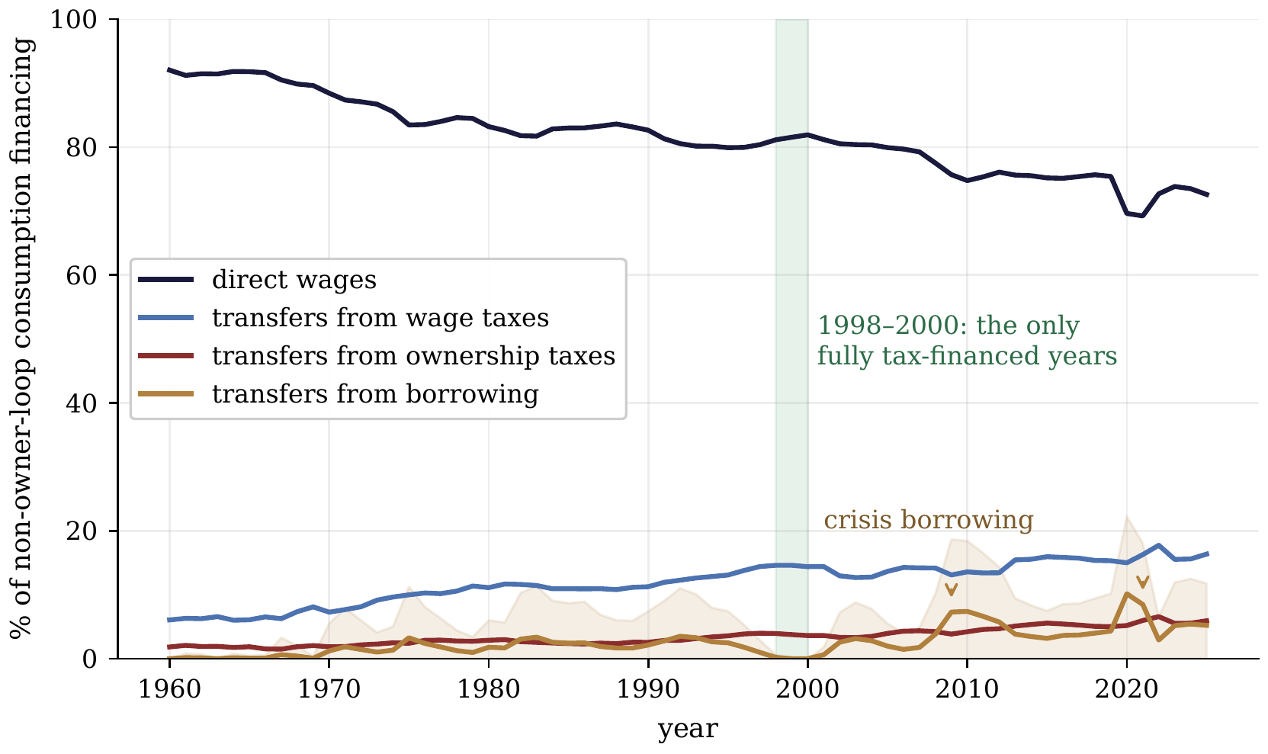
Figure D.1. Composition of U.S. consumption financing excluding consumption financed directly from household capital income, in which owners consume their own returns, 1960–2025. Lines are medians across the classification-rule grid; the shaded band spans the deficit-attribution rules. The direct-wage share fell by about twenty percentage points over sixty years. Transfers grew while approximately one quarter of their financing continued to come from taxes on ownership income. Borrowing financed 19% of transfers in 2025 and was zero only in 1998–2000. The allocation follows pro-rata accounting rules; estimating tax incidence requires a model of behavioral responses. Drawn by code written with Claude (Anthropic).

Appendix E. Human-required tasks
Let Appendix A’s set $H$ have positive measure $\left|H\right|$: tasks machines cannot hold — by capability residue, by verified preference for human hands, or by law — with $H$-wage $w_{H}$. Let machines grow unboundedly better at every task outside $H$: $γ\left(x\right)→0$ there, a capability improvement confined to the tasks machines can hold. A worker employed only in $H$ earns a wage determined within the human-required sector. Assume, in a common numeraire, that $w_{H}$ and $r$ converge to positive finite values, the rental $p_{m}$ remains bounded, and the machine work outside $H$ has total unit cost tending to zero. Human productivity on $H$ is constant at $γ_{L}>0$. This is a price-path condition: what vanishes is the cost of machine work, $p_{m}/γ_{M}\left(x\right)=p_{m}⋅γ\left(x\right)/γ_{L}\left(x\right)$. Aghion, Jones, and Jones (2019) raise the strongest stabilizer this paper faces: Baumol concentration — expenditure concentrating on the sector whose costs remain positive (Baumol 1967), here the human-required set — can preserve labor’s share indefinitely. Proposition E.1 grants the mechanism its theorem and makes its premise explicit.
Proposition E.1 (Baumol concentration). (i) A good with no additional direct requirement for non-produced inputs whose task list contains $H$ has unit cost tending to $\left|H\right|⋅w_{H}/γ_{L}$ as $γ→0$ outside $H$: labor’s share of its cost tends to one. (ii) Under CES substitution $σ_{H}$ between $H$-content and $H$-light substitutes, the expenditure share of $H$-content tends to 1 if $σ_{H}<1$, to the taste weight if $σ_{H}=1$, and to 0 if $σ_{H}>1$. (iii) On the $σ_{H}<1$ branch with three uses of expenditure (machine-made goods, non-produced services, and human-required services), end-state expenditure splits between the two whose costs remain positive, and labor’s aggregate share tends to the human-required share of that split. A persistent human-required sector can sustain a positive wage–rent ratio.
Proof. (i) $H$-tasks cost $\left|H\right|⋅w_{H}/γ_{L}$ whatever machines do; each task outside $H$ costs $p_{m}⋅γ\left(x\right)/γ_{L}\left(x\right)$, and the assumed vanishing total cost outside $H$ removes the remainder. (ii) is Appendix C’s share display with $q$ read as the relative price of $H$-content: the costlier service’s share rises with its relative price iff $σ_{H}<1$, and by (i) that relative price diverges. (iii) An $H$-free good’s price vanishes by (i) at $\left|H\right|=0$, so for $σ_{H}<1$ its share vanishes, leaving the displayed split; setting the $H$ taste weight to zero returns the baseline. □
The human-required sector depends on credible provenance and the distribution of demand. A premium for verified human work requires verification and enforceable penalties that make false claims unprofitable. In-person provision makes provenance directly observable, while legal task reservations depend on enforcement. Broadcastable services can concentrate demand on a small number of performers (Rosen 1981), allowing aggregate human-service earnings to persist alongside low earnings for most workers.
If $H$ employs a minority, most workers receive no income from its protected tasks. Aggregate labor income can therefore persist while the wages of workers outside $H$ fall relative to rents. Their participation depends on support, living costs, and preferences as in Section 4. Human-required services also enter the basic living basket through $z$. For example, adding $n_{s}$ hours of care priced at $w_{H}$ to the two-item basket gives $P_{s}=pg_{s}+rh_{s}+w_{H}n_{s}$ and coverage $κ=rT/\left(NP_{s}\right)$. At given rents and other prices, a higher care cost lowers coverage.

Appendix F. The financing and production accounts
Section 9 quotes two shares; this appendix defines and constructs them. The labor-origin financing share asks where the purchasing power used for personal consumption originates. The full-chain human-effort share asks how much of the purchaser-price value of consumed production resolves into human labor after intermediates are traced recursively.
For 2004–2023 the financing account uses annual BEA source distributions ranked by equivalized disposable income. Spending beyond current disposable income is recorded in an intertemporal bucket; within current-financed spending, tax incidence and allocation across fungible resources are partially identified and reported as bounds. The labor-origin financing share is 69.6% [59.8–83.1] in 2004 and 65.8% [52.7–80.1] in 2023; the model-based 2025 extension is 64.2% [54.1–81.3].
The production account follows the purchaser-price dollar through the production chain. Its BEA benchmark covers 1997–2023: human effort is 50.1% of consumed production in 1997 and 47.2% in 2023. Outside that window, a five-specification product-composition model supplies only a model-based extension, at 66.4% [61.3–68.6] in 1950 and 46.2% [45.1–47.4] in 2025. Figure 7 marks the benchmark-data windows explicitly.
The long extension suggests that the separation is newer than the postwar starting point, but that inference inherits the weaker status of the outer series.
Mapping back to the model. The production-content account corresponds to the common cost system $p=Ap+λw+Br$. The human-effort content of final consumption is $w{\tilde{λ}}^{T}f$, including labor throughout the supply chain. Recursive automation lowers that content at given wages and final quantities when total human requirements fall; the observed expenditure share also depends on prices and composition. The financing-origin account supplies $φ_{C}$ for Appendix D.5.
Data and computation. All U.S. figures are gross annual flows computed from BEA national accounts (annual NIPA series retrieved via FRED, 2026 vintage), with Federal Reserve Z.1 balance-sheet lines, BEA fixed-assets stocks, and the CPI for the coverage ratio. Financing splits 1960–2025, coverage ratio 1953–2025, deflator fork 1964–2024 on complete calendar years, with the food comparison from the CPI food index (FRED CPIUFDNS) over the same window. Reported values are medians with min–max bands across a rule grid. Flows are gross. The financing series uses annual BEA source profiles ranked by equivalized disposable income in 2004–2023 with partial-identification bounds and weaker outer extensions. The production series uses the BEA WP2026-01 full-chain benchmark in 1997–2023 and a five-specification NIPA product-composition extension outside that window. Notation. The direct labor coefficients $λ_{i}$ and total requirements ${\tilde{λ}}_{i}$ are unrelated to the wage-linkage shares $φ_{C},φ_{G}$ of Appendix D and to Acemoglu–Restrepo’s task-substitution elasticity $λ$; the human-required set $H$ is unrelated to the housing subscript of $T_{H}$; and $s$ denotes the reservation wage. Direct requirements of the non-produced input are $b_{i}$, total requirements are ${\tilde{b}}_{i}$, and $P_{s}$ is the cost of the basic living basket.
Numerical checks. The accompanying check_cost_system.py compares network prices with independently truncated production rounds, checks factor-income cancellation and feasible-method bounds, and verifies participation choices directly from utility. The companion check_interior.py checks task costs and income accounting, solves Appendix B’s equilibrium, and compares its output against an independently specified linear production program with 2,048 task cells. These checks accompany the analytical proofs.

Declaration of generative AI and AI-assisted technologies in the manuscript preparation process
During the preparation of this work the authors used Claude (Anthropic) and ChatGPT (OpenAI) to draft parts of the formalization, proofs, computations, figures, and initial prose, under the authors’ direction. The theory and its central claims are the authors’. After using these tools, the authors reviewed and edited the content as needed and take full responsibility for the content of the published article. All data were pulled live from public sources; the code and data are public.

References
Acemoglu, D., and D. Autor (2011). “Skills, Tasks and Technologies: Implications for Employment and Earnings.” In Handbook of Labor Economics, vol. 4B. Elsevier, pp. 1043–1171. https://doi.org/10.1016/s0169-7218(11)02410-5.
Acemoglu, D., and P. Restrepo (2018). “The Race between Man and Machine: Implications of Technology for Growth, Factor Shares, and Employment.” American Economic Review 108(6): 1488–1542. https://doi.org/10.1257/aer.20160696.
Acemoglu, D., and P. Restrepo (2022). “Tasks, Automation, and the Rise in U.S. Wage Inequality.” Econometrica 90(5): 1973–2016. https://doi.org/10.3982/ecta19815.
Acemoglu, D., and P. Restrepo (2026). “Automation and Rent Dissipation: Implications for Wages, Inequality, and Productivity.” The Quarterly Journal of Economics 141(2): 1521–1579. https://doi.org/10.1093/qje/qjag006.
Aghion, P., B. F. Jones, and C. I. Jones (2019). “Artificial Intelligence and Economic Growth.” In A. Agrawal, J. Gans, and A. Goldfarb (eds.), The Economics of Artificial Intelligence: An Agenda, University of Chicago Press, pp. 237–282. https://doi.org/10.7208/chicago/9780226613475.003.0009.
Allen, R. C. (2001). “The Great Divergence in European Wages and Prices from the Middle Ages to the First World War.” Explorations in Economic History 38(4): 411–447. https://doi.org/10.1006/exeh.2001.0775.
Arnott, R. J., and J. E. Stiglitz (1979). “Aggregate Land Rents, Expenditure on Public Goods, and Optimal City Size.” The Quarterly Journal of Economics 93(4): 471–500. https://doi.org/10.2307/1884466.
Arrow, K. J. (1951). “An Extension of the Basic Theorems of Classical Welfare Economics.” In Proceedings of the Second Berkeley Symposium on Mathematical Statistics and Probability, University of California Press, pp. 507–532. https://doi.org/10.1525/9780520411586-038.
Autor, D. (2015). “Why Are There Still So Many Jobs? The History and Future of Workplace Automation.” Journal of Economic Perspectives 29(3): 3–30. https://doi.org/10.1257/jep.29.3.3.
Autor, D., and D. Dorn (2013). “The Growth of Low-Skill Service Jobs and the Polarization of the US Labor Market.” American Economic Review 103(5): 1553–1597. https://doi.org/10.1257/aer.103.5.1553.
Autor, D., F. Levy, and R. J. Murnane (2003). “The Skill Content of Recent Technological Change: An Empirical Exploration.” The Quarterly Journal of Economics 118(4): 1279–1333. https://doi.org/10.1162/003355303322552801.
Baumol, W. J. (1967). “Macroeconomics of Unbalanced Growth: The Anatomy of Urban Crisis.” American Economic Review 57(3): 415–426.
Bouscasse, P., E. Nakamura, and J. Steinsson (2025). “When Did Growth Begin? New Estimates of Productivity Growth in England from 1250 to 1870.” The Quarterly Journal of Economics 140(2): 835–888. https://doi.org/10.1093/qje/qjae046.
Card, D., A. R. Cardoso, J. Heining, and P. Kline (2018). “Firms and Labor Market Inequality: Evidence and Some Theory.” Journal of Labor Economics 36(S1): S13–S70. https://doi.org/10.1086/694153.
Caselli, F., and A. Manning (2019). “Robot Arithmetic: New Technology and Wages.” American Economic Review: Insights 1(1): 1–12. https://doi.org/10.1257/aeri.20170036.
Clark, G. (2005). “The Condition of the Working Class in England, 1209–2004.” Journal of Political Economy 113(6): 1307–1340. https://doi.org/10.1086/498123.
Crafts, N. (2022). “Slow Real Wage Growth during the Industrial Revolution: Productivity Paradox or Pro-Rich Growth?” Oxford Economic Papers 74(1): 1–13. https://doi.org/10.1093/oep/gpab008.
Diamond, P. A. (1982). “Aggregate Demand Management in Search Equilibrium.” Journal of Political Economy 90(5): 881–894. https://doi.org/10.1086/261099.
Diamond, P., and J. Mirrlees (1971). “Optimal Taxation and Public Production I: Production Efficiency.” American Economic Review 61(1): 8–27.
George, H. (1879). Progress and Poverty.
Grossman, G. M., and E. Rossi-Hansberg (2008). “Trading Tasks: A Simple Theory of Offshoring.” American Economic Review 98(5): 1978–1997. https://doi.org/10.1257/aer.98.5.1978.
Gruber, J. (1997). “The Incidence of Payroll Taxation: Evidence from Chile.” Journal of Labor Economics 15(3, Part 2): S72–S101. https://doi.org/10.1086/209877.
Hagedorn, M., and I. Manovskii (2008). “The Cyclical Behavior of Equilibrium Unemployment and Vacancies Revisited.” American Economic Review 98(4): 1692–1706. https://doi.org/10.1257/aer.98.4.1692.
Hall, R. E. (2005). “Employment Fluctuations with Equilibrium Wage Stickiness.” American Economic Review 95(1): 50–65. https://doi.org/10.1257/0002828053828482.
Hémous, D., and M. Olsen (2022). “The Rise of the Machines: Automation, Horizontal Innovation, and Income Inequality.” American Economic Journal: Macroeconomics 14(1): 179–223. https://doi.org/10.1257/mac.20160164.
Hoynes, H., and J. Rothstein (2019). “Universal Basic Income in the United States and Advanced Countries.” Annual Review of Economics 11: 929–958. https://doi.org/10.1146/annurev-economics-080218-030237.
Jones, D., and I. Marinescu (2022). “The Labor Market Impacts of Universal and Permanent Cash Transfers: Evidence from the Alaska Permanent Fund.” American Economic Journal: Economic Policy 14(2): 315–340. https://doi.org/10.1257/pol.20190299.
Karabarbounis, L., and B. Neiman (2014). “The Global Decline of the Labor Share.” The Quarterly Journal of Economics 129(1): 61–103. https://doi.org/10.1093/qje/qjt032.
Knoll, K., M. Schularick, and T. Steger (2017). “No Price Like Home: Global House Prices, 1870–2012.” American Economic Review 107(2): 331–353. https://doi.org/10.1257/aer.20150501.
Korinek, A., and J. E. Stiglitz (2019). “Artificial Intelligence and Its Implications for Income Distribution and Unemployment.” In A. Agrawal, J. Gans, and A. Goldfarb (eds.), The Economics of Artificial Intelligence: An Agenda, University of Chicago Press, pp. 349–390. https://doi.org/10.7208/chicago/9780226613475.003.0014.
Korinek, A., and D. Suh (2024). “Scenarios for the Transition to AGI.” NBER Working Paper 32255. https://doi.org/10.3386/w32255.
Kugler, A., and M. Kugler (2009). “Labor Market Effects of Payroll Taxes in Developing Countries: Evidence from Colombia.” Economic Development and Cultural Change 57(2): 335–358. https://doi.org/10.1086/592839.
Leontief, W. W. (1936). “Quantitative Input and Output Relations in the Economic Systems of the United States.” The Review of Economics and Statistics 18(3): 105–125. https://doi.org/10.2307/1927837.
Lewis, W. A. (1954). “Economic Development with Unlimited Supplies of Labour.” The Manchester School 22(2): 139–191. https://doi.org/10.1111/j.1467-9957.1954.tb00021.x.
Ljungqvist, L., and T. J. Sargent (2017). “The Fundamental Surplus.” American Economic Review 107(9): 2630–2665. https://doi.org/10.1257/aer.20150233.
Malthus, T. R. (1798). An Essay on the Principle of Population.
Manning, A. (2003). Monopsony in Motion: Imperfect Competition in Labor Markets. Princeton University Press. https://doi.org/10.1515/9781400850679.
Mas, A., and A. Pallais (2019). “Labor Supply and the Value of Non-Work Time: Experimental Estimates from the Field.” American Economic Review: Insights 1(1): 111–126. https://doi.org/10.1257/aeri.20180070.
Moll, B., L. Rachel, and P. Restrepo (2022). “Uneven Growth: Automation’s Impact on Income and Wealth Inequality.” Econometrica 90(6): 2645–2683. https://doi.org/10.3982/ecta19417.
Mortensen, D. T., and C. A. Pissarides (1994). “Job Creation and Job Destruction in the Theory of Unemployment.” The Review of Economic Studies 61(3): 397–415. https://doi.org/10.2307/2297896.
Piketty, T., and G. Zucman (2014). “Capital is Back: Wealth-Income Ratios in Rich Countries 1700–2010.” The Quarterly Journal of Economics 129(3): 1255–1310. https://doi.org/10.1093/qje/qju018.
Pissarides, C. A. (2000). Equilibrium Unemployment Theory. 2nd ed., MIT Press.
Polanyi, K. (1944). The Great Transformation.
Ricardo, D. (1817). On the Principles of Political Economy and Taxation. Third edition, 1821, adds the chapter “On Machinery.”
Rognlie, M. (2015). “Deciphering the Fall and Rise in the Net Capital Share: Accumulation or Scarcity?” Brookings Papers on Economic Activity 2015(1): 1–69. https://doi.org/10.1353/eca.2016.0002.
Romer, P. M. (1990). “Endogenous Technological Change.” Journal of Political Economy 98(5, Part 2): S71–S102. https://doi.org/10.1086/261725.
Rosen, S. (1981). “The Economics of Superstars.” American Economic Review 71(5): 845–858.
Sachs, J. D., and L. J. Kotlikoff (2012). “Smart Machines and Long-Term Misery.” NBER Working Paper 18629. https://doi.org/10.3386/w18629.
Saez, E., B. Schoefer, and D. Seim (2019). “Payroll Taxes, Firm Behavior, and Rent Sharing: Evidence from a Young Workers’ Tax Cut in Sweden.” American Economic Review 109(5): 1717–1763. https://doi.org/10.1257/aer.20171937.
Samuelson, P. A. (1966). “A Summing Up.” The Quarterly Journal of Economics 80(4): 568–583. https://doi.org/10.2307/1882916.
Shapiro, C., and J. E. Stiglitz (1984). “Equilibrium Unemployment as a Worker Discipline Device.” American Economic Review 74(3): 433–444.
Shimer, R. (2005). “The Cyclical Behavior of Equilibrium Unemployment and Vacancies.” American Economic Review 95(1): 25–49. https://doi.org/10.1257/0002828053828572.
Sraffa, P. (1960). Production of Commodities by Means of Commodities. Cambridge University Press.
Susskind, D. (2017). “A Model of Technological Unemployment.” Oxford Department of Economics Discussion Paper 819.
Uzawa, H. (1961). “Neutral Inventions and the Stability of Growth Equilibrium.” The Review of Economic Studies 28(2): 117–124. https://doi.org/10.2307/2295709.
Zeira, J. (1998). “Workers, Machines, and Economic Growth.” The Quarterly Journal of Economics 113(4): 1091–1117. https://doi.org/10.1162/003355398555847.

