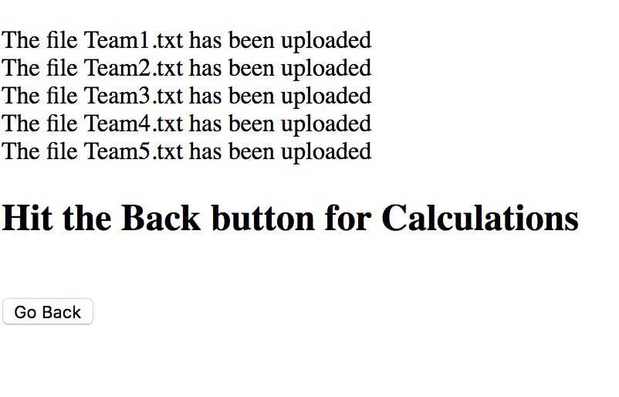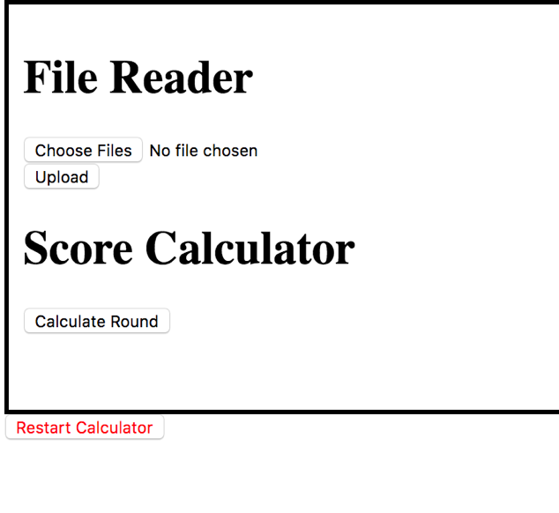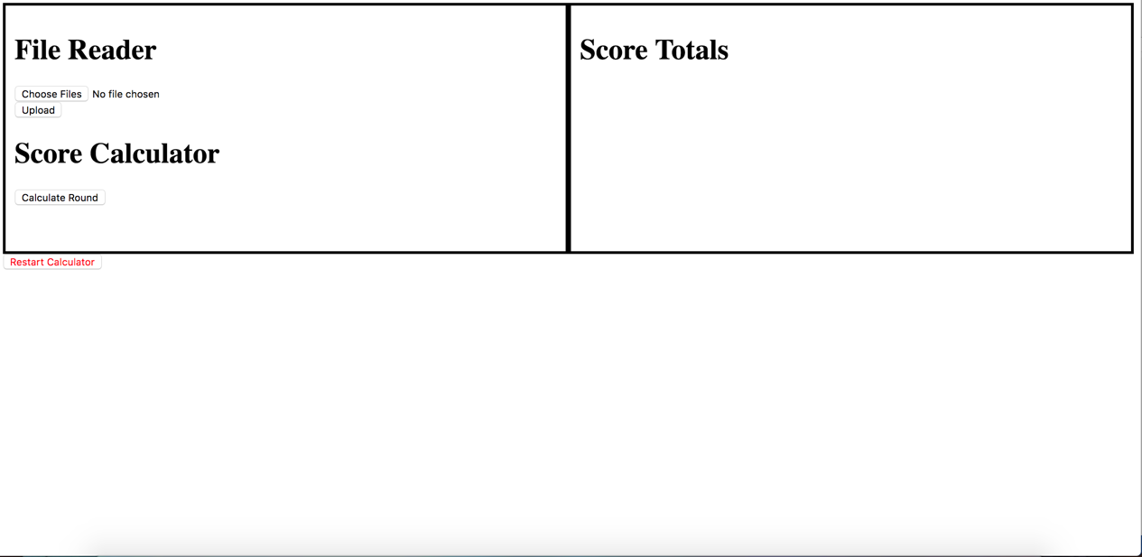

STEPS:

1. Choose Files to upload for calculations
2. Hit the upload button *Will move to a new page.
3. Click the back button on the upload page.
4. Click the “Calculate Round” button to calculate the scores for the round.
5. Hit the Refresh Total Scores to get the current scores for the competition.

Web Page Overview:

NOTE:

For the Text files being uploaded please name them **uniquely** with **“.txt”** extension for accuracy when calculating scores.

Ex. “Team1.txt”, “Team2.txt”, etc.

Hit the “Restart Calculator” when beginning new Calculations to clear out old scores

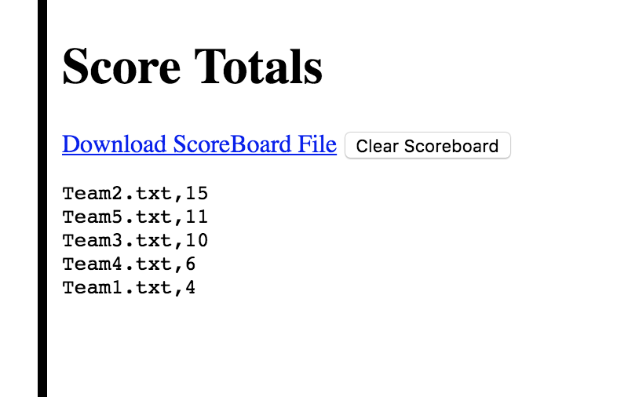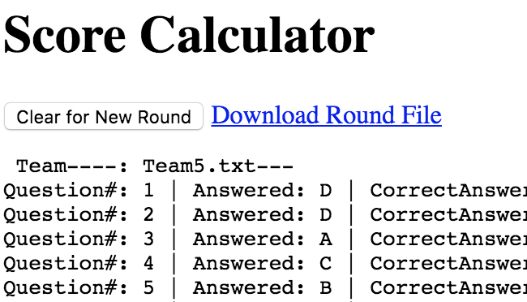

STEPS:

8. Click “Clear Scoreboard” to restart the scores for the whole competition.

7. Click “Download ScoreBoard File” to download a text file for the scores for the current competition.

STEPS:

6. Click “Clear for new round” to calculate scores for new files.

7. Click “Download Round file” to download a text file for the scores for the current round.