Computer Vision CS671 Fall 2025
Professor Dr. Juan Shan
Team:
- Kien Chung (Wilson)
  - GitHub: https://github.com/wilsonkchung
  - Email: kc86886n@pace.edu
- Vinh Long Tran (Steven)
  - GitHub: https://github.com/sillysavant
  - Email: vt35896n@pace.edu
Project Repository:
- github.com/wilsonkchung/knee-osteoarthritis-classification-using-bone-distance

Midterm Progress Report
Progress Overview
We have developed algorithms to compute the femur–tibia distance for each MRI slice and implemented a method to extract the valid slice range from the full set of 160 slices per case. For each case, a distance vector was created and used as the feature set X. Two target variables are being utilized: y₁, representing the Kellgren–Lawrence (KL) grade with ordinal labels 0 to 4, and y₂, representing the binary knee osteoarthritis (OA) classification with labels A (non-OA) and B (OA). The categorical labels for y₂ will be encoded numerically, where A = 0 and B = 1.
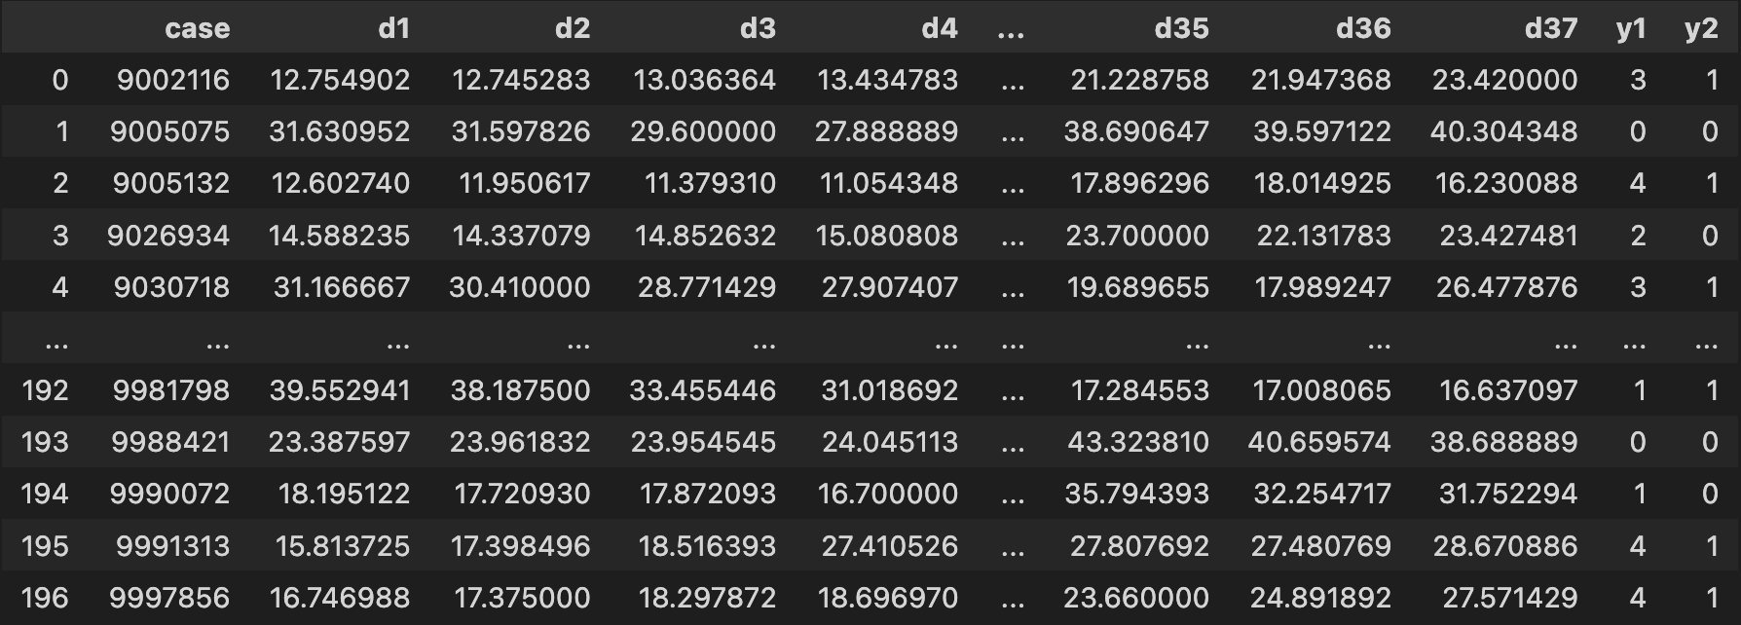
Image 1: Preview of the processed dataset prepared for machine learning
Dataset Link: github.com/wilsonkchung/knee-osteoarthritis-classification-using-bone-distance/blob/main/final_problem4-5-6_kien_steven/final_df_merged.csv

Machine Learning (ML) Models
We trained 2 ML models, one for KL grades “y1” output [0,1,2,3,4], and the second one for binary OA/non-OA “y2” [0,1]. Both uses train test size of 80/20 split. After running a few classic ML algorithms such as DecisionTree, XGBoost, RandomForest etc. We found the best result for “y1” is DecisionTree and for “y2” is XGBoost.
The best model using “DecisionTree” for predicting “y1” 10-fold cross validation score:
[0.25, 0.35, 0.20, 0.25, 0.15, 0.35, 0.25, 0.11, 0.26, 0.26] with the highest score of 0.35 (35%)
The best model using “XGBoost” for predicting “y2” 10-fold cross validation score:
[0.65, 0.75, 0.65, 0.75, 0.60, 0.70, 0.75, 0.68, 0.68, 0.47] with the highest score of 0.75 (75%)
Obstacle
Following slice selection and distance computation, we observed considerable variability in the number of valid slices across cases, with some cases containing as few as 37 valid slices and others up to 124. Since machine learning models require feature vectors of consistent length across all samples, this variability poses a challenge. To proceed, each case must be represented using an equal number of slices—currently, the minimum of 37 slices per case.
Let’s look at case “9002116”:
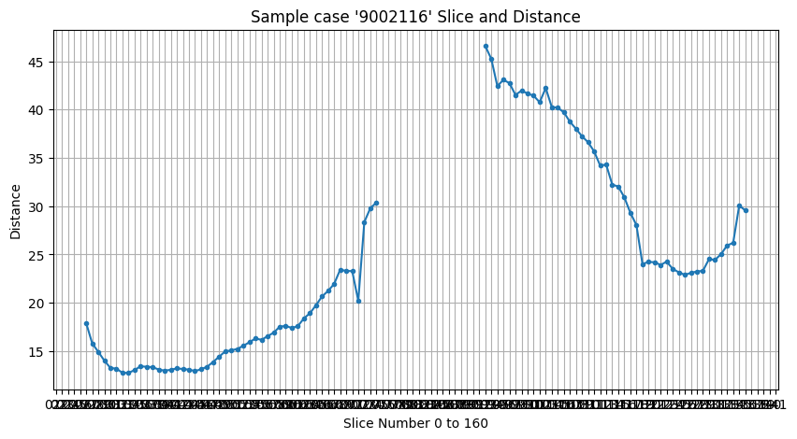
?
Image 2: Slice by Distance of case “9002116”
The algorithm detected femur-tibia bone and calculated the distance starting at slice#27 measured ~17.9 and stopped at slice#75 measured ~30.4, then continued at slice#93 measured ~46.6 to slice#136 measured ~29.6. It missed the mid-range between slice#76 and slice#92.
Compare that to MRI scan slice by slice for case “9002116” (Image 3).
- Red range: slice 27 to 75.
- Questionable range: slice 76 to 92.
- Green range: slice 93 to 136.
While the range of MRI scan slices between Red and Green appear to be complete and useful, our algorithm could not calculate the distance.
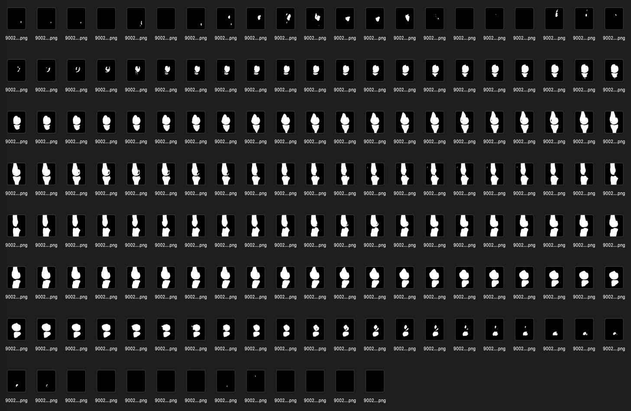
# 75
# 93
# 27
# 136
Image 3: Slice 1 to 160 of case “9002116”
Note: Read the slices sequentially from 1 to 160, ordered left to right and top to bottom.
Next Steps
In software development, machine learning, and data science, the workflow is inherently iterative. We will come back and improve the algorithms developed for Problems 1 and 2 with the objective of increasing both the number of valid slices per case and the accuracy of the computed distance measures. Enhancing these components will enable more robust feature extraction and is expected to improve model performance in predicting OA severity and KL grades.

