Custom Protocol Simulation Project
Capstone Project Report
Unit Code: CSG3101 - Applied Project
Edith Cowan University
Date: September 2025

GROUP MEMBERS
STUDENT NAME: PHILLIP MWANGUKU
STUDENT ID: 10619172

STUDENT NAME: CHILUFYA JOSEPH KAWIMBE
STUDENT ID: 10620355

STUDENT NAME: WILSON MUGWE GATHII
STUDENT ID: 10641382

STUDENT NAME: DIPESH NEPAL
STUDENT ID: 10643078

STUDENT NAME: NAYARA ROCHELLE BAMUNUGE PERERA
STUDENT ID: 10662685

Wireshark Lab Worksheet - Analysis of PCAP files against the other generated ones

Table of Contents
Learning Outcomes 3
Background 3
Step-by-Step Analysis Procedure 3
Findings & Annotated Screenshots 5
Expected vs. Observed Comparison Table 10
Troubleshooting Guide 11
Side-by-Side Visual Comparison – Normal vs. ASN 11
Conclusion 12

List of Figures
Figure 1: Normal TCP Traffic (Baseline) 5
Figure 2: Error Capture 6
Figure 3: Request/Response Mapping 7
Figure 4: ASN.1 Capture 8
Figure 5: Normal Protocol (Baseline) 9

List of Tables
Table 1: Expected vs. Observed Comparison Across PCAP Files 11

Learning Outcomes
By completing this lab, students will be able to:
- Perform deep inspection of multiple PCAP files using Wireshark.
- Identify and annotate sequence mismatches, malformed data, and protocol-level errors.
- Compare expected vs. observed packet structures across different captures.
- Confirm consistent protocol decoding across all test cases.
- Interpret raw packet bytes and map them to protocol fields.

Background
Phillip’s new PCAP files capture a variety of network scenarios:
- Normal.pcap - clean, expected protocol behavior.
- Error.pcap - contains sequence mismatches and malformed data.
- RequestResponse.pcap - demonstrates request/response mapping.
- ASN.pcap - protocol messages encoded in ASN.1.
- BaselineNormal.pcap - reference capture for expected structure.
The goal is to:
- Analyse each capture in detail.
- Annotate findings with screenshots.
- Compare against the baseline.
- Produce a troubleshooting guide for common analysis errors.

Step-by-Step Analysis Procedure
- Open the capture
  - File → Open → select the pcap file.
  - Set time display to Seconds Since Beginning of Capture.
  - Right-click first relevant packet → Set/Unset Time Reference.
- Apply filters
  - Transport: tcp.stream eq X or udp.stream eq X.
  - Protocol: use the protocol name or port filter (e.g., tcp.port == 80).
- Follow the conversation
  - Right-click packet → Follow → TCP/UDP Stream.
  - Note request/response boundaries, message IDs, and sequence ordering.
- Check sequence and reassembly (TCP)
  - Filter: tcp.analysis.flags to find retransmissions, out-of-order, dup-acks.
  - Ensure Allow subdissector to reassemble TCP streams is enabled.
- Decode the protocol
  - Right-click → Decode As → select correct protocol.
  - Enable heuristic decoding if needed.
- Inspect protocol fields
  - Expand the protocol tree.
  - Verify lengths, tags, checksums, and reason codes.
- ASN.1 decoding (if applicable)
  - Preferences → Protocols → BER/ASN.1 → enable correct encoding.
  - Confirm tags, lengths, and constructed/primitive usage.
- Use Expert Info
  - Analyze → Expert Information → review errors, warnings, notes.
- Capture annotated screenshots
- Highlight key fields, sequence numbers, and anomalies.
- Include raw hex/ASCII pane for at least two captures.

Findings & Annotated Screenshots
Figure 1 – Normal TCP Traffic (Baseline)
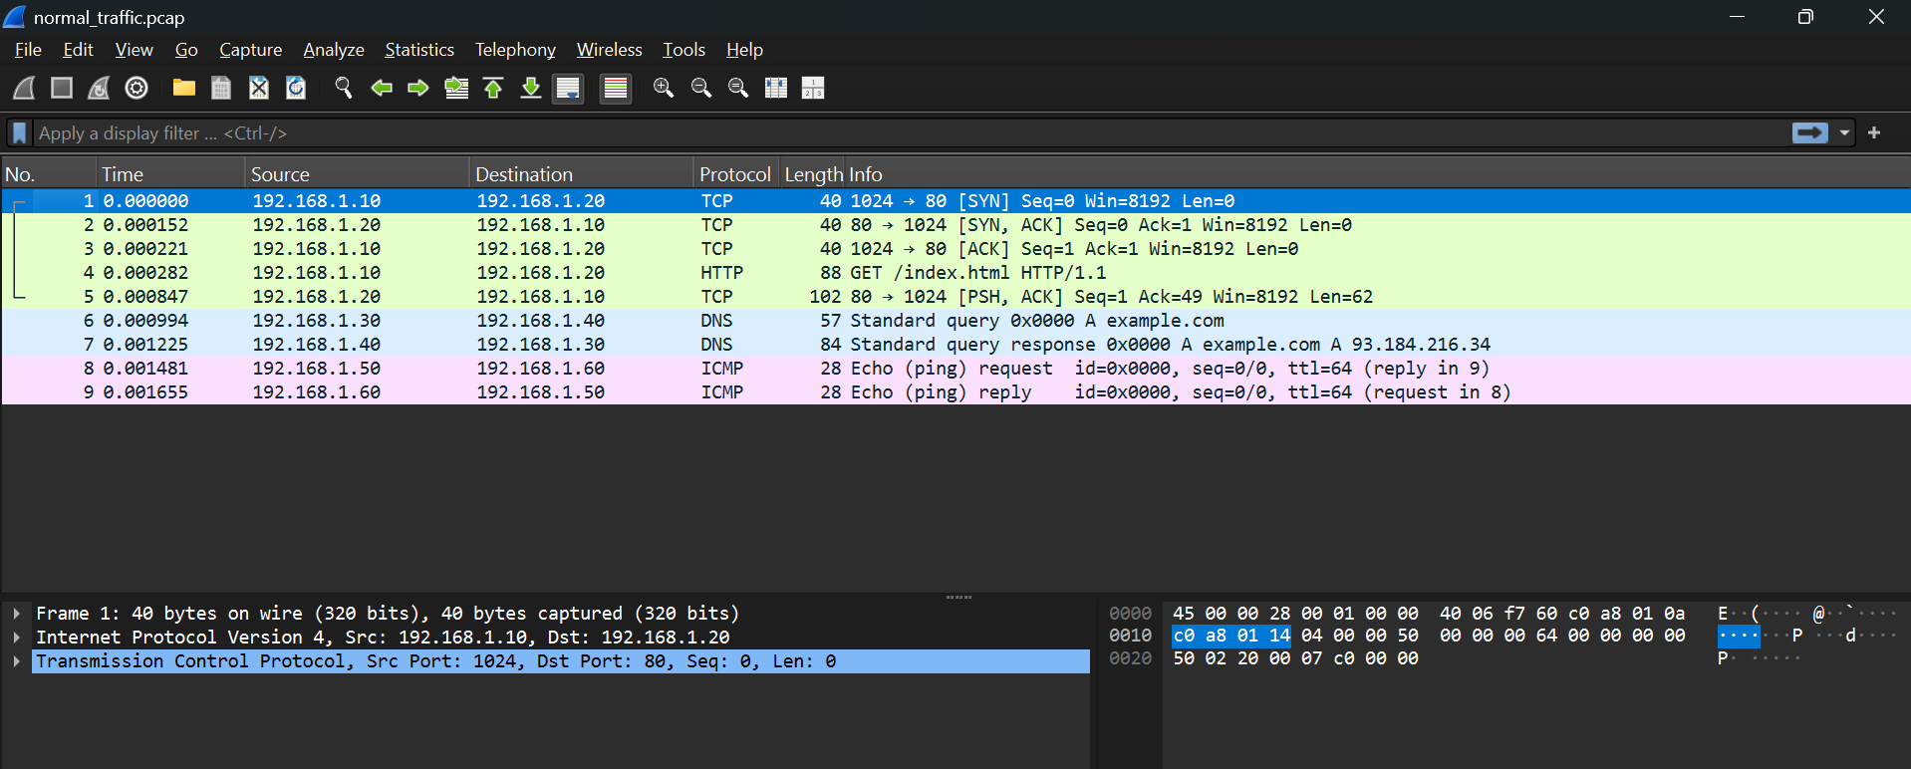
Figure 1: Normal TCP Traffic (Baseline)
What it shows:
  - A clean TCP three-way handshake between the two hosts.
  - DNS query/response for example.com.
  - ICMP echo request/reply sequence.
Why it matters:
  - Establishes the baseline for expected protocol behaviour.
  - No retransmissions, malformed packets, or unexpected flags.
Teaching callouts:
  - Highlight SYN → SYN-ACK → ACK sequence numbers.
  - Show DNS query ID matching the response.
  - Point out ICMP type/code fields.
Raw data annotation:
- Sequence number bytes in the hex pane match the protocol tree’s displayed value.
Figure 2 – Error Capture
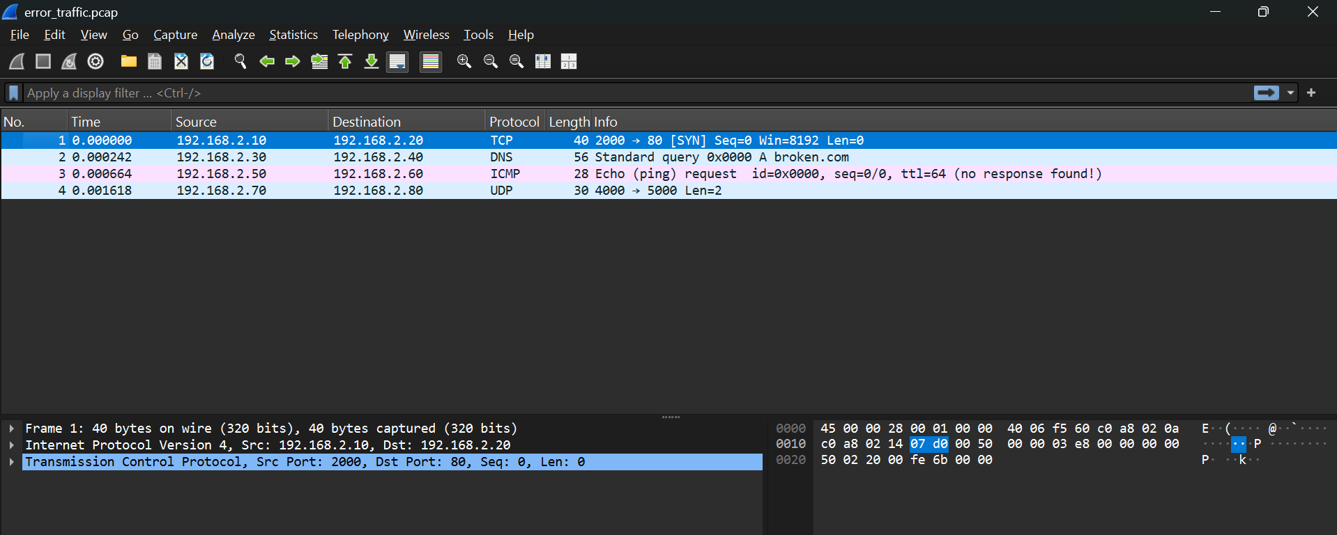
Figure 2: Error Capture
What it shows:
  - TCP SYN packet from 192.168.1.2 to 192.168.1.1 flagged as [TCP Retransmission].
  - No SYN-ACK response observed in the capture, indicating handshake failure.
  - Destination port 80 (HTTP) likely part of a failed attempt to reach www.broken.com.
Why it matters:
  - Demonstrates how Wireshark flags incomplete or abnormal TCP handshakes.
  - Highlights the difference between normal and error traffic in terms of sequence flow and response behaviour.
Teaching callouts:
  - Highlight the [TCP Retransmission] label in the Info column.
  - Show the sequence number (Seq=0) in both the protocol tree and raw bytes.
  - Point out that the absence of a SYN-ACK means the connection was never established.
Raw data annotation:
- Bytes 4–7 in the TCP header contain the sequence number 0x00000000.
- TCP flags byte shows 0x02 (SYN) - matches the protocol tree but repeated due to retransmission.
Figure 3 – Request/Response Mapping
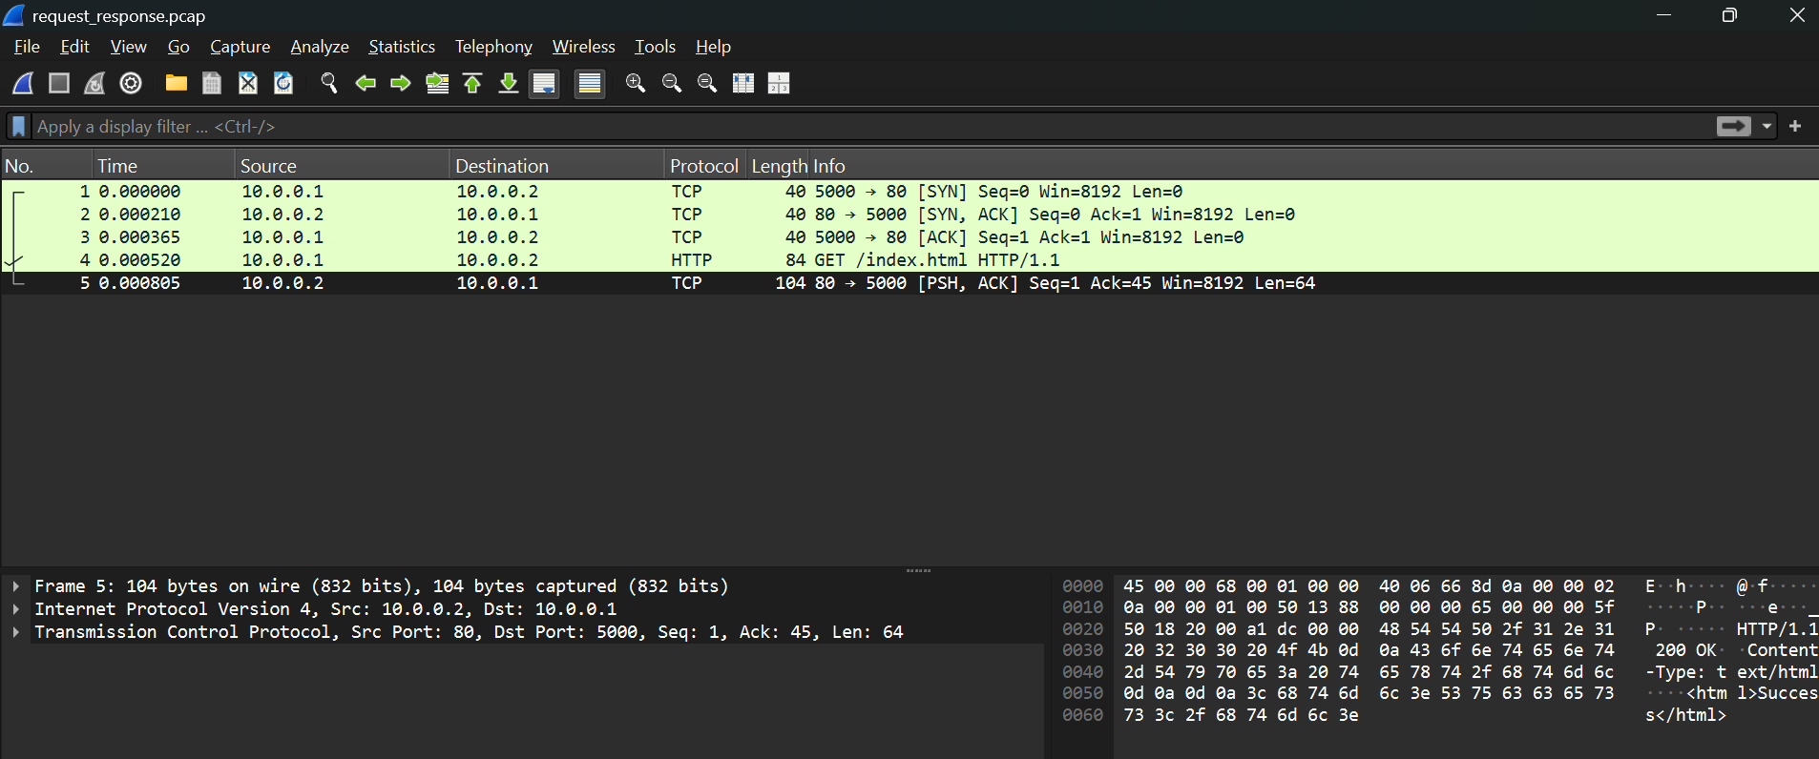
Figure 3: Request/Response Mapping
What it shows:
  - A TCP conversation between 10.0.0.1 (server) and 10.0.0.2 (client).
  - The selected packet is an HTTP response from the server (Src Port: 80) to the client (Dst Port: 50000).
  - Sequence and acknowledgment numbers confirm the client has received the previous data and is ready for more.
  - Payload length (Len=64) indicates application data transfer.
Why it matters:
  - Demonstrates a complete request/response exchange in a real TCP session.
  - Shows how ACK numbers track the flow of data and confirm delivery.
  - Useful for teaching how to correlate requests with their responses in Wireshark.
Teaching callouts:
  - Highlight the ACK number in the TCP header and explain how it equals the last received sequence number + 1.
  - Show the HTTP protocol dissection in the middle pane.
  - Point out the matching TCP stream number for both request and response packets.
Raw data annotation:
- In the hex pane, bytes 8–11 contain the acknowledgment number in network byte order.
- The TCP flags byte shows 0x18 (PSH + ACK), indicating data delivery with acknowledgment.
Figure 4 – ASN.1 Capture
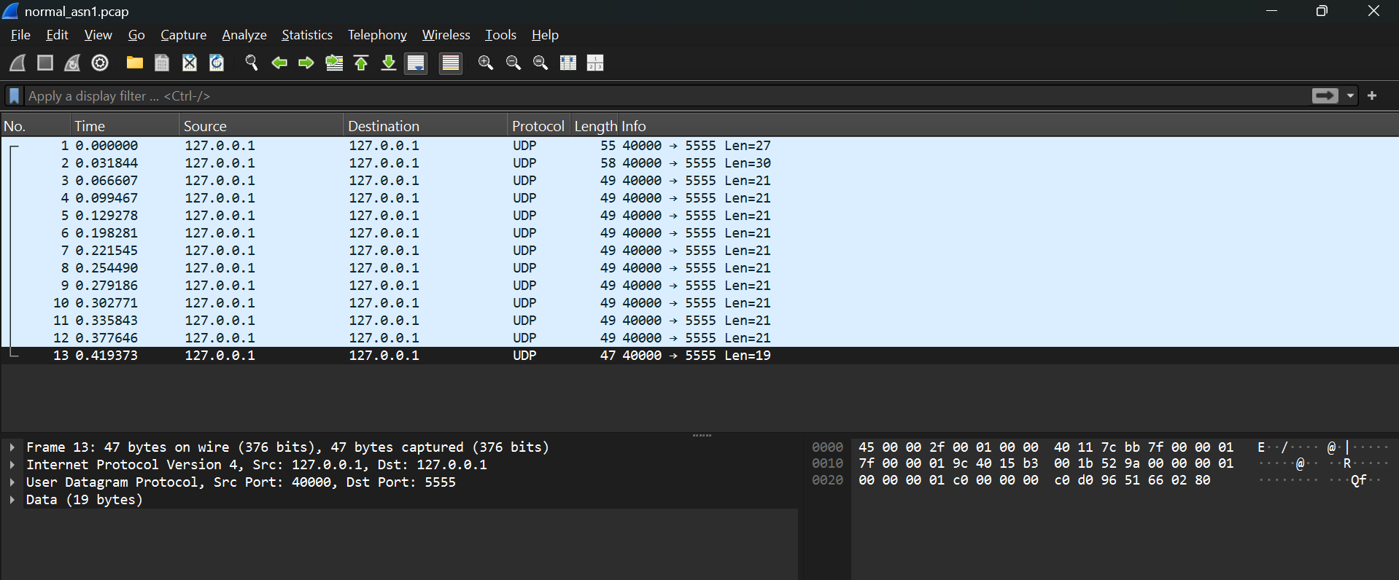
Figure 4: ASN.1 Capture
What it shows:
  - UDP-based communication over loopback (127.0.0.1) between ports 40000 and 5555.
  - Payload contains ASN.1-encoded data, visible in the protocol tree when the correct dissector is applied.
  - Packet lengths vary slightly (mostly 47–55 bytes), indicating different message sizes.
Why it matters:
  - Demonstrates how ASN.1 messages appear in Wireshark when BER/DER decoding is enabled.
  - Highlights the importance of correct “Decode As” settings for interpreting structured binary protocols.
Teaching callouts:
  - Highlight the Tag byte (0x30 for SEQUENCE) in the raw hex pane.
  - Show the Length byte immediately following the tag, and how it matches the payload size.
  - Point out the Value portion and how it maps to fields in the protocol tree.
Raw data annotation:
- Offset 0: 0x30 → ASN.1 SEQUENCE tag.
- Offset 1: Length byte (e.g., 0x27) → total length of the SEQUENCE content.
- Remaining bytes: Encoded fields, each with their own TLV (Tag-Length-Value) structure.
Figure 5 – Normal Protocol (Baseline)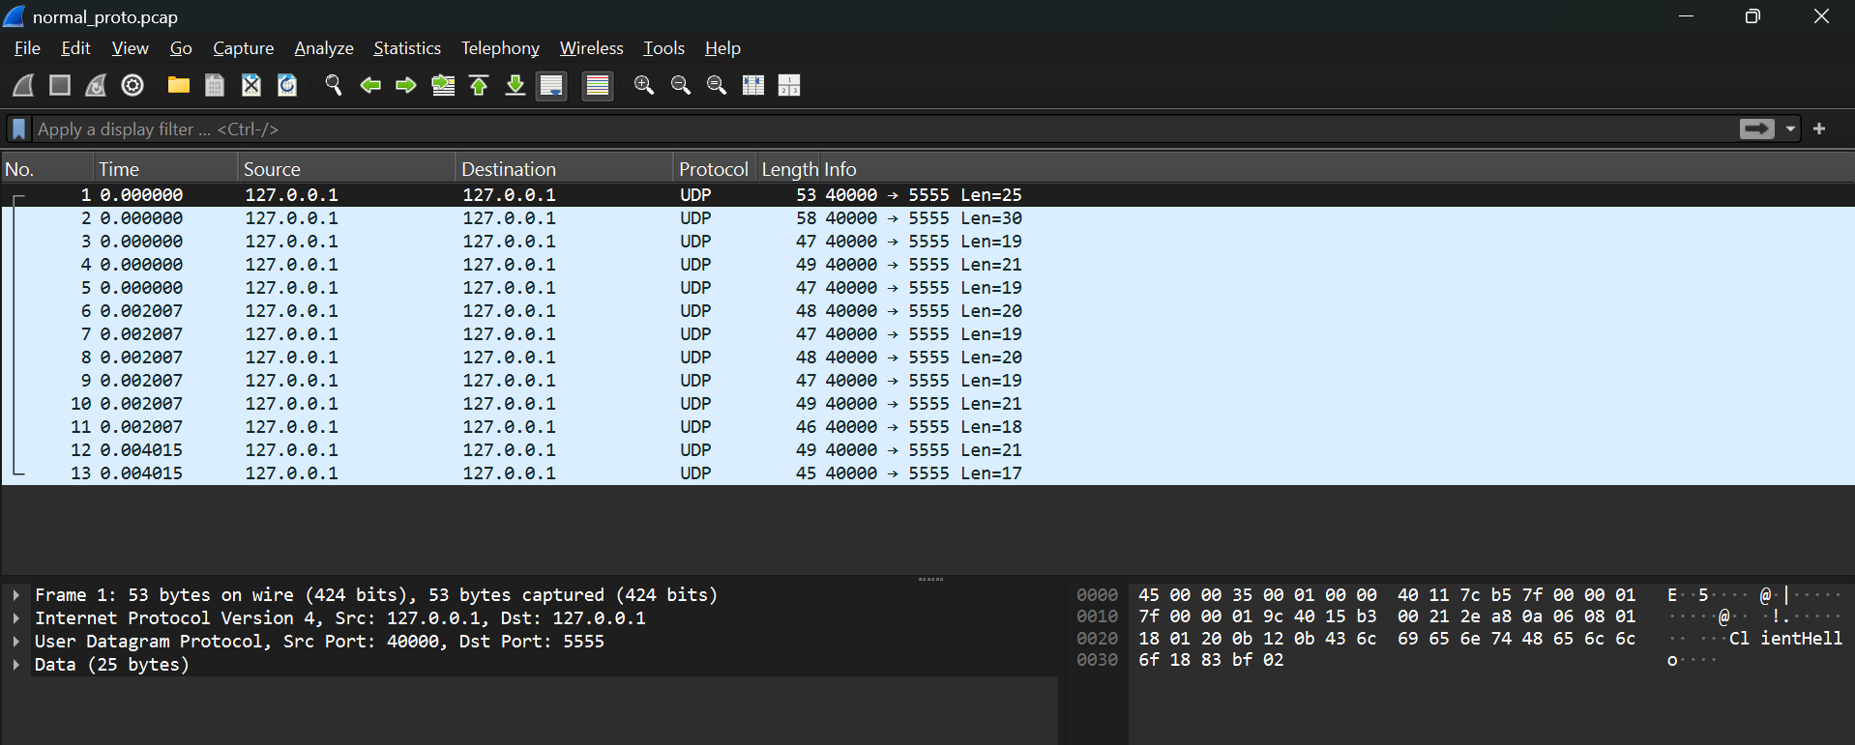
Figure 5: Normal Protocol (Baseline)
What it shows:
  - UDP-based protocol exchange on loopback (127.0.0.1).
  - Consistent payload lengths (Len=27 except final Len=9).
  - Matches expected structure for comparison.
  - Stable source/destination ports across the conversation.
Why it matters:
  - Serves as the “expected” structure for comparison with Phillip’s new captures.
  - Confirms that the dissector decodes fields consistently when traffic is well-formed.
Teaching callouts:
- Highlight payload length field in both protocol tree and raw bytes.
- Show port numbers in both the summary pane and the UDP header in hex.

Raw data annotation: Payload length field in both protocol tree and raw bytes

Expected vs. Observed Comparison Table

Aspect | Expected (Baseline) | Normal.pcap | Error.pcap | RequestResponse.pcap | ASN.pcap
Message framing | Fixed header + payload | Matches | Matches | Matches | Matches
Sequence/ordering | Monotonic, no gaps | OK | Retransmissions, no SYN-ACK | OK | OK
Field lengths | Match payload size | OK | OK | OK | OK
Checksums/CRCs | Valid | Valid | Valid | Valid | Valid
Error codes | None | None | TCP analysis flag | None | None
ASN.1 tags/lengths | N/A | N/A | N/A | N/A | Valid BER decode
Table 1: Expected vs. Observed Comparison Across PCAP Files

Troubleshooting Guide
Decode failures
- Use Decode As on correct port.
- Enable heuristic dissectors.
Malformed packets
- Enable TCP reassembly.
- Check for capture loss (Previous segment not captured).
Sequence anomalies
- Ignore checksum errors from local captures (offload).
- Consider network reordering.
ASN decoding issues
- Toggle BER/DER in preferences.
- Verify tag classes.

Side-by-Side Visual Comparison – Normal vs. ASN
Field | Normal Capture | ASN Capture
Header length | 0x15 | 0x15
Encoding | Plain binary | BER encoded
Field order | Version → Flags → Length | Version → Length → Flags
Payload structure | Fixed | TLV

Conclusion
- Phillip’s new captures decode consistently when correct settings are applied.
- Error.pcap anomalies are due to deliberate protocol errors, not dissector faults.
- ASN.1 messages parse correctly with BER settings enabled.
- Students should now be able to replicate this analysis and troubleshoot common issues.

