Rachael Wilson

Lab 5 Compen 331

Section One

Due 4/27/2025

Verilog design code:

`timescale 1ns / 1ps

# module datapath(

input wire clock,

output wire [31:0] pc,

output wire ewreg,

output wire em2reg,

output wire ewmem,

output wire [3:0] ealuc,

output wire ealuimm,

output wire [4:0] edestReg,

output wire [31:0] eqa,

output wire [31:0] eqb,

output wire [31:0] eimm32,

output wire [31:0] dinstOut,

output wire wwreg,

output wire wm2reg,

output wire [4:0] wdestReg,

output wire [31:0] wr,

output wire [31:0] wdo,

output wire mwreg,

output wire mm2reg,

output wire mwmem,

output wire [4:0] mdestReg,

output wire [31:0] mr,

output wire [31:0] mqb,

output wire [31:0] wbData

//output wire [31:0] mdo,

//output wire [31:0] b,

//output wire [31:0] r,

);

// wires for the inputs of modules (commented the module it came from):

wire [31:0] nextPc; // program_counter

wire [31:0] instOut; // ifid_pipeline_register

wire [5:0] op; // control_unit

wire [5:0] func; // countrol_unit

wire [4:0] rt; // regrt_multiplexer, register_file

wire [4:0] rd; // regrt_multiplexer

wire [4:0] rs; // register_file

wire [15:0] imm; // immediate_extender

wire wreg; // idexe_pipeline_register

wire m2reg; // idexe_pipeline_register

wire wmem; // idexe_pipeline_register

wire [3:0] aluc; // idexe_pipeline_register

wire aluimm; // idexe_pipeline_register

wire [4:0] destReg; // idexe_pipeline_register

wire [31:0] qa; // idexe_pipeline_register

wire [31:0] qb; // idexe_pipeline_register

wire [31:0] imm32; // idexe_pipeline_register

//wire [31:0] wbData; // register_file

wire [31:0] mdo;

wire [31:0] b;

wire [31:0] r;

// continuous assignments

assign op = dinstOut[31:26]; // first 6 bits of dinstOut

assign rs = dinstOut[25:21]; // next 5 bits after op

assign rt = dinstOut[20:16]; // next 5 bits after rt

assign rd = dinstOut[15:11]; // next 5 bits after rt

assign func = dinstOut[5:0]; // last 6 bits of dinstOut

assign imm = dinstOut[15:0]; // last 16 bits of dinstOut

// initiate instance of all the modules:

program_counter program_counter_inst (.nextPc(nextPc), .clock(clock), .pc(pc));

instruction_memory instruction_memory_inst (.pc(pc), .instOut(instOut));

pc_adder pc_adder_inst (.pc(pc), .nextPc(nextPc));

ifid_pipeline_register ifid_pipeline_register_inst (.instOut(instOut), .clock(clock), .dinstOut(dinstOut));

control_unit control_unit_inst (.op(op), .func(func), .wreg(wreg), .m2reg(m2reg), .wmem(wmem), .aluc(aluc),

.aluimm(aluimm), .regrt(regrt));

regrt_multiplexer regrt_multiplexer_inst (.rt(rt), .rd(rd), .regrt(regrt), .destReg(destReg));

register_file register_file_inst (.rs(rs), .rt(rt), .wdestReg(wdestReg), .wbData(wbData), .wwreg(wwreg), .clock(clock),

.qa(qa), .qb(qb));

immediate_extender immediate_extender_inst (.imm(imm), .imm32(imm32));

idexe_pipeline_register idexe_pipeline_register_inst (.wreg(wreg), .m2reg(m2reg), .wmem(wmem), .aluc(aluc),

.aluimm(aluimm), .destReg(destReg), .qa(qa), .qb(qb), .imm32(imm32), .clock(clock),

.ewreg(ewreg), .em2reg(em2reg), .ewmem(ewmem), .ealuc(ealuc), .ealuimm(ealuimm),

.edestReg(edestReg), .eqa(eqa), .eqb(eqb), .eimm32(eimm32));

alu_multiplexer alu_multiplexer_inst (.eqb(eqb), .eimm32(eimm32), .ealuimm(ealuimm), .b(b));

alu alu_inst (.eqa(eqa), .b(b), .ealuc(ealuc), .r(r));

exe_mem_pipeline_register exe_mem_pipeline_register_inst (.ewreg(ewreg), .em2reg(em2reg), .ewmem(ewmem), .edestReg(edestReg),

.r(r), .eqb(eqb), .clock(clock), .mwreg(mwreg), .mm2reg(mm2reg), .mwmem(mwmem), .mdestReg(mdestReg),

.mr(mr), .mqb(mqb));

data_memory data_memory_inst (.mr(mr), .mqb(mqb), .mwmem(mwmem), .clock(clock), .mdo(mdo));

mem_wb_pipeline_register mem_wb_pipeline_register_inst (.mwreg(mwreg), .mm2reg(mm2reg), .mdestReg(mdestReg), .mr(mr), .mdo(mdo), .clock(clock),

.wwreg(wwreg), .wm2reg(wm2reg), .wdestReg(wdestReg), .wr(wr), .wdo(wdo));

writeback_multiplexer writeback_multiplexer_inst (.wr(wr), .wdo(wdo), .wm2reg(wm2reg), .wbData(wbData));

endmodule

# module program_counter(

input wire [31:0] nextPc,

input wire clock,

output reg [31:0] pc

);

initial pc <= 100;

// when clock edge is positive assign pc value to nextPc

always @ (posedge clock) begin

pc <= nextPc; // assign pc to nextPc

end

endmodule

# module instruction_memory(

input wire [31:0] pc,

output reg [31:0] instOut

);

reg [31:0] memory [63:0]; // create memory register

initial begin // assume $1 has a value of 0

memory[25] = {// lw $2, 00($1) # $2 <- memory[$1+00];

6'b100011, // op = load word

5'b00000, // rs = $1 = 00000

5'b0010, // rt = $2 = 00010

16'b0000000000000000 // offset = 0 = 0...00000

};

memory[26] = {// lw $3, 04($1) # $3 <- memory[$1+04];

6'b100011, // op = load word

5'b00000, // rs = $1 = 00000

5'b00011, // rt = $3 = 00011

16'b0000000000000100 // offset = 4 = 0...00100

};

memory[27] = {// lw $4, 08($1) # $4 <- memory[$1+08];

6'b100011, // op = load word

5'b00000, // rs = $1 = 00000

5'b00100, // rt = $4 = 00100

16'b0000000000001000 // offset = 8 = 0...01000

};

memory[28] = {// lw $5, 12($1) # $5 <- memory[$1+12];

6'b100011, // op = load word

5'b00000, // rs = $1 = 00000

5'b00101, // rt = $5 = 00101

16'b0000000000001100 // offset = 12 = 0...01100

};

memory[29] = { // add $6, $2, $10

6'b000000, // op = r type = 000000

5'b00010, // rs = 00010

5'b01010, // rt = $10 = 01010

5'b00110, // rd = $6 = 000110

5'b00000, // shamt = 00000

6'b100000 // funct = add = 100000

};

end

always @(*) begin

// update value of instOut with any signal change to value of memory at pc location

instOut = memory[pc[7:2]];

end

endmodule

# module pc_adder(

input wire [31:0] pc,

output reg [31:0] nextPc

);

parameter four = 4;

always @(*) begin

nextPc = pc + four; // update nextPc to pc + 4

end

endmodule

# module ifid_pipeline_register(

input wire [31:0] instOut,

input wire clock,

output reg [31:0] dinstOut

);

always @ (posedge clock) begin // at positive edge of clock

dinstOut <= instOut; // assign instOut to dinstOut

end

endmodule

# module control_unit(

input wire [5:0] op, // input vector

input wire [5:0] func, //input vector

output reg wreg, // write register

output reg m2reg, // memory to register

output reg wmem, // write memory

output reg [3:0] aluc, // ALU control

output reg aluimm, // ALU immediate

output reg regrt // register rt

);

// always loop from hint video for lab 3

always @(*) begin

case (op)

6'b000000: // r-types

begin

wreg <= 1;

m2reg <= 0;

wmem <= 0;

aluimm <= 0;

regrt <= 0;

case (func) // add function

6'b100000: // ADD instruction

begin // setting values of control

aluc <= 4'b0010;

end // signals for ADD instruction

endcase

end

6'b100011: // load word

begin // setting values of control signals

wreg <= 1;

m2reg <= 1;

wmem <= 0;

aluc <= 4'b0010;

aluimm <= 1;

regrt <= 1;

end // for load word instructions

endcase

end

endmodule

# module regrt_multiplexer(

input wire [4:0] rt,

input wire [4:0] rd,

input wire regrt,

output reg [4:0] destReg

);

always @(*) begin

if (regrt == 0) begin

destReg <= rd;

end

else begin

destReg <= rt;

end

end

endmodule

# module register_file(

input wire [4:0] rs,

input wire [4:0] rt,

input wire [4:0] wdestReg,

input wire [31:0] wbData,

input wire wwreg,

input wire clock,

output reg [31:0] qa,

output reg [31:0] qb

);

// create register register

reg [31:0] register [0:63];

integer i;

initial begin // initalize all integers to zero

for (i = 0; i < 32; i = i + 1) begin

register[i] = 0;

end

end

always @(negedge clock) begin

if (wwreg == 1) begin

register[wdestReg] = wbData;

end

// assign rs to qa and rt to qb by expanding rs and rt

qa <= register[rs];

qb <= register[rt];

end

endmodule

# module immediate_extender(

input wire [15:0] imm,

output reg [31:0] imm32

);

always @(*) begin

imm32 <= {{16{imm[15]}}, imm}; // assign imm32 to imm using concatenation

end

endmodule

# module idexe_pipeline_register(

input wire wreg,

input wire m2reg,

input wire wmem,

input wire [3:0] aluc,

input wire aluimm,

input wire [4:0] destReg,

input wire [31:0] qa,

input wire [31:0] qb,

input wire [31:0] imm32,

input wire clock,

output reg ewreg,

output reg em2reg,

output reg ewmem,

output reg [3:0] ealuc,

output reg ealuimm,

output reg [4:0] edestReg,

output reg [31:0] eqa,

output reg [31:0] eqb,

output reg [31:0] eimm32

);

always @ (posedge clock) begin

ewreg <= wreg;

em2reg <= m2reg;

ewmem <= wmem;

ealuc <= aluc;

ealuimm <= aluimm;

edestReg <= destReg;

eqa <= qa;

eqb <= qb;

eimm32 <= imm32;

end

endmodule

# module alu_multiplexer(

input wire [31:0] eqb,

input wire [31:0] eimm32,

input wire ealuimm,

output reg [31:0] b

);

always @ (*) begin

if (ealuimm == 0) begin

b <= eqb;

end

else begin

b <= eimm32;

end

end

endmodule

# module alu(

input wire [31:0] eqa,

input wire [31:0] b,

input wire [3:0] ealuc,

output reg [31:0] r

);

always @ (*) begin

case(ealuc) 4'b0010: // ADD

r <= (eqa + b);

default:

r <= (eqa + b);

endcase

end

endmodule

# module exe_mem_pipeline_register(

input wire ewreg,

input wire em2reg,

input wire ewmem,

input wire [4:0] edestReg,

input wire [31:0] r,

input wire [31:0] eqb,

input wire clock,

output reg mwreg,

output reg mm2reg,

output reg mwmem,

output reg [4:0] mdestReg,

output reg [31:0] mr,

output reg [31:0] mqb

);

always @ (posedge clock) begin

mwreg <= ewreg;

mm2reg <= em2reg;

mwmem <= ewmem;

mdestReg <= edestReg;

mr <= r;

mqb <= eqb;

end

endmodule

# module data_memory(

input wire [31:0] mr,

input wire [31:0] mqb,

input wire mwmem,

input wire clock,

output reg [31:0] mdo

);

reg [31:0] memory [63:0];

initial begin

memory[0] = 32'hA00000AA;

memory[4] = 32'h10000011;

memory[8] = 32'h20000022;

memory[12] = 32'h30000033;

memory[16] = 32'h40000044;

memory[20] = 32'h50000055;

memory[24] = 32'h60000066;

memory[28] = 32'h70000077;

memory[32] = 32'h80000088;

memory[36] = 32'h90000099;

end

always @ (*) begin

mdo = memory[mr];

end

always @ (negedge clock) begin

if (mwmem == 1) begin

memory[mr] <= mqb;

end

end

endmodule

# module mem_wb_pipeline_register(

input wire mwreg,

input wire mm2reg,

input wire [4:0] mdestReg,

input wire [31:0] mr,

input wire [31:0] mdo,

input wire clock,

output reg wwreg,

output reg wm2reg,

output reg [4:0] wdestReg,

output reg [31:0] wr,

output reg [31:0] wdo

);

always @ (posedge clock) begin

wwreg <= mwreg;

wm2reg <= mm2reg;

wdestReg <= mdestReg;

wr <= mr;

wdo <= mdo;

end

endmodule

# module writeback_multiplexer(

input wire [31:0] wr,

input wire [31:0] wdo,

input wire wm2reg,

output reg [31:0] wbData

);

always @ (*) begin

if (wm2reg == 0) begin

wbData <= wr;

end

else begin

wbData <= wdo;

end

end

endmodule

Verilog Testbench code:

`timescale 1ns / 1ps

# module testbench();

reg clk;

// add wires from help video

wire [31:0] pc;

wire [31:0] dinstOut;

wire ewreg;

wire em2reg;

wire ewmem;

wire [3:0] ealuc;

wire ealuimm;

wire [4:0] edestReg;

wire [31:0] eqa;

wire [31:0] eqb;

wire [31:0] eimm32;

wire [31:0] dinstOut;

wire wwreg;

wire wm2reg;

wire [4:0] wdestReg;

wire [31:0] wr;

wire [31:0] wdo;

wire mwreg;

wire mm2reg;

wire mwmem;

wire [4:0] mdestReg;

wire [31:0] mr;

wire [31:0] mqb;

wire [31:0] wbData;

//wire [31:0] mdo;

//wire [31:0] b;

//wire [31:0] r;

// datapath instance

datapath datapath_instance (clk, pc, ewreg, em2reg, ewmem, ealuc, ealuimm, edestReg, eqa, eqb, eimm32, dinstOut,

wwreg, wm2reg, wdestReg, wr, wdo, mwreg, mm2reg, mwmem, mdestReg, mr, mqb, wbData);

//initialize clock to zero

initial clk = 0;

//increment clock

always begin

#1;

clk = ~clk;

end

endmodule

Waveform:

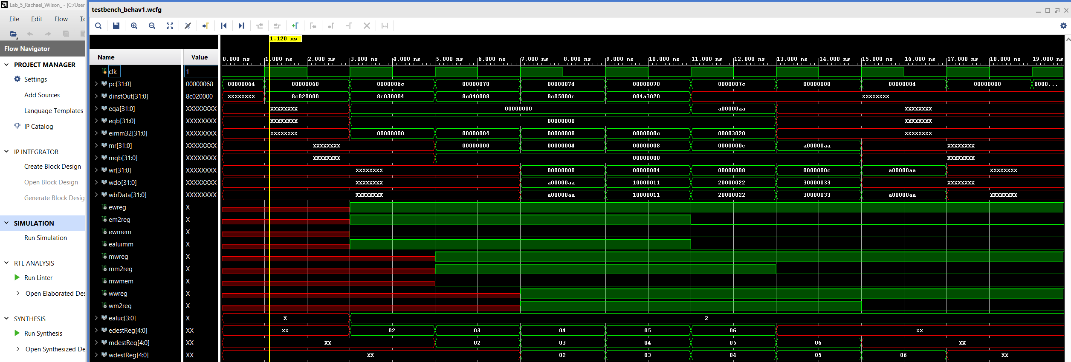

design schematics from synthesis  
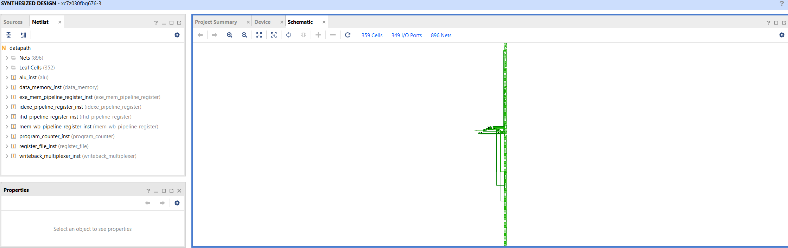

I/O Planning Screenshot

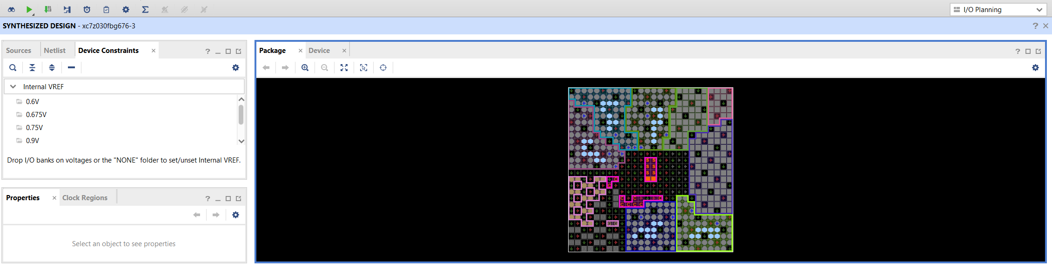

Floor Planning Screenshot

