Hollyhock Corner Gifts · email pack
Welcome sequence · November and December 2026 newsletters · abandoned basket
SAMPLE. Hollyhock Corner Gifts is a fictional Harlow gift shop, made up to show our work. Its story, prices, offers and opening hours are invented for this sample. Every email is finished and ready to paste into Mailchimp, Klaviyo, Shopify Email, MailerLite or whichever tool you already use. A real pack is written only from your own products, prices, offers and story, and we never invent reviews, awards or statistics.
What is in the pack. Six emails: a 3-email welcome sequence for new subscribers, newsletters for November and December 2026, and an abandoned-basket email. Each one has a subject line, a back-up subject to test against it, preview text, the body, a button (call to action) and when to send it. UK dates checked on 21 October 2026: Bonfire Night (Thu 5 Nov), Black Friday (27 Nov), Small Business Saturday UK (Sat 5 Dec, smallbusinesssaturdayuk.com) and Royal Mail's published last UK posting dates for Christmas 2026 (royalmail.com/christmas/last-posting-dates). Words in {curly brackets} are filled in by your email tool or by you.
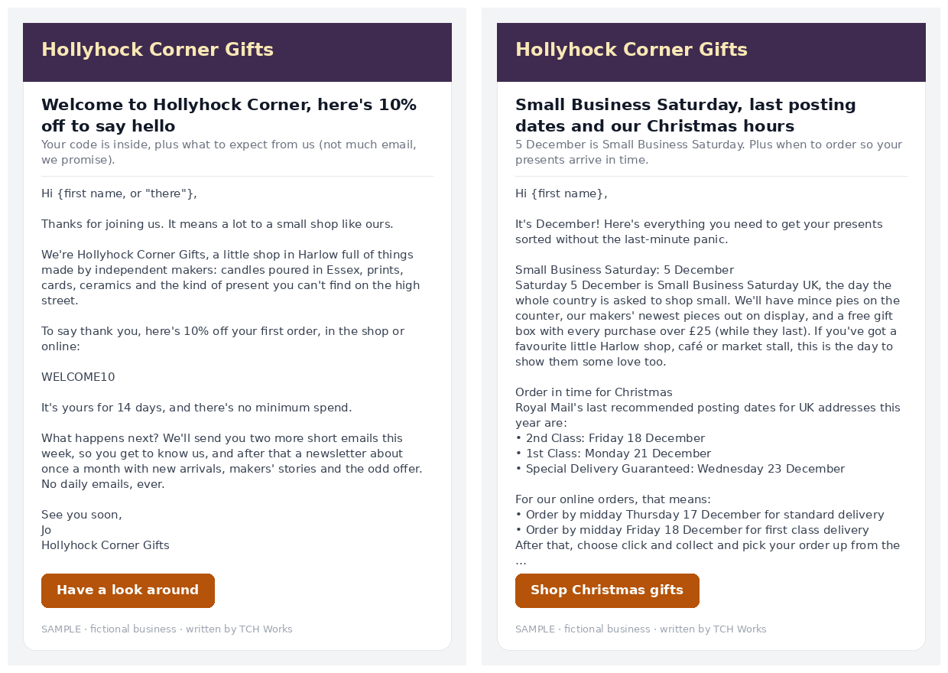

W1 · Welcome email 1 of 3: hello and your thank-you code
When to send | Straight away, as soon as someone signs up
Subject line | Welcome to Hollyhock Corner, here's 10% off to say hello
Back-up subject to test | You're in! A little hello from Harlow
Preview text | Your code is inside, plus what to expect from us (not much email, we promise).

Hi {first name, or "there"},
Thanks for joining us. It means a lot to a small shop like ours.
We're Hollyhock Corner Gifts, a little shop in Harlow full of things made by independent makers: candles poured in Essex, prints, cards, ceramics and the kind of present you can't find on the high street.
To say thank you, here's 10% off your first order, in the shop or online:
WELCOME10
It's yours for 14 days, and there's no minimum spend.
What happens next? We'll send you two more short emails this week, so you get to know us, and after that a newsletter about once a month with new arrivals, makers' stories and the odd offer. No daily emails, ever.
See you soon,
Jo
Hollyhock Corner Gifts
[ Button: Have a look around ] links to {your shop homepage}
Hollyhock Corner Gifts · {your business postal address}
You're getting this because you signed up at {where they signed up}. Unsubscribe: {unsubscribe link}

W2 · Welcome email 2 of 3: our story and our makers
When to send | 3 days after sign-up
Subject line | The story behind the shop (and the candle that started it)
Back-up subject to test | Why we only sell things made by small makers
Preview text | How a kitchen-table hobby turned into a shop full of other people's talent.

Hi {first name},
A quick story, because we think it matters where your presents come from.
Hollyhock Corner started with one candle. Jo was pouring them at her kitchen table for friends, and kept meeting other makers at craft fairs who had lovely things and nowhere to sell them. So she opened a shop for all of them.
Today almost everything on our shelves is made by a small, independent maker, and when you buy from us, a fair share goes straight back to the person who made it.
A few of the makers you'll find with us:
• Our own soy candles, poured in small batches in the back room
• Hand-thrown mugs from a potter in Essex
• Illustrated cards and prints from local artists
And because a present should feel like a present, gift wrapping is free on every order. Just tick the box at checkout, or ask at the till.
Your 10% welcome code, WELCOME10, is still waiting for you.
Jo
[ Button: Meet our makers ] links to {your makers or about page}
Hollyhock Corner Gifts · {your business postal address}
You're getting this because you signed up at {where they signed up}. Unsubscribe: {unsubscribe link}

W3 · Welcome email 3 of 3: gift ideas by budget and a code reminder
When to send | 7 days after sign-up
Subject line | Stuck for a present? Ideas under £10, £20 and £30
Back-up subject to test | Gift ideas sorted by budget, and your code ends soon
Preview text | Our most-asked-for presents, sorted by price. Your welcome code ends in 7 days.

Hi {first name},
The question we hear most in the shop is "what can I get for someone who has everything?" So here are a few of our go-to answers, sorted by budget:
Under £10
• Illustrated greeting card and a bar of local chocolate
• Mini travel candle in a tin
Under £20
• Hand-poured soy candle in a glass jar
• Small art print, ready to frame
Under £30
• Hand-thrown mug from our Essex potter
• Pick-your-own gift box: choose three bits and we'll wrap them together
Every one of these can be gift wrapped for free, and we're happy to pop in a handwritten card with your message.
One last thing: your welcome code WELCOME10 ends in 7 days, so if something's caught your eye, now's a good time.
Happy browsing,
Jo
P.S. Not sure what to choose? Just reply to this email with who it's for and your budget, and we'll suggest something. A real person reads every reply.
[ Button: Shop gifts by budget ] links to {your gifts-by-price collection}
Hollyhock Corner Gifts · {your business postal address}
You're getting this because you signed up at {where they signed up}. Unsubscribe: {unsubscribe link}

N1 · November 2026 newsletter: Christmas shop open, Bonfire Night, Black Friday
When to send | Monday 2 November 2026, about 7pm
Subject line | The Christmas shelves are up (and the kettle's on)
Back-up subject to test | November at Hollyhock Corner: cosy nights and the first Christmas gifts
Preview text | New arrivals, our Bonfire Night candle, late opening Thursdays and our take on Black Friday.

Hi {first name},
November is here, the evenings are dark by five, and the shop has gone full Christmas. Here's what's new this month.
Cosy nights in for Bonfire Night
Thursday 5 November is Bonfire Night. If you'd rather watch the fireworks from the window (or you're keeping a nervous dog company), our Bonfire Toffee candle smells like a treacle-toffee apple and is back in stock for November only. £16.
The Christmas shelves are up
New this month: hand-painted glass baubles, Christmas cards from local illustrators, advent calendars filled by our makers and festive mugs. Small makers only make so many, so if you see something you love, don't leave it too long.
Late opening on Thursdays
From 12 November until Christmas we're open until 8pm every Thursday, so you can shop after work without the rush. Mulled apple juice on us.
Our take on Black Friday (27 November)
We won't be doing huge discounts, because we pay our makers fairly and we'd rather keep it that way. Instead, every order on Black Friday weekend gets a free mini candle and free gift wrapping. Fair to you, fair to them.
Thank you for shopping small this year. It genuinely keeps our doors open.
Jo and the Hollyhock Corner team
[ Button: See the Christmas collection ] links to {your Christmas collection page}
Hollyhock Corner Gifts · {your business postal address}
You're getting this because you signed up at {where they signed up}. Unsubscribe: {unsubscribe link}

N2 · December 2026 newsletter: Small Business Saturday, posting dates, opening hours
When to send | Tuesday 1 December 2026, about 7pm
Subject line | Small Business Saturday, last posting dates and our Christmas hours
Back-up subject to test | Everything you need for a stress-free Christmas from Hollyhock Corner
Preview text | 5 December is Small Business Saturday. Plus when to order so your presents arrive in time.

Hi {first name},
It's December! Here's everything you need to get your presents sorted without the last-minute panic.
Small Business Saturday: 5 December
Saturday 5 December is Small Business Saturday UK, the day the whole country is asked to shop small. We'll have mince pies on the counter, our makers' newest pieces out on display, and a free gift box with every purchase over £25 (while they last). If you've got a favourite little Harlow shop, café or market stall, this is the day to show them some love too.
Order in time for Christmas
Royal Mail's last recommended posting dates for UK addresses this year are:
• 2nd Class: Friday 18 December
• 1st Class: Monday 21 December
• Special Delivery Guaranteed: Wednesday 23 December
For our online orders, that means:
• Order by midday Thursday 17 December for standard delivery
• Order by midday Friday 18 December for first class delivery
After that, choose click and collect and pick your order up from the shop.
Our Christmas opening hours
• Thursdays in December: open until 8pm
• Christmas Eve: open 9am to 2pm
• Closed from 25 December, back on 2 January
Running out of ideas?
Our pick-your-own gift box is the easy answer: choose three pieces, we'll wrap them together with a handwritten card. Ask at the till or choose it online.
From all of us, thank you for every order, every visit and every kind word this year. Have a lovely Christmas.
Jo and the Hollyhock Corner team
[ Button: Shop Christmas gifts ] links to {your Christmas collection page}
Hollyhock Corner Gifts · {your business postal address}
You're getting this because you signed up at {where they signed up}. Unsubscribe: {unsubscribe link}

A1 · Abandoned basket email
When to send | About 2 hours after someone leaves items in their basket (set up once in your shop platform, then it runs by itself)
Subject line | Did something catch your eye?
Back-up subject to test | Your basket is saved, {first name}
Preview text | We've kept your basket safe. Small makers only make so many, so don't miss out.

Hi {first name},
Looks like you were halfway through choosing something lovely. We've saved your basket for you:
{basket items, picture, name and price, added automatically by your shop platform}
A few things that might help:
• Gift wrapping is free on every order, just tick the box at checkout
• Most of our pieces are made in small batches, so once they're gone, they may not come back
• Got a question about size, colour or delivery? Just reply to this email and Jo will get back to you
No pressure at all. If you've changed your mind, that's absolutely fine.
Jo
Hollyhock Corner Gifts
[ Button: Go back to my basket ] links to {basket link, added automatically}
Hollyhock Corner Gifts · {your business postal address}
You're getting this because you signed up at {where they signed up}. Unsubscribe: {unsubscribe link}

Notes for sending
- Send from your own email tool to people who signed up to hear from you. We never supply or use bought lists.
- Under UK GDPR and PECR, consent and the unsubscribe link are the sender's responsibility.
- Welcome and abandoned-basket emails are set up once as automations; newsletters are sent on the dates shown.
- Posting dates come from Royal Mail's published Christmas 2026 list, which may change. Check again before sending.
Written by TCH Works · tchworks.co.uk/services/newsletters · tchworks.shop@agentmail.to

