CZ3006/CE3005 Assignment 1

The detailed throughput analyses for ALOHA and CSMA can be found in the classical Kleinrock-Tobagi paper "Packet Switching in Radio Channels: Part I-Carrier Sense Multiple-Access Modes and Their Throughput-Delay Characteristics". The Kleinrock-Tobagi paper can be found online and is also attached.

Based on equations in the Kleinrock-Tobagi paper, please use Matlab or any other software to plot a figure similar to Figure 9 of the Kleinrock-Tobagi paper to compare between the following:
- Slotted ALOHA
- Pure ALOHA
- Non-Persistent CSMA
- 1-Persistent CSMA
- P-Persistent CSMA
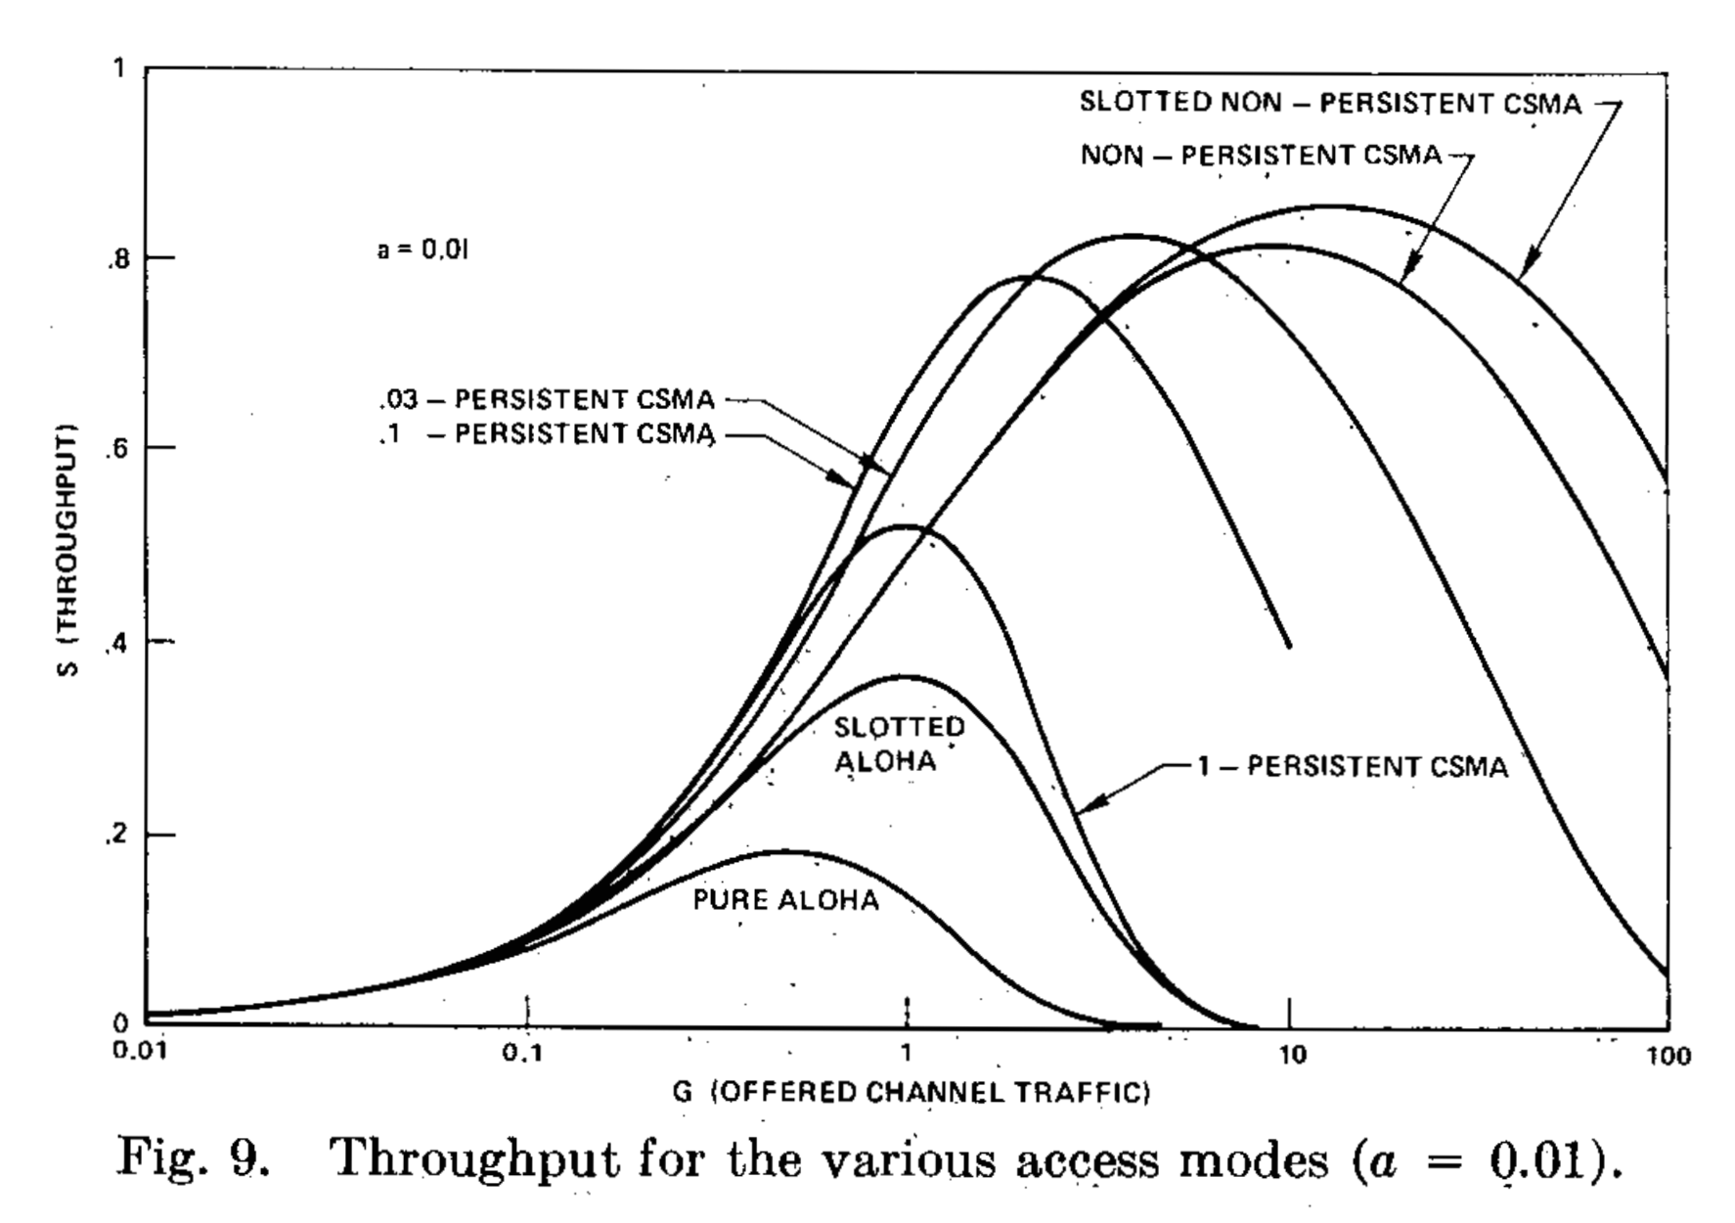

Your figure should not be exactly the same as Figure 9 of the Kleinrock-Tobagi paper (more details are provided in the requirements below). After plotting the figure, please submit a report (in pdf, doc, or docx) which presents your figure and your findings based on the derived figures.

The report should be no more than two pages. Please also submit your code used to generate the figure. You need not submit the figure separately since it should already be present in your report.

Figure Requirements:
- As a=0.01 is already used in Figure 9 of the Kleinrock-Tobagi paper, please choose a different value for the parameter a.
- For P-Persistent CSMA, choose any value for p and draw the corresponding curve. However, please do not set p=0.1 or p=0.03. (used in Figure 9 of the Kleinrock-Tobagi paper)
- Since Slotted Non-Persistent CSMA was not taught in class., you need not plot the curve for Slotted Non-Persistent CSMA.

Clarification:
You do not need to implement any of ALOHA or CSMA protocols. Just use equations in the provided Kleinrock-Tobagi paper to plot throughput curves for generating your figure.
Among those graphs, P-Persistent CSMA will probably take the most amount of time. Please start early.

Note:
In our lecture notes, a is referred to as the normalized propagation delay.
Similarly, as noted in the Kleinrock-Tobagi paper, a is defined as the ratio of propagation delay to the packet transmission time.

