# Data processing

At the end, I have created 3 csv files in order to fulfilled 3 visualisation in this project.

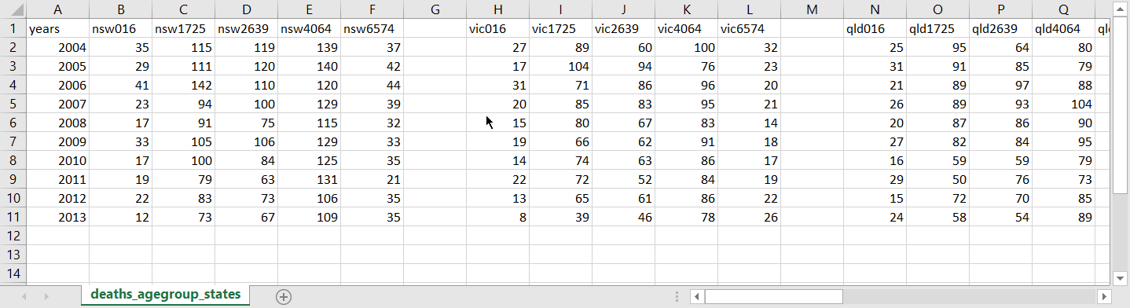

figure :data of deaths by states and age groups

The figure above shows the data of deaths by states and age groups. I have combined states and age groups so the visualisation will look more comparable. It shows the number of road traffic injuries from year 2004 to 2013.

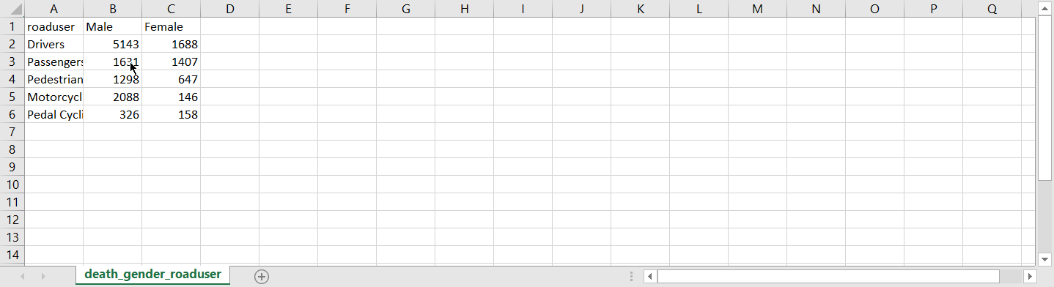

figure : data of deaths by genders and road users

The figure above shows the data of deaths by road users and genders. I have combined the data of deaths by genders and road users. This is looks simple because I have done calculation from multiple tables set of data.

# Requirement

I have fulfilled all the must have requirements in this project. As promise, I have implemented hover feature which data value will be shown whenever the mouse move to any bar in the bar chart. And also, I have implemented radio button for each type of road users so the it has interaction between each type of data. Furthermore, the lines and bars transition also implemented while change the data.

For optional features, I were not able to implement bootstrap for the website due to running out of time. However, I used CSS to replace bootstrap. I made a navigation bar to link 3 visualisations by CSS and HTML. Due to I could not find the data sets which are relatable, I did not implement interaction between each visualisations.

# Visualisation design

1. Deaths by road users and age groups

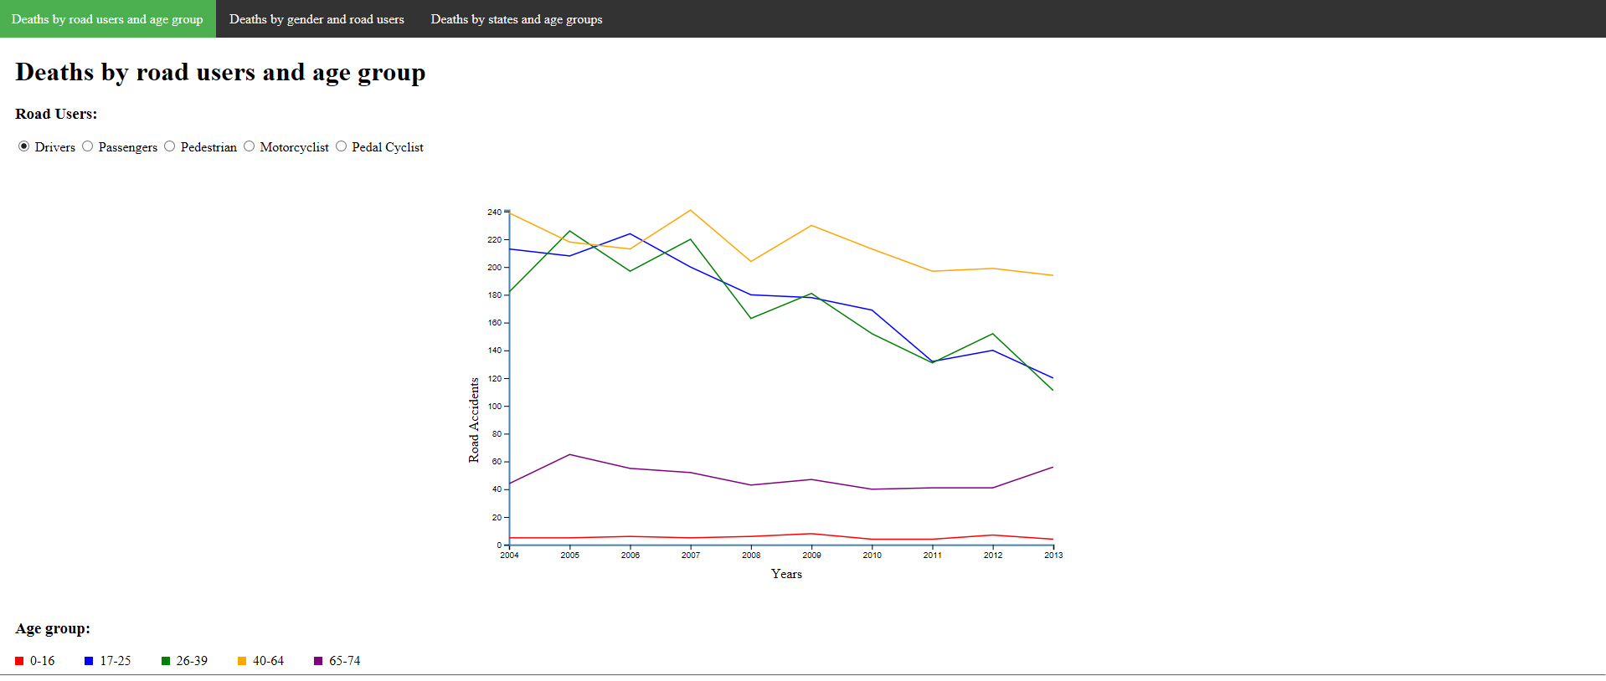

figure : visualisation 1-deaths by road users and age group

This is the final design of my visualisation. This visualisation shows the deaths by road users and age group. There are 5 groups of road users which are drivers, passengers, pedestrians, motorcyclist, and pedal cyclist. I made these road users into radio button group so reader can change the data by clicking the radio buttons. In this line chart, there are 5 lines in the chart with different colors. Each color stands for different age group. Red stands for age 0-16, blue is 17-25, green is 26-39, and yellow is 40-64, and purple is 65-74.

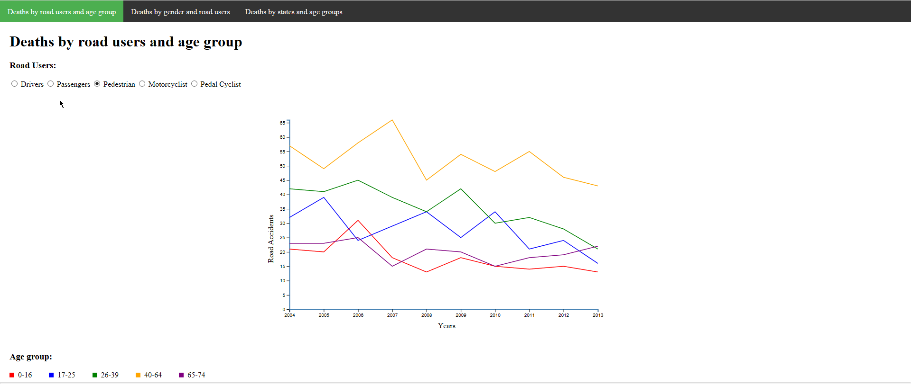

figure :visualisation 1--deaths by road users and age group

When clicking on any radio button, not only the lines change, the y-axis as well. The reason why I change the y-axis value when clicking other radio button is because the gap of number of injuries between drivers and pedal cyclist are too big. If I do not change the y-axis, the readers would not be able to compare the value in pedal cyclist category.

1. Deaths by genders and road users

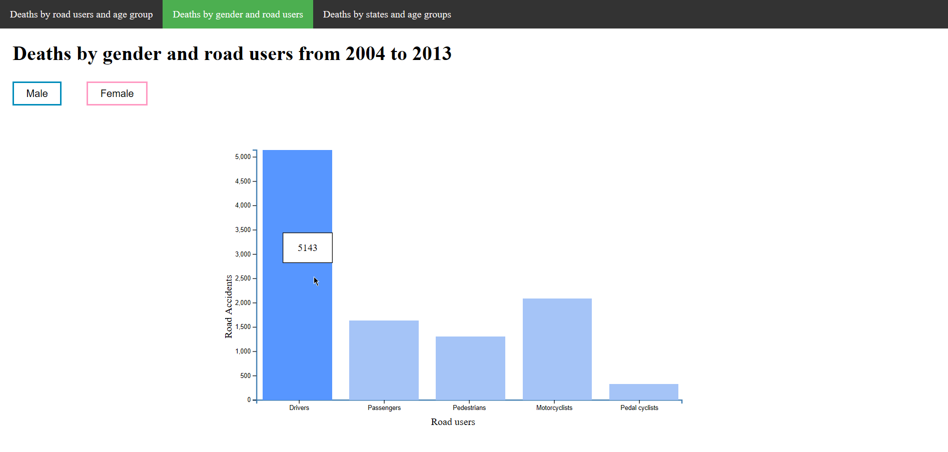

figure : bar chart

This is the final design of my bar chart. This bar chart shows the deaths by genders and road users from 2004 to 2013. I gather all the data from 2004 to 2013 of each type of road users and show it in bar chart. As promised feature, the exact number of injuries will be shown when the mouse move over the bar. Not only number, the color of the bar will change deeper as well in order to create color contrast.

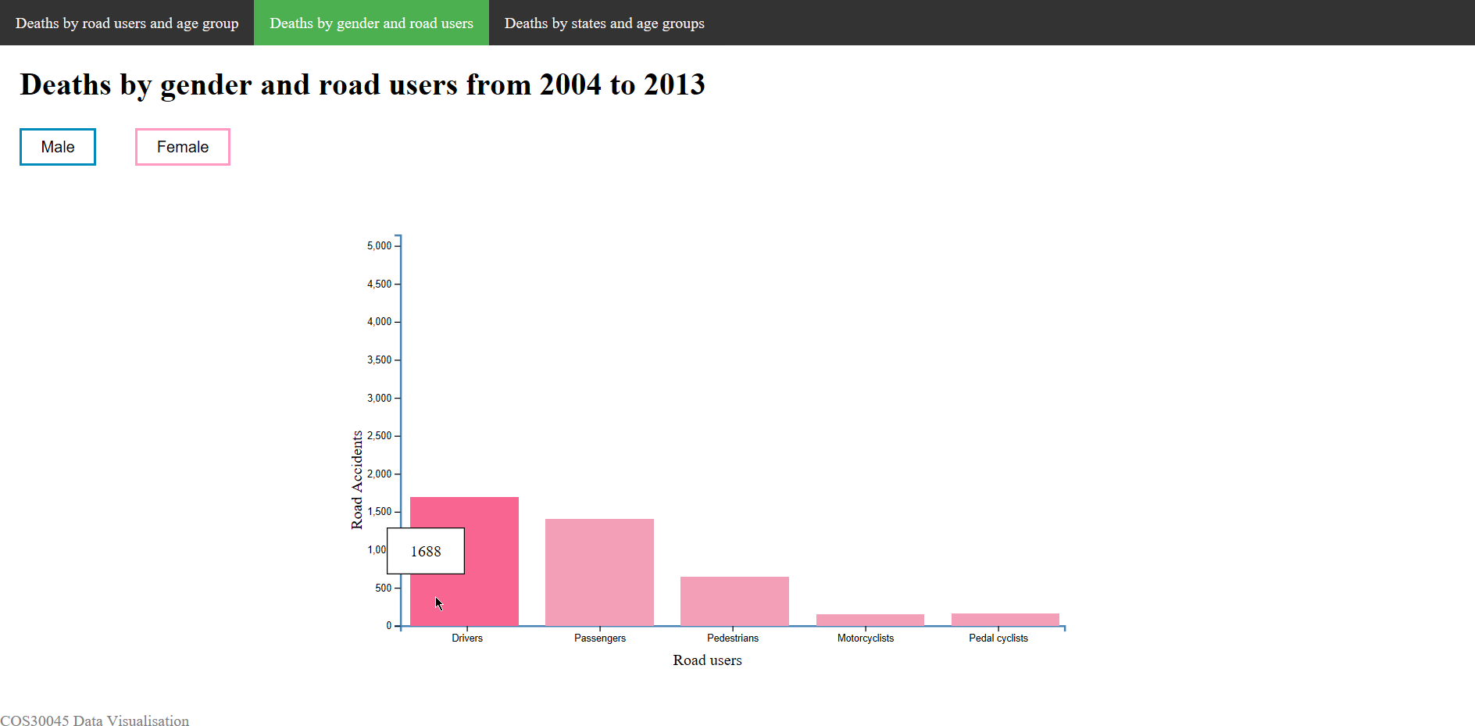

figure : bar chart 2

This bar chart shows the death by female and road users from 2004 to 2013. When reader click on the female button, the bars and colors will change to same color with the button. So the reader can tell which type of data are they watching.

1. Deaths by states and age groups

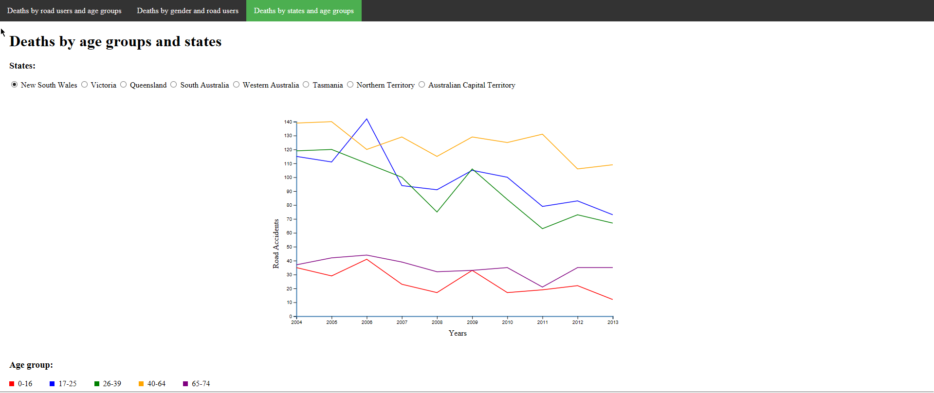

figure : deaths by age group and states

The design is exactly the same with the first one. 5 lines with different colors in the chart and each color represent different age groups. There are 5 radio button group which are New South Wales, Victoria, Queensland, South Australia, Western Australia, Tasmania, Northern Territory, Australian Capital Territory.