Audio Joiner - User Guide
Based on the current Audio Joiner implementation

Overview
Audio Joiner joins a folder's recordings end to end into one file. A live set recorded to ten files, a spoken-word series, a DJ mix cut into sides: anything whose parts belong in a single file is joined in the order you choose, with an optional silence gap or an equal-power crossfade at every boundary.
A straight join is a stream copy when every segment already carries the first file's codec and parameters, so nothing is re-encoded and nothing is lost. Segments that differ are re-encoded together to the first file's sample rate and channel count, and the run report says so instead of quietly copying mismatched streams. The joined file carries the first segment's tags.
The window has three tabs: Setup holds the folder, the segment order, the boundary settings and the action; Processing shows the run's progress; and Results appears when the run finishes, with the counters, the run report and the output folder.

Quick Start
- Open Audio_Joiner.pyw.
- On the Setup tab, select the folder holding the segments, or use the restored last folder.
- Check the segment list: it lists the folder's audio files in join order. Use Move up and Move down to reorder, and Reload after adding files.
- Leave Gap and Crossfade at 0 for a straight join, or set one of them. They describe the same boundary two ways, so a run uses one or the other.
- Name the output file in Join into, or leave it empty to write the first segment's name with `_joined` beside the originals.
- Click Join Segments.
- View the Results tab for the segment count, the joined length and the writer (stream copy or re-encode), then open the folder to check the file.
A Dry Run on the same folder reports the plan and writes nothing, so it is the way to check the order and the settings before a long join.

Setup Tab
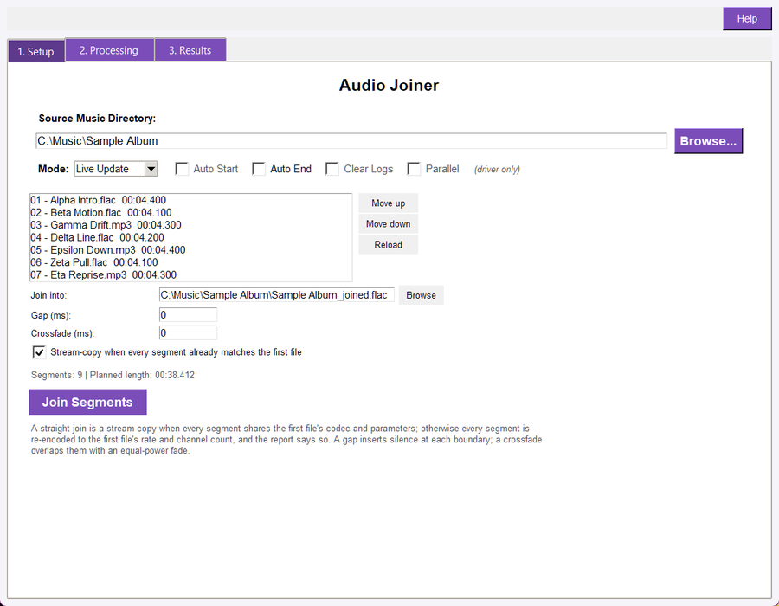
The Setup tab: the source folder, the segment list with its reorder buttons, the output file, the boundary settings and the join button
- Source folder: The folder holding the segments. It is read for the supported audio extensions, and the list shows each file with its measured length.
- Segment list: The join order, top to bottom. Move up and Move down reorder the selected entry; Reload re-reads the folder and keeps the order you chose.
- Join into: The file the join is written to. Empty writes the first segment's stem with `_joined` beside it, so no segment is ever replaced. A name the filesystem accepts is used as typed, including commas, apostrophes and brackets; only characters no filesystem can hold are refused, with the offending name in the message.
- Gap (ms): Silence inserted at every boundary.
- Crossfade (ms): Equal-power overlap at every boundary. The outgoing tail and the incoming head are faded by a cosine and a sine over the same quarter turn, so correlated audio keeps its level instead of dipping.
- Stream-copy when every segment already matches: On by default. It lets a straight join run without re-encoding; turning it off re-encodes anyway.
- Dry Run / Live: Live writes the joined file; Dry Run plans it and writes nothing.

Processing Tab
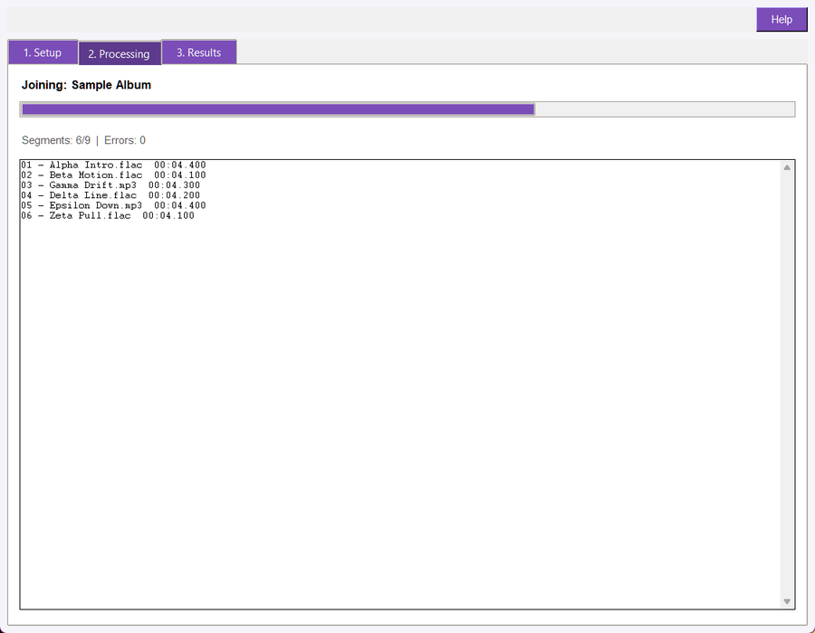
The Processing tab: the progress bar, the segment counter and one line per segment read
The Processing tab reports the run as it happens: a progress bar over the segments, a `Segments: done/total | Errors: n` counter, and one line per segment read, naming the file and its measured length. A long join therefore shows that it is working through the order, and where in the order it is.

Segment Order
The order is the join order, and it is the one thing a joiner must get right. The list is filled from the folder sorted by name, because that is the order a split recorded to numbered files leaves behind. A file name that itself contains a comma is no problem: the order is matched against the folder's own files, so `1-03 Johnny, Don't Do It.mp3` is one entry, not two. Any order you set is kept when you reload, and a run names the order it used in its report, so a joined file can be re-created exactly.
A folder with fewer than two supported files cannot be joined, and the window says so instead of writing a copy of one file.

Boundary Settings
Two settings describe what happens where one segment meets the next, and a run sets at most one of them.
- Gap: Inserts silence between the segments, so the joined file is longer than its parts by that amount at every boundary. Use it for a spoken-word series or anything that should not run together.
- Crossfade: Overlaps the end of one segment with the start of the next, so the joined file is shorter by that amount at every boundary. Use it for a continuous mix. The overlap must be shorter than the shortest segment; a longer one would consume a whole segment, so the tool refuses it and names the reason.
- Neither: A hard join at the sample where one segment ends and the next begins. Nothing is added and nothing is removed.
The planned length is always `sum + gaps - overlaps`, and the window shows it under the list before you run, so the count can be checked against the file that comes out.

Compatibility and Re-encoding
The extension does not say whether two files can be copied together: two MP3s at different sample rates are both `.mp3`. Audio Joiner probes every segment and compares its codec, sample rate, channel count and container with the first file's.
- All identical: a straight join (no gap, no crossfade, same output extension) is written by copying the streams, so no generation of lossy re-encoding is added.
- Any difference: every segment is re-encoded to the first file's sample rate and channel count, and the report names the first segment that differed and what it carried. Nothing is copied into a mismatched stream.
A lossless source keeps its bit depth: a 24-bit FLAC joins to a 24-bit FLAC.

Tags
The joined file takes the first segment's tags: title, artist, album, album artist, date, genre, track and disc numbers, and comment. That is the one policy that never invents a value: the join is the first segment's recording extended by the rest. WAV and AIFF carry no writable tag block, so the report says the tags were not written rather than claiming they were.

Results Tab
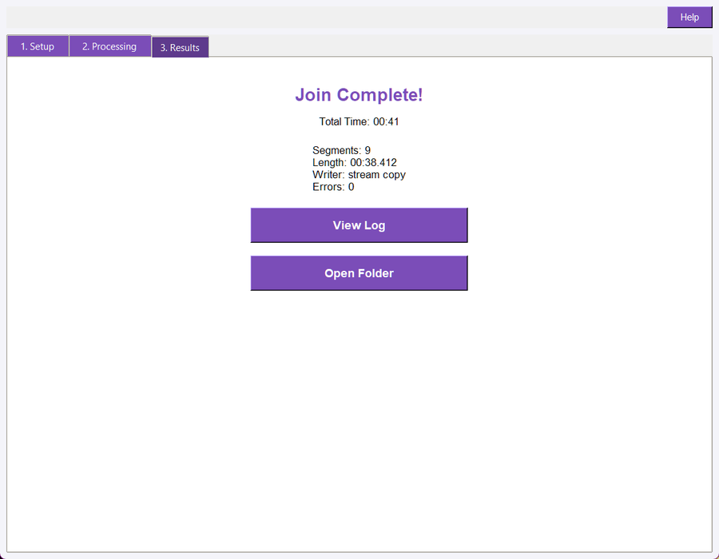
The Results tab: the completion heading, the time and the join summary
The Results tab shows the completion heading, the total time, and the summary:
- Segments: how many files were joined.
- Length: the planned length of the joined file, in `MM:SS.mmm`.
- Writer: stream copy or re-encode.
- Errors: how many segments could not be read.
View Log opens this run's report, and Open Folder opens the folder the join was written to.

The Run Report
Every run writes its report beside the segments it joined:
- `audio_joiner_sync_log.txt` for a live run.
- `audio_joiner_dry_run_log.txt` for a dry run.
The report opens with `AUDIO JOINER REPORT` and the mode, then the folder, the output file, the segment count, the gap and crossfade settings and the compatibility decision, one line per segment with its measured length, and a `SUMMARY:` block with the planned length, how many files were written, the writer, whether the tags were copied, the error count and the elapsed time. A dry run and a live run write different files, so the report you open is always the run you started.

Command Line
python -m audio_suite_shared.cli_app join "D:\Music\Live Set" --order "01 intro.flac,02 theme.flac,03 outro.flac"
python -m audio_suite_shared.cli_app join "D:\Music\Live Set" --crossfade-ms 1500 --output "D:\Music\set.flac"
python -m audio_suite_shared.cli_app join "D:\Music\Live Set" --gap-ms 800 --dry
python -m audio_suite_shared.cli_app join "D:\Music\Live Set" --json

`--order` names the files inside the folder, in join order; leave it out to join every supported file in name order. `--output` names the joined file, `--gap-ms` inserts silence, `--crossfade-ms` overlaps, `--no-copy` forces a re-encode and `--dry` writes nothing. The command exits 0 for a clean run, 1 when the join failed, and 2 for a usage error.

Troubleshooting
- The segment list is empty: the folder holds no supported audio files, or it is the wrong folder. Pick the folder that contains the segments and press Reload.
- A join needs at least two files: the folder has one supported file; add the rest or name them with --order.
- The crossfade is refused: it is not shorter than the shortest segment. Lower it, or use a gap instead.
- Gap and crossfade together are refused: they describe the same boundary two ways. Set one.
- The result sounds like a different recording: the segments were re-encoded because their streams differ. Open the report: it names the first segment that differed and what it carried.
- The tags are missing: the output is a WAV or AIFF, which carries no writable tag block, or the first segment had none to copy. The report states which case applied.

