Hot Chips 2017–2026 Executive Brief
Audience questions and infrastructure decisions
Ten-year descriptive comparison • Official-recording reviews for 2017–2021 • 2026 retains its prior mixed-source aggregate
Thesis — analyst inference. Across ten conference years, the mechanisms changed while the qualification problems persisted: data placement, useful software, complete measurement and physical or security boundaries. The earlier recordings extend those concerns back before today's large serving systems; they do not prove a smooth shift in industry demand.

How recorded question attention changed
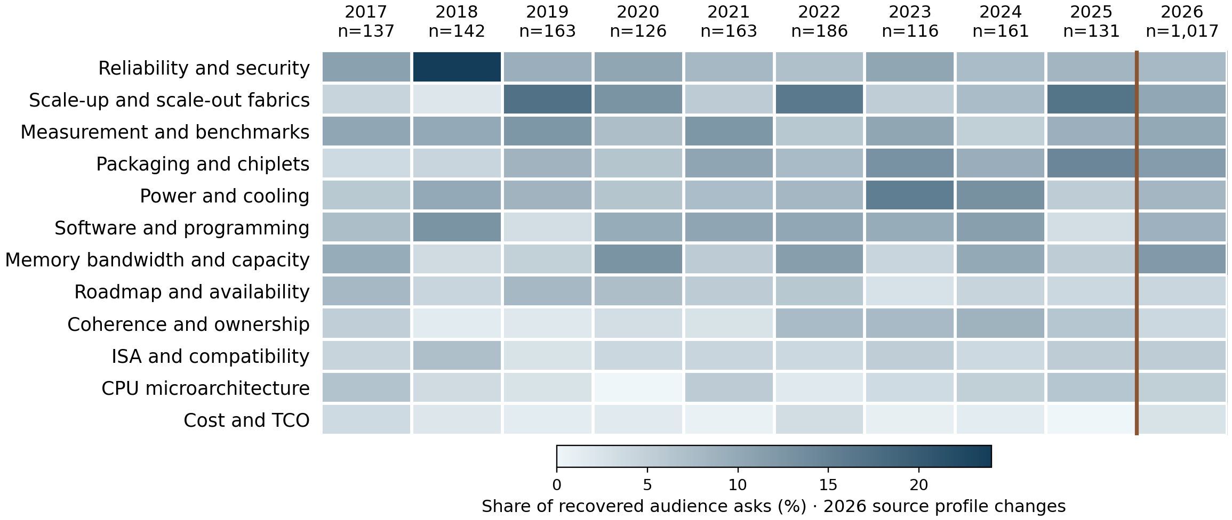
Gradient-only cells use one global percentage scale. Years run chronologically; themes rank by mean within-year share, giving each year equal weight. Counts and denominators are available in CSV.
The new historical years show why a single trend label is insufficient. Security concentrates in 2018, while other years expose different mixes of execution, placement and measurement questions. The later reviews add larger-scale fabric, packaging, cooling and serving detail; annual shares remain conditioned on the reviewed sources.
Share = theme asks ÷ all eligible audience asks in that year. The twelve shared categories omit execution/dataflow and precision/sparsity from the new historical reviews; original later taxonomies also have omitted families. Displayed shares therefore do not sum to100%.
2017–2021 includes tutorials and keynotes as well as technical sessions. Later reviews have different coverage and counting judgments; 2026 combines existing Slack and live-Q&A evidence. Source profile, question opportunities and attribution differ. This is an exploratory comparison of reviewed evidence, not a controlled industry survey or adoption trend. No new Slack content was accessed.
Interactive comparison, annual briefs and exact data

Patterns
Data movement has a long history. 2017 serial-memory and reduction-locality questions precede 2019 embeddings, 2020 memory economics and 2022 placement/coherence discussions. Later memory and fabric scrutiny develops an existing system problem, rather than establishing a new one.
Software promises need operational proof. 2017 manual FPGA partitioning, 2018 mapping friction and 2019 compiler/format choices precede 2020 relocation and the later runtime questions. Portability repeatedly depends on exact operators, placement and synchronization.
Integration multiplies qualification gates. 2017 EMIB access/test questions and 2019 stacked-die uncertainty precede later chiplet, cooling and optical serviceability scrutiny. Denser integration changes power, repair and failure boundaries as well as bandwidth.
Trust boundaries remain architecture boundaries. 2018 speculative-state isolation and 2020 encryption gaps show why coherent addressing or a security block is insufficient. Later shared-memory and ownership questions still require explicit agent privileges, state transitions and recovery contracts.
Credible measurement is a recurring request. VM and timing definitions in 2017, energy boundaries in 2018, mismatched algorithms in 2019 and simulated photonics in 2020 precede later system-power and bandwidth questions. Useful comparisons require consistent workloads and accounting boundaries.

Implications and concrete vendor asks
Analyst inference: these present-day acceptance tests follow from historical uncertainties. Historical statements and roadmap promises do not establish later delivery.
Decision and timing | Vendor ask and decision test
CPU/accelerator balance  Before fleet sizing | Measure host work, memory placement and synchronization with the serving workload. Choose the configuration meeting throughput and tail latency at complete system cost.
Software readiness  Before architecture commitment | Port an independent workload corpus. Count unsupported operators, placement changes, compilation tails and recovery work; require correctness and service targets without hidden fallback costs.
Fabric and memory tiers  Before interface freeze | Specify ownership and ordering. Test mixed traffic, contention, remote accesses and faults, including transfer, flush and synchronization costs.
Physical and security readiness  Before deployment | Request thermal/service limits and complete threat boundaries. Test degraded operation, repair paths, cross-context isolation and encrypted performance under sustained load.
Vendor evidence contract  Before comparative ranking | Separate measured, simulated and projected results. Match quality, workload, hardware/software and full energy boundaries; require reproducible absolute results beside ratios.

