Hot Chips 2017 Executive Brief
Audience questions and infrastructure decisions
Official YouTube automatic captions • 12/13 recordings recovered • Caption review; not independently audio-verified
Thesis — analyst inference. Specialized compute and heterogeneous integration advanced faster than the disclosed contracts for programming, data placement, isolation and qualification. The useful architectural question was how the complete machine would behave under a real workload.

Where audience questions concentrated
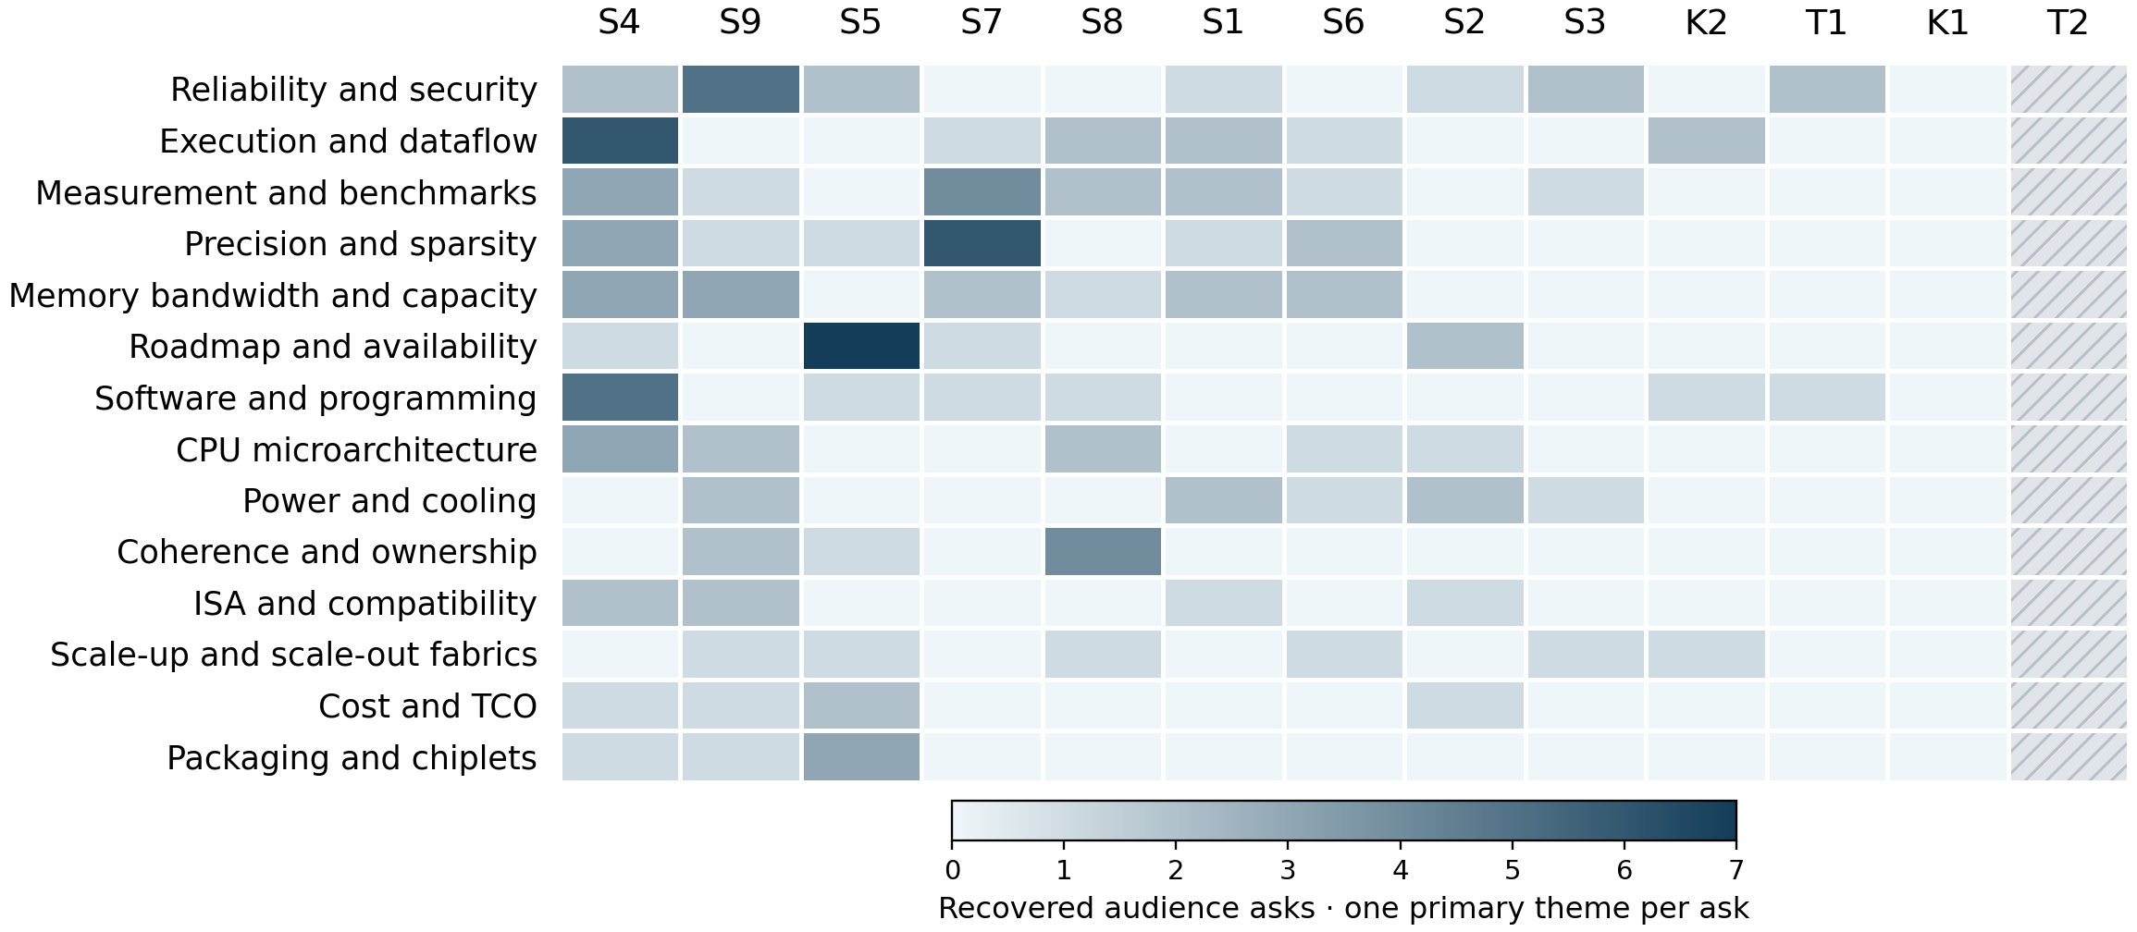
Darker cells mean more recovered asks; one common raw-count scale. Both axes rank by total asks. Hatched columns mean missing captions; * marks partial exports. Values are in the companion CSV.
137 eligible audience asks. Leading themes: reliability and security 15 (10.9%); measurement and benchmarks 14 (10.2%); execution and dataflow 14 (10.2%). Processor, FPGA and server exchanges contain much of the recovered technical scrutiny. Their time budgets and speaker counts differ, so this is attention within the reviewed evidence.
Caption response status in the audience subset: answered 66; partial 57; deferred 7; unanswered 3; unclear 4. Unclear means missing/unintelligible evidence; answers are not independently verified.
Session key: T1 P4 for Software Defined Networks: Language and Hardware Implementation · T2 Building Autonomous Vehicles with NVIDIA’s DRIVE Platform · S1 GPU/Gaming · S2 IOT/Embedded · K1 The Direct Human/Machine Interface and Hints of a General Artificial Intelligence · S3 Automotive · S4 Processors · S5 FPGAs · S6 Neural Net I · K2 Machine Learning and the Implications for Computer System Design · S7 Neural Net II · S8 Architecture · S9 Server
Counting rule: one independently answerable technical ask, one primary theme. 165 audit rows; 28 excluded. Recorded origins: 145 audience, 4 moderator, 16 unknown. Unintelligible or out-of-scope asks are also excluded. Missing captions: T2. Attention is not importance. Unequal Q&A time and caption loss limit comparisons. No Slack content was accessed.
Official archive · Report, counts and source anchors

Patterns
Programmability leaves isolation work. P4 described trusted program control but deferred concurrent independent-program virtualization. Vega's guest ownership mechanism did not supply switching-latency figures. A programming interface alone did not establish predictable tenant sharing. [T1 128:59]
Locality shapes useful throughput. Volta's tensor reduction depended on the kernel/framework and intermediate placement. Cisco's serial-attached memory traded capacity and connectivity against higher latency and I/O power. Peak arithmetic and link bandwidth hid different costs. [S1 95:08]
Packaging needs economic and test evidence. EMIB questions probed access, cost and known-good-die assurance. EPYC's organic package prompted performance and die-yield questions. Integration feasibility did not settle supplier access, usable yield or the complete platform tradeoff. [S5 62:41]
Formats and software constrain specialization. Brainwave questions pressed precision and accuracy assumptions. TPU exchanges examined workload size, sparsity and framework selection. AWS F1 required manual partitioning across FPGAs. Hardware specialization still demanded model and application work. [S5 117:55]
Timing figures need complete paths. Arm defined L2 timing from address generation through the access path; system atomic details remained incomplete. EPYC's encryption answer discussed latency against coherence behavior. A cycle count or coherent address did not specify the whole transaction. [S8 57:57]

Implications and concrete vendor asks
Analyst inference: these present-day acceptance tests follow from historical uncertainties. Historical statements and roadmap promises do not establish later delivery.
Decision and timing | Vendor ask and decision test
Shared programmable devices  Before tenant deployment | Request state ownership, isolation and preemption contracts. Stress hostile co-tenants and measure switching tails, residual leakage and throughput under contention.
Memory and compute topology  Before sizing | Measure dependent loads, intermediate traffic and useful throughput across local/remote paths. Accept capacity gains only when latency and energy targets hold.
Chiplet/package selection  Before sourcing commitment | Request access terms, known-good-die coverage, yield assumptions and complete package cost. Test power delivery, repairability and the exact deployed configuration.
Accelerator software fit  During proof of concept | Port target models at fixed quality. Count unsupported operators, partitioning effort and datatype conversions; measure whole-pipeline performance, including host work.
Shared-memory semantics  Before interface freeze | Specify ownership transitions, stashing and atomic execution paths. Test contended producer/consumer transfers for correctness, traffic and tail latency.

