Hot Chips 2018 Executive Brief
Audience questions and infrastructure decisions
Official YouTube automatic captions • 13/13 recordings recovered • Caption review; not independently audio-verified
Thesis — analyst inference. Specialized hardware moved ahead of the system contracts needed to deploy it. Secure boundaries, usable software mapping and complete memory-and-power accounting became practical qualification gates.

Where audience questions concentrated
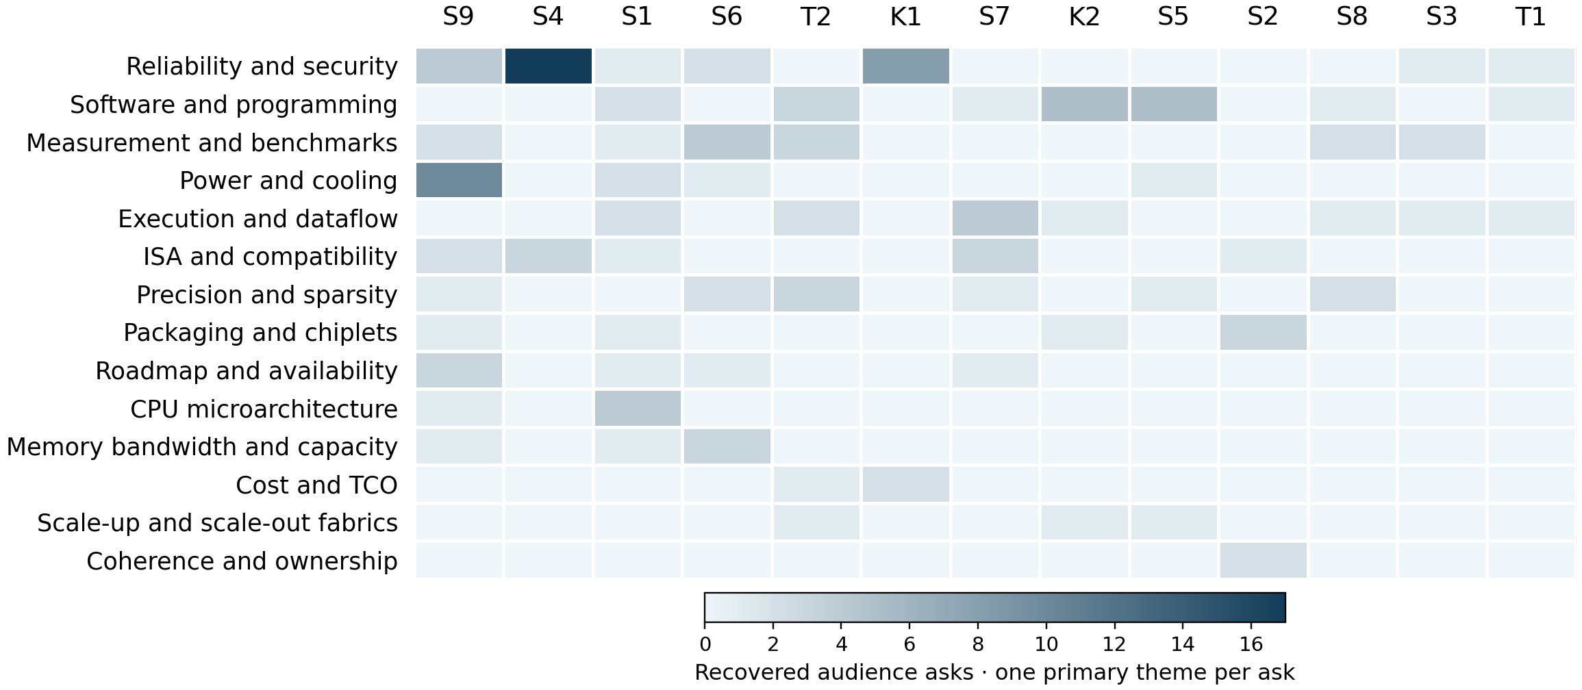
Darker cells mean more recovered asks; one common raw-count scale. Both axes rank by total asks. Hatched columns mean missing captions; * marks partial exports. Values are in the companion CSV.
142 eligible audience asks. Leading themes: reliability and security 34 (23.9%); software and programming 18 (12.7%); measurement and benchmarks 14 (9.9%). Security spans speculative state, roots of trust and persistent memory. Server processors and the security session carry the largest recovered session totals.
Caption response status in the audience subset: partial 60; answered 64; deferred 14; unanswered 3; unclear 1. Unclear means missing/unintelligible evidence; answers are not independently verified.
Session key: T1 Blockchains and Distributed Ledgers · T2 Architectures for Accelerating Deep Neural Nets · S1 Mobile/Power Efficient Processors · S2 Graphics Solutions · K1 Spectre/Meltdown · S3 IoT/Edge Computing · S4 Security · S5 Switching Fabrics and FPGA Architectures · S6 New Technologies · K2 Adaptable Intelligence: The Next Computing Era · S7 Machine Learning I · S8 Machine Learning II · S9 Server Processors
Counting rule: one independently answerable technical ask, one primary theme. 170 audit rows; 28 excluded. Recorded origins: 144 audience, 12 moderator, 14 unknown. Unintelligible or out-of-scope asks are also excluded. T1 covers Mohan's segment; the later XRP program segment is absent from this recording. Another 20 caption gaps/out-of-scope items are logged separately. Attention is not importance. Unequal Q&A time and caption loss limit comparisons. No Slack content was accessed.
Official archive · Report, counts and source anchors

Patterns
Security needs an explicit contract. The Spectre/Meltdown panel discussed protected execution subcontexts and shared accelerator state. Cascade Lake supplied no verification evidence for mitigation coverage. Titan narrowed the trusted surface without removing every CPU, software or foundry dependency. [K1 88:26]
Programmability shifts work into mapping. Project Everest disclosed no autovectorizing compiler and deferred receive-programming details. Pixel Visual Core and dynamic-graph questions tested what developers still had to map and synchronize. Higher-level access did not prove transparent application portability. [S5 90:37]
Memory needs lifecycle accounting. Mythic's intermediate activations occupied tile SRAM; A64FX had an HBM capacity ceiling. Optane answers withheld requested endurance and operating-state power figures. Density and bandwidth alone did not establish service lifetime or working-set fit. [S9 123:48]
Sparsity benefits differ by mechanism. Arm said 3D convolution could be mapped without native support; DeePhi used structured sparsity. Mythic said zero weights would reduce current without increasing dense-matrix capacity. Energy, compute and capacity benefits required workload-specific evidence. [S6 64:46]
Efficiency claims need matching boundaries. Samsung's power comparison was not fully process-normalized. XDNN described mapped compute rather than all FPGA resources. NRAM cell energy and Mythic whole-chip energy covered different budgets; their ratios could not be compared directly. [S1 38:28]

Implications and concrete vendor asks
Analyst inference: these present-day acceptance tests follow from historical uncertainties. Historical statements and roadmap promises do not establish later delivery.
Decision and timing | Vendor ask and decision test
Shared-compute security  Before deployment | Request protected-state and mitigation-validation coverage. Test cache, predictor and device-state leakage across hostile contexts; measure the cost of required isolation.
Application portability  During proof of concept | Request compiler coverage, partitioning and synchronization rules. Port dynamic and unfamiliar operators; count manual work and fallback overhead at the service latency target.
Capacity and persistence  Before platform commitment | Disclose SRAM limits, endurance, encryption location and idle/read/write power. Sweep working sets and sustained writes against the service lifetime and complete energy budget.
Numeric/operator fit  Before accelerator selection | Specify native/mapped operators and which sparsity patterns save compute, energy or capacity. Test target shapes and precision settings at fixed model quality.
Comparative efficiency  Before procurement ranking | Request matching baselines, process assumptions and resource occupancy. Reproduce useful throughput and energy including host, memory, interfaces and co-resident workloads.

