Hot Chips 2019 Executive Brief
Audience questions and infrastructure decisions
Official YouTube automatic captions • 13/13 recordings recovered • Caption review; not independently audio-verified
Thesis — analyst inference. Accelerator differentiation was becoming a system problem. Memory placement, fabric behavior and the software contract repeatedly qualified arithmetic throughput, while recorded questions pressed architectural ambitions toward implementable interfaces and workload evidence.

Where audience questions concentrated
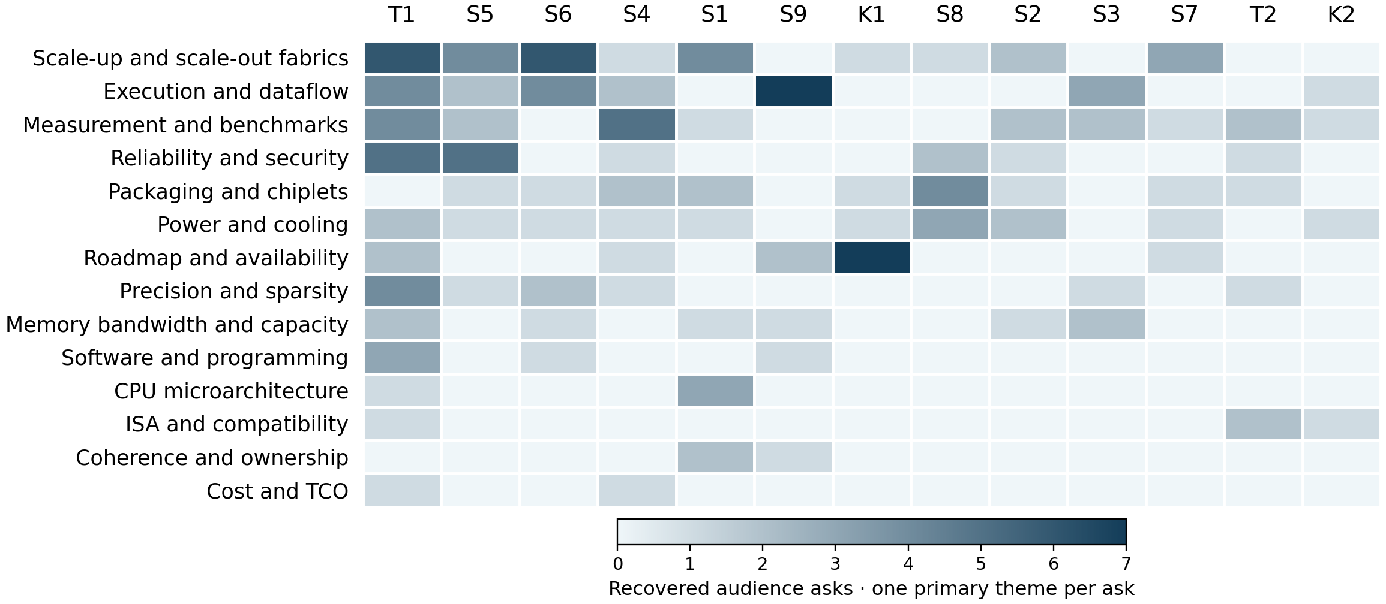
Darker cells mean more recovered asks; one common raw-count scale. Both axes rank by total asks. Hatched columns mean missing captions; * marks partial exports. Values are in the companion CSV.
163 eligible audience asks. Leading themes: scale-up and scale-out fabrics 28 (17.2%); execution and dataflow 23 (14.1%); measurement and benchmarks 20 (12.3%). Tutorials contribute a substantial share of the recovered asks. Their longer question opportunities, conservative attribution and differing subject matter affect the annual distribution.
Caption response status in the audience subset: partial 65; deflected 7; answered 75; deferred 9; unanswered 7. Unclear means missing/unintelligible evidence; answers are not independently verified.
Session key: K1 AMD keynote · K2 TSMC keynote · S1 General Purpose Compute · S2 Memory · S3 Methodology and ML Systems · S4 ML Training · S5 Embedded and Auto · S6 ML Inference · S7 Interconnects · S8 Packaging and Security · S9 Graphics and AR · T1 Acceleration in the Cloud · T2 RISC-V
Counting rule: one independently answerable technical ask, one primary theme. 211 audit rows; 48 excluded. Recorded origins: 163 audience, 4 moderator, 44 unknown. Unintelligible or out-of-scope asks are also excluded. Another 8 caption gaps/out-of-scope items are logged separately. Attention is not importance. Unequal Q&A time and caption loss limit comparisons. No Slack content was accessed.
Official archive · Report, counts and source anchors

Patterns
Interconnect names leave mechanisms unresolved. Arm's cache stashing needed software and interface prerequisites; Xilinx qualified its nonblocking-mesh claim through traffic-class isolation. AWS discussed placement groups and packet-aware limiting. Topology and peak link rate did not describe congestion behavior. [S1 66:07]
Peak compute needs workload evidence. Huawei and Spring Crest faced benchmark and MLPerf questions. Cerebras deferred working-system performance. Microsoft's compression comparison used different algorithms. Those answers exposed comparison boundaries that peak throughput alone could not resolve. [S4 30:23]
Sparse workloads make placement decisive. Facebook described profile-guided embedding partitioning, local bandwidth versus distributed latency, and prefetch overfetch. UPMEM DPUs communicated through the CPU. Irregular accesses and host work belonged in accelerator sizing alongside dense kernels. [S2 25:52]
Numerical formats carry software obligations. Intel linked its Flexpoint-to-BF16 change to software scaling. Google's BF16 and array-size answers described tested models and compiler co-design. Datatype support alone did not establish convergence, rounding behavior or utilization on real tensor shapes. [S4 61:07]
Integration adds power, test and trust gates. Lakefield described known-good-die testing but left stacking limits unquantified. Tesla's dual-SoC safety intent did not specify disagreement handling. Jintide's monitor answer did not establish a complete host trust boundary. [S8 26:47]

Implications and concrete vendor asks
Analyst inference: these present-day acceptance tests follow from historical uncertainties. Historical statements and roadmap promises do not establish later delivery.
Decision and timing | Vendor ask and decision test
Fabric/interface commitment  Before topology selection | Specify ordering, traffic isolation, stashing prerequisites and forward progress. Test mixed traffic, congestion and recovery at the workload's tail-latency target.
Accelerator sizing  Before using scaling graphs | Require reproducible matched algorithms, precision, batch and quality. Measure host, memory and network utilization with useful end-to-end throughput.
Sparse memory/CPU balance  Before deployment | Sweep embedding size, skew, locality and profile drift. Include ingestion and updates; measure prefetch overfetch, latency and effective bandwidth.
Datatype/compiler contract  Before model commitment | Verify convergence, rounding and overflow at fixed quality. Profile tensor shapes and schedules; include rejected operators and porting cost in acceptance.
Integrated platform readiness  Before sign-off | Request stack power, thermal headroom, die-test coverage and fault handling. Inject failures and disagreement; verify monitor privileges and service recovery.

