Hot Chips 2020 Executive Brief
Audience questions and infrastructure decisions
Official YouTube automatic captions • 12/12 recordings recovered • Caption review; not independently audio-verified
Thesis — analyst inference. Recovered Q&A probed whether heterogeneous machines could be fed, programmed, isolated and measured as useful systems. Memory economics, software behavior and degraded operation qualified peak compute rather than following from it.

Where audience questions concentrated
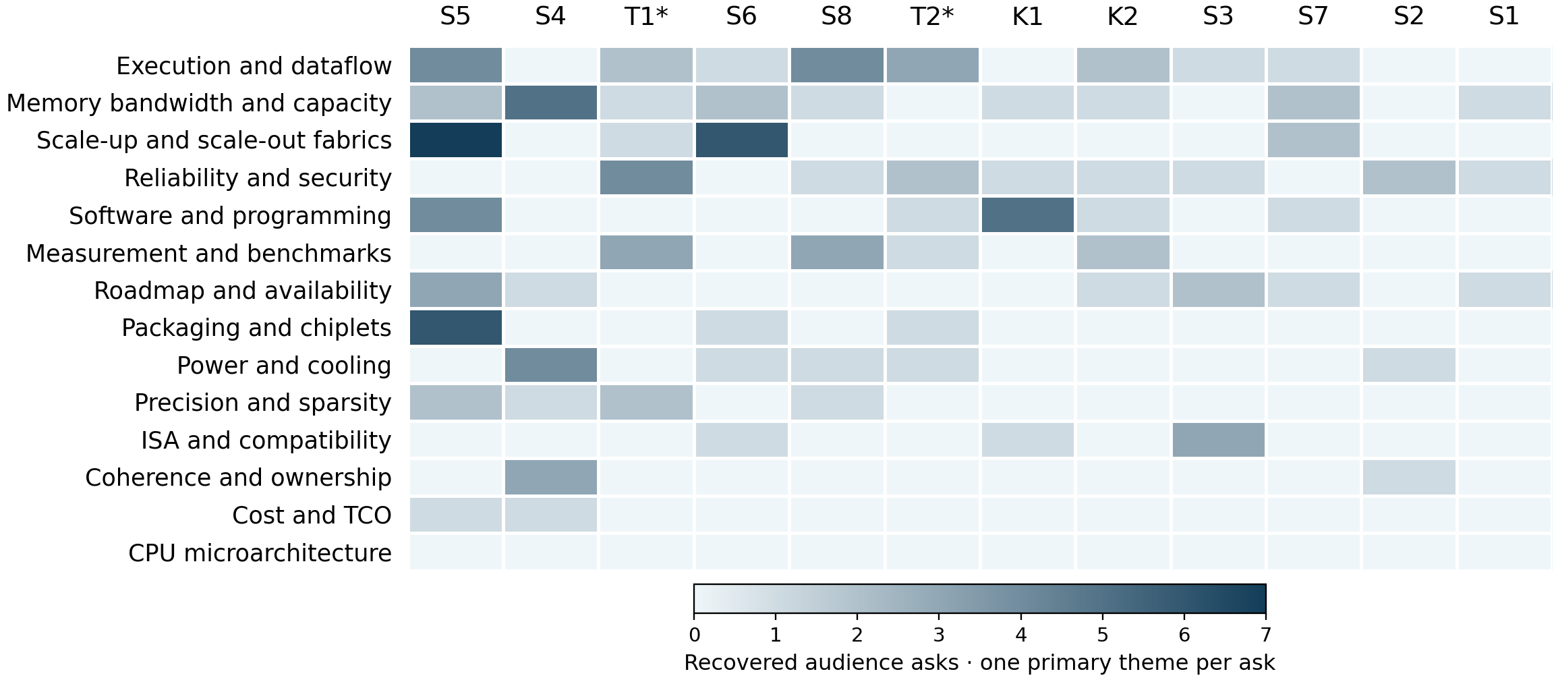
Darker cells mean more recovered asks; one common raw-count scale. Both axes rank by total asks. Hatched columns mean missing captions; * marks partial exports. Values are in the companion CSV.
126 eligible audience asks. Leading themes: execution and dataflow 18 (14.3%); memory bandwidth and capacity 16 (12.7%); scale-up and scale-out fabrics 16 (12.7%). S5, FPGAs and Reconfigurable Architectures, contributes the most eligible asks. Conservative attribution leaves many CPU prompts outside the audience matrix; zero CPU-theme cells do not establish absent CPU interest.
Caption response status in the audience subset: answered 58; deferred 10; deflected 8; partial 49; unclear 1. Unclear means missing/unintelligible evidence; answers are not independently verified.
Session key: K1 No Transistor Left Behind · K2 AI Research at Scale — Opportunities on the Road Ahead · S1 Server Processors · S2 Mobile Processors · S3 Edge Computing and Sensing · S4 GPUs and Gaming Architectures · S5 FPGAs and Reconfigurable Architectures · S6 Networking and Distributed Systems · S7 ML Training · S8 ML Inference · T1 Machine Learning Scale Out · T2 Quantum Computing
Counting rule: one independently answerable technical ask, one primary theme. 206 audit rows; 80 excluded. Recorded origins: 127 audience, 20 moderator, 59 unknown. Unintelligible or out-of-scope asks are also excluded. Tutorial exports are truncated; their unreviewed tails are missing coverage. Attention is not importance. Unequal Q&A time and caption loss limit comparisons. No Slack content was accessed.
Official archive · Report, counts and source anchors

Patterns
Memory choice follows workload and economics. Pensando justified HBM-to-DDR migration through capacity flexibility, buffering and cost. Tenstorrent distinguished inference LPDDR4 from training GDDR6. Xbox balanced GPU bandwidth with CPU latency. No single memory hierarchy won every workload. [S6 59:20]
Useful scale includes failed links. Tofino telemetry distinguished local timing from WAN synchronization. Fungible emphasized connectivity; TPU Pod recovery details remained incomplete. Cerebras described redundant cores and routes. Nominal line rate did not establish degraded-mode behavior. [T1 106:31]
Placement and compilation remain deployment work. Versal relocation depended on repeated fabric patterns. Tenstorrent claimed dynamic-graph support; Cerebras described typical compilation in minutes. These answers did not establish general operator coverage, difficult-model compile tails or effortless placement changes. [S5 61:58]
Security and lifetime need operating evidence. Ice Lake encryption overhead came from unspecified preproduction experiments; Tiger Lake withheld latency figures. Lightmatter discussed manufacturing precedents without quantitative array lifetime evidence. Targets and precedent left qualification gaps. [S1 45:43]
Benchmarks need full pipeline boundaries. DeepMind treated MLPerf as useful but insufficient for evolving research. Lightmatter separated simulator results and analog timing from measured digital performance. Conversion, transfers, host work and workload diversity remained essential comparison terms. [K2 56:27]

Implications and concrete vendor asks
Analyst inference: these present-day acceptance tests follow from historical uncertainties. Historical statements and roadmap promises do not establish later delivery.
Decision and timing | Vendor ask and decision test
Memory configuration  Before sizing | Sweep working sets, concurrency and batch. Compare capacity pressure, effective bandwidth, p99 latency, power and delivered system cost.
Scale and availability  Before cluster commitment | Run fixed-work scaling and adversarial traffic at the target topology. Inject link/node failures; measure recovery, lost work and completion tails.
Compiler/runtime readiness  During proof of concept | Use independent models with dynamic control flow. Measure unsupported operations, relocation recompilation, compile-time distributions and debugging effort.
Isolation and durability  Before qualification sign-off | Test encrypted operation and cross-tenant reassignment. Request photonic drift, lifetime, yield and recalibration distributions under the deployed operating envelope.
Performance comparison  Before purchasing | Reproduce same-batch, same-quality results on delivered silicon, including conversion, host work and transfers. Expand the corpus beyond a fixed benchmark suite.

