Hot Chips 2021 Executive Brief
Audience questions and infrastructure decisions
Official YouTube automatic captions • 14/16 recordings recovered • Caption review; not independently audio-verified
Thesis — analyst inference. The recovered Q&A tests specialization at system boundaries: memory and ingestion, software portability, transport and ordering, numerical behavior and package power. These dependencies qualify useful compute; they do not establish that a particular architecture fails.

Where audience questions concentrated
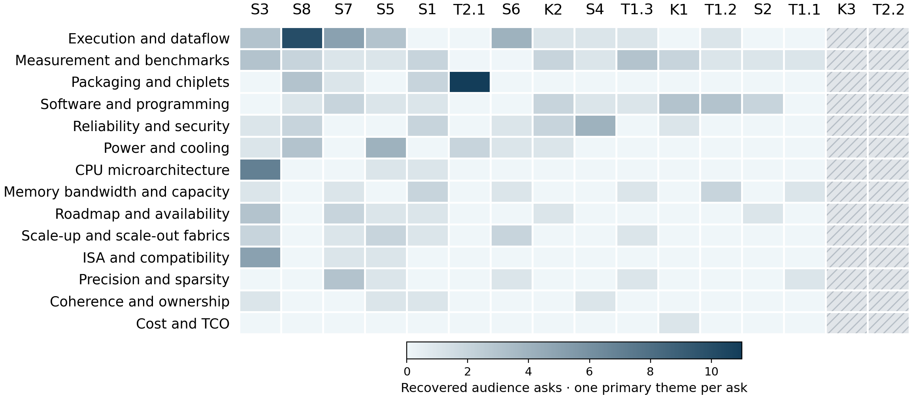
Darker cells mean more recovered asks; one common raw-count scale. Both axes rank by total asks. Hatched columns mean missing captions; * marks partial exports. Values are in the companion CSV.
163 eligible audience asks. Leading themes: execution and dataflow 29 (17.8%); measurement and benchmarks 20 (12.3%); software and programming 17 (10.4%). Infrastructure and data processors attract the most eligible asks. Caption response gaps are substantial: unclear status describes missing or unintelligible evidence, not proof of an unanswered question in the recording.
Caption response status in the audience subset: answered 54; partial 38; unanswered 1; unclear 64; deflected 2; deferred 4. Unclear means missing/unintelligible evidence; answers are not independently verified.
Session key: S1 Server Processors · S2 Academic Spinout Chips · S3 Infrastructure and Data Processors · S4 Enabling Technologies · S5 ML Inference for the Cloud · S6 ML and Computation Platforms · S7 Graphics and Video · S8 New Technologies · K1 Does Artificial Intelligence Require Artificial Architects? · K2 Skydio Autonomy Engine: Enabling the Next Generation of Autonomous Flight · K3 Architectural Challenges: AI Chips, Decision Support, and High Performance Computing · T1.1 Machine Learning Performance and Challenges, Part 1 · T1.2 Machine Learning Performance and Challenges, Part 2 · T1.3 Machine Learning Performance and Challenges, Part 3 · T2.1 Advanced Packaging, Part 1 · T2.2 Advanced Packaging, Part 2
Counting rule: one independently answerable technical ask, one primary theme. 246 audit rows; 83 excluded. Recorded origins: 170 audience, 24 moderator, 52 unknown. Unintelligible or out-of-scope asks are also excluded. Missing captions: K3, T2.2. Attention is not importance. Unequal Q&A time and caption loss limit comparisons. No Slack content was accessed.
Official archive · Report, counts and source anchors

Patterns
Feed the accelerator before judging arithmetic. Samsung attributed the gap between PIM bandwidth uplift and application speedup to unchanged host and ordering overheads. Facebook emphasized ingestion benchmarking and reuse. Translation, DRAM-bank behavior and preprocessing still limited useful throughput. [S4 88:51]
The software path is part of the architecture. Skydio described expensive architecture-specific optimization during porting. Alder Lake Linux-support questions survived without recoverable answers. Facebook's merged reads were client software. An engine or instruction did not establish a ready application path. [K2 47:07]
Transport and ordering define integration. IBM described scoped ordering around Telum's accelerator; Enflame used noncoherent copies and mailboxes. Mount Evans' transport details were deferred. Compatibility, coherence and reliable transport were distinct properties requiring separate evidence. [S1 97:29]
Precision needs replay and quality evidence. Graphcore described controlled seeds for stochastic-rounding replay. Xilinx distinguished BF16 from block floating point; Anton selected formats by pipeline stage. Efficiency depended on numerical behavior and workload quality rather than the format name alone. [S6 29:24]
Density and power need separate proof. Intel discussed PowerVia with stacking and EMIB's yield/reach tradeoffs. Anton justified a global clock mesh through latency and power. TSMC cooling questions lacked useful caption answers; package scalability did not establish facility feasibility. [T2.1 52:49]

Implications and concrete vendor asks
Analyst inference: these present-day acceptance tests follow from historical uncertainties. Historical statements and roadmap promises do not establish later delivery.
Decision and timing | Vendor ask and decision test
Specialized compute  Before selection | Run matched end-to-end workloads including ingestion, host orchestration and storage. Measure utilization, tails and whole-system energy against a CPU baseline; profile the remaining bottleneck.
Software migration  Before resource commitment | Request versioned compiler/runtime/kernel support and a reproducible port. Measure engineering effort, rejected operators and performance against the deployment schedule.
Accelerator/DPU integration  Before host commitment | Specify coherence, ordering, transport and management separately. Test contended transfers, mixed hosts and recovery with versioned software and correctness checks.
Reduced precision  Before model approval | Compare quality and convergence across formats and seeds. Verify deterministic replay; identify operations requiring higher precision and include their overhead.
Package and cooling  Before platform commitment | Request design-kit access, process/yield evidence and steady/transient power. Test expected inlet temperature and flow, including facility energy and service limits.

