Hot Chips 2023 Executive Brief
Audience questions and infrastructure decisions
YouTube automatic captions • Partial conference coverage
Inference: software compatibility and validated system efficiency should carry as much weight as core and accelerator specifications.

Where audience questions concentrated
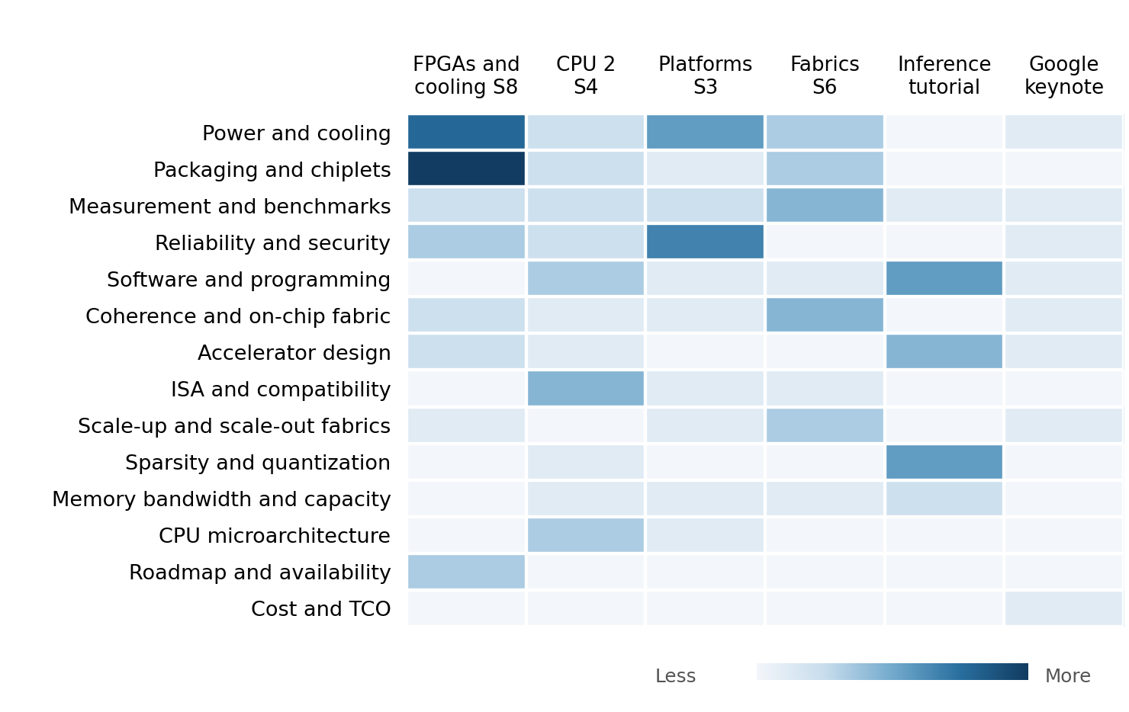
Darker cells indicate more audience questions in reviewed session blocks. Both axes run from hottest to coolest. Moderator prompts are excluded.
FPGAs and cooling attract the most questions in the reviewed material. Cooling volume is concentrated in the Fabric8 Labs exchange; software and measurement questions spread across more talks and affiliations.
Question volume shows attention among participating attendees. Decision importance also depends on the consequence of the issue raised.

Patterns
Software compatibility is part of the architecture. ROCm coverage, vector support and compiler responsibility drew questions across vendors. A hardware feature did not establish a usable software path.
Claims were tested against real workloads. Questions asked what had been built and measured. Intel distinguished physical graph-compute testbeds from larger modeled configurations.
Packaging raised integration questions. Chiplet arrangement, verification, materials and assembly all drew scrutiny. Physical integration answers were more concrete than future interoperability plans.
Cooling scrutiny included operational maturity. Google described favorable operating experience. Fabric8 Labs said lifetime testing remained outstanding, despite promising thermal results.
Precision gains depended on model fit. Questions tested sparsity structure, format choice and accuracy. Tutorial answers emphasized sensitivity and workload dependence.

Implications and concrete vendor asks
Inference: current vendor asks derived from the historical evidence, ordered by decision impact. Timing below reflects our decision gates.
Decision and timing | Vendor ask and decision test
Head nodes  Before shortlist | AMD and Intel: provide Venice and DMR ISA, compiler, memory-topology and accelerator-I/O support matrices. Run identical host services under memory and I/O contention. Prefer the platform that preserves throughput and tail latency with less migration work.
MI400  Before prototype | AMD: demonstrate supported model paths, format accuracy, sparsity constraints and CPU–GPU handoff in the intended software release. Require sustained serving throughput at the same quality target; nominal compute alone cannot decide.
Scale-up and scale-out  Before design freeze | Fabric suppliers: separate physical-system results from modeled scale. Supply topology, workload and failure-injection tests. Reconsider the topology if measured collectives or recovery erase its cost advantage.
KV-cache offload  Before architecture lock | CPU, accelerator and memory suppliers: benchmark local memory versus peer or host-memory access using shared-prefix traces. Include copies, synchronization and contention. Offload wins only if useful capacity lowers serving cost within latency targets.
Cooling  Before qualification | Server and cold-plate suppliers: provide lifetime, filtration, corrosion and maintenance results at the intended coolant conditions. Reject thermal-only comparisons that omit pumping power or service cost.

