Hot Chips 2024 Executive Brief
Audience questions and infrastructure decisions
YouTube automatic captions • Partial conference coverage
Inference: memory topology, runtime support and cooling qualification belong in accelerator purchase criteria.

Where audience questions concentrated
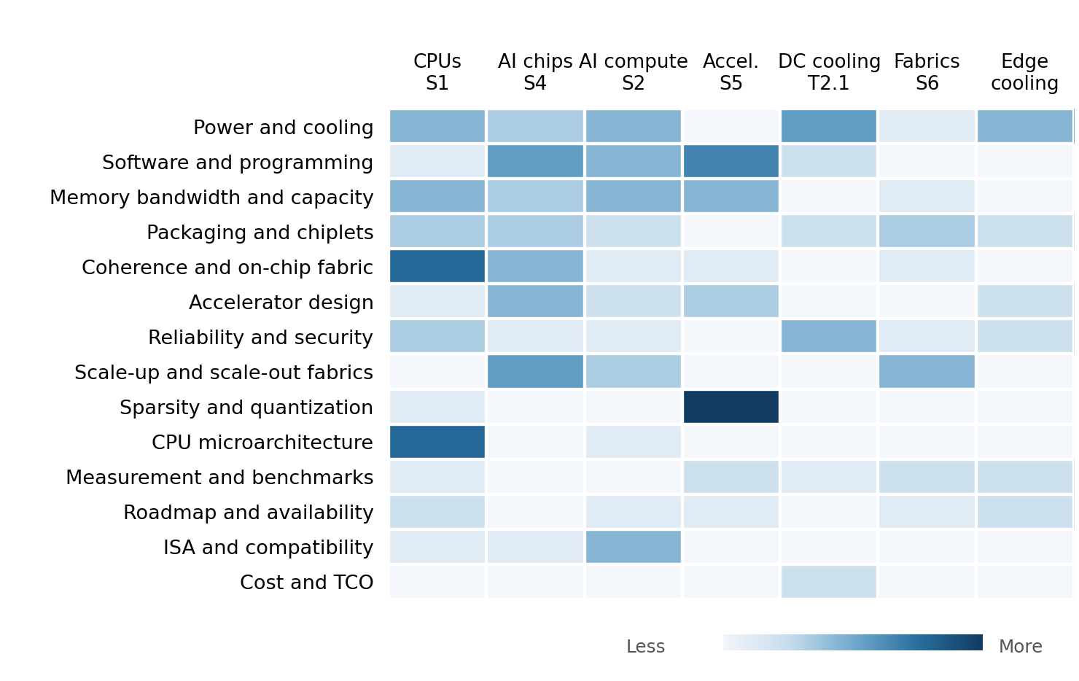
Darker cells indicate more audience questions in reviewed session blocks. Both axes run from hottest to coolest. Moderator prompts are excluded.
CPU sessions lead by question volume, while power and cooling lead among themes. Memory and software questions recur across CPU, accelerator and interconnect talks; specialist sparse-compute questioning is concentrated in the accelerator session.
Question volume shows attention among participating attendees. Decision importance also depends on the consequence of the issue raised.

Patterns
Memory placement and coherence drew sustained probing. AMD confirmed directed probes but left protocol details unresolved. Questions also tested HBM access efficiency, PIM interfaces and memory overhead.
Runtime flexibility needed practical detail. Questions examined partitioning, debugging, context switching and concurrent models. Some configuration features were explained while their overhead remained unquantified.
Sparse gains needed full cost accounting. Onyx questions exposed conversion and metadata costs. Meta separated evaluated or analytical benefits from deployed improvements.
Cooling was examined at system level. Questions covered rack limits, maintenance, capex and prototype evidence. Chip heat removal alone did not settle the facility decision.
Optical integration still needed qualification. Intel called OCI a technology demonstration. Laser history from pluggable modules did not establish reliability in the proposed CPU package.

Implications and concrete vendor asks
Inference: current vendor asks derived from the historical evidence, ordered by decision impact. Timing below reflects our decision gates.
Decision and timing | Vendor ask and decision test
Head nodes  Before shortlist | AMD and Intel: expose Venice and DMR cross-die access paths, coherence behaviour and loaded latency. Test CPU work alongside accelerator traffic. Prefer the topology with better delivered host service and memory access under contention.
MI400  Before prototype | AMD: specify supported partitions, runtime reconfiguration, isolation and context-switch cost. Demonstrate concurrent models and compare sparse/quantized gains after conversion, metadata and quality costs. Require results from the intended software release.
KV-cache offload  Before architecture lock | Memory and accelerator suppliers: show dynamic KV allocation, eviction, synchronization and placement across memory tiers. Test long contexts and shared prefixes. Change the design only when capacity savings survive transfer and scheduling overhead.
Scale-up and scale-out  Before design freeze | Optics and network suppliers: provide loaded latency, error recovery, thermal-transient qualification and field-replaceable boundaries. Separate technology demonstrations from qualified product results before choosing package-integrated optics.
Cooling  Before facility commitment | Server and cooling suppliers: price the full retrofit, residual air cooling and maintenance burden. Measure sustained workload energy and rack flow limits. Accept a design on facility economics and availability, not a chip-cooling result alone.

