Hot Chips 2025 Executive Brief
Audience questions and infrastructure decisions
YouTube automatic captions • Partial conference coverage
Inference: select the serving system as a whole. Fabric behaviour, memory access and recovery can determine the value of faster compute.

Where audience questions concentrated
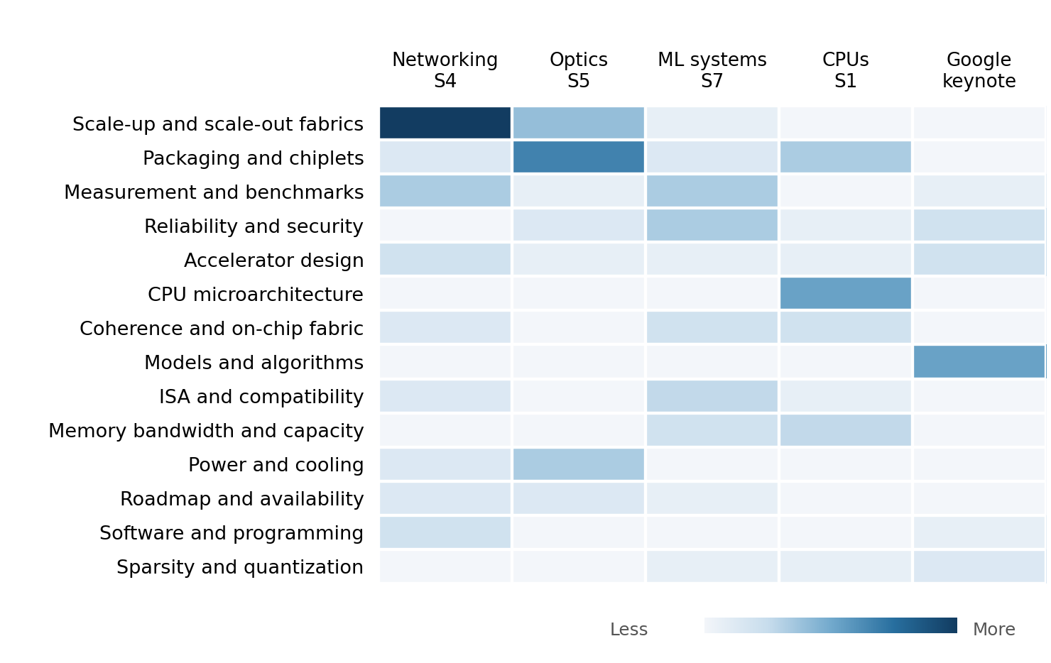
Darker cells indicate more audience questions in reviewed session blocks. Both axes run from hottest to coolest. Moderator prompts are excluded.
Networking leads by question volume, followed by optics. Questions about fabric mechanisms recur across vendors; optical packaging detail draws repeated follow-ups from a smaller specialist group. Model questions are concentrated in the keynote.
Question volume shows attention among participating attendees. Decision importance also depends on the consequence of the issue raised.

Patterns
Fabric mechanisms mattered beyond bandwidth. Questions probed retries, buffers, programmable controls and mixed-vendor operation. Interoperability did not establish equal performance.
Optics exposed packaging and repair tradeoffs. Thermal paths, fiber connections and driver placement drew scrutiny. External laser replacement left internal optical-engine repair unresolved.
Metric boundaries changed the interpretation. Marvell excluded DRAM latency from its expander figure. d-Matrix reported a core efficiency metric; NVIDIA clarified the traffic used in its noise test.
Memory expansion needed an access model. Questions tested host paths, capacity and coherence. Marvell scoped coherence to the expander; IBM discussed added memory-path latency and capacity tradeoffs.
Reliability required system-level recovery. Stacked-memory mitigations lacked field failure statistics. Huawei’s recovery depended on checkpoints and spare racks, not just a redundant chip.

Implications and concrete vendor asks
Inference: current vendor asks derived from the historical evidence, ordered by decision impact. Timing below reflects our decision gates.
Decision and timing | Vendor ask and decision test
Scale-up and scale-out  Before design freeze | NVIDIA, AMD, Intel and Broadcom: run matched mixed-vendor tests with incast, background traffic and link faults. Report loaded tail latency, retry limits and recovery. Choose on delivered job performance and operating cost.
KV-cache offload  Before architecture lock | Memory and fabric suppliers: measure the complete GPU-to-memory path, including DRAM, queues, copies and synchronization. Compare local memory, RDMA and coherent options on long-context serving. Offload must lower cost while meeting TTFT and TPOT targets.
Head nodes  Before shortlist | AMD and Intel: compare Venice and DMR with identical accelerator I/O, memory population and host workloads. Include cross-domain shared-data access and contention. Component latency claims cannot substitute for the full serving path.
MI400  Before prototype | AMD: provide workload-matched serving results with explicit precision, quality, memory residency and whole-server energy. Test concurrent traffic and recovery. Advance only if the gain persists beyond accelerator-core measurements.
Optical reliability  Before qualification | NVIDIA, Ayar Labs, Lightmatter and other optics suppliers: disclose internal engine repair, spare requirements and workload interruption. Compare ring and alternative modulation under matched thermal transients and complete power boundaries.

