Hot Chips 2026 Executive Brief
Inference: evaluate the CPU, accelerator, memory and fabric as one serving system. The evidence does not yet establish a Venice or DMR winner.

Recurring questions
- Performance and fabric: comparable workloads, delivered bandwidth, contention and failure behavior.
- Memory: where data resides, how it moves and what spilling or offloading costs.
- Execution: software placement, coherence boundaries and SMT isolation.

Where discussion concentrated
Darker blue means more questions. These are patterns across sessions, not trends over time.
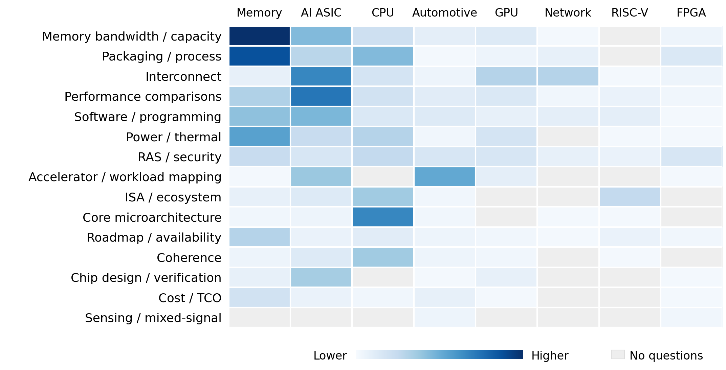

Patterns across sessions
Comparable performance: participants challenged precision, workloads and measurement boundaries, not just headline speedups.
Fabric behavior: routing, shared bandwidth and recovery mattered alongside aggregate link rates.
Memory movement: capacity questions also probed spill, migration and KV placement costs.
Software control: framework support did not settle porting effort or placement control.
Coherence boundaries: protocol names left ownership and data-return paths unresolved.
SMT trade-offs: threading rationales still needed workload-specific isolation and utilization comparisons.
Decision relevance: discussion volume does not determine decision importance. A lightly discussed coherence or reliability gap can still block deployment.

Implications and concrete vendor asks
All implications below are Inference. Prioritize each ask before the associated selection or procurement decision.

AMD and Intel before head node selection
Keep Venice versus DMR conditional on real data-sharing behavior under load.
Ask: Explain cache ownership and when data comes from a peer cache or memory. Compare producer–consumer latency, useful bandwidth and CPU overhead while GPU and NIC traffic run concurrently. Provide counters to diagnose the results.
Decision test: Choose the platform that meets latency, bandwidth and reliability requirements under concurrency.

AMD before committing to MI400
Architecture disclosures improve the evaluation plan; comparable serving results must establish the business case.
Ask: Run agreed prefill, decode and MoE workloads with matched model, precision, context, batch and software. Report throughput, tail latency, energy per token, memory and link traffic, host utilization, system price and availability.
Decision test: Commit when measured performance and cost meet the service target.

Fabric suppliers before procurement
Link bandwidth alone cannot establish delivered performance, interoperability or recovery behavior.
Ask: Document coherence, ordering and interoperability guarantees. Test all-to-all and small-message collectives at the intended scale, with competing traffic, congestion and failures.
Decision test: Require useful bandwidth and tail latency to hold under contention and after failures.

Memory and offload suppliers before KV partitioning
Capacity savings must cover data movement, latency, power and operating cost. Shared addressing does not by itself establish coherence.
Ask: Explain KV ownership, cache maintenance and migration. Compare offload against keeping KV in HBM at the same accuracy and service target. Report bytes moved, write intensity, tail latency, recovery behavior, endurance and delivered cost per usable capacity.
Decision test: Offload only when the measured capacity benefit exceeds the added system cost without breaking the service target.
Priority follow-ups: DMR data-source selection, Vera coherence behavior and HBM4 economics remain unresolved.

